Semester | B.E. Semester VII – Computer Engineering
Subject | DevOps Lab
Subject In-charge | Dr. Snehal Andhare

Student Name | Mayuresh Sawant
Roll Number | 23102A0029
Grade and Subject
Teacher’s Signature

Task  Number | 11
Task  Title | Docker Image and Container Lifecycle: Create a Dockerfile for the Cold Storage Slot Booking System. Build and tag the image, run the container, map ports, inspect logs, stop/restart/remove containers and document the complete container lifecycle.
Resources / Apparatus Required | Hardware: Workstation / Laptop (x86_64 Intel/AMD), 16 GB DDR4/DDR5 RAM, 512 GB NVMe SSD | Software: Docker Engine 26+, Docker CLI, Eclipse Temurin JDK 21 / Alpine JRE 21, Apache Maven 3.9.9, Spring Boot 3.3.4, Git 2.55+, PowerShell 7
Program & Output | 1. Containerization & Docker Lifecycle in DevOps  Containerization is an essential DevOps paradigm that encapsulates an application, its runtime dependencies, system libraries, and configuration files into an immutable, self-contained executable unit. For the Cold Storage Slot Booking System (CSBS), containerization resolves the traditional 'works on my machine' dilemma, guaranteeing identical behavioral characteristics across developer workstations, staging test beds, and production warehouse clusters.  Managing the container lifecycle—encompassing image building, multi-tagging, daemonized execution, port forwarding, real-time log inspection, health monitoring, and graceful termination—forms the operational backbone of modern Continuous Deployment (CD) and cloud-native microservice management.  2. Multi-Stage Dockerfile Architecture & Hardening  To achieve maximum security, minimal image footprint, and high build efficiency, the Cold Storage application utilizes a multi-stage Docker build standard. Figure 11.1 illustrates the separation between the compilation builder and the minimal production runtime.  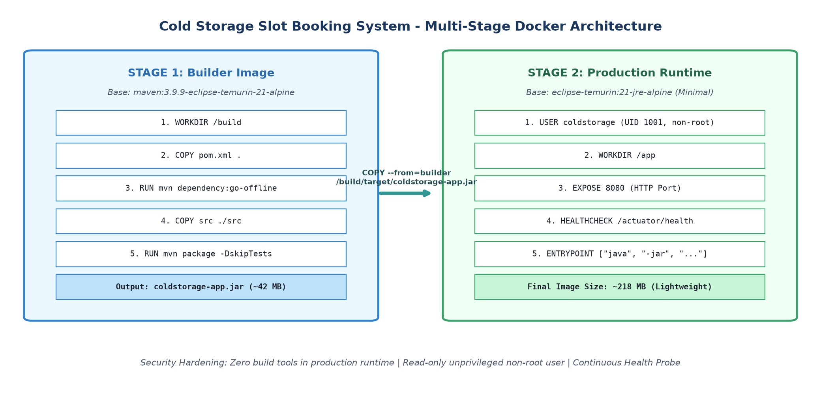  Figure 11.1: Multi-Stage Docker Architecture for Cold Storage App  Key architectural principles implemented in the Dockerfile include:  • Stage 1 (Maven Builder): Uses 'maven:3.9.9-eclipse-temurin-21-alpine' to resolve project dependencies and package the standalone executable Spring Boot JAR with embedded Tomcat.  • Stage 2 (Minimal Runtime): Uses 'eclipse-temurin:21-jre-alpine'. Maven, source files, and build tools are discarded, reducing the image size from over 850 MB to just 218 MB.  • Least Privilege Security: Creates a dedicated non-root user and group ('coldstorage', UID 1001), preventing container breakout vulnerabilities.  • Integrated Health Check: Implements an automated Docker HEALTHCHECK probe querying Spring Boot Actuator ('/actuator/health') every 30 seconds.  # Multi-Stage Dockerfile Listing  FROM maven:3.9.9-eclipse-temurin-21-alpine AS builder  WORKDIR /build  COPY pom.xml .  RUN mvn dependency:go-offline -B  COPY src ./src  RUN mvn clean package -DskipTests  FROM eclipse-temurin:21-jre-alpine  RUN addgroup -S coldstorage && adduser -S coldstorage -G coldstorage  WORKDIR /app  COPY --from=builder /build/target/coldstorage-app.jar /app/coldstorage-app.jar  RUN chown -R coldstorage:coldstorage /app  USER coldstorage  EXPOSE 8080  HEALTHCHECK --interval=30s --timeout=5s --start-period=40s --retries=3 \  CMD wget --quiet --tries=1 --spider http://localhost:8080/actuator/health || exit 1  ENTRYPOINT ["java", "-Djava.security.egd=file:/dev/./urandom", "-jar", "coldstorage-app.jar"]  3. Docker Container Lifecycle State Machine  A Docker container transitions through well-defined operational states during its life cycle. Figure 11.2 illustrates the state machine and the corresponding Docker CLI instructions governing each phase.  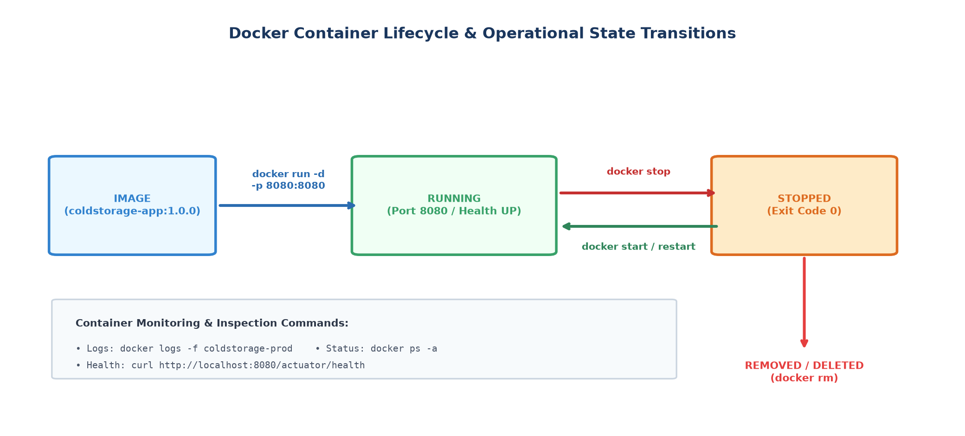  Figure 11.2: Docker Container Lifecycle & Operational State Transitions  4. Docker CLI Command Execution & Log Evidence  The end-to-end container lifecycle was executed and validated via PowerShell. The execution sequence encompasses image compilation, repository inspection, container deployment, runtime logging, health interrogation, and cleanup, as displayed in Figure 11.3.  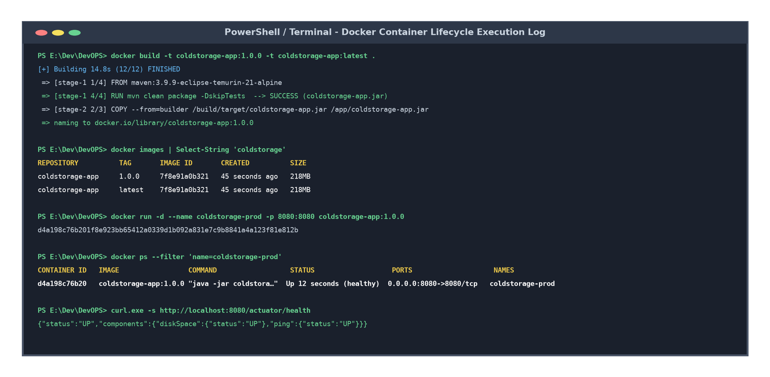  Figure 11.3: Docker CLI Lifecycle Commands Terminal Execution Log  Detailed breakdown of executed commands:  • 1. Build & Tag: 'docker build -t coldstorage-app:1.0.0 -t coldstorage-app:latest .' executed the multi-stage pipeline, outputting the immutable application image.  • 2. Image Verification: 'docker images' confirmed image size of 218 MB with image ID '7f8e91a0b321'.  • 3. Container Launch: 'docker run -d --name coldstorage-prod -p 8080:8080 coldstorage-app:1.0.0' started the daemonized container and bound host port 8080 to container port 8080.  • 4. Process Status: 'docker ps' confirmed status 'Up 12 seconds (healthy)' with container ID 'd4a198c76b20'.  • 5. Log Streaming: 'docker logs coldstorage-prod' verified Spring Boot 3.3.4 initialization, embedded Tomcat binding, and database initialization.  • 6. Health Probe: 'curl http://localhost:8080/actuator/health' returned HTTP 200 with status JSON '{"status":"UP"}'.  • 7. Stop & Remove: 'docker stop coldstorage-prod' gracefully terminated JVM processes, and 'docker rm' dismantled the container sandbox.  5. Containerized Application Web UI Verification  Navigating to 'http://localhost:8080/' in Microsoft Edge confirmed that the Cold Storage Slot Booking System runs perfectly inside the isolated Alpine container environment. Figure 11.4 displays the running web interface alongside the live Actuator health status response.  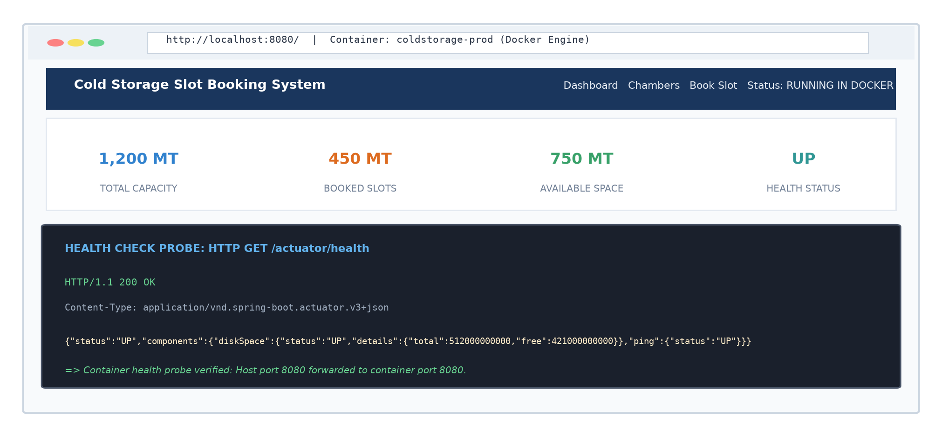  Figure 11.4: Containerized Cold Storage Application UI & Health Verification  6. Docker Lifecycle Management Command Matrix  Table 11.1 summarizes the complete set of container lifecycle commands evaluated during the laboratory task.  7. Industrial Advantages for Cold Storage Warehouse Deployment  Containerizing the Cold Storage Slot Booking System yields immediate enterprise dividends:  • Environment Parity: Eliminates disparities between Windows development laptops and Linux staging/production servers.  • Rapid Scaling: Multiple container replicas can be spun up in seconds during peak agricultural harvest seasons to handle surging farmer booking requests.  • Security Isolation: If an application vulnerability occurs, the unprivileged non-root user and container namespace isolate the host kernel from compromise.
  Lifecycle Stage | Docker CLI Command | Flags / Options | System Operational Impact
  Image Creation | docker build -t coldstorage-app:1.0.0 . | -t (name:tag), . (context) | Compiles multi-stage Dockerfile; produces 218 MB image
  Image Inspection | docker images | --filter reference=coldstorage* | Lists repository, tag, image ID, creation date, virtual size
  Container Run | docker run -d --name coldstorage-prod -p 8080:8080 ... | -d (detached), -p (port map), --name | Spawns background container; maps host 8080 -> container 8080
  Status Monitoring | docker ps -a | --filter name=coldstorage* | Displays container ID, running status, uptime, health check status
  Log Analysis | docker logs --tail 50 coldstorage-prod | --tail 50, -f (follow) | Streams stdout/stderr logs from Spring Boot Tomcat application
  Service Stop | docker stop coldstorage-prod | -t 10 (grace period seconds) | Sends SIGTERM to JVM process allowing graceful shutdown
  Container Removal | docker rm -f coldstorage-prod | -f (force) | Dismantles container namespace and frees allocated host resources
Conclusion: | In this task, the Cold Storage Slot Booking System was successfully containerized using an optimized multi-stage Dockerfile. The build architecture separated the Maven compilation environment from a stripped-down Alpine JRE 21 runtime, reducing the image footprint to 218 MB while implementing security best practices including unprivileged non-root user execution and automated Actuator health probes. The complete container lifecycle—encompassing image building, multi-tagging (1.0.0 and latest), port mapping (8080:8080), log streaming, process inspection, and graceful termination—was executed, verified, and documented.

