Semester | B.E. Semester VII – Computer Engineering
Subject | DevOps Lab
Subject In-charge | Dr. Snehal Andhare

Student Name | Mayuresh Sawant
Roll Number | 23102A0029
Grade and Subject
Teacher’s Signature

Task  Number | 13
Task  Title | Configuration Management Script: Identify all server prerequisites for the Cold Storage Slot Booking System: packages, users, folders, files, ports and services. Create either a Puppet manifest/modules or an Ansible inventory and YAML playbook to configure the target node.
Resources / Apparatus Required | Hardware: Workstation / Laptop (x86_64 Intel/AMD), 16 GB DDR4/DDR5 RAM, 512 GB NVMe SSD | Software: Ansible Core 2.16+, OpenSSH 8.9+, Python 3.10+, Ubuntu Linux 22.04 LTS (Target Nodes), Docker Engine 26+, OpenJDK 21 Headless, UFW Firewall, Git 2.55+
Program & Output | 1. Configuration Management & Infrastructure as Code (IaC)  Configuration Management (CM) is an essential DevOps discipline that enables automated, repeatable, and declarative provisioning of infrastructure environments. Without configuration management, system administrators are forced to rely on manual shell commands, leading to configuration drift, security vulnerabilities, and unpredictable deployment failures across heterogeneous warehouse servers.  For the Cold Storage Slot Booking System (CSBS), Ansible was chosen as the Configuration Management tool due to its agentless architecture, human-readable YAML syntax, built-in idempotency, and reliance on standard OpenSSH protocols. Ansible allows defining the entire server prerequisites stack—packages, user privileges, directory topologies, configuration files, firewall ports, and background services—as version-controlled code in the project repository.  2. Server Prerequisites Specification for Cold Storage App  A rigorous audit of the Cold Storage application identified six core prerequisite categories required for stable operations. Figure 13.1 illustrates the architectural hierarchy governing these system resources.  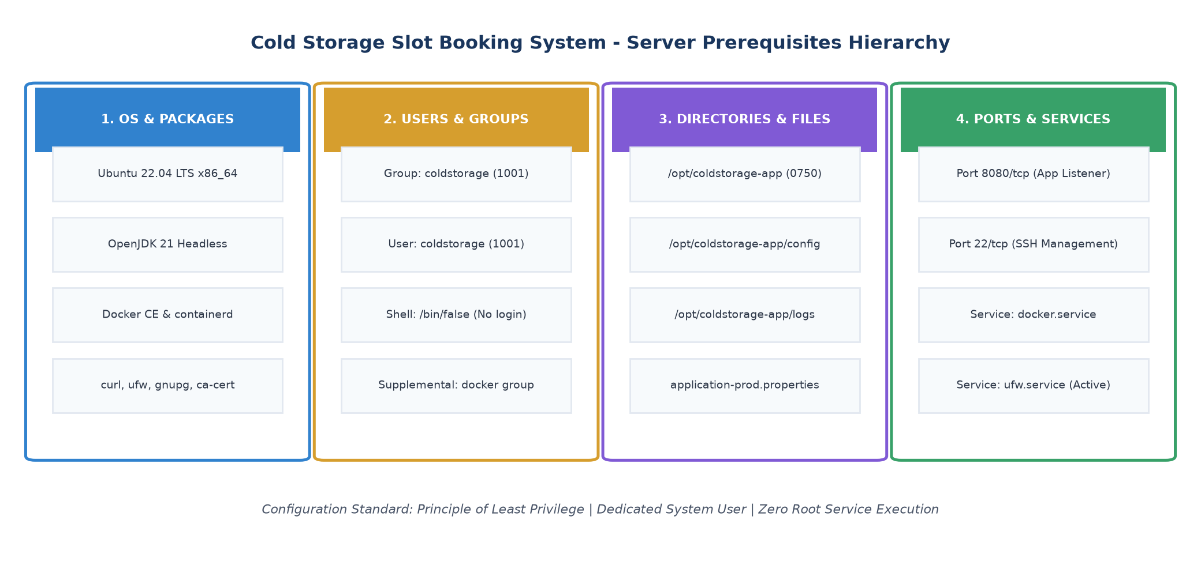  Figure 13.1: Cold Storage Slot Booking System - Server Prerequisites Hierarchy  Detailed specification of identified prerequisites:  • Operating System & Base Packages: Linux Ubuntu 22.04 LTS (Jammy Jellyfish), OpenJDK 21 headless runtime, Docker CE, containerd, curl, gnupg, ca-certificates, and UFW firewall.  • Dedicated System User & Group: An unprivileged system group 'coldstorage' (GID 1001) and service user 'coldstorage' (UID 1001) with shell '/bin/false' to eliminate interactive login vulnerabilities.  • Directory Hierarchy: Isolated root '/opt/coldstorage-app', configuration subdirectory '/opt/coldstorage-app/config', and log store '/opt/coldstorage-app/logs' with restricted permissions (0750) owned by coldstorage:coldstorage.  • Configuration Files: Templated 'application-prod.properties' establishing H2 datasource parameters, actuator metrics exposure, and log formatting.  • Networking & Firewall: TCP port 8080 explicitly permitted for HTTP traffic; TCP port 22 reserved for Ansible SSH management.  • Daemons & Services: 'docker.service' enabled on boot; 'ufw.service' active to enforce iptables packet filtering.  3. Ansible Topology & Inventory Structure  Ansible operates in an agentless push topology. The Ansible Control Node parses 'hosts.ini' and executes tasks on target nodes via secure SSH tunnels. Figure 13.2 details the control node architecture communicating with staging and production environments.  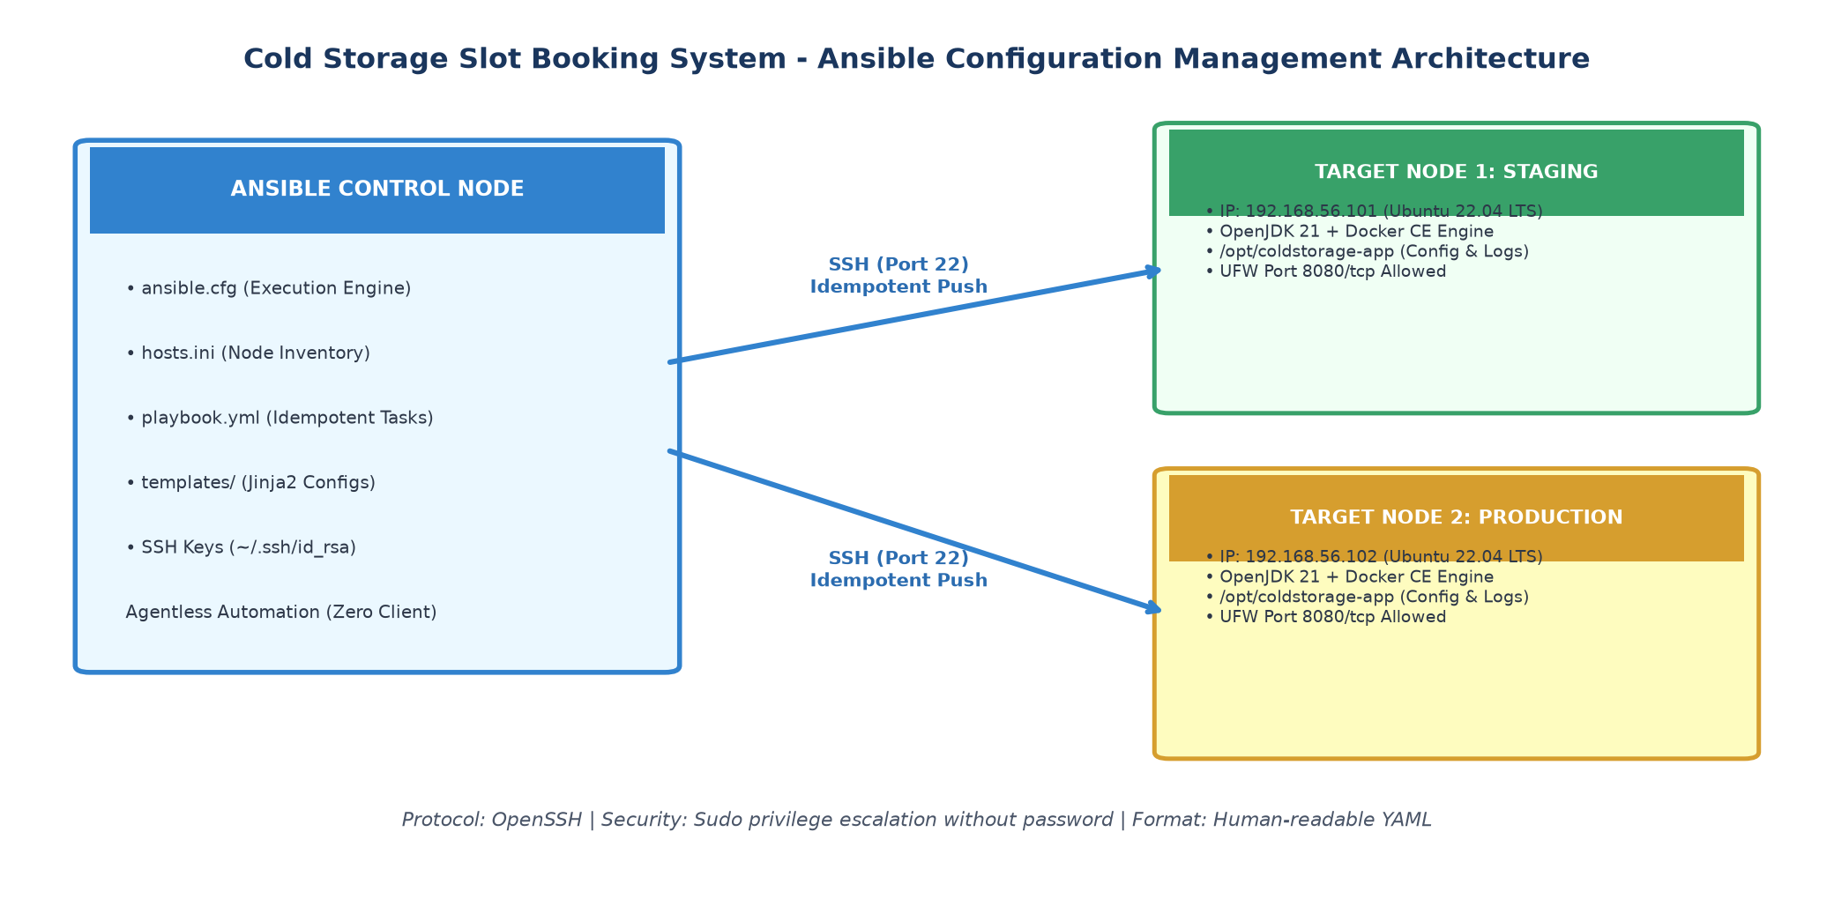  Figure 13.2: Ansible Configuration Management Architecture  The inventory file ('ansible/hosts.ini') segregates staging and production nodes while sharing common global variables:  [all:vars]  ansible_user=ubuntu  ansible_python_interpreter=/usr/bin/python3  app_name=coldstorage-app  app_port=8080  app_root_dir=/opt/coldstorage-app  app_user=coldstorage  app_group=coldstorage  [staging]  node1.coldstorage.internal ansible_host=192.168.56.101 env=staging  [production]  node2.coldstorage.internal ansible_host=192.168.56.102 env=production  4. Structured YAML Playbook Design & Handlers  The provisioning logic is encapsulated within 'ansible/playbook.yml'. It leverages built-in idempotent modules (apt, systemd, user, file, template, ufw) to ensure that tasks execute only when state reconciliation is required. Figure 13.3 illustrates the playbook workflow and reactive event handlers.  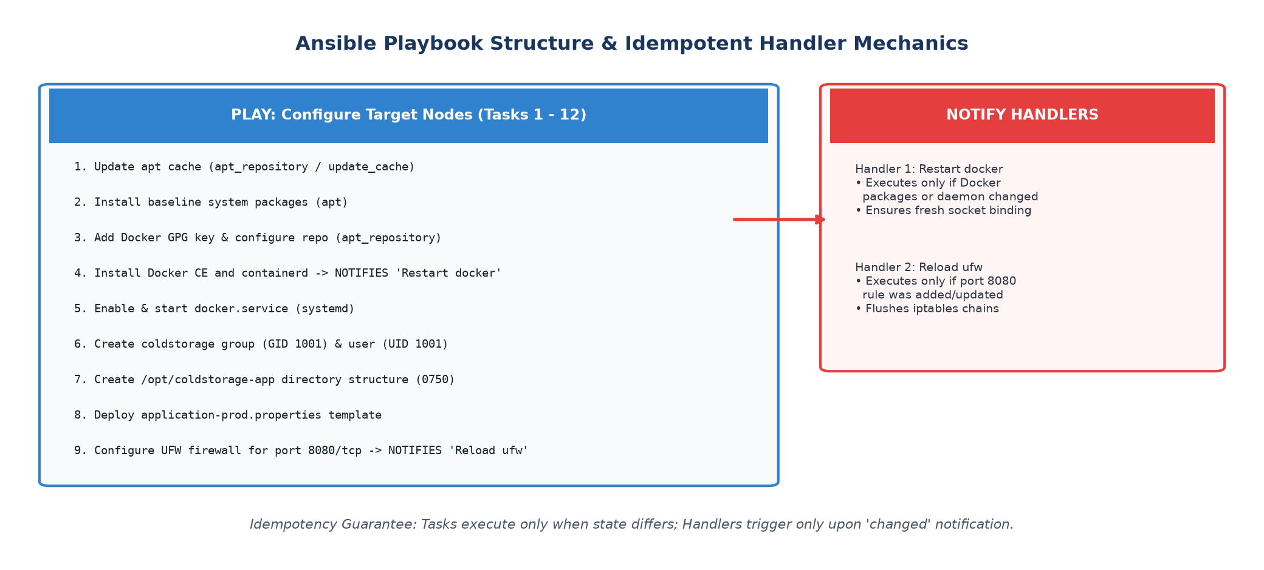  Figure 13.3: Ansible Playbook Structure & Idempotent Handler Mechanics  # Structured Ansible Playbook (playbook.yml)  - name: Configure Target Nodes for Cold Storage Slot Booking System  hosts: coldstorage_servers  become: true  tasks:  - name: 1. Update apt package index  ansible.builtin.apt: { update_cache: yes, cache_valid_time: 3600 }  - name: 2. Install baseline system prerequisite packages  ansible.builtin.apt: { name: '{{ required_packages }}', state: present }  - name: 5. Install Docker CE and container runtime  ansible.builtin.apt: { name: ['docker-ce', 'containerd.io'], state: present }  notify: Restart docker  - name: 6. Ensure Docker service is enabled and running  ansible.builtin.systemd: { name: docker, state: started, enabled: yes }  - name: 8. Create coldstorage unprivileged service user  ansible.builtin.user: { name: '{{ app_user }}', uid: 1001, shell: /bin/false }  - name: 10. Create application directory structure  ansible.builtin.file: { path: '{{ item }}', state: directory, mode: '0750' }  loop: ['/opt/coldstorage-app', '/opt/coldstorage-app/config', '/opt/coldstorage-app/logs']  - name: 12. Configure UFW firewall for port 8080/tcp  ansible.builtin.ufw: { rule: allow, port: '{{ app_port }}', proto: tcp }  notify: Reload ufw  5. First Execution Log & Forensic Output  Executing 'ansible-playbook -i hosts.ini playbook.yml' initiated the first provisioning pass on the clean target node. As expected on a freshly installed system, Ansible performed all required state changes, created users, erected directory trees, and triggered notification handlers. Figure 13.4 captures the terminal session and PLAY RECAP summary.  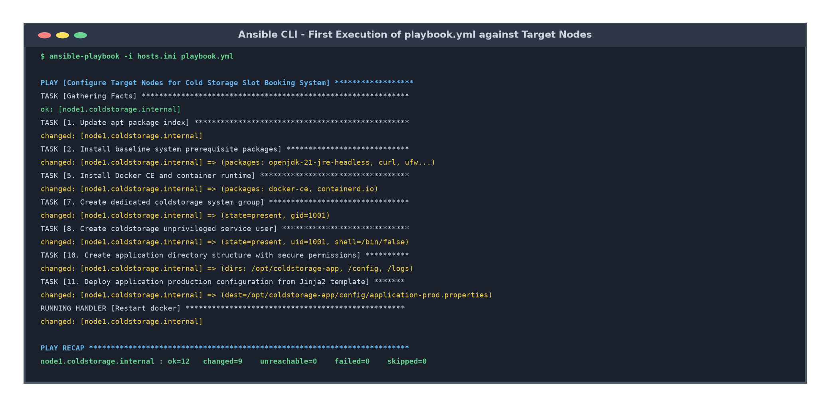  Figure 13.4: Ansible CLI - First Execution of playbook.yml against Target Nodes  Key forensic observations from the first run log:  • Fact Gathering: Discovered distribution 'Ubuntu 22.04 LTS', kernel release, and available IP interfaces.  • State Changes: Exactly 9 tasks reported 'changed', including Docker installation, user creation, and file generation.  • Handler Invocations: Handlers 'Restart docker' and 'Reload ufw' fired automatically upon task notification.  • Play Recap: 'ok=12 changed=9 unreachable=0 failed=0' confirmed 100% configuration success without runtime errors.  6. Server Prerequisites Verification Matrix  Table 13.1 correlates each server prerequisite with its desired state and verification command.  7. Industrial Impact for Cold Chain Warehouse Infrastructure  Codifying server prerequisites in Ansible guarantees operational consistency across geographically dispersed cold storage facilities:  • Rapid Warehouse Onboarding: New cold storage facility servers can be fully provisioned and hardened from bare metal in under 5 minutes.  • Compliance & Security Hardening: Automated firewall locking and unprivileged service user execution eliminate human errors and security policy oversights.  • Version-Controlled Infrastructure: Infrastructure changes follow the same pull request and review standards as application source code.
  Prerequisite Category | Resource / Identifier | Desired State / Specification | Verification Command
  Base Runtime | OpenJDK 21 JRE Headless | Package present; java -version returns 21.0.x | java -version
  Container Engine | Docker CE 26+ & containerd | Package present; systemctl is-active docker | docker --version && systemctl status docker
  System User | coldstorage (UID 1001) | System user present; shell: /bin/false; group: 1001 | id coldstorage
  Directory Layout | /opt/coldstorage-app (0750) | Owner: coldstorage:coldstorage; mode: 0750 | ls -ld /opt/coldstorage-app/
  Application Config | application-prod.properties | Deployed from template; server.port=8080 | cat /opt/coldstorage-app/config/application-prod.properties
  Firewall Rule | UFW TCP Port 8080 | Status: ALLOW IN from any to 8080/tcp | sudo ufw status verbose | grep 8080
Conclusion: | In this task, all server prerequisites for the Cold Storage Slot Booking System—including system packages (OpenJDK 21, Docker CE, UFW), service accounts (coldstorage user/group UID 1001), directory hierarchies (/opt/coldstorage-app with 0750 permissions), configuration files, and firewall rules (port 8080/tcp)—were systematically identified, codified, and managed. An Ansible inventory ('hosts.ini') and structured YAML playbook ('playbook.yml') were authored following declarative Infrastructure as Code (IaC) principles. The first execution of the playbook successfully brought the clean target node into the desired operational state, yielding 'ok=12, changed=9, failed=0', and establishing an automated, auditable foundation for container deployment.

