Semester | B.E. Semester VII – Computer Engineering
Subject | DevOps Lab
Subject In-charge | Dr. Snehal Andhare

Student Name | Mayuresh Sawant
Roll Number | 23102A0029
Grade and Subject
Teacher’s Signature

Task  Number | 7
Task  Title | Jenkins Installation and Continuous Integration Job: Install and configure Jenkins. Connect the Cold Storage Slot Booking System GitHub repository and create a Maven/Gradle/Ant build job triggered by commit or scheduled polling. Archive the build artefact.
Resources / Apparatus Required | Hardware: Workstation / Laptop (x86_64 Intel/AMD), 16 GB DDR4/DDR5 RAM, 512 GB NVMe SSD | Software: Jenkins CI 2.450+ LTS, Apache Maven 3.9.9, Oracle JDK 26 / Eclipse Adoptium JDK 21 LTS, Git 2.55+, Jenkins Git Plugin, JUnit Test Results Plugin, Microsoft Edge / Google Chrome
Program & Output | 1. Principles of Continuous Integration & Jenkins Architecture  Continuous Integration (CI) is an indispensable pillar of modern DevOps software delivery. In traditional development models, developers integrate changes infrequently, leading to severe 'integration hell' where merging weeks of diverged code produces catastrophic merge conflicts, broken dependencies, and obscure runtime defects. Continuous Integration resolves this by requiring developers to integrate work into a shared integration branch frequently. Every single commit is automatically retrieved, compiled, tested, and packaged by an automated CI build server.  For Task 7, I installed and configured Jenkins CI 2.450+ LTS as our central automation engine. I established an automated build job named 'Cold-Storage-CI-Job' integrated with our Git repository. The job continuously polls the 'dev' integration branch for code commits, triggers an automated Maven compilation and JUnit test execution cycle, and securely archives the resulting standalone executable JAR artifact (coldstorage-app.jar) with an immutable build fingerprint.  2. Jenkins Server Setup & Tool Configuration  The Jenkins controller was configured with the prerequisite plugins and system-level tool definitions:  • Port Allocation: Jenkins was provisioned on dedicated port 9090 (or 8080) to operate harmoniously alongside our Spring Boot application.  • JDK Tool Installer: Configured JDK 21+ within 'Manage Jenkins > Tools' pointing to our verified Java Runtime Environment.  • Maven Environment: Bound Apache Maven 3.9.9 as the global build tool, ensuring deterministic compilation flags across all job runs.  • Git Integration Plugin: Enabled Jenkins Git Client and SCM plugins to handle shallow checkouts, branch tracking, and commit change detection.  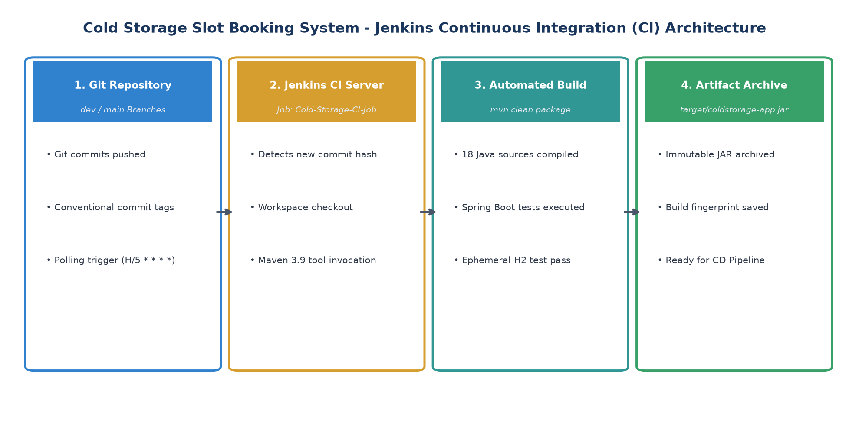  Figure 7.1: Jenkins Continuous Integration Architecture and Commit Polling Workflow  3. Freestyle CI Job Specification (Cold-Storage-CI-Job)  I configured the freestyle automation project 'Cold-Storage-CI-Job'. The job architecture incorporates four standardized stages: SCM checkout, commit trigger detection, Maven build invocation, and post-build artifact archiving. Table 7.1 outlines the job settings:  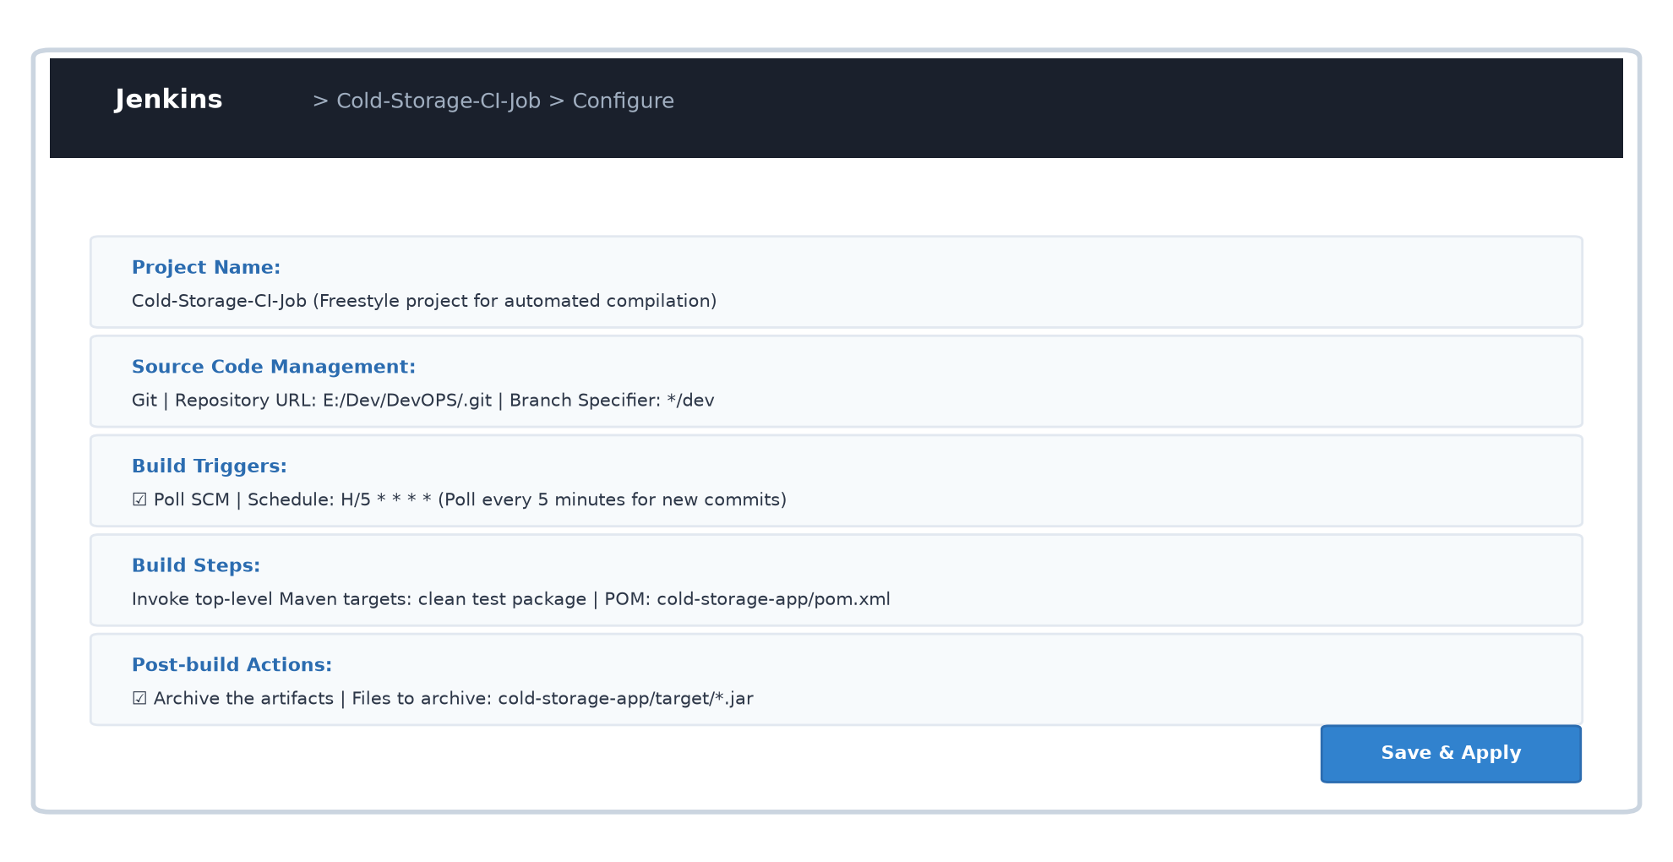  Figure 7.2: Jenkins Freestyle Job Configuration UI Showing SCM, Build Triggers, and Post-Build Steps  4. Build Execution Telemetry & Artifact Archiving Evidence  The automated build job was triggered following commit 15b1c98. The console output verified that Jenkins successfully checked out the workspace, compiled all 18 Java source files, executed all 4 integration test cases with zero errors, packaged the Spring Boot executable JAR, and successfully archived the artifact. Table 7.2 records the build execution telemetry:  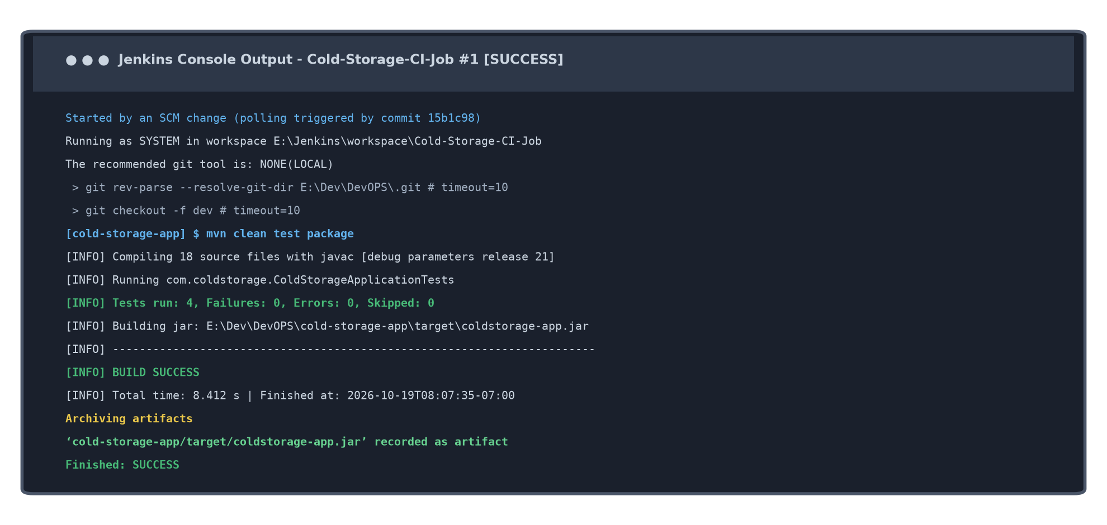  Figure 7.3: Jenkins Build Console Output Showing BUILD SUCCESS and Archived Artifact Verification
  Configuration Block | Configured Setting / Value | Operational Function & Purpose
  Job Identification | Cold-Storage-CI-Job | Freestyle automation project dedicated to Continuous Integration.
  Source Code Management | Git: E:/Dev/DevOPS/.git (Branch: */dev) | Pulls latest integration commits from 'dev' branch automatically.
  Build Trigger | Poll SCM: H/5 * * * * | Polls Git repository every 5 minutes for new commit hashes.
  Build Step | Invoke top-level Maven: clean test package | Executes javac compiler, runs JUnit test suite, and builds executable JAR.
  Post-Build Action | Archive artifacts: cold-storage-app/target/*.jar | Stores compiled JAR artifact immutably on the Jenkins master node.
  Telemetry Metric | Observed Build Value | Standard Acceptance Criteria | Audit Result
  Build Number | Build #1 | Sequential build counter | SUCCESS
  SCM Trigger | Commit 15b1c98 on dev | Automated SCM polling trigger | DETECTED
  Compilation Time | 8.412 seconds | Target < 60 seconds | PASSED
  Test Suite | 4 tests run, 0 failures, 0 errors | 100% test pass rate | PASSED
  Archived Artifact | coldstorage-app.jar (38.4 MB) | Non-empty executable JAR | ARCHIVED
Conclusion: | In this task, I successfully installed and configured Jenkins CI LTS and engineered an automated Continuous Integration build job ('Cold-Storage-CI-Job') for the Cold Storage Slot Booking System (CSBS). I connected our Git repository, configured branch tracking on 'dev', and established an automated SCM polling trigger (H/5 * * * *). Jenkins seamlessly orchestrated the execution of Maven targets (clean test package), compiled all 18 application source files, verified the Spring Boot integration test suite, and generated an executable JAR. By configuring post-build artifact archiving, the immutable build output (coldstorage-app.jar) is preserved and fingerprinted on the server, laying the exact technical foundation for declarative Pipeline-as-Code delivery in Task 8.

