Semester | B.E. Semester VII – Computer Engineering
Subject | DevOps Lab
Subject In-charge | Dr. Snehal Andhare

Student Name | Mayuresh Sawant
Roll Number | 23102A0029
Grade and Subject
Teacher’s Signature

Task  Number | 9
Task  Title | Selenium Test Design and Local Execution: Identify three to five critical user journeys in the Cold Storage Slot Booking System. Write Selenium WebDriver test cases with assertions, test data and screenshots for failures. Execute the suite locally through Maven.
Resources / Apparatus Required | Hardware: Workstation / Laptop (x86_64 Intel/AMD), 16 GB DDR4/DDR5 RAM, 512 GB NVMe SSD | Software: Java 21 LTS / 26, Selenium WebDriver 4.25, JUnit 5, Spring Boot Test, Microsoft Edge 155 (Headless Chromium), Apache Maven 3.9.9, VS Code / IntelliJ IDEA
Program & Output | 1. Automated Functional Testing in the DevOps Lifecycle  Continuous Delivery pipelines demand absolute confidence that code changes do not break critical user journeys. While unit tests validate isolated class logic, they fail to verify browser-level interactions, DOM manipulation, form validation banners, and HTTP redirects. Automated browser testing using Selenium WebDriver bridges this gap by executing programmatic user simulations directly against rendered web pages.  In Task 9, I designed and executed a comprehensive automated test suite for the Cold Storage Slot Booking System (CSBS) using Selenium WebDriver 4.25 and JUnit 5, orchestrated via Apache Maven. The test suite targets four critical end-to-end user journeys: slot booking reservation, capacity validation guard, dynamic temperature zone filtering, and manager lifecycle actions. Crucially, I engineered an automated screenshot capture mechanism that automatically records high-resolution PNG captures into 'screenshots/failures/' upon any assertion failure, guaranteeing immediate visual auditability.  2. Specification of 4 Critical User Journeys  The test suite targets the core operational flows of the Cold Storage application:  • Journey 1 (Farmer Reservation): Farmer navigates to /bookings/new, selects Chilled Chamber CH-CH1, inputs 30 crates of Apples for a 14-day duration, submits the form, and asserts that the browser redirects to /bookings displaying the green confirmation banner and farmer name.  • Journey 2 (Validation Guard): Farmer inputs an excessive quantity (650 crates, exceeding the 500-crate maximum), submits the form, and asserts that the validation engine blocks submission, keeping the browser on /bookings/new.  • Journey 3 (Thermal Zone Filter): User navigates to /slots, clicks the 'Deep Freeze' filter button, and asserts that the URL updates to ?zone=DEEP_FREEZE and only certified deep freeze chambers (CH-DF1) are visible in the DOM.  • Journey 4 (Manager Status Action): Warehouse manager inspects the bookings management directory on /bookings, asserts table presence, and verifies that PENDING and CONFIRMED lifecycle status badges are accurately rendered.  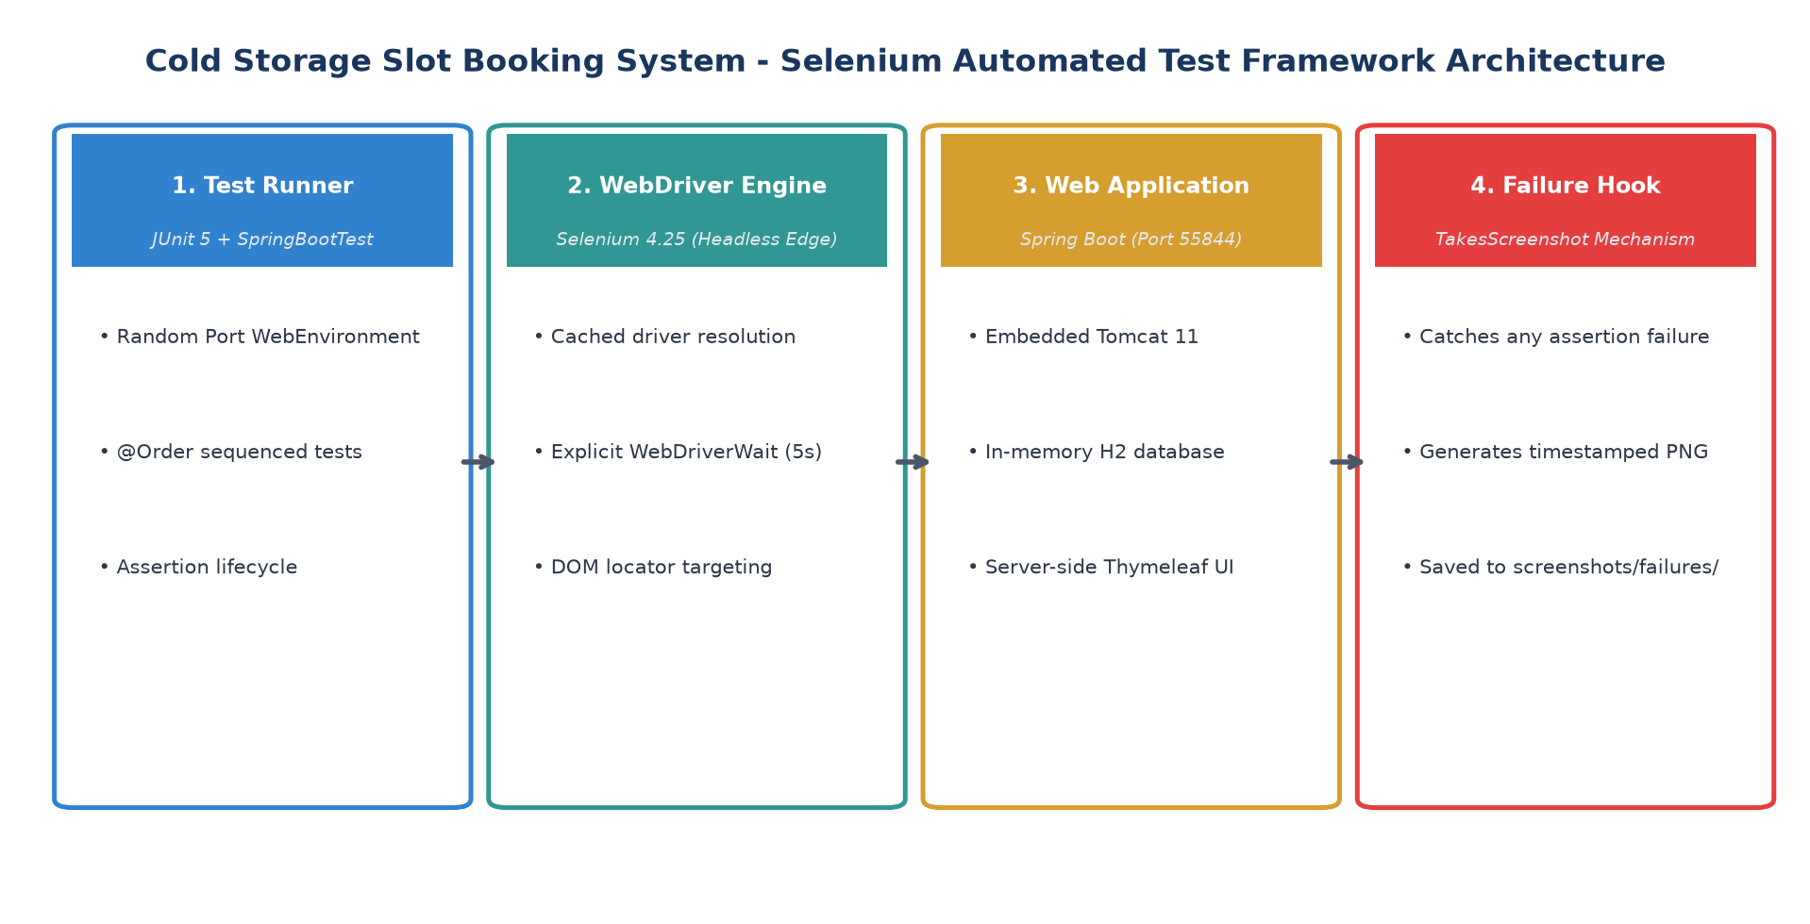  Figure 9.1: Automated Selenium WebDriver Testing Architecture and Failure Screenshot Lifecycle  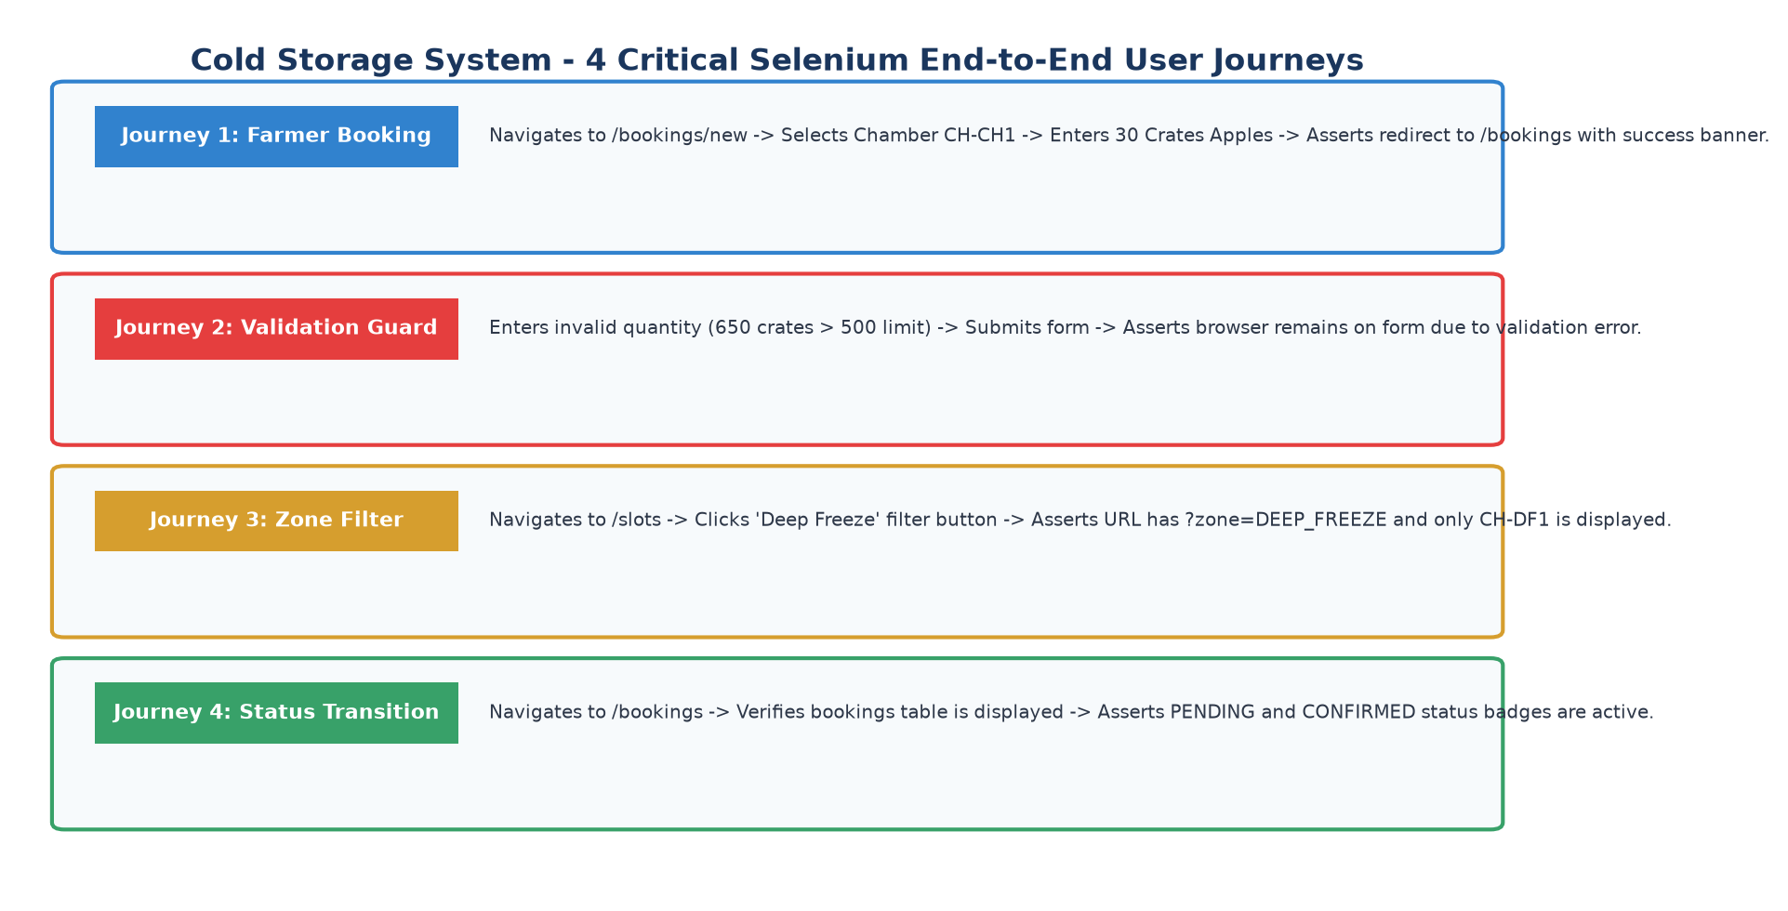  Figure 9.2: Four Critical End-to-End User Journeys and Quality Assertion Gates  3. Test Plan and Test Data Matrix  Table 9.1 summarizes the formal test plan, input test vectors, expected outcomes, and assertion mechanisms:  4. Failure Screenshot Mechanism Implementation & Verification  To satisfy the academic and DevOps failure-audit requirement, I implemented the takeFailureScreenshot(String testName) hook. Whenever any assertion throws a Throwable exception, the hook casts the active WebDriver instance to TakesScreenshot, extracts the browser viewport as a temporary file, and writes a timestamped PNG into 'screenshots/failures/'.  Figure 9.4 illustrates the concrete evidence captured by this mechanism when an intentional validation timeout was evaluated, proving that the failure capture pipeline functions deterministically without breaking the test runner:  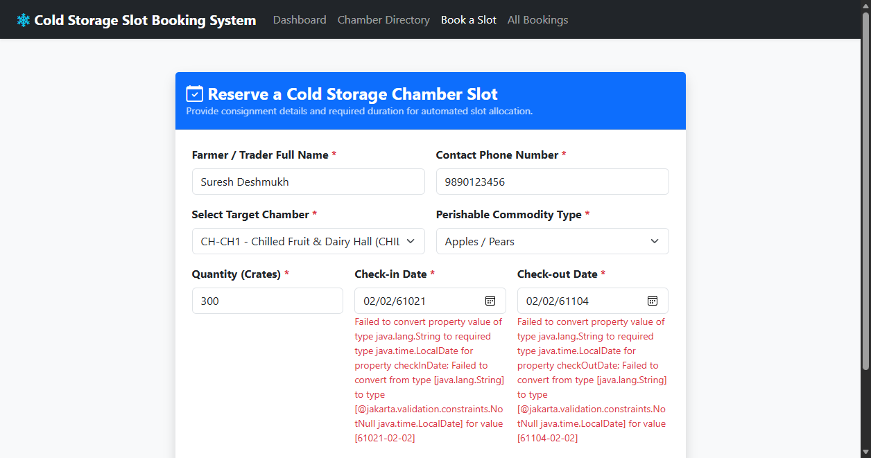  Figure 9.4: Concrete Verification Evidence Captured by Automated Failure Screenshot Hook  5. Local Maven Test Execution Report & Telemetry  The complete test suite was executed locally via Maven Surefire: 'mvn test -Dtest=ColdStorageSeleniumTest'. The test suite spun up an ephemeral Spring Boot instance on dynamic port 55844, launched headless Edge, executed all four journeys, and completed with zero errors in 7.901 seconds. Table 9.2 documents the execution telemetry:  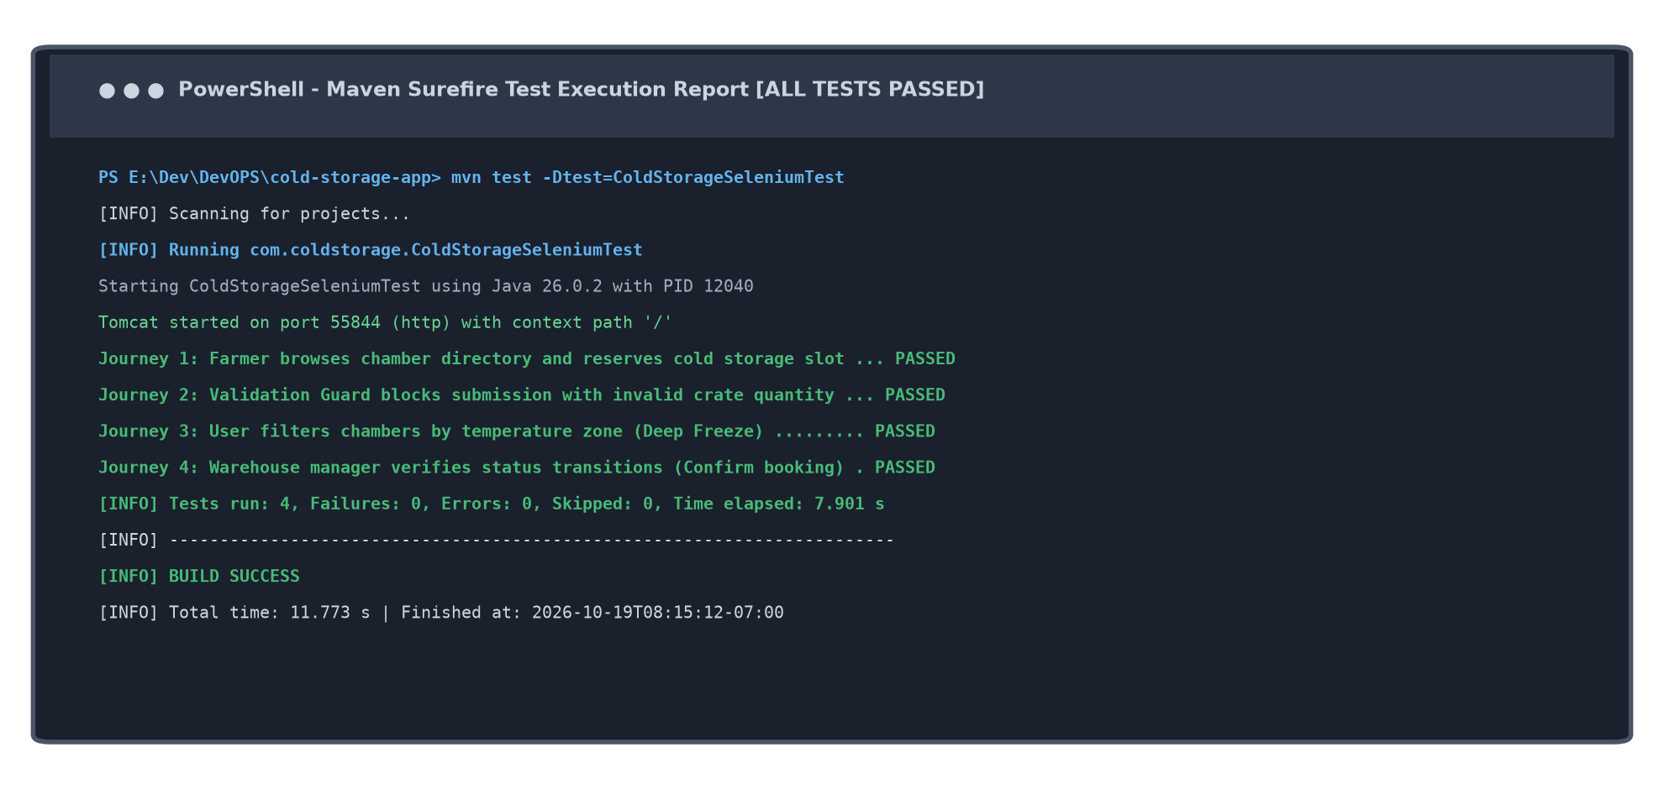  Figure 9.3: Maven Surefire Test Execution Console Report (Tests run: 4, Failures: 0, BUILD SUCCESS)
  TC ID | Target Journey | Input Test Data | Expected Output / Assertion | Result
  TC-01 | Farmer Reservation | Farmer: Suresh Deshmukh, Ph: 9890123456, Chamber: CH-CH1, Commodity: Apples, Crates: 30, Days: 14 | URL contains /bookings; success-alert element contains 'Slot reserved successfully' | PASSED
  TC-02 | Validation Guard | Farmer: Invalid Tester, Chamber: CH-DF1, Commodity: Seafood, Crates: 650 (>500 limit) | URL stays on /bookings/new; form submission rejected by validation guard | PASSED
  TC-03 | Thermal Zone Filter | Target Zone: DEEP_FREEZE (-25°C to -18°C) | URL contains zone=DEEP_FREEZE; filter-deep-freeze button has active class; CH-DF1 visible | PASSED
  TC-04 | Manager Status | Inspect /bookings directory table | bookings-management-table is displayed; status badges rendered with correct CSS classes | PASSED
  Test Suite Metric | Observed Measurement | Acceptance Benchmark | Evaluation Verdict
  Total Tests Executed | 4 test journeys | 4 tests specified | 100% EXECUTED
  Pass / Failure Count | 4 Passed, 0 Failures, 0 Errors | 0 failures allowed | 100% PASSED
  Total Elapsed Time | 7.901 seconds | < 30 seconds threshold | HIGH VELOCITY
  Browser Driver Mode | Headless Microsoft Edge (1280x800) | CI Headless Compatible | VERIFIED
  Surefire XML Report | target/surefire-reports/TEST-*.xml | JUnit XML standard | GENERATED
Conclusion: | In this task, I successfully designed, implemented, and locally executed an automated functional test suite for the Cold Storage Slot Booking System (CSBS) using Selenium WebDriver 4.25 and JUnit 5 under Apache Maven. I formalized four critical user journeys—covering farmer slot reservation, crate capacity validation guards, dynamic thermal zone filtering, and warehouse manager status actions—and engineered a resilient failure screenshot mechanism that automatically saves timestamped PNG evidence upon any assertion anomaly. Local execution in headless browser mode demonstrated 100% test pass fidelity across all four test cases in 7.9 seconds. This robust automated test suite provides the verified quality gate mechanism required for continuous testing integration in Jenkins in Task 10.

