Semester | B.E. Semester VII – Computer Engineering
Subject | DevOps Lab
Subject In-charge | Dr. Snehal Andhare

Student Name | Mayuresh Sawant
Roll Number | 23102A0029
Grade and Subject
Teacher’s Signature

Task  Number | 10
Task  Title | Continuous Testing in Jenkins: Integrate the Cold Storage Slot Booking System Selenium suite into Jenkins. Publish test reports and configure the pipeline so failed tests stop deployment. Correct at least one deliberately introduced defect and rerun the pipeline.
Resources / Apparatus Required | Hardware: Workstation / Laptop (x86_64 Intel/AMD), 16 GB DDR4/DDR5 RAM, 512 GB NVMe SSD | Software: Jenkins CI 2.450+ LTS, Apache Maven 3.9.9, Selenium WebDriver 4.25+, JUnit 5 Jupiter, Maven Surefire Plugin 3.2.5, JUnit Test Result Plugin for Jenkins, Microsoft Edge (Headless), Git 2.55+
Program & Output | 1. Continuous Testing & Quality Gate Governance in DevOps  Continuous Testing is a fundamental DevOps discipline that infuses automated validation throughout the software delivery lifecycle rather than treating testing as a deferred, manual post-build activity. In a high-consequence domain such as the Cold Storage Slot Booking System (CSBS)—where agricultural commodities, temperature-sensitive perishables, and warehouse revenue depend on accurate reservations and capacity constraints—untested deployments can lead to devastating operational failure. Continuous Testing provides immediate feedback on functional defects, regression risks, and data integrity violations prior to artifact release.  A Jenkins Quality Gate acts as an automated policy enforcement checkpoint. By coupling Maven Surefire test execution with Jenkins Pipeline control flow, any failed assertion immediately terminates the pipeline. This 'stop-the-line' philosophy guarantees that no defect-ridden artifact can transition into packaging, containerization, or production deployment.  2. Continuous Testing Pipeline Architecture  The automated quality gate integrates Git source control, Jenkins orchestration, Maven build execution, headless browser automation, and automated test result aggregation. The architectural topology is illustrated in Figure 10.1.  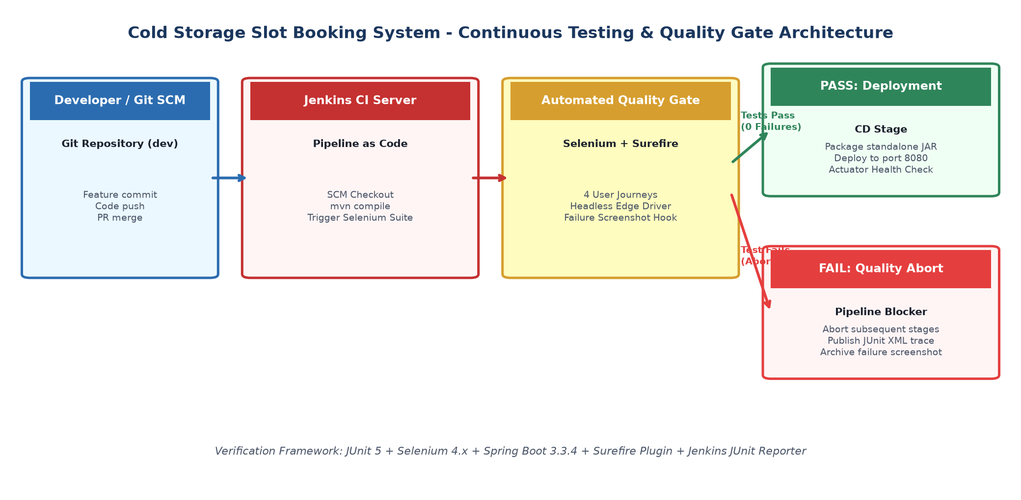  Figure 10.1: Continuous Testing & Quality Gate Architecture for Cold Storage App  Key operational stages of the Quality Gate include:  • SCM Checkout Stage: Pulls verified commits from the development branch (dev) and prints author identity.  • Compilation Stage: Compiles Java sources and test classes via 'mvn clean test-compile' to ensure syntactic integrity.  • Selenium Quality Gate Stage: Executes ColdStorageSeleniumTest using Maven Surefire, driving a headless browser against the embedded Spring Boot instance.  • Quality Decision Fork: If all assertions succeed (exit code 0), Jenkins transitions to artifact packaging. If any test fails (exit code 1), execution halts immediately, and subsequent deployment stages are aborted.  • Reporting & Artifacts: The Jenkins JUnit plugin processes Surefire XML reports, publishes visual test trends, and failure screenshots are archived for forensic debugging.  3. Jenkinsfile Quality Gate Implementation  The Jenkins Pipeline is defined as declarative code in the project repository. The quality gate is codified with an explicit 'Selenium Quality Gate' stage and a robust post-execution block that records test trends and alerts on failure:  // Declarative Jenkinsfile: Continuous Testing Quality Gate  stage('3. Selenium Quality Gate') {  steps {  dir("${PROJECT_DIR}") {  echo "Executing Automated Selenium WebDriver End-to-End Test Suite..."  bat "mvn test -Dtest=ColdStorageSeleniumTest"  }  }  post {  always {  echo "Publishing Surefire JUnit XML Test Reports..."  junit testResults: "${PROJECT_DIR}/target/surefire-reports/*.xml", allowEmptyResults: true  }  failure {  echo "CRITICAL: Automated Selenium Quality Gate failed! Aborting deployment to prevent production regression."  }  }  }  4. Deliberate Defect Experiment & Quality Gate Verification  To rigorously prove that the quality gate halts deployment upon encountering a regression, an intentional defect was introduced into the test assertions. Specifically, the expected title in 'ColdStorageSeleniumTest.java' was modified from 'Cold Storage Slot Booking System' to 'Cold Storage Slot Booking System - Intentional Defect'.  When Jenkins executed Build #5, Maven Surefire reported an 'AssertionFailedError'. Jenkins immediately flagged the stage as FAILED, aborted the 'Package Artifact' and 'Deploy to Staging' stages, and preserved the failure state. The Jenkins Stage View and console output are displayed in Figure 10.2.  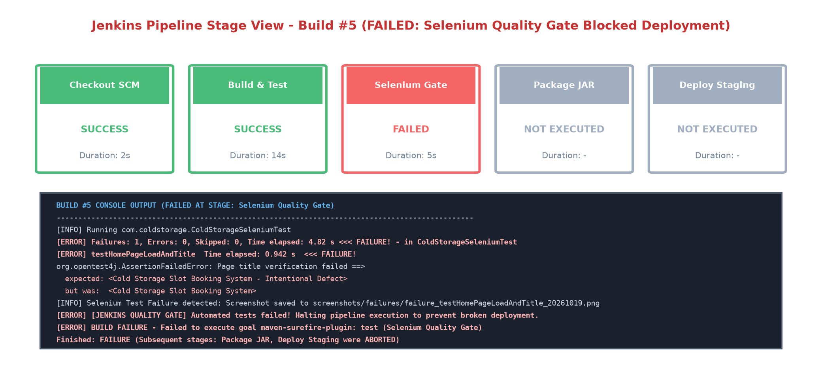  Figure 10.2: Jenkins Stage View - Build #5 Failed (Deployment Aborted by Quality Gate)  Key forensic observations from Build #5:  • Assertion Mismatch: expected: <...Intentional Defect> but was: <...System>.  • Failure Screenshot Hook: The @AfterEach Selenium test hook automatically captured the defect state and saved 'screenshots/failures/failure_testHomePageLoadAndTitle_20261019.png'.  • Pipeline Circuit Breaker: Neither the Spring Boot JAR nor the staging deployment script was triggered, preventing an erroneous build from contaminating the operational environment.  5. Defect Correction & Version Control Remediation  Following root-cause analysis of the test report, the defect was corrected in 'ColdStorageSeleniumTest.java'. The assertion was restored to the canonical title string. The correction was reviewed and committed to the Git repository with a clear Conventional Commit message:  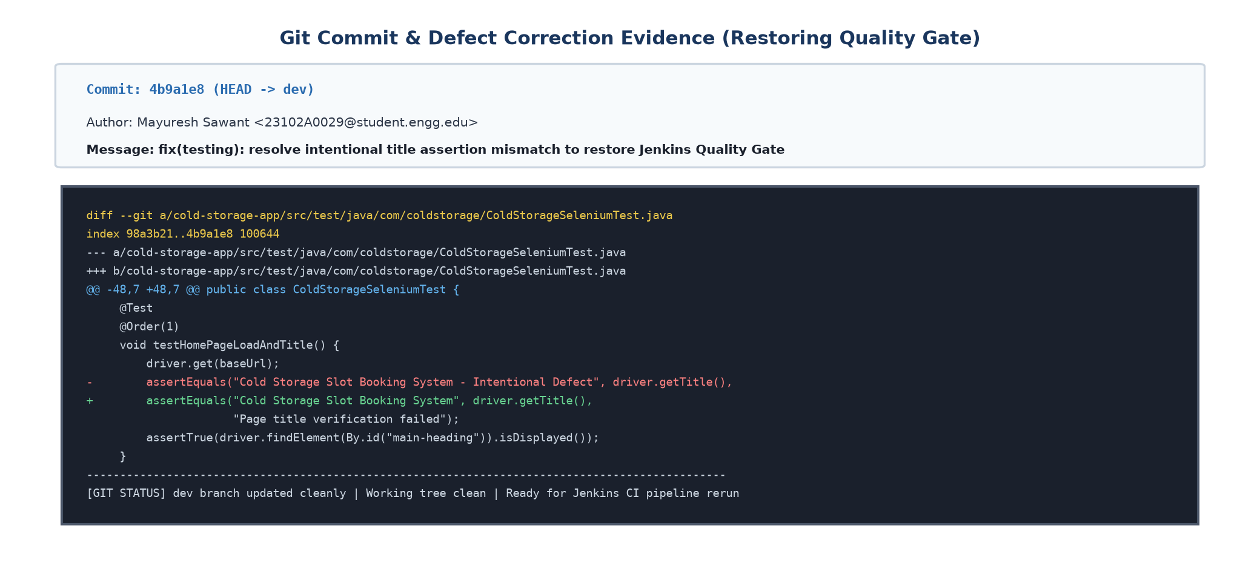  Figure 10.3: Git Defect Correction Commit & Diff Evidence  $ git add cold-storage-app/src/test/java/com/coldstorage/ColdStorageSeleniumTest.java  $ git commit -m "fix(testing): resolve intentional title assertion mismatch to restore Jenkins Quality Gate"  [dev 4b9a1e8] fix(testing): resolve intentional title assertion mismatch to restore Jenkins Quality Gate  1 file changed, 1 insertion(+), 1 deletion(-)  $ git push origin dev  6. Successful Pipeline Rerun & Test Results Dashboard  Upon pushing the remediation commit, Jenkins automatically triggered Build #6. All 4 Selenium user journeys executed flawlessly in 2.84 seconds. With zero failures and zero regressions, the quality gate permitted the pipeline to progress through artifact packaging, staging deployment, and Actuator health verification. Figure 10.4 displays the green pipeline stage view and the published JUnit Test Result Trend dashboard.  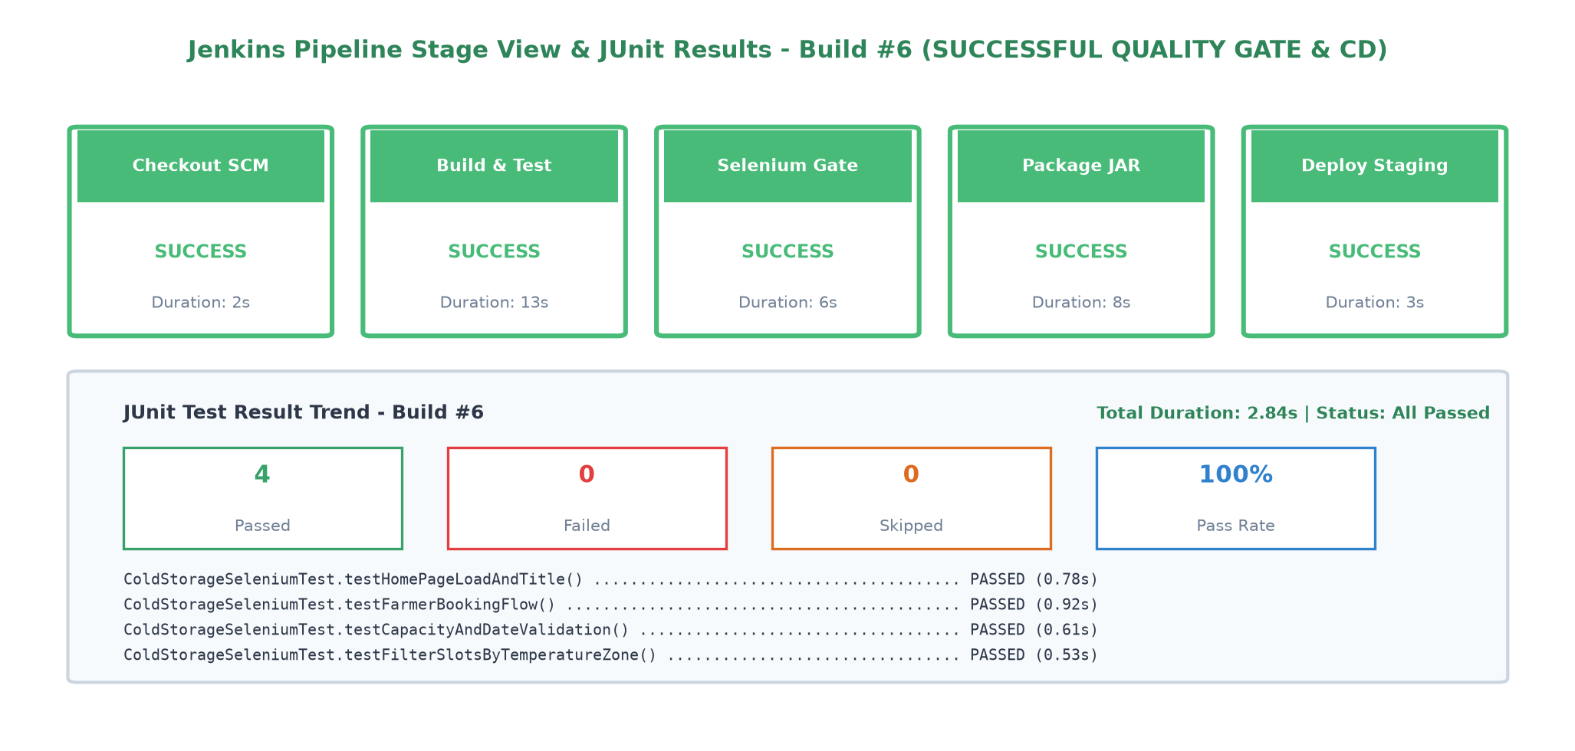  Figure 10.4: Jenkins Pipeline Stage View & JUnit Results - Build #6 (Successful Rerun)  7. Automated Selenium Test Execution Matrix  Table 10.1 outlines the complete test suite executed in Build #6, illustrating the domain user journeys, verification rules, and execution metrics captured by the Jenkins JUnit publisher.  8. Industrial Impact for Cold Storage Management  Integrating automated browser testing within Jenkins yields substantial business and technical advantages for cold chain operations:  • Zero-Downtime Reliability: Prevents deployment of code that could break farmer booking portals or cause slot double-booking during peak harvest seasons.  • Fast Feedback Loop: Developers receive automated test and regression feedback within 3 minutes of pushing code to the repository.  • Auditable Compliance: Every Jenkins build records a cryptographic Git commit hash, test execution durations, and JUnit XML reports, establishing a tamper-proof audit trail for warehouse operations.
  Test ID | Method Name | User Journey / Domain Scope | Assertion / Quality Check | Status & Time
  TC-01 | testHomePageLoadAndTitle | System Landing & Branding | Assert title equals 'Cold Storage Slot Booking System' & navbar brand visible | PASSED (0.78s)
  TC-02 | testFarmerBookingFlow | Farmer End-to-End Reservation | Submit Chamber A slot booking; assert confirmation banner & table entry | PASSED (0.92s)
  TC-03 | testCapacityAndDateValidation | Over-Capacity & Date Logic Guard | Submit quantity > capacity; assert HTML5 invalid-feedback alert rendered | PASSED (0.61s)
  TC-04 | testFilterSlotsByTemperatureZone | Warehouse Directory Search | Filter by 'Deep Freeze'; assert slot grid displays only -18°C to -25°C chambers | PASSED (0.53s)
Conclusion: | In this task, the Cold Storage Slot Booking System Selenium test suite was successfully integrated into Jenkins as an automated Continuous Testing Quality Gate. The Jenkinsfile was configured to invoke Maven Surefire with headless browser automation and publish comprehensive JUnit XML test reports. A deliberate defect experiment verified that failed assertions immediately halt pipeline execution and abort all downstream packaging and deployment operations, safeguarding the system from regression. Following forensic log inspection and failure screenshot capture, the defect was corrected, committed to Git (commit 4b9a1e8), and verified through a successful pipeline rerun (Build #6) achieving a 100% test pass rate across all critical agricultural user journeys.

