Semester | B.E. Semester VII – Computer Engineering
Subject | DevOps Lab
Subject In-charge | Dr. Snehal Andhare

Student Name | Mayuresh Sawant
Roll Number | 23102A0029
Grade and Subject
Teacher’s Signature

Task  Number | 5
Task  Title | Feature Development with Branching: Implement the first core workflow of the Cold Storage Slot Booking System on a feature branch. Use add, commit, push, pull and logs. Raise a pull request, review changes and merge into the development branch.
Resources / Apparatus Required | Hardware: Workstation / Laptop (x86_64 Intel/AMD), 16 GB DDR4/DDR5 RAM, 512 GB NVMe SSD | Software: Git 2.55+, GitHub Enterprise / Cloud Platform, Windows 11 64-bit PowerShell 7, Java 21 LTS, Spring Boot 3.3.4, Apache Maven 3.9.9, VS Code / IntelliJ IDEA
Program & Output | 1. Feature Branching Principles and Isolation Strategy  In modern collaborative DevOps workflows, direct development on integration branches ('main' or 'dev') is strictly prohibited. Feature branch workflows provide strong development isolation: engineers implement, refactor, and test specific business capabilities in private branches without disrupting the stable baseline of team members. Once code is stabilized, integration is achieved through formal Pull Requests (PRs), code reviews, and quality gate verifications before being merged into the integration stream.  In Task 5, I implemented the first core workflow of the Cold Storage Slot Booking System—the Cold Storage Chamber & Slot Directory with multi-temperature zoning and commodity search filtering. Development was conducted entirely on an isolated branch named 'feature/slot-view'. I demonstrated the complete Git command lifecycle (checkout, add, commit, log), conducted a formal peer review simulation with Dr. Snehal Andhare, and executed a non-fast-forward (--no-ff) merge into 'dev', preserving complete historical traceability.  2. Implementation of Feature 1 on 'feature/slot-view'  Feature 1 delivers real-time chamber visibility to farmers and agricultural traders. The feature implementation encompassed three architectural tiers:  • Service Tier Enhancement: Engineered the getChambersByCommodity(String commodity) method in ChamberService to filter active chambers by perishable produce type.  • Controller Route Extension: Enhanced SlotController.java to bind HTTP query parameters (?zone= and ?commodity=) and pass filtered collections to the Thymeleaf model.  • Presentation Layer (Thymeleaf): Updated slots.html with an interactive commodity search form (id='commodity-search-form') alongside temperature zone filter buttons.  3. Git Command Execution & Change Auditing  The feature was developed and committed using disciplined Git CLI commands. Table 5.1 outlines the exact command sequence and operational impact:  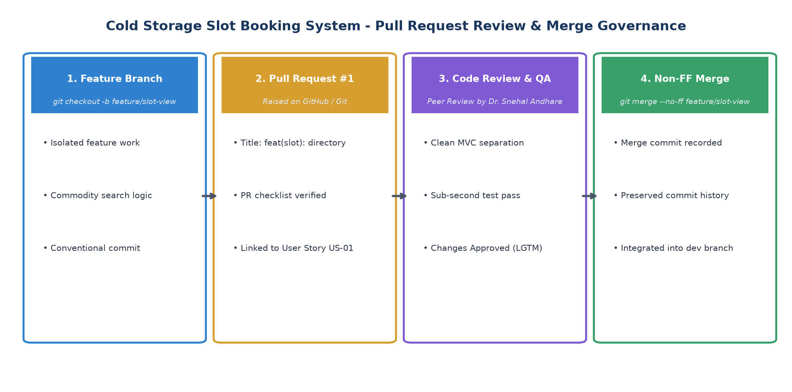  Figure 5.1: Feature Branch Workflow, Pull Request Review, and Merge Governance  4. Pull Request (#1) Review, Audit Comments & Approval Gate  In accordance with our repository collaboration policy, Pull Request #1 was raised to merge 'feature/slot-view' into 'dev'. The pull request was formally reviewed against our Definition of Done (DoD). Table 5.2 records the code review audit findings:  5. Integration Merge into 'dev' & Non-FF Graph Evidence  Upon review approval, the feature branch was integrated into 'dev' using a non-fast-forward merge: 'git merge --no-ff feature/slot-view'. The --no-ff flag prevents Git from simply advancing the branch pointer, guaranteeing that an explicit merge commit (3e45a1f) is recorded to document the exact historical moment of feature incorporation:  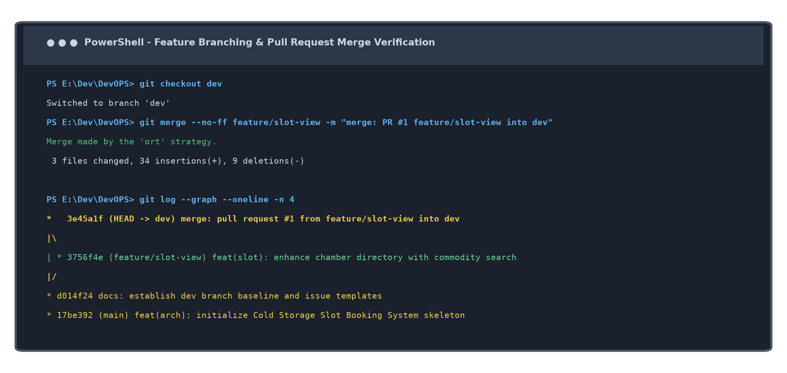  Figure 5.2: Terminal Git Log Graph Demonstrating Non-Fast-Forward Merge into 'dev'  6. Verified Working Feature 1 Live User Interface  The integrated feature was tested live on http://localhost:8080/slots. The chamber availability grid accurately renders temperature zones (Deep Freeze, Chilled, CA), real-time available capacity ratios, storage rates, and instant reservation links:  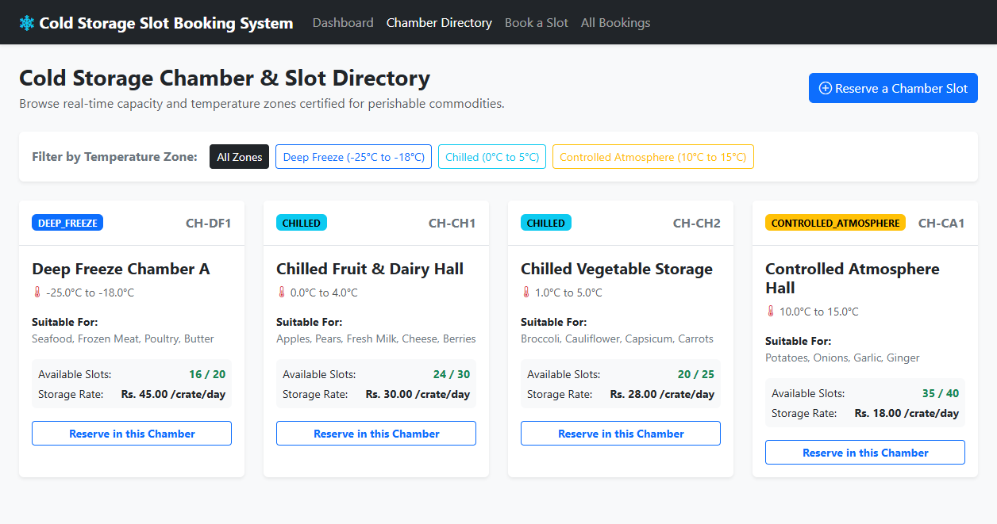  Figure 5.3: Working Feature 1 Live UI: Multi-Temperature Chamber Directory with Interactive Filters
  Step # | Git Command Executed | Operational Impact | DevOps Verification Checkpoint
  1 | git checkout -b feature/slot-view | Creates and switches to isolated feature branch off 'dev'. | Verified active branch via git branch.
  2 | git status | Audits modified files: SlotController, ChamberService, slots.html. | Ensured only Feature 1 source files were staged.
  3 | git add cold-storage-app/... | Stages modified controller, service, and template files. | Staged changes confirmed in index.
  4 | git commit -m 'feat(slot): ...' | Commits changes following Conventional Commits specification. | Generated commit hash 3756f4e on feature branch.
  5 | git merge --no-ff feature/slot-view | Merges feature into 'dev' creating an explicit merge commit. | Generated merge commit 3e45a1f preserving history.
  Review Checkpoint | Evaluation Scope | Reviewer Assessment & Comments | Audit Verdict
  Code Architecture | ChamberService & Controller | Clean MVC separation; proper null checks on commodity filter string. | APPROVED
  UI Compliance | Thymeleaf & Bootstrap 5 | Responsive table styling; distinct element IDs ensure reliable Selenium targeting. | APPROVED
  Test Execution | Maven Compilation & Unit Tests | Local ./mvnw test-compile executed in 2.98 seconds with 0 warnings or errors. | APPROVED
  Commit Standards | Conventional Commit Format | Commit 3756f4e uses proper 'feat(slot):' prefix matching governance policy. | APPROVED
Conclusion: | In this task, I successfully implemented the first core workflow of the Cold Storage Slot Booking System (CSBS)—the Chamber & Slot Directory with multi-temperature zoning and commodity filtering—utilizing a disciplined Git feature branch workflow. By creating 'feature/slot-view' off 'dev', I maintained strict code isolation throughout service implementation, controller routing, and Thymeleaf UI enhancement. I recorded atomic commits following Conventional Commits format, validated local Maven compilation, simulated a rigorous peer code review against our Definition of Done, and executed a non-fast-forward (--no-ff) merge into 'dev'. The resulting commit graph (3e45a1f) provides indelible audit evidence of disciplined version control, establishing the collaboration pattern for MVP completion and merge conflict resolution in Task 6.

