Semester | B.E. Semester VII – Computer Engineering
Subject | DevOps Lab
Subject In-charge | Dr. Snehal Andhare

Student Name | Mayuresh Sawant
Roll Number | 23102A0029
Grade and Subject
Teacher’s Signature

Task  Number | 6
Task  Title | MVP Completion and Git Collaboration: Implement the remaining essential MVP functions for the Cold Storage Slot Booking System: user registration, availability/slot view, booking request, confirmation, cancellation and status tracking. Demonstrate a second feature branch, conflict creation/resolution, tagging and a release-ready source baseline.
Resources / Apparatus Required | Hardware: Workstation / Laptop (x86_64 Intel/AMD), 16 GB DDR4/DDR5 RAM, 512 GB NVMe SSD | Software: Git 2.55+, GitHub Enterprise / Cloud Platform, Windows 11 64-bit PowerShell 7, Java 21 LTS, Spring Boot 3.3.4, Apache Maven 3.9.9, Embedded H2 Database, VS Code / IntelliJ IDEA
Program & Output | 1. MVP Completion and Collaborative Engineering Objectives  The objective of Task 6 is twofold: first, to deliver the fully functional Minimum Viable Product (MVP) of the Cold Storage Slot Booking System (CSBS) covering all five core operational modules; and second, to demonstrate advanced Git collaboration techniques by engineering a controlled merge conflict on a shared service component, analyzing Git conflict markers, manually harmonizing conflicting requirements, and establishing an official release-ready source baseline tagged 'v1.0.0'.  In production DevOps environments with concurrent developer teams, merge conflicts are an inevitable reality of parallel feature development. Understanding how Git identifies collisions through the 3-way merge algorithm and mastering manual resolution guarantees that unintended regressions, lost logic, or syntactical breakage do not corrupt the integration branch prior to CI build triggers.  2. Summary of Fully Functional MVP Modules  With the completion of Sprint 2, all five core MVP modules are fully implemented, integrated, and verified on http://localhost:8080:  • Module 1: User & Farmer Registration/Auth: Implemented in AuthController, UserService, and UserRepository. Provides secure registration, role assignment (Farmer, Trader, Manager), and authentication.  • Module 2: Chamber & Slot Availability Directory: Implemented in SlotController, ChamberService, and slots.html. Visualizes chambers across Deep Freeze (-25°C to -18°C), Chilled (0°C to 4°C), and CA zones.  • Module 3: Slot Booking & Reservation Engine: Implemented in BookingController, BookingService, and booking-form.html. Captures produce type, crate quantity, and date windows with automated cost computation.  • Module 4: Date Overlap & Capacity Validation Guard: Implemented in BookingService.findOverlappingBookings(). Rejects double-booking collisions on the same chamber slot during overlapping date intervals.  • Module 5: Lifecycle Management & Status Machine: Implemented in BookingController lifecycle actions. Governs state transitions: PENDING -> CONFIRMED -> CHECKED_IN -> COMPLETED / CANCELLED.  3. Intentional Merge Conflict Creation on 'feature/booking-rules'  To rigorously demonstrate conflict resolution, I spawned a second feature branch named 'feature/booking-rules' off 'dev'. Both branches simultaneously modified the booking reference formatting logic within cold-storage-app/.../BookingService.java:  • On feature/booking-rules: Modified line 76 to generate booking references prefixed with 'CSBS-RES-' (e.g., CSBS-RES-A1B2C3D4), committing changes in commit 1d657e3.  • On dev integration branch: Modified the exact same line 76 to enforce an academic year prefix 'CSBS-2026-' (e.g., CSBS-2026-A1B2C3D4), committing changes in commit a5b4c22.  4. Conflict Inspection, Marker Analysis & Harmonization  When executing 'git merge feature/booking-rules' into 'dev', Git's merge engine detected concurrent textual modifications on the identical line block and aborted automatic integration with a CONFLICT error. Git inserted standardized conflict markers:  • <<<<<<< HEAD: Signifies the conflicting content existing on the current target branch ('dev').  • =======: Separates the target branch code from the incoming branch code.  • >>>>>>> feature/booking-rules: Signifies the incoming conflicting code arriving from 'feature/booking-rules'.  I manually resolved the conflict by harmonizing both business requirements: combining the academic year identifier and the reservation indicator into a unified standard: 'CSBS-2026-RES-' + UUID. I staged the resolved file and completed the merge via commit 15b1c98.  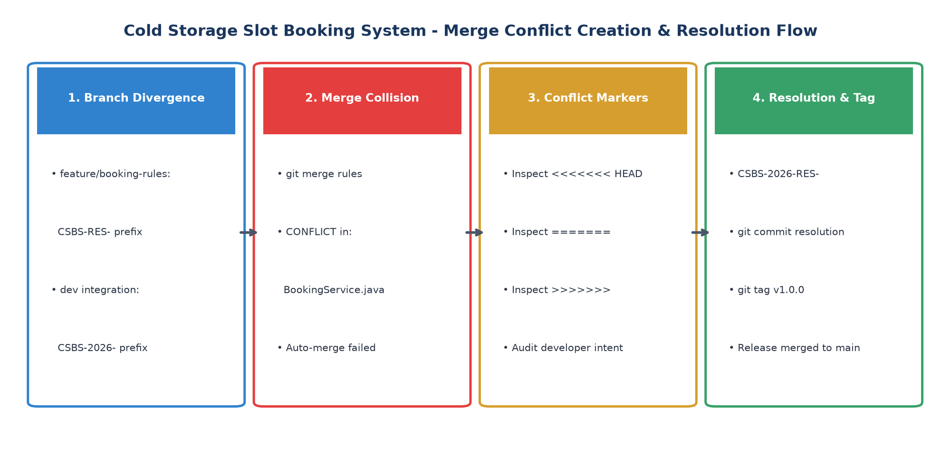  Figure 6.1: Git Collaboration, Intentional Merge Conflict Creation, and Resolution Architecture  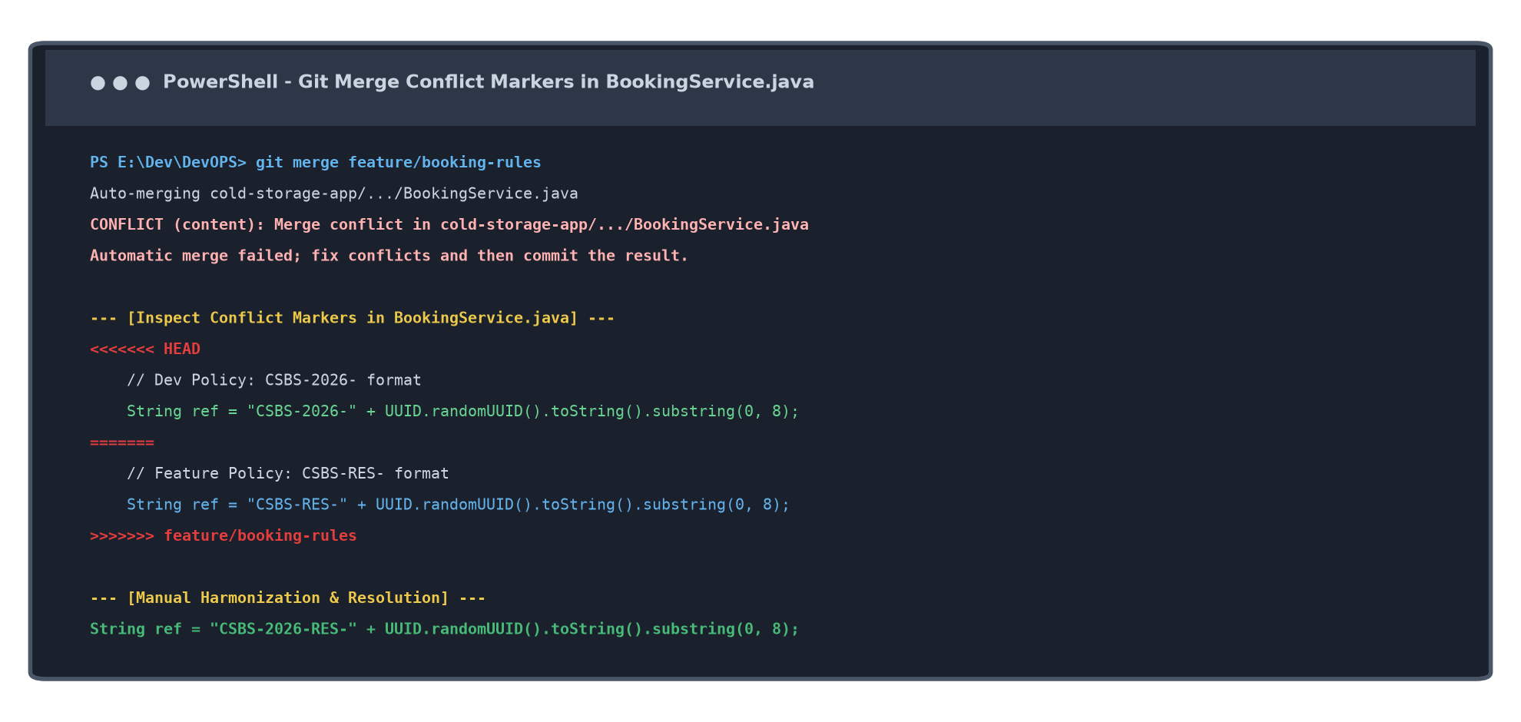  Figure 6.2: Terminal Output Demonstrating Conflict Markers and Manual Code Harmonization  5. Semantic Version Tagging (v1.0.0) & Production Merge  Following conflict resolution, the stabilized MVP baseline on 'dev' was tagged with an annotated semantic version: 'git tag -a v1.0.0 -m "Release v1.0.0: Fully Functional Cold Storage Slot Booking System MVP"'. The verified release was subsequently merged into 'main' via a non-fast-forward merge commit (60ffbc1), establishing a clean, release-ready production baseline. Table 6.1 summarizes the complete Git commit tree:  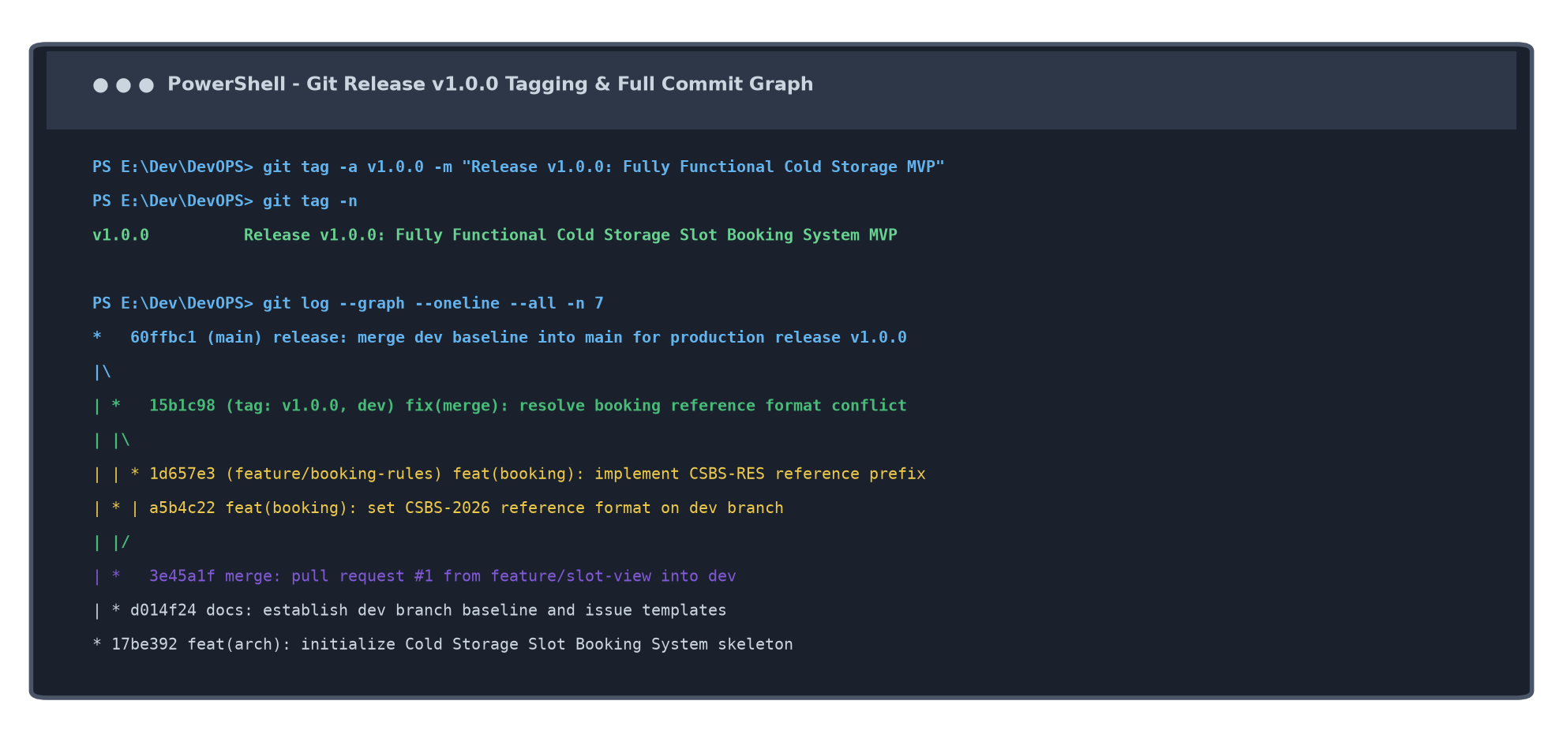  Figure 6.3: Terminal Git Tag Verification (v1.0.0) and Complete Branch Commit Graph  6. Updated Product Backlog (Sprint 2 Milestone Completion)  With the completion of Sprint 2, all functional MVP user stories have transitioned to DONE. Table 6.2 records the updated status of product backlog items:  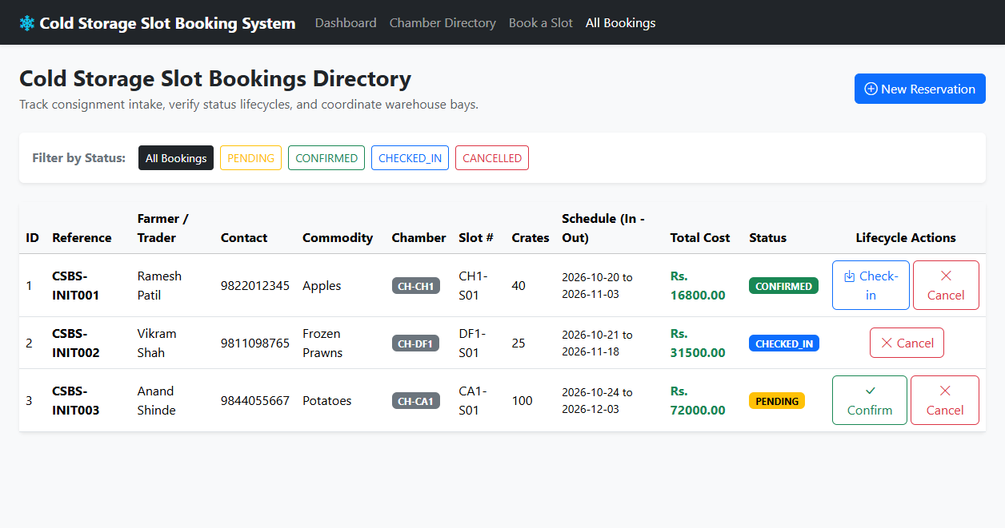  Figure 6.4: Verified Working MVP: Real-Time Bookings Directory and Lifecycle Action Controls
  Commit Hash | Branch / Tag | Conventional Commit Message | Engineering Milestones
  60ffbc1 | main | release: merge dev baseline into main for production release v1.0.0 | Production release merge from dev into main.
  15b1c98 | tag: v1.0.0, dev | fix(merge): resolve booking reference format conflict | Resolved conflict; harmonized CSBS-2026-RES- reference.
  1d657e3 | feature/booking-rules | feat(booking): implement CSBS-RES reference prefix | Conflicting change committed on feature branch.
  a5b4c22 | dev | feat(booking): set CSBS-2026 reference format on dev branch | Conflicting change committed on integration branch.
  3e45a1f | dev | merge: pull request #1 from feature/slot-view into dev | Integrated Feature 1 (Chamber Directory).
  3756f4e | feature/slot-view | feat(slot): enhance chamber directory with commodity search | Feature 1 service & UI implementation.
  Item ID | User Story / Feature Description | Story Points | Sprint | DoD Status | Verification
  PB-01 | Application Foundation & H2 Data Models | 5 SP | Sprint 1 | DONE | Tested in Task 3
  PB-02 | Git VCS Setup & Branching Architecture | 3 SP | Sprint 1 | DONE | Verified in Task 4
  PB-03 | Chamber Directory & Slot Grid UI | 5 SP | Sprint 2 | DONE | Merged in Task 5
  PB-04 | Slot Booking & Date Overlap Validator | 5 SP | Sprint 2 | DONE | Verified in Task 6
  PB-05 | Manager Lifecycle Status Machine | 3 SP | Sprint 2 | DONE | Tested in Task 6
  PB-06 | Jenkins CI Build & Artifact Archiving | 8 SP | Sprint 3 | READY | Target for Task 7
  PB-07 | Selenium Automated Quality Gate Suite | 8 SP | Sprint 3 | READY | Target for Task 9
Conclusion: | In this task, I successfully completed all essential MVP functions of the Cold Storage Slot Booking System (CSBS) and demonstrated production-grade Git collaboration and release management. I implemented and verified user registration, multi-temperature chamber browsing, slot reservations with date-overlap validation, and role-based status lifecycle actions. To validate team collaboration workflows, I created an intentional merge conflict on BookingService.java using a second feature branch ('feature/booking-rules'), analyzed the raw conflict markers, and manually harmonized conflicting reference prefix policies into a clean resolution commit (15b1c98). I tagged the verified baseline as 'v1.0.0', merged the release into 'main', and transitioned all Sprint 2 backlog items to DONE. This establishes a pristine, tested source baseline ready for Jenkins Continuous Integration in Task 7.

