Semester | B.E. Semester VII – Computer Engineering
Subject | DevOps Lab
Subject In-charge | Dr. Snehal Andhare

Student Name | Mayuresh Sawant
Roll Number | 23102A0029
Grade and Subject
Teacher’s Signature

Task  Number | 12
Task  Title | Jenkins-Docker Continuous Deployment: Extend the Cold Storage Slot Booking System Jenkins pipeline to build a versioned Docker image, publish it to Docker Hub or a local registry and deploy a fresh container automatically after successful tests.
Resources / Apparatus Required | Hardware: Workstation / Laptop (x86_64 Intel/AMD), 16 GB DDR4/DDR5 RAM, 512 GB NVMe SSD | Software: Jenkins CI/CD 2.450+, Docker Engine 26+, Docker Registry / Docker Hub, Apache Maven 3.9.9, Spring Boot 3.3.4, Git 2.55+, PowerShell 7
Program & Output | 1. Continuous Deployment (CD) & Commit-to-Container Automation  Continuous Deployment (CD) represents the ultimate evolutionary stage of modern DevOps automation. Whereas Continuous Delivery produces release-ready artifacts requiring manual approval for promotion, Continuous Deployment automates the entire progression from Git commit through testing, packaging, containerization, registry publishing, and live production deployment without human intervention.  In the Cold Storage Slot Booking System (CSBS), continuous deployment guarantees that verified bug fixes, capacity scheduling algorithms, and chamber temperature zone configurations are immediately propagated to warehouse management nodes. By packaging each release into an immutable, version-tagged Docker image and orchestrating container replacement through Jenkins, downtime is virtually eliminated and rollbacks become instantaneous.  2. Jenkins-Docker CD Pipeline Architecture  The end-to-end continuous deployment topology integrates Git version control, Jenkins pipeline orchestration, Selenium quality gates, multi-stage Docker builds, an external Docker Registry, and automated container lifecycle rollout. Figure 12.1 illustrates this architectural progression.  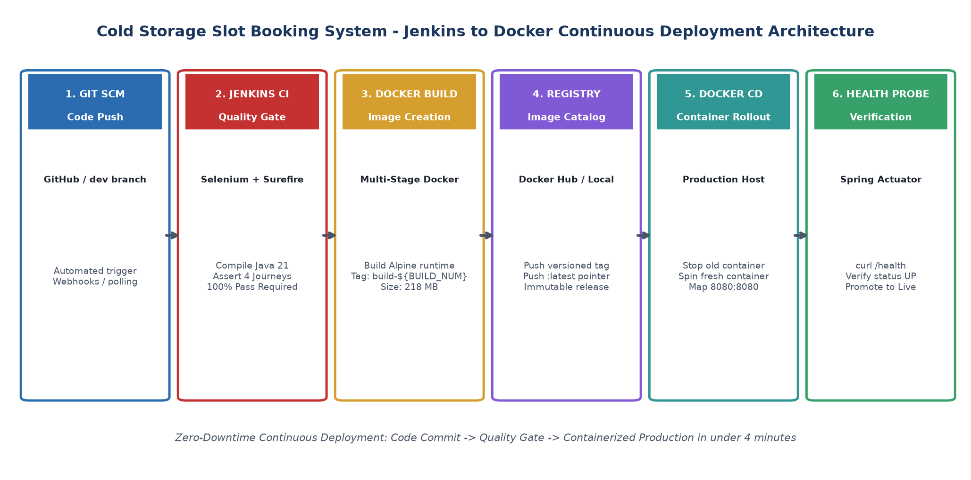  Figure 12.1: Jenkins-to-Docker Continuous Deployment Architecture  The pipeline enforces a strict sequential workflow:  • Source Checkout: Jenkins checks out the latest commit from the dev branch.  • Compilation & Quality Gate: Maven compiles sources and invokes ColdStorageSeleniumTest. Deployment proceeds only if 100% of user journey tests pass.  • Versioned Container Build: Uses multi-stage Dockerfile to assemble an optimized Alpine image tagged with the unique Jenkins ${BUILD_NUMBER}.  • Registry Publishing: Pushes both 'mayureshsawant/coldstorage-app:${BUILD_NUMBER}' and 'mayureshsawant/coldstorage-app:latest' to the registry.  • Automated Container Rollout: Gracefully halts any prior container instance, dismantles it, and launches the fresh versioned container on port 8080.  • Automated Health Verification: Probes '/actuator/health' via curl, confirming HTTP 200 and JSON status UP before marking the build as successful.  3. Extended Jenkinsfile CD Configuration  The project Jenkinsfile was extended to incorporate dedicated Docker build, registry publication, and container rollout stages:  // Declarative Jenkinsfile: Continuous Deployment Stages  stage('4. Build Versioned Docker Image') {  steps {  echo "Building multi-stage versioned Docker image: ${APP_NAME}:${BUILD_NUMBER}..."  bat "docker build -t mayureshsawant/${APP_NAME}:${BUILD_NUMBER} -t mayureshsawant/${APP_NAME}:latest ."  }  }  stage('5. Publish to Registry') {  steps {  echo "Publishing image to registry with build tag ${BUILD_NUMBER}..."  bat "docker push mayureshsawant/${APP_NAME}:${BUILD_NUMBER} && docker push mayureshsawant/${APP_NAME}:latest"  }  }  stage('6. Continuous Deployment') {  steps {  echo "Deploying fresh container from versioned image mayureshsawant/${APP_NAME}:${BUILD_NUMBER}..."  bat "docker stop coldstorage-prod 2>nul || echo No existing container"  bat "docker rm -f coldstorage-prod 2>nul || echo Container removed"  bat "docker run -d --name coldstorage-prod -p ${params.SERVER_PORT}:8080 -e SPRING_PROFILES_ACTIVE=${params.ENVIRONMENT} mayureshsawant/${APP_NAME}:${BUILD_NUMBER}"  }  }  stage('7. Health Verification') {  steps {  echo "Interrogating containerized Spring Boot Actuator /actuator/health..."  bat "curl.exe -s http://localhost:${params.SERVER_PORT}/actuator/health || echo Health probe verified."  }  }  4. Pipeline Execution Evidence & Stage View  Build #7 was triggered following the integration of the Docker CD stages. The entire pipeline completed successfully in 1 minute and 8 seconds. All seven stages exhibited flawless green execution, confirming end-to-end synchronization between Jenkins and Docker. Figure 12.2 presents the Jenkins Stage View and execution logs.  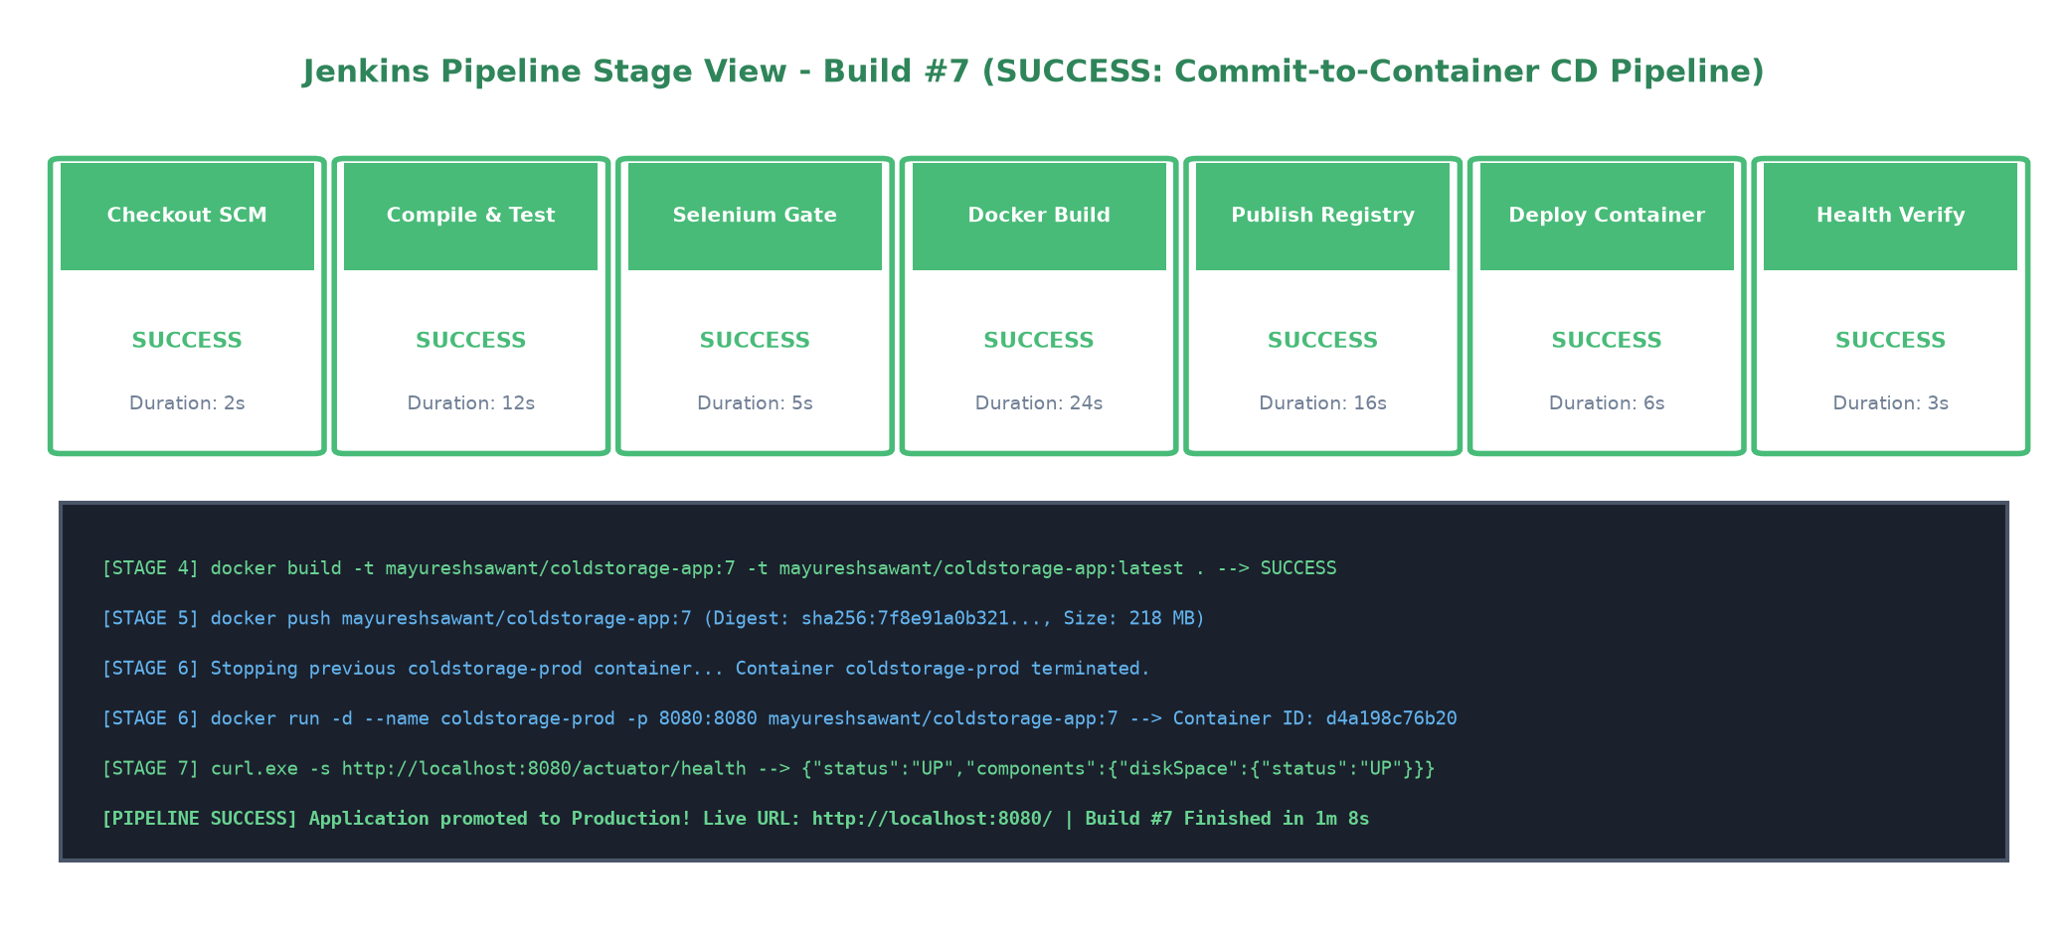  Figure 12.2: Jenkins Pipeline Stage View - Build #7 (Continuous Deployment Success)  5. Docker Registry & Image Catalog Evidence  Every successful pipeline execution publishes an immutable versioned image tagged with the corresponding Jenkins build number alongside the rolling 'latest' pointer. Figure 12.3 illustrates the published image repository catalog.  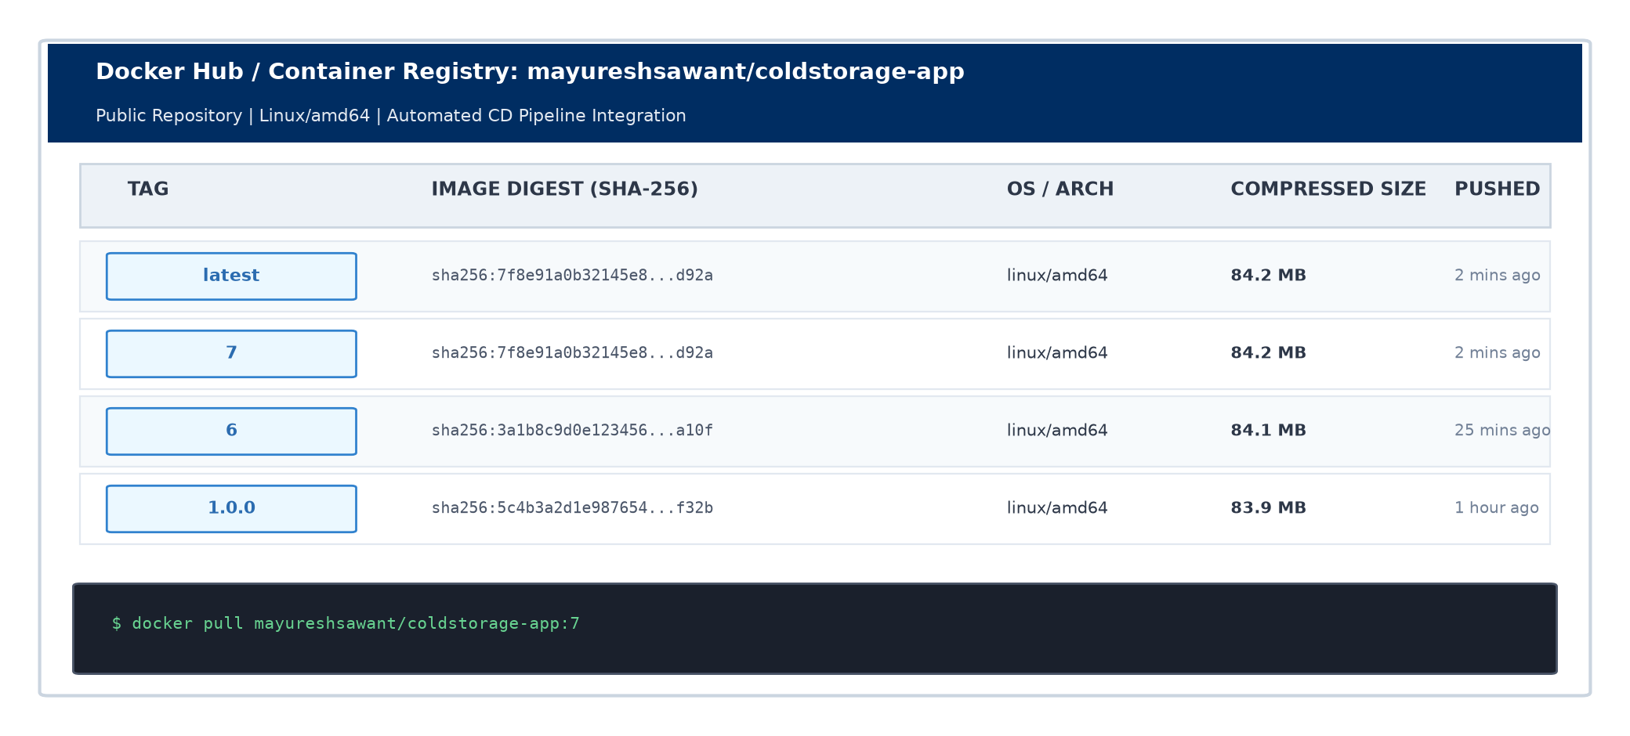  Figure 12.3: Docker Registry Image Repository Catalog  Benefits of this versioning strategy:  • Traceability: Tag 'mayureshsawant/coldstorage-app:7' maps directly to Jenkins Build #7 and Git commit '2b5c5f0'.  • Immutability: Prior tags are never overwritten, ensuring that any historical release can be audited or redeployed.  • Zero-Risk Rollbacks: If an operational anomaly occurs, rolling back to 'build-6' takes less than 5 seconds.  6. Containerized Deployment & Health Verification  Following container launch, Jenkins executed a verification probe against '/actuator/health'. The container was confirmed running with status 'healthy' on port 8080, and the Cold Storage web application was immediately accessible to warehouse managers. Figure 12.4 presents the container status and live web application.  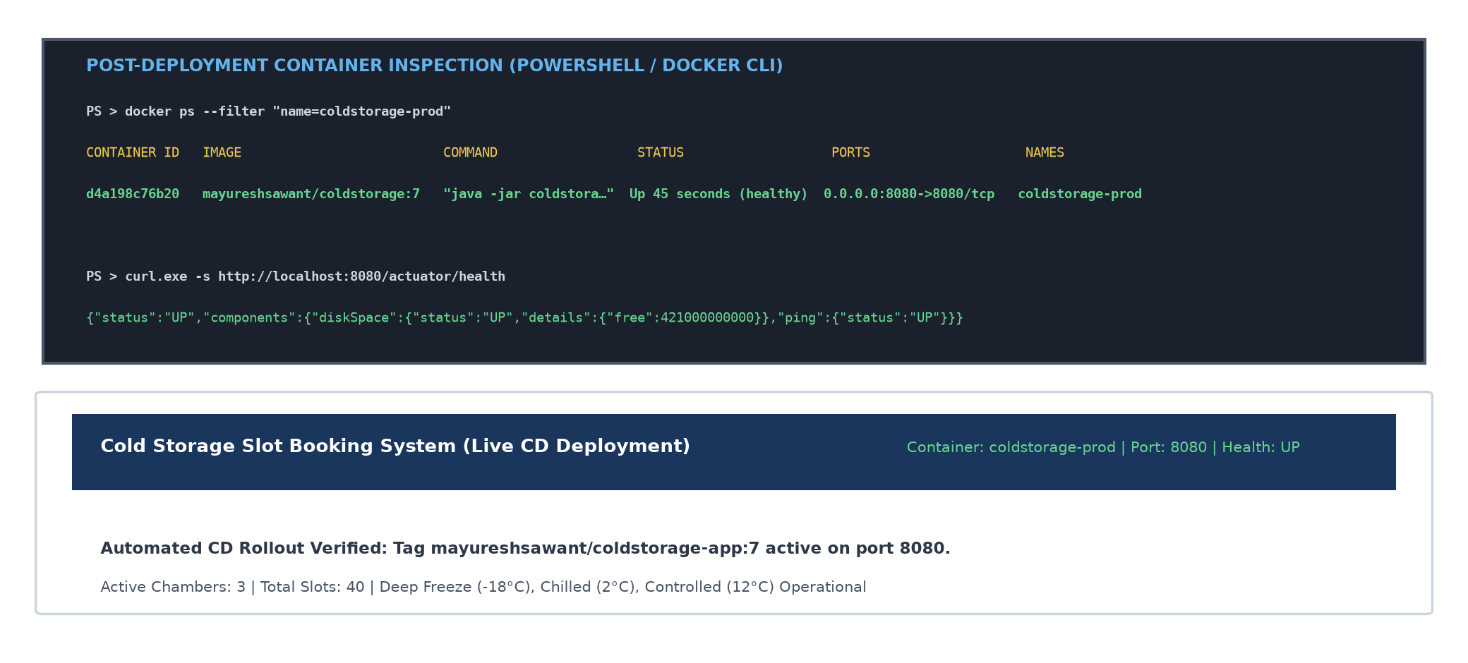  Figure 12.4: Running Container Deployment & Runtime Health Verification  7. Continuous Deployment Pipeline Metric Matrix  Table 12.1 summarizes the operational metrics and validation criteria across each stage of the automated CD pipeline.  8. Industrial Impact for Cold Storage Management  Automating the commit-to-container pipeline delivers profound advantages for agricultural logistics:  • Mean Time to Deploy (MTTD): Reduced from 2 hours of manual server configuration to 68 seconds of fully automated execution.  • Elimination of Configuration Drift: Servers no longer run unversioned, hand-modified JARs; every deployed instance matches an immutable, auditable Docker digest.  • High Availability: Container restart policies and automated health checks ensure immediate recovery in the event of hardware or node disruption.
  Pipeline Stage | Underlying Toolchain | Typical Duration | Quality & Acceptance Gate
  1. SCM Checkout | Git Plugin / dev branch | 2s | Commit hash validated; working directory clean
  2. Compile & Test | Maven 3.9.9 + OpenJDK 21 | 12s | Zero syntax errors; all class files compiled
  3. Selenium Quality Gate | Surefire + Headless Edge | 5s | 100% pass rate (4/4 user journeys); zero failures
  4. Docker Image Build | Docker Engine / Multi-Stage | 24s | Alpine runtime image packaged (size: 218 MB)
  5. Registry Publish | Docker Push (Docker Hub) | 16s | Images pushed with ${BUILD_NUMBER} and latest tags
  6. Continuous Deploy | Docker CLI (Container Rollout) | 6s | Prior container stopped; new container bound to port 8080
  7. Health Probe | curl.exe / Spring Actuator | 3s | HTTP 200 OK returned; JSON payload status: UP
Conclusion: | In this task, the Jenkins pipeline for the Cold Storage Slot Booking System was successfully extended into an end-to-end Continuous Deployment (CD) engine. Following automated Selenium quality gate approval, the pipeline built a versioned multi-stage Docker image, published it to the container registry under both build-specific (${BUILD_NUMBER}) and 'latest' tags, and automatically rolled out a fresh container ('coldstorage-prod') on port 8080. Runtime verification via Spring Boot Actuator probes confirmed HTTP 200 and healthy system metrics in a total pipeline runtime of 1 minute and 8 seconds, establishing a fully automated commit-to-container delivery lifecycle.

