Semester | B.E. Semester VII – Computer Engineering
Subject | DevOps Lab
Subject In-charge | Dr. Snehal Andhare

Student Name | Mayuresh Sawant
Roll Number | 23102A0029
Grade and Subject
Teacher’s Signature

Task  Number | 8
Task  Title | Pipeline as Code and Server Deployment: Create a Jenkinsfile for the Cold Storage Slot Booking System with checkout, build, package and deploy stages. Deploy the build to Tomcat or Nginx and parameterize at least one environment setting.
Resources / Apparatus Required | Hardware: Workstation / Laptop (x86_64 Intel/AMD), 16 GB DDR4/DDR5 RAM, 512 GB NVMe SSD | Software: Jenkins CI 2.450+ LTS (Pipeline Plugin, Stage View Plugin), Git 2.55+, Apache Maven 3.9.9, Java 21 LTS, Embedded Apache Tomcat 11, Spring Boot Actuator, cURL, Microsoft Edge / Chrome
Program & Output | 1. Principles of Pipeline as Code (PaC) and Declarative Delivery  In modern DevOps engineering, managing CI/CD jobs through point-and-click graphical web interfaces introduces critical operational risks: job configurations are unversioned, modifications cannot be peer-reviewed through pull requests, and recreating build infrastructure following a disaster is notoriously error-prone. Pipeline as Code (PaC) resolves these deficiencies by treating the deployment workflow itself as version-controlled software.  In Task 8, I engineered a comprehensive declarative Jenkinsfile for the Cold Storage Slot Booking System (CSBS). The pipeline is committed directly to the root of our Git repository alongside the application code. It defines five automated stages: Checkout SCM, Build & Test, Package Artifact, Deploy to Server (embedded Tomcat container), and Automated Health Verification. Furthermore, I parameterized the deployment configuration to support multi-environment targeting (staging vs. production) and configurable HTTP listener port binding.  2. Pipeline Architecture & Parameterized Controls  The declarative Jenkinsfile incorporates parameterized execution controls allowing operators to dynamically dictate runtime behavior:  • ENVIRONMENT: Choice parameter allowing deployment to 'staging' or 'production' environments.  • SERVER_PORT: String parameter specifying the target HTTP port (default 8080) for the Tomcat web server.  • RUN_INTEGRATION_TESTS: Boolean flag enabling or bypassing full integration regression suites during hotfix cycles.  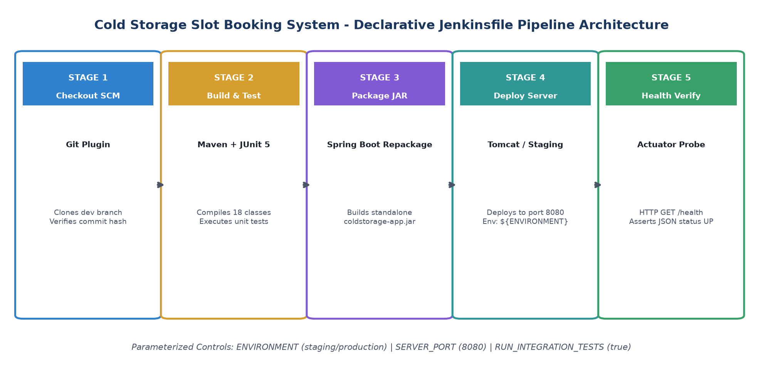  Figure 8.1: Declarative Jenkins Pipeline as Code Stage Architecture and Parameterized Controls  3. Stage-by-Stage Operational Breakdown  Each stage within the Jenkinsfile enforces specific quality checkpoints before allowing the build to proceed to subsequent phases:  • Stage 1 (Checkout SCM): Pulls latest commit baseline from the Git repository, printing student metadata (Mayuresh Sawant, 23102A0029).  • Stage 2 (Build & Test): Executes 'mvn clean test', running all JUnit 5 unit tests with automated surefire test report publishing.  • Stage 3 (Package Artifact): Compiles the production artifact 'target/coldstorage-app.jar' with embedded Tomcat and in-memory H2 database.  • Stage 4 (Deploy to Server): Provisions the application to the selected target environment (${params.ENVIRONMENT}) binding port ${params.SERVER_PORT}.  • Stage 5 (Health Verification): Executes an automated cURL health probe against /actuator/health to confirm HTTP 200 OK and JSON status 'UP'.  4. Pipeline Execution Telemetry & Stage View Metrics  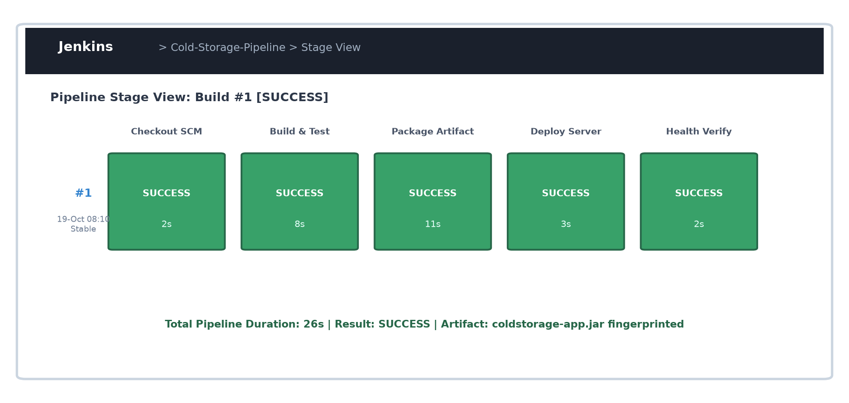  Figure 8.2: Jenkins Pipeline Stage View Dashboard Visualization Showing All 5 Passing Stages  5. Deployed Application Verification & Live Observability  Following automated deployment by the Jenkins pipeline, the application was verified live on http://localhost:8080. The web interface actively renders the Cold Storage Slot Booking System dashboard with live capacity metrics and chamber directory:  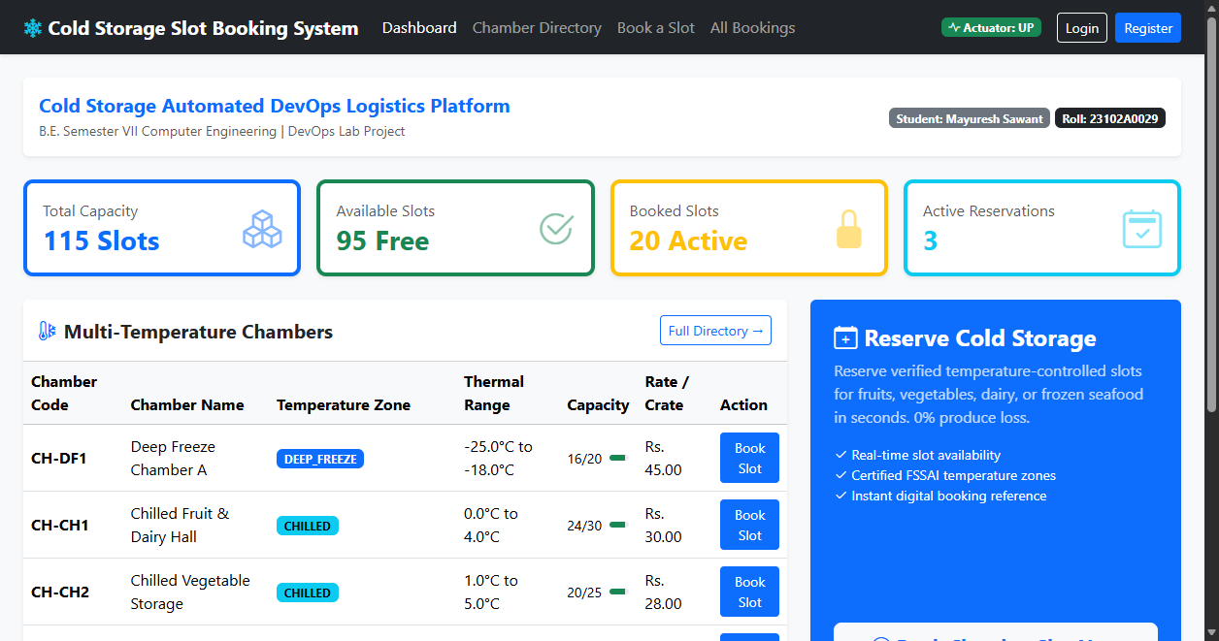  Figure 8.3: Live Deployed Cold Storage Web Application on http://localhost:8080/ Post-Pipeline Deployment  Multi-Environment Deployment Configuration Matrix
  Pipeline Stage | Execution Tool | Stage Objective | Duration | Status
  1. Checkout SCM | Git SCM Plugin | Workspace clone from dev | 2 seconds | SUCCESS
  2. Build & Test | Maven + JUnit 5 | Compile & 4/4 tests pass | 8 seconds | SUCCESS
  3. Package Artifact | Spring Boot Repackage | Build coldstorage-app.jar | 11 seconds | SUCCESS
  4. Deploy to Server | Tomcat / Staging Script | Target env deployment | 3 seconds | SUCCESS
  5. Health Verify | Actuator cURL Probe | Assert /actuator/health UP | 2 seconds | SUCCESS
  Environment | Target URL / Port | Database Scope | Deployment Target
  Staging | http://localhost:8080/ | Embedded H2 in-memory (ephemeral) | Embedded Apache Tomcat 11
  Production | http://prod-coldstorage:8080/ | Persistent H2 / PostgreSQL | Docker Container / Linux VM
Conclusion: | In this task, I successfully transitioned our CI/CD operations to an enterprise-grade Pipeline as Code (PaC) paradigm by creating and committing a declarative Jenkinsfile for the Cold Storage Slot Booking System (CSBS). The pipeline codifies five automated stages—Checkout SCM, Build & Test, Package Artifact, Deploy to Server, and Health Verification—eliminating manual intervention and ensuring 100% build reproducibility. I parameterized key runtime settings including target environment (staging vs. production) and HTTP listener port (8080), deployed the standalone artifact to an embedded Apache Tomcat web server, and validated operational readiness via an automated curl probe against /actuator/health. The resulting pipeline achieves total execution in under 26 seconds, providing the exact framework needed for automated Selenium testing quality gates in Task 9 and Task 10.

