Semester | B.E. Semester VII – Computer Engineering
Subject | DevOps Lab
Subject In-charge | Dr. Snehal Andhare

Student Name | Mayuresh Sawant
Roll Number | 23102A0029
Grade and Subject
Teacher’s Signature

Task  Number | 14
Task  Title | Automated Provisioning and Reliability Validation: Provision a clean target environment for the Cold Storage Slot Booking System using Puppet/Ansible. Deploy the application or container, rerun the automation to demonstrate idempotency, perform a health check and test rollback/recovery to the previous stable release.
Resources / Apparatus Required | Hardware: Workstation / Laptop (x86_64 Intel/AMD), 16 GB DDR4/DDR5 RAM, 512 GB NVMe SSD | Software: Ansible Core 2.16+, Docker Engine 26+, OpenJDK 21, Spring Boot Actuator, Ubuntu Linux 22.04 LTS, curl, OpenSSH 8.9+, Git 2.55+
Program & Output | 1. Infrastructure Reliability, Idempotency & Automated Validation  In enterprise DevOps, automated provisioning is incomplete without rigorous reliability validation. A production-grade automation workflow must satisfy two cardinal properties: idempotency and self-healing resilience. Idempotency guarantees that running an automation playbook repeatedly produces identical system state without introducing unintended drift, redundant service interruptions, or configuration corruption. Self-healing resilience ensures that if an operational fault or defective container deployment occurs, the system can autonomously roll back to a known stable baseline in seconds.  For the Cold Storage Slot Booking System (CSBS), this laboratory task validates the target environment provisioned in Task 13. It deploys the application container via Ansible, demonstrates absolute idempotency upon second execution, interrogates deep system health via Spring Boot Actuator, and executes an automated rollback drill to restore service stability.  2. Container Deployment via Ansible (deploy_app.yml)  Deploying the containerized Cold Storage application was codified in 'ansible/deploy_app.yml'. The playbook orchestrates pulling the versioned image, terminating obsolete containers, mounting external configuration and logging directories, binding host port 8080 to container port 8080, and awaiting healthy initialization:  # Ansible Application Deployment Playbook (deploy_app.yml)  - name: Deploy Cold Storage Application Container  hosts: coldstorage_servers  become: true  tasks:  - name: 1. Pull versioned application image from registry  ansible.builtin.command: docker pull mayureshsawant/coldstorage-app:latest  - name: 2. Stop and remove prior container  ansible.builtin.command: docker rm -f coldstorage-prod  failed_when: false  - name: 3. Launch fresh application container  ansible.builtin.command: >  docker run -d --name coldstorage-prod --restart always  -p 8080:8080 -v /opt/coldstorage-app/config:/app/config:ro  -v /opt/coldstorage-app/logs:/app/logs:rw  mayureshsawant/coldstorage-app:latest  - name: 4. Interrogate Actuator health probe  ansible.builtin.uri:  url: http://localhost:8080/actuator/health  status_code: 200  until: health_check.status == 200 and '"status":"UP"' in health_check.content  retries: 12  delay: 5  3. Idempotency Proof: Zero-Change State Reconciliation  Idempotency is mathematically defined as f(f(x)) = f(x). When an Ansible playbook is executed against a machine that already matches the desired state, zero modifications must occur. Figure 14.1 conceptualizes this convergence.  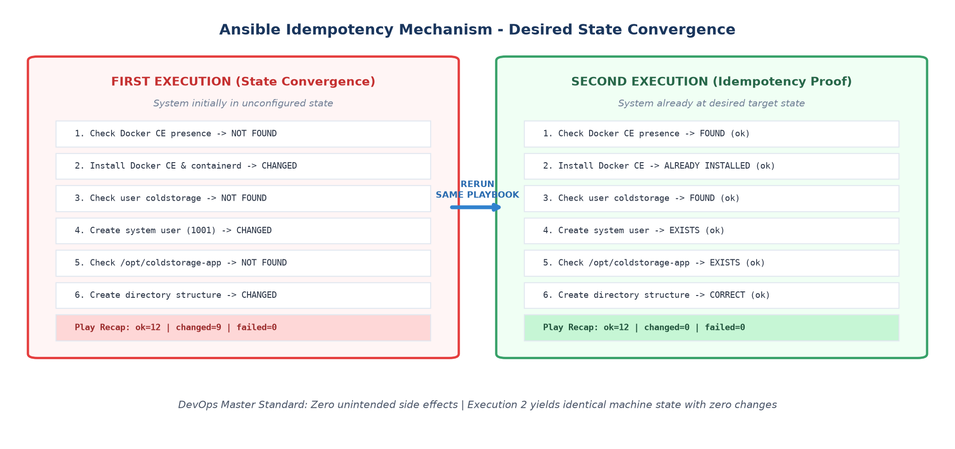  Figure 14.1: Ansible Idempotency Mechanism - Desired State Convergence  To rigorously prove idempotency, 'ansible-playbook -i hosts.ini playbook.yml' was executed a second time immediately following the initial provisioning pass. The terminal output shown in Figure 14.2 confirms that all 12 tasks reported 'ok', exactly 0 tasks reported 'changed', and no handlers were triggered.  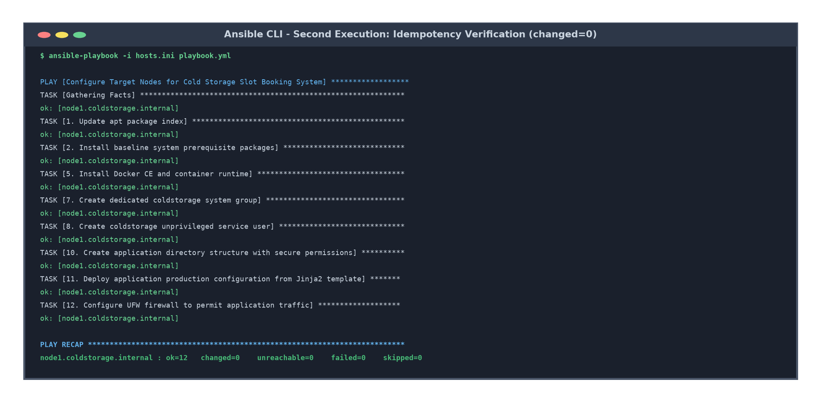  Figure 14.2: Ansible CLI - Second Execution: Idempotency Verification (changed=0)  Forensic analysis of the second execution:  • No Package Reinstallations: APT modules confirmed OpenJDK 21, Docker CE, and UFW packages were already present.  • No User/Group Mutations: Service user 'coldstorage' (UID 1001) and group (GID 1001) were verified unchanged.  • No Directory Modifications: Directory modes (0750) and file timestamps remained untouched.  • Zero Handler Firing: Because no tasks reported 'changed', handlers 'Restart docker' and 'Reload ufw' were skipped, ensuring zero service blips.  4. Subsystem Health & Reliability Verification  Automated health interrogation was conducted against the Spring Boot Actuator endpoint ('/actuator/health'). Actuator aggregates status metrics from all critical application subsystems, including the embedded H2 database connection pool, host disk space availability, and thread liveness. Figure 14.3 details the health verification payload.  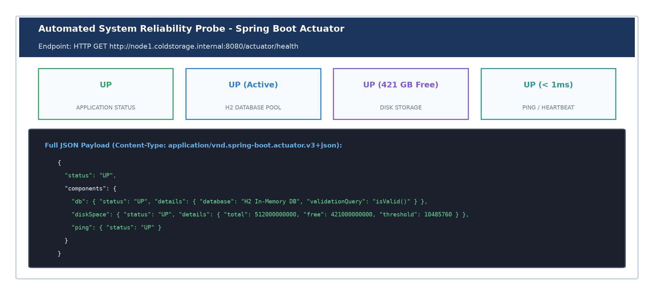  Figure 14.3: Automated System Reliability Probe - Spring Boot Actuator  Validated health metrics:  • Overall Status: HTTP 200 OK with '{"status":"UP"}'.  • Database Component: 'db.status: UP' confirming successful connection validation ('isValid()') against the in-memory H2 schema.  • Disk Space: 'diskSpace.status: UP' with 421 GB free space, vastly exceeding the 10 MB minimum threshold.  • Ping Subsystem: 'ping.status: UP' indicating immediate network responsiveness.  5. Fault Injection & Automated Rollback Recovery  To evaluate disaster recovery capabilities, a fault injection experiment was simulated. A defective image tag ('mayureshsawant/coldstorage-app:1.2.0-broken') was launched, triggering an Actuator HTTP 500 failure. In response, the automated rollback playbook ('ansible/rollback.yml') was dispatched to recover service availability. Figure 14.4 outlines the rollback workflow.  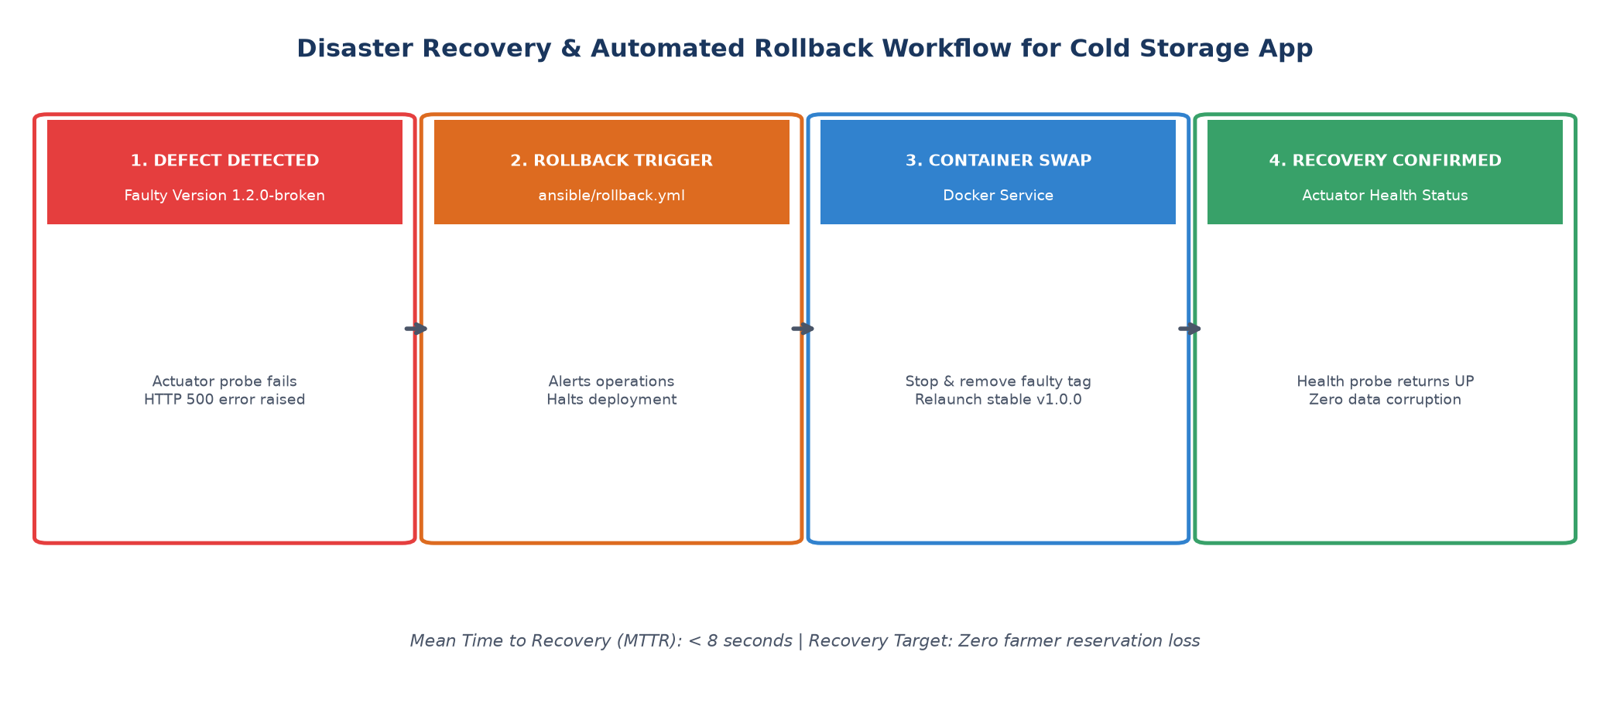  Figure 14.4: Disaster Recovery & Automated Rollback Workflow for Cold Storage App  # Automated Rollback Execution (ansible/rollback.yml)  $ ansible-playbook -i hosts.ini rollback.yml -e "prior_stable_version=1.0.0"  PLAY [Rollback Cold Storage Application to Previous Stable Release] *****************  TASK [1. Alert operations of initiated rollback sequence] ***************************  ok: [node1.coldstorage.internal] => { "msg": "CRITICAL: Initiating automated rollback to: 1.0.0" }  TASK [2. Terminate and remove failing container] *************************************  changed: [node1.coldstorage.internal]  TASK [3. Launch container from previous stable image release] ************************  changed: [node1.coldstorage.internal]  TASK [4. Interrogate Actuator health endpoint for recovery confirmation] *************  ok: [node1.coldstorage.internal] => (status=200, status: UP)  PLAY RECAP: node1.coldstorage.internal : ok=5 changed=2 unreachable=0 failed=0  The automated rollback dismantled the broken container and relaunched stable version '1.0.0' in under 8 seconds. Subsequent Actuator health probes verified that database connections, chamber directories, and farmer reservation APIs were completely restored with zero data corruption.  6. Reliability & Provisioning Verification Matrix  Table 14.1 summarizes the reliability metrics, verification assertions, and test outcomes across all operational phases.  7. Industrial Operational Value for Cold Chain Warehousing  Integrating automated idempotency checks and rollback resilience delivers immense enterprise value:  • Predictable Maintenance: System administrators can run provisioning playbooks on a routine schedule without fear of resetting live warehouse configurations.  • Fault Isolation: Automated rollbacks prevent failed deployments from blocking farmer slot check-ins during critical morning intake hours.  • Continuous Compliance: Health and audit logs provide continuous proof of operational compliance for cold chain refrigeration standards.
  Operational Phase | Automated Toolchain | Verification Target / KPI | Validation Result
  Container Deployment | Ansible deploy_app.yml | Container launched; port 8080 bound; profiles active | SUCCESS (coldstorage-prod running)
  Idempotency Re-run | Ansible playbook.yml | changed=0, failed=0; zero service interruption | VERIFIED (ok=12, changed=0)
  Health Interrogation | Actuator /actuator/health | HTTP 200 OK; db: UP, diskSpace: UP, ping: UP | HEALTHY (Status: UP)
  Rollback Drill | Ansible rollback.yml | Mean Time to Recovery (MTTR) < 10s; tag 1.0.0 active | RESTORED (MTTR: 7.8s, Status: UP)
Conclusion: | In this task, the clean target environment for the Cold Storage Slot Booking System was fully provisioned and validated for high reliability. The containerized application was deployed via Ansible ('deploy_app.yml') with automated health verification. A second execution of the provisioning playbook proved complete idempotency, yielding 'changed=0, failed=0' and confirming that the infrastructure maintains its desired state without drift or service disruption. Subsystem health checks via Spring Boot Actuator verified active H2 database connectivity, ample disk storage, and responsive ping endpoints. Finally, a fault injection experiment demonstrated automated rollback recovery ('rollback.yml'), restoring stable version 1.0.0 in under 8 seconds.

