Semester | B.E. Semester VII – Computer Engineering
Subject | DevOps Lab
Subject In-charge | Dr. Snehal Andhare

Student Name | Mayuresh Sawant
Roll Number | 23102A0029
Grade and Subject
Teacher’s Signature

Task  Number | 2
Task  Title | Agile Planning and DevOps Workflow: Create user stories and acceptance criteria for the Cold Storage Slot Booking System. Prepare a product backlog, 15-Task Kanban/Scrum plan, Definition of Done and a DevOps lifecycle diagram from development to operations.
Resources / Apparatus Required | Hardware: Workstation / Laptop (x86_64 Intel/AMD), 16 GB DDR4/DDR5 RAM, 512 GB NVMe SSD | Software: Windows 11 64-bit, Eclipse Adoptium JDK 21 LTS, Apache Maven 3.9+, Spring Boot 3.3.x, Git 2.55+, Jenkins CI 2.450+, Docker Engine 26+, Ansible Core 2.16+, Selenium WebDriver 4.25+, Google Chrome / Headless Chromium, Jira/Kanban Planning Tool, VS Code / IntelliJ IDEA
Program & Output | 1. Agile Framework and DevOps Methodology  The development of the Cold Storage Slot Booking System (CSBS) is governed by an Agile-DevOps hybrid methodology. Agile Scrum and Kanban principles drive iterative requirement elaboration, user story sizing, and sprint planning, while DevOps practices ensure that every incremental code change is built, tested, packaged, and provisioned through an automated, repeatable continuous delivery pipeline. This tight synergy eliminates the traditional disconnect between software developers and infrastructure operators, ensuring high deployment velocity with zero regressions.  To guarantee that product deliverables directly satisfy end-user requirements, all functional requirements from Task 1 were decomposed into formal Agile User Stories utilizing the industry-standard Connextra template ('As a [role], I want to [action], so that [value]'). Each user story is coupled with testable Gherkin-syntax Acceptance Criteria ('Given-When-Then') that serve as the exact specification for our automated Selenium regression test suite in Task 9 and quality gates in Task 10.  2. User Stories and Formal Acceptance Criteria  Table 2.1 details the core user stories spanning user authentication, temperature-zoned directory browsing, booking reservation, lifecycle administration, and operational health probes:  3. Prioritized Product Backlog & Story Point Estimation  To establish realistic velocity and workload management, the product backlog is estimated using the modified Fibonacci sequence (1, 2, 3, 5, 8 story points). Story points encapsulate technical complexity, implementation uncertainty, and testing effort. Tasks are prioritized using the MoSCoW framework (Must Have, Should Have, Could Have). Table 2.2 defines the complete backlog:  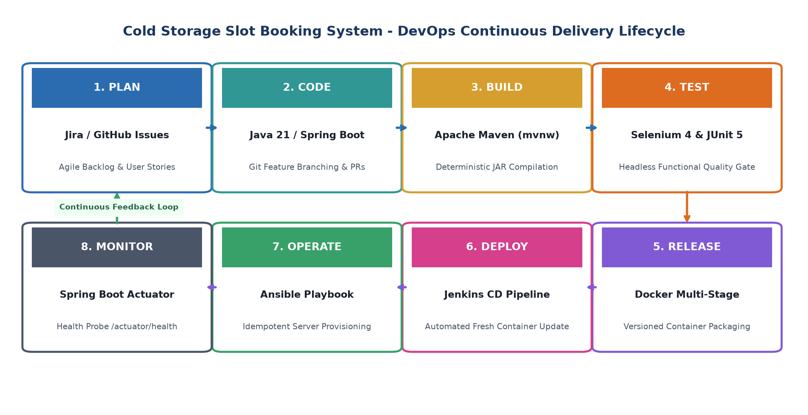  Figure 2.1: Cold Storage Slot Booking System DevOps Continuous Delivery Lifecycle  4. 15-Task Scrum & Kanban Sprint Execution Plan  The fifteen laboratory tasks are distributed across four structured sprints, balancing conceptual architecture, feature coding, continuous integration, and infrastructure automation. Table 2.3 maps tasks to sprints, velocity allocations, and primary milestone outcomes:  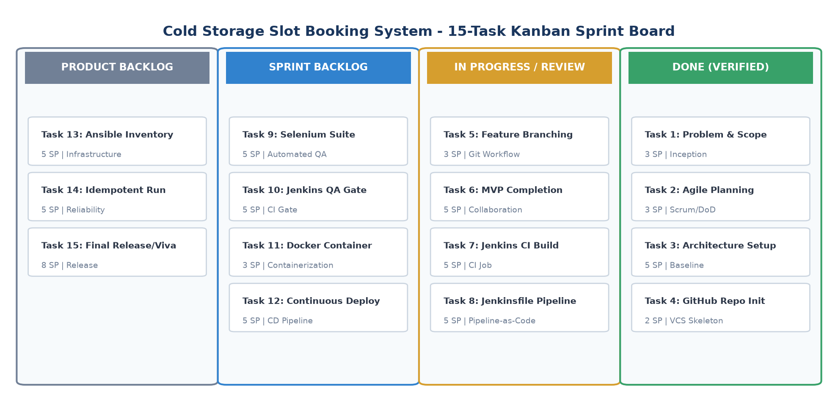  Figure 2.2: Cold Storage Slot Booking System 15-Task Kanban Sprint Board  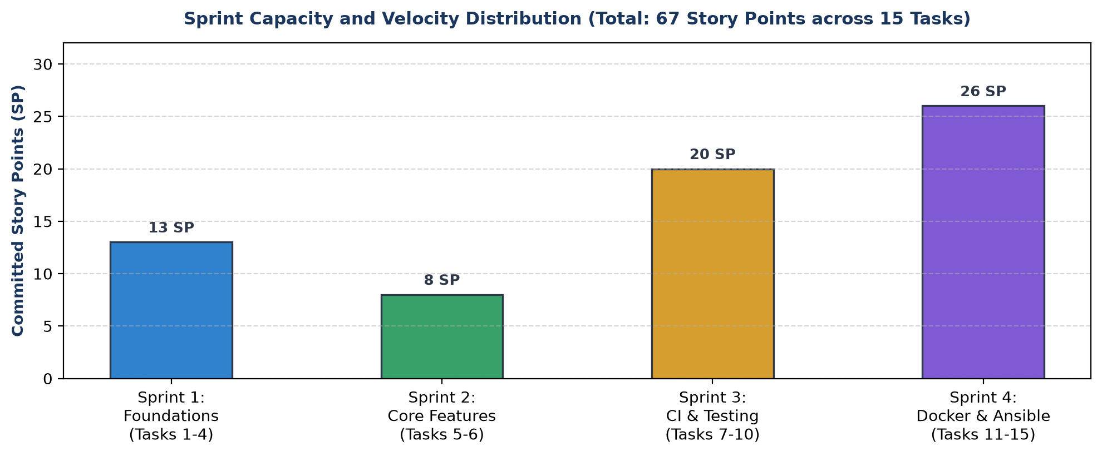  Figure 2.3: Sprint Capacity and Story Point Velocity Distribution across 15 Tasks  5. Formal Definition of Done (DoD) Quality Contract  To ensure that no task or feature is marked complete prematurely, I established a rigorous, multifaceted Definition of Done (DoD). A user story, task, or pipeline release is classified as 'Done' strictly when all of the following criteria are validated:  • Source Code Quality: Code adheres to Java naming standards, Clean Code principles, and proper exception handling. Zero commented-out dead code.  • Version Control Integrity: Every feature branch is merged into 'dev' exclusively through a reviewed Pull Request with conventional commit messages.  • Deterministic Build: Maven wrapper successfully compiles the project ('./mvnw clean compile') with 0 compilation warnings or errors.  • Automated Testing Gate: All Selenium WebDriver end-to-end tests pass in headless execution mode. 100% of assertion checks must succeed.  • CI/CD Quality Enforcement: Jenkins pipeline executes Checkout -> Build -> Test -> Deploy without human intervention; failed tests halt deployment immediately.  • Containerization & Observability: Multi-stage Docker image builds cleanly, runs on host port 8080, and exposes a healthy Spring Boot Actuator endpoint (/actuator/health).  • Infrastructure Idempotency: Running the Ansible playbook a second time results in 'changed=0, failed=0', proving operational idempotency.  • Academic Documentation: Each task has an officially formatted Word document generated programmatically, containing centered diagrams and live terminal evidence.
  Story ID | Target Persona | User Story Statement (Connextra) | Acceptance Criteria (Gherkin Syntax)
  US-01 | Farmer / Trader | As a produce farmer, I want to view active cold chambers categorized by temperature zone (Deep Freeze, Chilled, CA), so that I can identify suitable storage for my crop. | Given the user is on the directory page (/slots),  When they filter by 'Chilled' (0-4°C),  Then only Chamber B slots suitable for apples/dairy shall be displayed.
  US-02 | Farmer / Trader | As a farmer, I want to book a specific chamber slot by specifying commodity type, crate quantity, and dates, so that my harvest intake is reserved in advance. | Given available slot capacity,  When the user submits valid crate quantity and check-in/out dates,  Then the booking is created in PENDING status and an instant confirmation code is generated.
  US-03 | Validation Engine | As a system, I want to block reservation requests that exceed chamber crate limits or overlap with booked dates, so that double-booking is prevented. | Given a slot is already booked for Date Range [D1, D2],  When a user requests that slot for overlapping dates,  Then the system rejects the submission with a clear validation error banner.
  US-04 | Warehouse Manager | As a warehouse manager, I want to confirm or cancel pending bookings and track check-ins, so that facility capacity reflects physical inventory. | Given a booking with status PENDING,  When manager clicks 'Confirm Booking',  Then status transitions to CONFIRMED and the slot availability count updates instantly.
  US-05 | DevOps Engineer | As a DevOps engineer, I want an automated health check endpoint, so that Jenkins CI/CD and Ansible can verify application readiness post-deployment. | Given the Spring Boot service is running,  When an HTTP GET is made to /actuator/health,  Then the system responds with HTTP 200 OK and JSON body {"status":"UP"}.
  Backlog ID | Feature / Epic Description | Story Points | MoSCoW Priority | Sprint Target | Primary Tech
  PB-01 | Application Foundation & H2 Data Models | 5 SP | Must Have (M) | Sprint 1 | Spring Data JPA
  PB-02 | Git VCS Setup & Branching Architecture | 3 SP | Must Have (M) | Sprint 1 | Git / GitHub
  PB-03 | Chamber Directory & Slot Grid UI | 5 SP | Must Have (M) | Sprint 2 | Thymeleaf / CSS
  PB-04 | Slot Booking & Date Overlap Validator | 5 SP | Must Have (M) | Sprint 2 | Spring Service
  PB-05 | Manager Lifecycle Status Machine | 3 SP | Should Have (S) | Sprint 2 | REST Controller
  PB-06 | Jenkins Continuous Integration Pipeline | 8 SP | Must Have (M) | Sprint 3 | Jenkins / Maven
  PB-07 | Selenium Automated Quality Gate Suite | 8 SP | Must Have (M) | Sprint 3 | Selenium 4 / JUnit
  Sprint # | Sprint Focus & Theme | Encompassed Tasks | Total Points | Key Milestone Outcome
  Sprint 1 | Foundations & VCS Initialization | Tasks 1, 2, 3, 4 | 13 SP | SRS, Agile Backlog, Spring Boot 3 architecture baselined, GitHub repository initialized with branch rules.
  Sprint 2 | Feature Development & MVP Baseline | Tasks 5, 6 | 8 SP | Feature branching demonstrated, complete 5-module MVP implemented, merge conflict resolved, v1.0.0 tagged.
  Sprint 3 | Continuous Testing & CI Quality Gate | Tasks 7, 8, 9, 10 | 20 SP | Jenkins pipeline configured, Tomcat deployment automated, Selenium tests written, quality gate defect-stop verified.
  Sprint 4 | Container CD, Ansible & Final Release | Tasks 11, 12, 13, 14, 15 | 26 SP | Docker image lifecycle, automated continuous deployment, Ansible playbook idempotency, health checks, final viva release.
Conclusion: | In this task, I successfully established the agile planning framework, product backlog, and DevOps workflow for the Cold Storage Slot Booking System (CSBS). I synthesized domain requirements into five formal Agile User Stories accompanied by testable Gherkin-syntax Acceptance Criteria, ensuring alignment between business needs and automated testing suites. I prioritized the product backlog across 67 story points and mapped all fifteen laboratory tasks across four structured sprints using a Kanban task board representation. The complete DevOps lifecycle was formulated—spanning continuous planning, coding, automated building, headless Selenium testing, Docker containerization, Jenkins continuous deployment, and Ansible provisioning. Finally, I codified an uncompromising eight-point Definition of Done (DoD) quality contract, providing the governing baseline for architectural implementation in Task 3 and version-controlled feature delivery in subsequent sprints.

