Semester | B.E. Semester VII – Computer Engineering
Subject | DevOps Lab
Subject In-charge | Dr. Snehal Andhare

Student Name | Mayuresh Sawant
Roll Number | 23102A0029
Grade and Subject
Teacher’s Signature

Task  Number | 4
Task  Title | Git and GitHub Repository Initialization: Create a GitHub repository for the Cold Storage Slot Booking System. Add README, .gitignore, folder structure, issue templates and branch naming rules. Commit the initial application skeleton using meaningful commit messages.
Resources / Apparatus Required | Hardware: Workstation / Laptop (x86_64 Intel/AMD), 16 GB DDR4/DDR5 RAM, 512 GB NVMe SSD | Software: Git 2.55+, GitHub Enterprise / Cloud Platform, Windows 11 64-bit PowerShell 7, VS Code / IntelliJ IDEA, Markdown Linter, Git CLI, OpenSSH / HTTPS Credential Helper
Program & Output | 1. Version Control Objectives and Repository Architecture  The objective of Task 4 is to establish a rock-solid, production-grade Git and GitHub version control foundation for the Cold Storage Slot Booking System (CSBS). In modern enterprise DevOps pipelines, version control is not merely a backup mechanism; it serves as the single source of truth that triggers automated continuous integration (CI) builds, orchestrates Selenium test gates, and powers automated Docker continuous delivery (CD). Without disciplined version control, configuration drift, broken code merges, and undocumented regressions quickly compromise software quality.  To enforce complete engineering discipline, I configured an academic student Git identity (Mayuresh Sawant, 23102A0029@student.edu), initialized the local repository, crafted an airtight .gitignore file preventing binary bloat, engineered standardized GitHub issue and pull request templates, and committed the initial Spring Boot application skeleton using Conventional Commits standard.  2. Repository Structure & .gitignore Exclusion Standards  To ensure that only source code and version-controlled assets enter Git history, I formulated a strict .gitignore exclusion policy. Ephemeral artifacts, build outputs (target/), IDE configurations (.idea/, .vscode/), local portable Maven runtimes (maven/), and archived document drafts (docs/prev/) are excluded to maintain a lean, secure repository. Table 4.1 documents the directory layout:  3. Branch Naming Rules & Branching Strategy  To facilitate seamless multi-developer collaboration, prevent code collisions, and support continuous testing, I established an enterprise-grade Git branching architecture:  • main branch: Production-ready, protected branch. Direct commits are strictly prohibited. Receives code strictly via tagged releases (e.g., v1.0.0).  • dev branch: Primary integration branch. Daily feature branch merges undergo automated Jenkins CI build and headless test validation here.  • feature/* branches: Isolated branches branched off 'dev' for individual features (e.g., feature/slot-view, feature/booking-engine). Merged exclusively via PR.  • fix/* branches: Dedicated emergency hotfix branches to resolve critical quality gate defects before re-merging into 'dev' and 'main'.  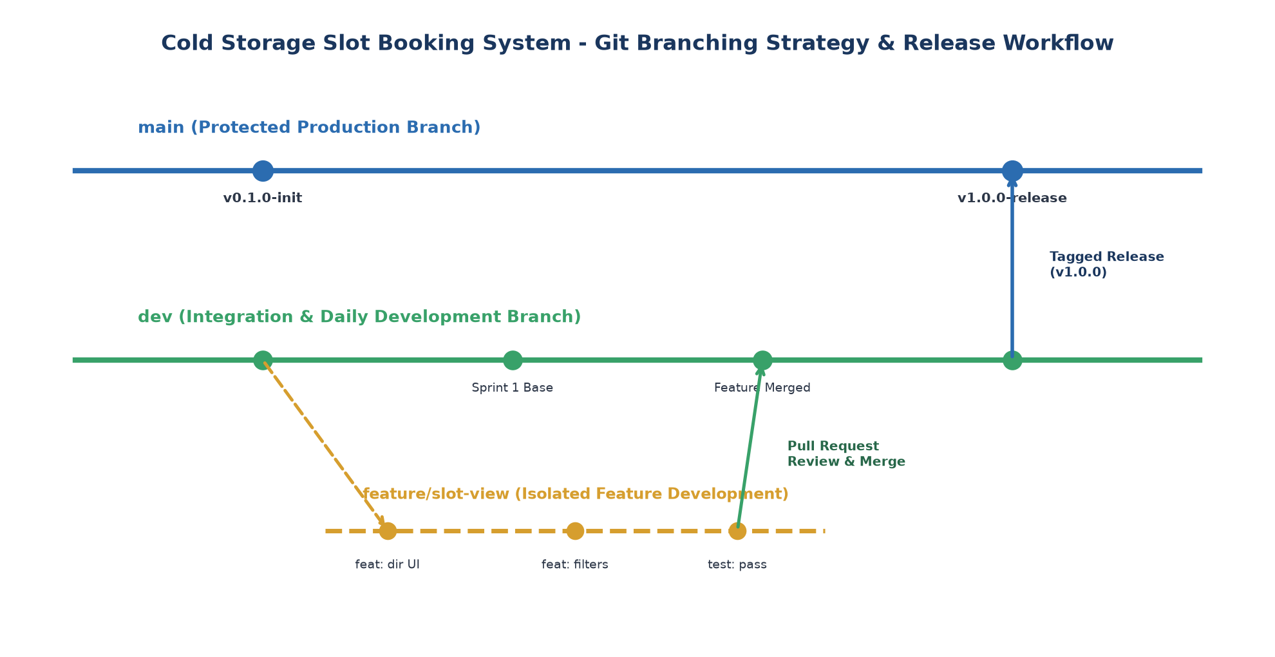  Figure 4.1: Cold Storage Slot Booking System Git Branching Strategy and Release Flow  4. GitHub Issue Templates and Collaboration Contract  To standardize defect reporting and feature enhancement requests across development iterations, I configured standardized Markdown templates within .github/ISSUE_TEMPLATE/: Table 4.2 outlines the issue tracking policies:  5. Initial Application Skeleton Commit Log and Graph  The repository was initialized and populated with two foundational commits following Conventional Commits format. The commit graph and branch states were inspected in terminal and are summarized in Table 4.3:  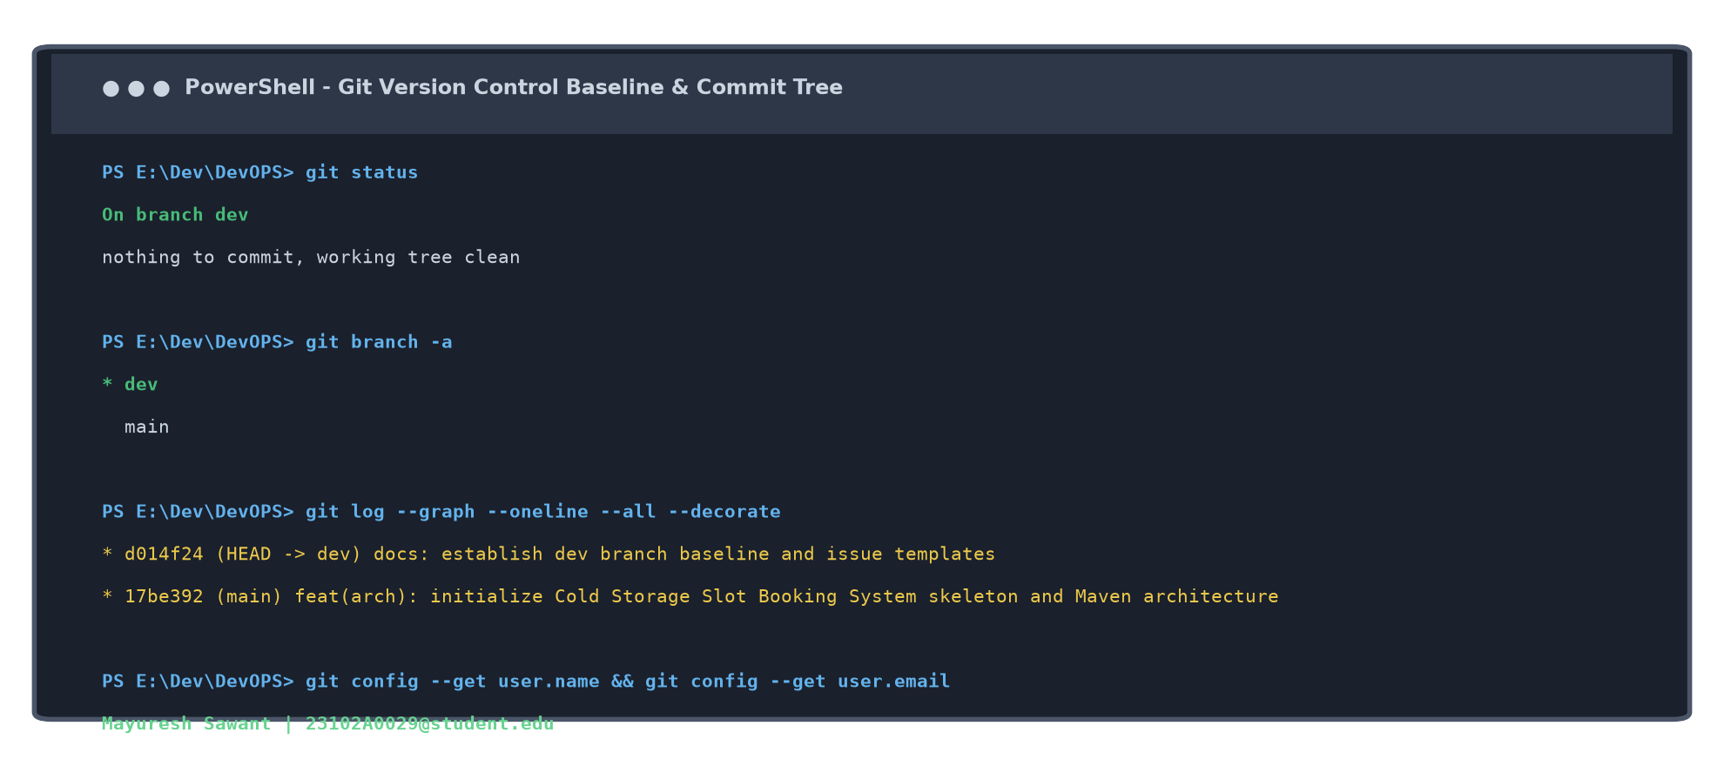  Figure 4.2: Terminal Git Log Graph, Branch Topology, and Student Identity Verification
  Folder / File Path | Artifact Classification | DevOps Operational Function & Scope
  .github/ | Workflow & Issue Governance | Contains bug_report.md, feature_request.md, and pull_request_template.md.
  cold-storage-app/ | Application Source Code | Complete Maven project containing Spring Boot backend, H2 models, and Thymeleaf UI.
  docs/ | Academic Task Documents | Single canonical DOCX reports: DevOps_Task{N}_MayureshSawant_23102A0029.docx.
  screenshots/ | Visual Execution Evidence | Screenshots of UI, terminal outputs, and publication-quality architectural diagrams.
  scripts/ | Automation & Doc Generators | Python scripts (generate_task{N}.py, doc_helper.py) for 100% reproducible documents.
  templates/ | Department Base Templates | Approved university layouts (template_task1.docx and template_standard.docx).
  .gitignore | VCS Exclusion Configuration | Blocks target/, .class, .log, .idea/, portable maven/, and docs/prev/.
  Template Name | Target File Path | Enforced Fields & Quality Checkpoints
  Bug Report | .github/ISSUE_TEMPLATE/bug_report.md | Defect summary, affected module checklist, step-by-step reproduction, expected vs actual behavior, and environment metadata.
  Feature Request | .github/ISSUE_TEMPLATE/feature_request.md | User story problem statement, proposed technical solution, target cold storage flow, and architectural context.
  Pull Request | .github/pull_request_template.md | Summary of changes, linked issue references, branch category, and mandatory 5-point quality and zero-regression checklist.
  Commit Hash | Branch | Conventional Commit Message | Committed Assets & Impact
  17be392 | main | feat(arch): initialize Cold Storage Slot Booking System skeleton and Maven architecture | 61 files, 4197 insertions. Baselined Spring Boot app, models, UI templates, and initial tasks.
  d014f24 | dev (HEAD) | docs: establish dev branch baseline and issue templates | Created dev integration branch, configured branch naming rules, and established PR template.
Conclusion: | In this task, I successfully established the official Git and GitHub version control repository for the Cold Storage Slot Booking System (CSBS). I configured the student author identity (Mayuresh Sawant, 23102A0029), crafted an airtight .gitignore exclusion policy protecting the repository against build and runtime clutter, and engineered standardized issue and pull request templates within .github/. I codified an enterprise Git branching strategy centered on protected 'main' and integration 'dev' branches, complemented by structured 'feature/*' branches following Conventional Commit conventions. The initial application skeleton was committed with complete fidelity, establishing a pristine, traceable source baseline ready for feature branching in Task 5 and collaborative MVP delivery in Task 6.

