**Standard Operating Procedure**

**Embedding: Paraffin**

**Maya Arteaga Juan Pablo**

1. **Objective:**

The purpose of this Standard Operating Procedure (SOP) is to describe an appropriate method to embed tissue (brain, spinal cord, and adrenal gland) from adult rat.

1. **Scope:**

This procedure applies to all students and personnel working in the Neurobiology Institute at UNAM.

1. **Responsibilities:**

It is responsibility of the students the use of basic safety laboratory equipment (coat, facemask, safety goggles and gloves).

1. **Materials:**
   1. Solutions
      1. Dehydration solutions (different percentage of ethanol from 50%-100%)
2. **Theoretical Framework**

Once the tissue is fixed, it is further processed for observation with the microscope. Samples must be hardened before sectioning, The thinner we want the sections, the harder has to be the sample. There are two common procedures to do this: freezing and embedding.

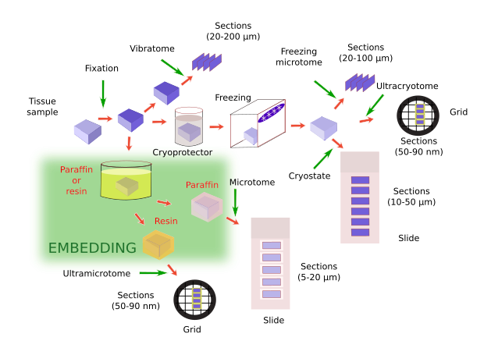

Embedding is the most widely used method for hardening samples. During embedding, substances in liquid state are infiltrated through the sample and, after a period of polymerization, the embedding substance (and the sample) gets solid without altering the morphological or molecular features of tissues. In this way, depending on the embedding substance, very thin section (from μm to nm) can be obtained. Different embedding substances are available to get specific section thickness and particular techniques. For light microscopy, paraffin is the most common embedding substance. For electron microscopy, epoxy and acrylic resins are the most used embedding medium. Most embedding media are hydrophobic, which requires that the sample exchange the water for hydrophobic compounds. This is important due to if some water is remaining in the sample, the embedding process does not properly reach all the sample regions, resulting in a poor-quality section of the tissues.

Paraffin is a wax-like substance composed of a mix of saturated hydrocarbons. It is solid at room temperature. The melting point is between 40ºC-70ºC (depending on the hydrocarbons mix compositions). As it was said, paraffin is not miscible with water, but tissues are mostly water. In addition, most fixatives are aqueous solutions. This means that water must be removed from tissues before they are infiltrated with liquid paraffin. It is done by dehydration of tissues with ethanol (from 50% to 100%). All water needs to be removed for a good embedding. After dehydration, samples are transferred to an intermediary liquid, like xylene, benzene, propylene oxide or toluene, which are miscible with both absolute alcohol and paraffin. These are clearing/bleaching substances that make the sample translucent. The last step of the embedding is to plunge the sample in melted paraffin. It is done in a stove at a temperature properly set for the paraffin type. For a complete replacement of the intermediary liquid with paraffin, three changes in fresh paraffin are recommended: 1) how long the sample are incubated in paraffin depends on the intermediary liquid, 2) size of the sample, 3) type of paraffin. After the complete substation of the intermediary liquid by paraffin, the sample is placed properly oriented in a metallic mold filled with liquid paraffin. Then, the mold with the infiltrated sample and the paraffin surrounding the sample are left at room temperature or onto a cooled plate so that paraffin gets solid.

1. **Procedure**
   1. **Cassette:**
      1. After perfusion and dissection of the tissue, put it in the cassette.
   2. **Dehydration:**
      1. Dehydrate the tissue moving the cassette from recipes cointaining ethanol from 50-100%
   3. **Intermediary liquid:**
      1. Clear the tissue through changes of xylene
   4. **Embedding: Plugging in Paraffin:**
      1. Once the tissue is dehydrated, pour the liquid paraffin over the tissue
      2. Make sure of put the tissue in the correct orientation
      3. Move the cassette to a cold place, the paraffin would solidify gradually
      4. The paraffin tissue block can be stored at room temperature for years
   5. **Trimmed Paraffin Block:**
      1. Remove the excess of paraffin by trimming the block to the shape of the sample

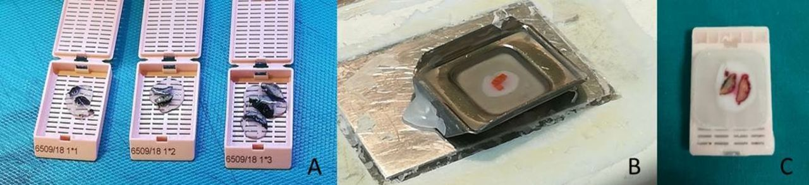

1. **Bibliography:**

<https://mmegias.webs.uvigo.es/02-english/6-tecnicas/3-inclusion.php>