**Standard Operating Procedure**

**Perfusion: Paraformaldehyde**

**Maya Arteaga Juan Pablo**

1. **Objective:**

The purpose of this Standard Operating Procedure (SOP) is to outline the proper procedure for euthanasia, intracardiac perfusion, fixation, and brain dissection in adult rats.

1. **Scope:**

This procedure applies to all students and personnel working in the Neurobiology Institute at UNAM.

1. **Responsibilities:**

It is responsibility of the students the use of basic safety laboratory equipment (coat, facemask, safety goggles and gloves).

1. **Materials:**
   1. Reagents
      1. Pentobarbital
   2. Solutions
      1. Phosphate-Buffered Saline solution (PBS)
      2. 4% Paraformaldehyde (PFA)
   3. Equipment
      1. Perfusion pump
      2. Dissection kit (iris scissors, Mayo scissors, Plane forceps, Kelly forceps, etc.)
      3. Syringe (insulin syringe)
      4. Syringe needle
      5. Falcon tubes (50ml)
      6. Necropsy table (grid and aluminum tray)
      7. Scotch tape
2. **Solutions:**
   1. 1X Phosphate-Buffered Saline solution (PBS)

|  |  |
| --- | --- |
| Reagents | Quantities |
| Sodium Chloride | 8.06 g |
| Potassium Chloride | 0.22 g |
| Sodium Phosphate (Na2HPO4) | 1.15 g |
| Potassium Phosphate (KH2PO4) | 0.2 g |
| Distilled Water | Gauge to 1L |

* 1. 4% Paraformaldehyde (PFA) 1 L

|  |  |
| --- | --- |
| Reagents | Quantities |
| Paraformaldehyde powder | 40 g |
| 1X PBS | 800mL + 200mL |
| Sodium hydroxide (NaOH) | 5N: drops/pearls |

1. **Theoretical Framework:**

Tissues possess malleable, fragile, and degradable properties, necessitating preservation methods to maintain their structural integrity for study. Researchers typically process tissues through fixation and embedding, which stabilize them to capture their in vivo state, followed by sectioning for subsequent staining and visualization techniques.

Fixation involves using chemical methods to preserve, stabilize, and reinforce biological specimens. This process terminates ongoing biochemical reactions by "fixing" proteins into place, deactivating endogenous proteolytic enzymes, and eliminating microorganisms that could degrade the specimen. Fixatives can be categorized into coagulant and cross-linking types. Coagulant fixatives remove water from tissues, causing coagulation and protein denaturation, primarily in the extracellular matrix. Examples include alcohol-based fixatives like Bouin's solution and Carnoy's solution. Cross-linking fixatives form covalent chemical bonds between tissue molecules. Common examples are formaldehyde and glutaraldehyde, with formaldehyde being the preferred choice.

Formaldehyde binds to protein functional groups, rendering hemiacetal groups and rendering most enzymes non-functional, thereby preventing degradation. It forms bonds with various groups such as amino, sulfhydryl, guanidyl, and aliphatic hydroxyl groups. This reaction produces hydroxymethyl compounds, which further react with other groups to form methylene bridges. Paraformaldehyde (PFA) is a polymer of formaldehyde. It offers the advantage of breaking down into formaldehyde when dissolved in water. Additionally, PFA tends to be purer compared to formaldehyde solutions, making it the preferred option for researchers. The recommended fixation time for PFA ranges from 24 to 50 hours, although it can extend up to 1-2 weeks. For immunohistochemistry purposes, a 12 to 24-hour fixation at 4ºC is advisable. Prolonged fixations can lead to tissue hardening and potential nucleic acid instability. To partially remove fixative from the tissue, extended washes are recommended.

* **Formaldehyde** is a well-preserver for lipids, which is improved by adding calcium to the fixative solution because calcium minimizes the solubility of phospholipids, and it does not react with carbohydrates.

1. **Procedure:**

* 1. **Preparations:**
     1. The perfusion process must be conducted within a chemical fume hood.
     2. Fill one bottle with 250ml per animal (200mL + 50 as a margin of error) of PBS and another bottle with 250ml per animal of PFA.
     3. Purge the hose to ensure proper flow.
     4. Check the pressure of the pump, aiming for 10mL per minute.
     5. Prepare the necropsy table with a grid and aluminum tray, along with the necessary instruments such as scissors and forceps, and have scotch tape ready for use.
  2. **Anesthesia:**
     1. Administer pentobarbital intraperitoneally (IP) at a loading dose of 30-60mg/kg. If the initial dose is insufficient, administer 20-25% of the initial dose additionally.
     2. Assess the hypnotic effects using parameters such as tail pinch, paw pinch, sternum pinch, and corneal reflex.
     3. Once the rat is anesthetized, transfer it to the necropsy table.
  3. **Incision:**
     1. Secure each limb of the animal with scotch tape
     2. Pinch the xyphoid process and lift it to make an incision in the skin without risking injury to any other tissue.
     3. Make a lateral incision through the integument and abdominal wall just beneath the rib cage on both sides.
     4. Using Kelly forceps to hold the xyphoid process, expose the diaphragm muscle, and carefully remove it to open the thoracic cavity.
     5. Cut along both lateral sides of the ribs and carefully displace the lungs.
     6. Lift the sternum away and trim any tissue connecting it to the heart.
     7. Gently grasp the heart with forceps.
     8. Pass a needle through the left ventricle (apex) into the ascending aorta.
     9. Secure the needle with scotch tape.

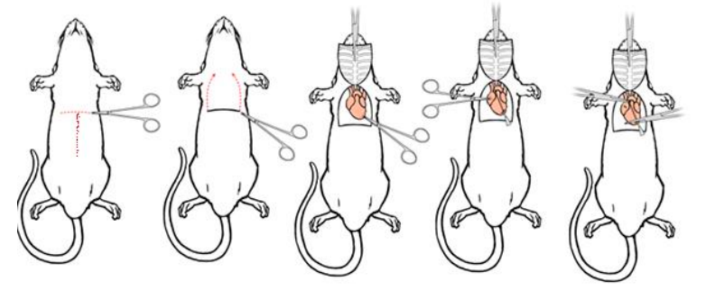

* 1. **Perfusion:**
     1. Start the flow of the PBS solution
     2. With scissors, cut the right atrium
     3. After 20 minutes or after the fluid exiting the animal is running clear, turn down the pump and change the hose to PFA solution (take care of not introducing air in the hose)
     4. Fixation tremors should be observed within seconds. These muscle contractions and blanching of the liver and mesenteric blood vessel are signs of a successful perfusion.
     5. Perfusion is complete after 20 min or after all muscle contractions have stopped, the liver and mesenteric vessels are blanched. The animal should feel rigid.
  2. **Organ dissection:**
     1. **Brain:**
        + With scissors or guillotine, decapitate the rat
        + Remove Skin and muscle from the skull
        + Introduce the scissors in the palatine foramen (below the lacrimal bone, in the zygomatic notch) and cut diagonally towards nasal bone)
        + Introduce the scissors in the low side part of the foramen magnum, and cut laterally the occipital condyle
        + Introduce the scissors in the high side part of the foramen magnum and cut laterally the supraoccipital bone.
        + Introduce the scissors in the high middle part of the foramen magnum and cut towards the nasal bone.
        + The skull should peel off
        + Be wary of dissect the dura mater which is attached to the brain.
        + Put the brain in a falcon tube with PFA
     2. **Thoracic-Lumbar Spinal cord and Adrenal Gland:**
        + Lift away the anterior organs (liver, bowels, pancreas, spleen) till you find the kidneys
        + Once you find them, follow the tissue connecting them to the spine.
        + Remove that part of the spine and the kidneys
        + Dissect the adipose tissue above the kidneys and you will find some sphere glands (one in each side).
        + Carefully, remove the Spine bone from the spinal cord.
        + Put the glands and the Spinal cord in a Flacon tube with PFA

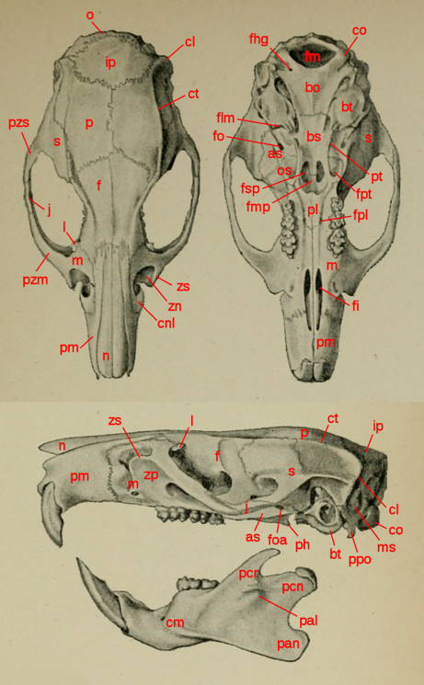 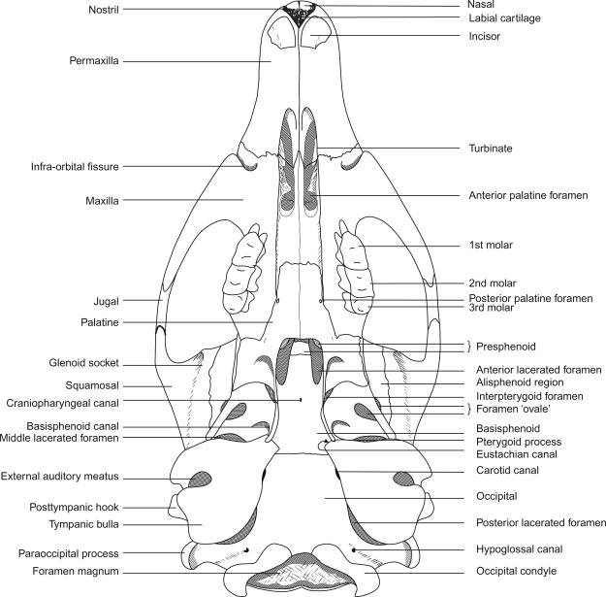

co: occipital condyle; fpl: palatine foramen; zn: zygomatic notch; l: lacrimal bone; n: nasal bone

1. **Bibliography:**
   1. <https://www.queensu.ca/animals-in-science/sites/aiswww/files/uploaded_files/sops/2022/mice/SOP-7-15-%20Whole-Body-Perfusion-for-Small-Rodents(Mice).pdf>
   2. <https://mmegias.webs.uvigo.es/02-english/6-tecnicas/2-fijadores.php>
   3. <https://commons.wikimedia.org/wiki/File:Rattus_macleari_skull_labeled.svg#/media/File:Rattus_macleari_skull_labeled.svg>
   4. <https://www.researchgate.net/figure/Canariomys-bravoi-IPS36548-holotype-three-dimensional-model-of-the-cranium-and_fig4_358717657>