**Nume**: Cucu

**Prenume**: Maria-Virginia

**E-mail**: mariacristina_cucu@yahoo.com

**Poza**: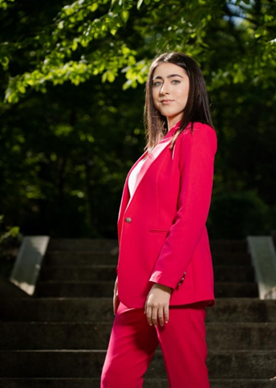

**Asteptari legate de educatie**:

* Imi doresc sa invat cat mai multe lucruri, care o sa-mi fie de folos in viitor.

**Discipline**: <https://etti.utcluj.ro/planuri-de-invatamant.html>

|  |  |  |
| --- | --- | --- |
| Disciplina | An | Link |
| Informatica Aplicata | 1 | https://etti.utcluj.ro/files/Acasa/Site/FiseDisciplina/EaRo/06.pdf |
| Algebra liniara si geometrie analitica si diferentiala | 1 | [02b.pdf (utcluj.ro)](https://etti.utcluj.ro/files/Acasa/Site/FiseDisciplina/EaRo/02b.pdf) |
| Analiza matematica | 1 | [01b.pdf (utcluj.ro)](https://etti.utcluj.ro/files/Acasa/Site/FiseDisciplina/EaRo/01b.pdf) |
| Programarea calculatoarelor si limbaje de programare | 1 | [ANEXA nr (utcluj.ro)](https://etti.utcluj.ro/files/Acasa/Site/FiseDisciplina/EaRo/04b.pdf) |
| Componente si circuite pasive | 1 | [Microsoft Word - 05_Fisa_disciplinei_Componente_si_Circuite_Electronice_Pasive.docx (utcluj.ro)](https://etti.utcluj.ro/files/Acasa/Site/FiseDisciplina/EaRo/05b.pdf) |

**Hobby-uri**:

* fotografie
* tenis de masa
* hiking