**Tomcat –** I have worked on **Test environment**

Apache File Structure

(Reference -- https://examples.javacodegeeks.com/enterprise-java/tomcat/tomcat-server-xml-configuration-example/)

Once you installed tomcat, it will be placed in your local storage. For windows, it’s usually in “Program Files” folder, for Mac or Linux, it can be on the /user/var/opt or /User/<>/Application folder. Once you’re in the directory, you can see the different folders and files available:

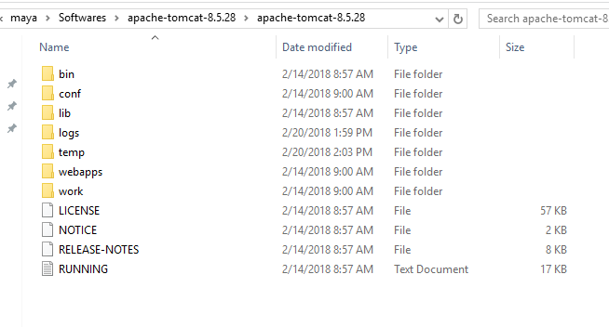

* **bin**: for Tomcat’s binaries and startup scripts.

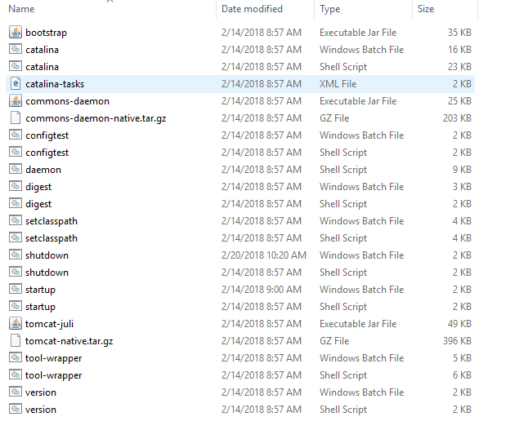

* **conf**: global configuration applicable to all the webapps. The default installation provides:
  + catalina.policy for specifying security policy.
  + Two Properties Files: catalina.properties and logging.properties,
  + Four Configuration XML Files: server.xml (Tomcat main configuration file), web.xml (global web application deployment descriptors), context.xml (global Tomcat-specific configuration options) and tomcat-users.xml (a database of user, password and role for authentication and access control).

The conf also contain a sub-directory for each engine, e.g., Catalina, which in turn contains a sub-sub-directory for each of its hosts, e.g., localhost. You can place the host-specific context information (similar tocontext.xml, but named as webapp.xml for each webapp under the host).

The conf also contain a sub-directory for each engine, e.g., Catalina, which in turn contains a sub-sub-directory for each of its hosts, e.g., localhost. You can place the host-specific context information (similar tocontext.xml, but named as webapp.xml for each webapp under the host).

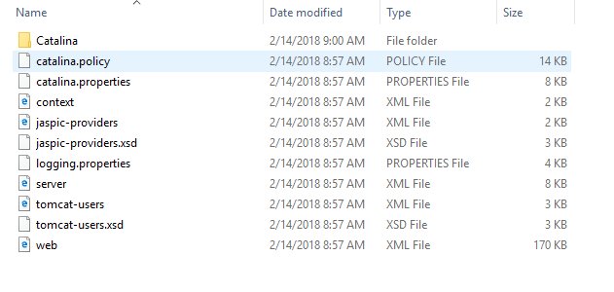

* **lib**: Keeps the JAR-file that are available to all webapps. The default installation include servlet-api.jar (Servlet), jasper.jar (JSP) and jasper-el.jar (EL). External JARs can be put here such as MySQL JDBC driver (mysql-connector-java-5.1.{xx}-bin.jar) and JSTL (jstl.jar and standard.jar).

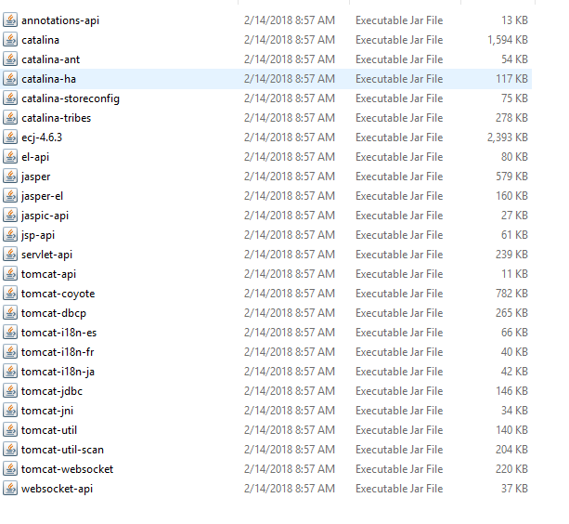

* **logs**: contains the engine logfile Catalina.{yyyy-mm-dd}.log, host logfile localhost.{yyyy-mm-dd}.log, and other application logfiles such as manger and host-manager. The access log (created by theAccessLogValve) is also kept here.

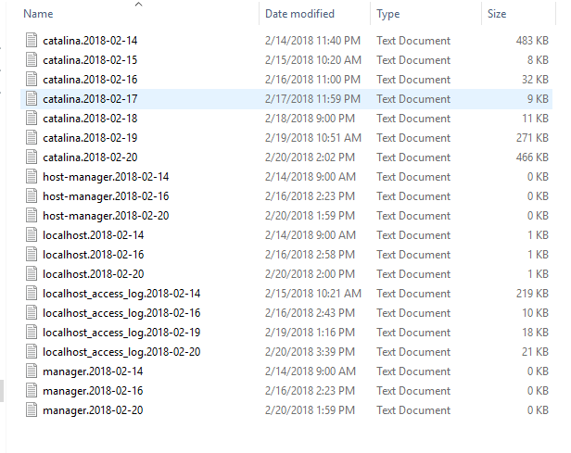

* **webapps**: the default appBase – web applications base directory of the host localhost.

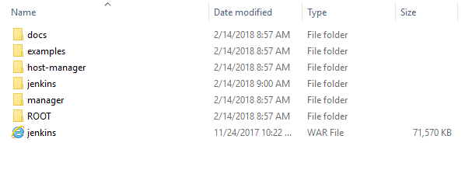

Work🡪Catelina🡪localhost

* **work**: contains the translated servlet source files and classes of JSP/JSF. Organized in hierarchy of engine name (Catalina), host name (localhost), webapp name, followed by the Java classes package structure.

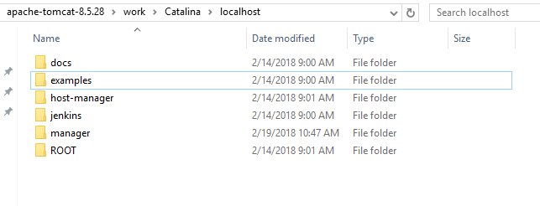

* **temp**: temporary files.

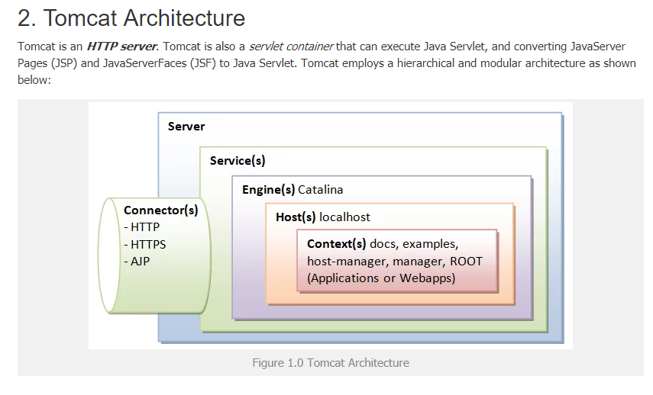

* **what is the use of all tomcat config files**

path -- D:\apache-tomcat-8.5.28\conf

files

* server.xml

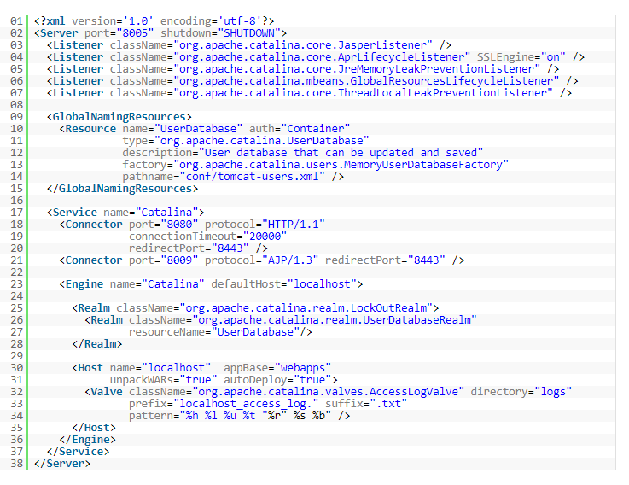

* tomcat-users.xml
* catalina.properties—properties file
* web.xml
* logging.properties--properties file
* context.xml
* **difference between http and https**

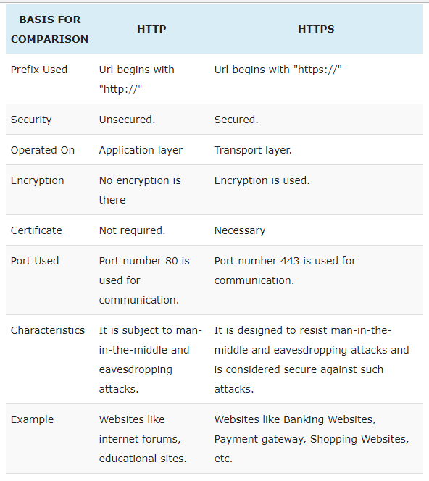

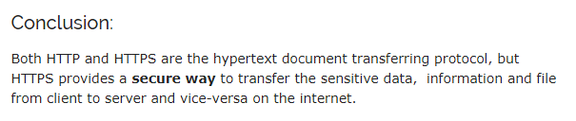

* **application server and web server**

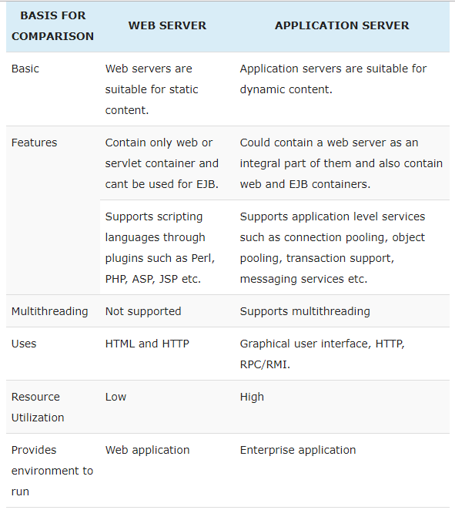

**Web server –** can deploy only .**war** files

Examples**- Apache, Microsoft’s Internet Information Server (IIS), Novell’s Web**Server etc.

**Application server –** Can deploy .**ear** as well as .**war** files

Examples- **Boss(Red Hat), JRun(Adobe), WebLogic Server(BEA)** etc.

Conclusion

Web servers are primarily designed to serve HTTP content whereas Application server can also serve HTTP content but is not restricted to just HTTP and supports protocol such as **RMI/RPC**. An application server can contain web server in it, which means it can perform operations performed by a web server as well as it has additional components and features to support connection pooling, object pooling, transaction support, messaging services, etcetera.

* **How to the secure tomacat**

To secure tomcat need SSL connection and I did not worked on the same till but i can secure Manager Apps by changing tomcat-user.xml username and password.

* **tell me batch command to tell me the given port is used or no**

🡪 Netstat

Unix commands : $ netstat -apn tcp(or udp) | grep LISTEN

* **ports used in tomcat with port no**

apache/conf/server.xml

**Ports –**

Connector ports – HTTP-8080

AJP-8009

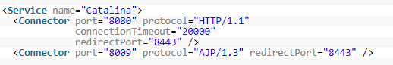

Shutdown port – 8005 –under <server> tags attribute



* **Explain how you can deploy/configure web application using war file and GUI**
* Goto apache/conf/tomcat-users.xml
* Edit
* Uncomment role section and edit as below



* Goto apache/bin and run startup.bat/.sh
* Goto deploy section –

Enter context Path - .war file name

Enter WAR or directory URL-

Click deploy

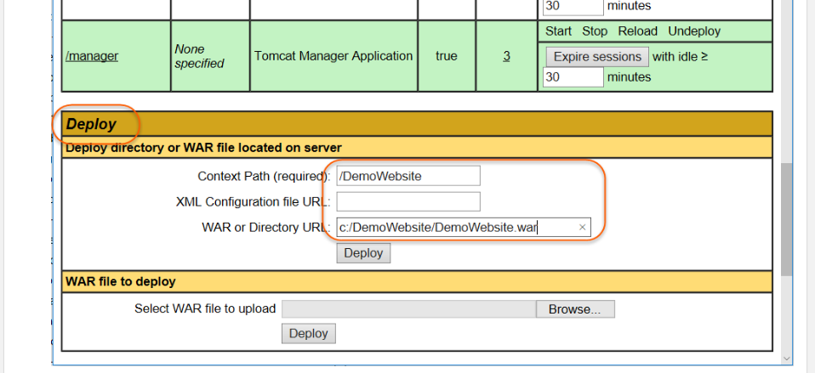

* **Can we add multiple users/roles here in tomcat-users.xml**?
* Yes
* How?

Add <username, password, user roles > tag with required specifications