Flight Cancellation Risk
Final Project — Documentation

Maya Babadganov and Michael Sidorov
Naya College — CDE Program
April 2026

Table of Contents
# | Section | Page
1 | Project Overview | 3
2 | Objectives | 4
3 | System Architecture | 5
4 | Environment & Infrastructure | 6
5 | Pipeline Components | 7
6 | Data Storage | 9
7 | Visualization & BI | 11
8 | Appendix | 12

1. Project Overview
The Flight Weather Risk Pipeline is an end-to-end cloud data engineering system that automatically evaluates the weather-related cancellation or diversion risk for every scheduled flight over the next two days. The system fetches live flight schedules from the AeroDataBox API, retrieves 72-hour weather forecasts from Open-Meteo for each departure and arrival airport, scores each flight as LOW / MEDIUM / HIGH risk based on wind speed and precipitation, and displays the results in a live web dashboard.
The pipeline runs entirely inside Docker containers with a single docker-compose up command. No cloud accounts or paid services are required. All data is persisted locally in PostgreSQL and MinIO. The architecture is designed so every component can be replaced with its cloud equivalent (AWS RDS, S3, MSK) by changing a single environment variable.

Problem Statement
Airlines, airports, and travellers need early warning of weather conditions that may disrupt flights. Existing tools either require expensive subscriptions or only report weather at the departure airport. This pipeline scores both the departure AND arrival airport, taking the worst of the two scores — giving a more complete picture of the actual flight risk.

Key Features
- Automated daily schedule ingestion via REST API with Kafka as the transport layer
- Real-time weather enrichment every 30 minutes using free Open-Meteo API (no key needed)
- Rule-based risk scoring with human-readable explanations per flight
- Dual storage: PostgreSQL for live queries, MinIO for append-only historical archive
- Two Airflow DAGs with automatic retry and monitoring via the Airflow web UI
- Live Streamlit dashboard with colour-coded risk table and charts
- Power BI connection via direct PostgreSQL connector

2. Objectives
This project demonstrates mastery of the following cloud big data engineering skills:
Skill Area | Implementation
API Data Ingestion | AeroDataBox (RapidAPI) + Open-Meteo, Python requests
ETL Pipeline | 5-step fetch → enrich → score → load chain
Kafka Streaming | 2 topics, producers + consumers, consumer groups
Data Warehouse | PostgreSQL 15, 2 tables, 3 indexes, UPSERT pattern
Partitioned Storage | MinIO Hive-style date/hour partitioning, append-only
Airflow Scheduling | 2 DAGs: daily schedule + 30-min risk refresh
Visualization | Streamlit web dashboard + Power BI Desktop

3. System Architecture
The pipeline is divided into two Airflow DAGs that share a PostgreSQL database. The schedule DAG runs once a day and feeds the risk DAG, which refreshes every 30 minutes.

Data Flow
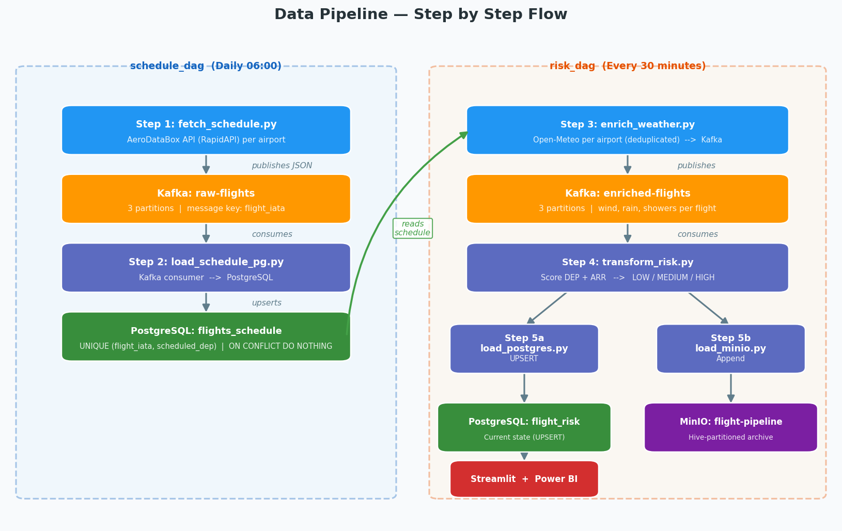

Two-DAG Design
Separating the schedule DAG from the risk DAG is a deliberate design choice. Flight schedules change slowly — once a day is enough. Weather changes every hour. By running weather enrichment and risk scoring every 30 minutes independently of schedule fetching, we avoid unnecessary API calls to AeroDataBox (which has a 500 calls/month free tier limit) while keeping weather data fresh.
- schedule_dag — runs at 06:00 daily. Calls AeroDataBox for today + tomorrow. Publishes to Kafka raw-flights. Loads PostgreSQL flights_schedule.
- risk_dag — runs every 30 minutes. Reads schedule from PostgreSQL. Fetches Open-Meteo for each unique airport. Scores risk. UPSERTs flight_risk. Appends snapshot to MinIO.

4. Environment & Infrastructure
All services run as Docker containers on a shared bridge network (pipeline-net). The entire stack starts with docker-compose up -d. No cloud accounts are needed.

Docker Services
Service | Image | Port(s) | Role
zookeeper | confluentinc/cp-zookeeper:7.5.0 | 2181 | Kafka coordination
kafka | confluentinc/cp-kafka:7.5.0 | 9092, 29092 | Message broker
kafka-init | cp-kafka (one-shot) | — | Creates 2 topics on startup
postgres | postgres:15 | 5432 | Data warehouse
minio | minio/minio:latest | 9000, 9001 | Object storage + web UI
airflow | custom airflow.Dockerfile | 8080 | DAG orchestration + UI
pipeline | custom Dockerfile | — | Runs ETL scripts
streamlit | python:3.11-slim | 8501 | Live web dashboard
volume-init | busybox (one-shot) | — | Sets shared volume permissions

Starting the Stack
To start all services:
docker-compose up -d
To initialize the database (first time only):
docker-compose run pipeline python scripts/db_init.py

Service UIs
Service | URL | Credentials
Airflow | http://localhost:8080 | admin / admin
MinIO | http://localhost:9001 | minioadmin / minioadmin123
Streamlit | http://localhost:8501 | No login required

5. Pipeline Components

Step 1 — fetch_schedule.py
Calls the AeroDataBox API (via RapidAPI) for each configured airport. Each call uses a 12-hour window (06:00–18:00 UTC) to stay well under the 500-call/month free-tier limit (5 airports × 2 days = 10 calls/day ≈ 300/month). Maps each flight to a standardised record including IATA codes, airport coordinates, and scheduled times. Publishes each flight as a JSON message to the Kafka topic raw-flights using the flight IATA code as the message key. Writes a backup JSON file to the shared Docker volume.
- Why AeroDataBox: Free tier (500 req/month), supports per-airport queries with ICAO codes, returns full departure windows
- Alternative considered: AviationStack — rejected because free tier does not support flight_date filtering
- Kafka producer uses confluent_kafka, partitioned by flight IATA key for consistent ordering per flight

Step 2 — load_schedule_pg.py
Consumes all messages from the raw-flights Kafka topic using a per-day consumer group (load-schedule-YYYY-MM-DD). The daily group ID ensures the consumer always reads from offset 0 for today's batch, regardless of previous runs. Stops automatically when all 3 partitions signal EOF. Upserts each flight into the PostgreSQL flights_schedule table using ON CONFLICT DO NOTHING — safe to re-run.
- Consumer group per day: prevents stale data from previous days being re-inserted
- EOF detection: polls until all 3 partitions return _PARTITION_EOF — no arbitrary sleep needed
- Duplicate safety: ON CONFLICT (flight_iata, scheduled_dep) DO NOTHING

Step 3 — enrich_weather.py
Reads all upcoming scheduled flights from PostgreSQL. Deduplicates airports — if 20 flights share the same departure airport, Open-Meteo is called only once for that airport (not 20 times). Retrieves 72-hour hourly weather forecast per airport. Matches each flight to its exact scheduled hour in the forecast array. Attaches wind speed, rain, and shower values to each flight record. Publishes enriched records to Kafka enriched-flights topic.
- Airport deduplication: one Open-Meteo call per unique airport (~10–12 per run) instead of one call per flight
- Why Open-Meteo: completely free, no API key, 7-day hourly forecast, global coverage
- Hour matching: finds the closest forecast hour to the scheduled departure/arrival time

Step 4 — transform_risk.py
Reads the enriched flight data from the shared volume (current run only). Applies the risk scoring function independently to the departure airport weather and the arrival airport weather. Takes the worst score of the two. Stores the result with the triggering airport (DEP or ARR) and a human-readable explanation. Writes results to a run-specific directory for downstream loaders.
Condition | Risk Level | Example Reason
Wind > 50 km/h OR precipitation > 5 mm/h | HIGH | wind 62.3 km/h
Wind > 30 km/h | MEDIUM | wind 38.1 km/h
All other conditions | LOW

Steps 5a & 5b — load_postgres.py / load_minio.py
load_postgres.py UPSERTs the scored flights into the flight_risk table using ON CONFLICT (flight_iata, scheduled_dep) DO UPDATE — always reflecting the latest weather assessment. load_minio.py appends a new time-partitioned JSON snapshot to MinIO — nothing is ever overwritten, building a complete historical archive.

6. Data Storage

Why Two Storage Systems?
Aspect | PostgreSQL | MinIO
Content | Latest risk per flight (one row per flight) | Every historical snapshot, forever
Write pattern | UPSERT — updates existing rows | New file per run — nothing deleted
Query style | Fast: 'show today's high-risk flights' | Bulk: 'rebuild all data from March'
Used by | Streamlit dashboard, Power BI | Data scientists, audit trail
Analogy | Bank's current balance screen | Complete transaction history

PostgreSQL Schema
flights_schedule — populated once daily, 3-day rolling window:
Column | Type | Notes
flight_iata | VARCHAR(20) | e.g. 'EK202'
airline | VARCHAR(100) | Full airline name
dep_iata | VARCHAR(10) | Departure airport IATA code
dep_lat/lon | DOUBLE PRECISION | From hardcoded airport dictionary
arr_iata | VARCHAR(10) | Arrival airport IATA code
arr_lat/lon | DOUBLE PRECISION
scheduled_dep | TIMESTAMPTZ | Scheduled departure (UTC)
scheduled_arr | TIMESTAMPTZ | Scheduled arrival (UTC)
fetched_date | DATE | The date this record was fetched

flight_risk — UPSERTed every 30 minutes:
Column | Type | Notes
flight_iata | VARCHAR(20) | Flight number, e.g. ‘EK202’
airline | VARCHAR(100) | Operating airline name
dep_iata | VARCHAR(10) | Departure airport IATA code
arr_iata | VARCHAR(10) | Arrival airport IATA code
scheduled_dep | TIMESTAMPTZ | Scheduled departure time (UTC)
scheduled_arr | TIMESTAMPTZ | Scheduled arrival time (UTC)
dep_wind_kmh | DOUBLE PRECISION | Wind speed at departure airport at dep time
dep_rain_mm_h | DOUBLE PRECISION | Precipitation at departure airport
arr_wind_kmh | DOUBLE PRECISION | Wind speed at arrival airport at arr time
arr_rain_mm_h | DOUBLE PRECISION | Precipitation at arrival airport
risk_level | VARCHAR(10) | 'low', 'medium', or 'high'
risk_reason | TEXT | Human-readable explanation
risk_airport | VARCHAR(10) | 'DEP' or 'ARR'
last_updated | TIMESTAMPTZ | Timestamp of last risk assessment

MinIO Storage Layout
Bucket: flight-pipeline. Hive-style partitioning by year/month/day/hour:
raw-schedules/year=2026/month=04/day=19/schedules_20260419.json
enriched-flights/year=2026/month=04/day=19/hour=10/enriched_20260419_1000.json
risk-assessments/year=2026/month=04/day=19/hour=10/risk_20260419_1000.json
Every 30-min run writes three partitioned files — the daily flight schedule, the enriched flight+weather records, and the scored risk assessments. Files are newline-delimited JSON (one record per line) and are never overwritten, so the bucket accumulates a complete historical archive for re-processing or audit.

7. Visualization & BI

Streamlit Dashboard (http://localhost:8501)
The Streamlit dashboard provides a live, colour-coded view of all scored flights. It reads directly from the flight_risk PostgreSQL table and auto-refreshes every 60 seconds to stay in sync with the risk DAG.
- Color coding: red = HIGH risk, orange = MEDIUM, green = LOW
- Columns: Flight, Airline, Route (DEP→ARR), Departure Time, Risk Level, Reason, Last Updated
- Filters: risk level, departure airport, and free-text search by flight number or airline
- Bar chart: flight count by departure airport coloured by risk level
- Summary metrics: total flights, high-risk count, last pipeline run time

Power BI Desktop Connection
Power BI connects directly to PostgreSQL at localhost:5432 using the Npgsql ODBC driver. The flight_risk table is loaded as a live data source.
- Color coding: red = HIGH risk, orange = MEDIUM, green = LOW
- Columns: Flight, Airline, Route (DEP→ARR), Scheduled Departure, Scheduled Arrival, Risk level, Risk Reason, Risk Airport, Departure Wind, Arrival Wind, Departure Rain, Arrival Rain
- Filters: Airline, Flight, Departure Airport, Arrival Airport, Risk level and Departure Date
- Summary metrics: total flights, high-risk count, last pipeline run time

8. Appendix

A. Technology Comparison
Need | Tool Chosen | Alternative | Why We Chose This
Flight schedule API | AeroDataBox (RapidAPI) | AviationStack | Free tier supports per-airport queries; AviationStack blocks flight_date param on free tier
Weather API | Open-Meteo | OpenWeatherMap | Completely free, no API key, 7-day hourly forecast
Streaming | Apache Kafka | RabbitMQ | Industry standard for data pipelines
Data warehouse | PostgreSQL | MySQL | Better TIMESTAMPTZ support, native UPSERT (ON CONFLICT)
Object storage | MinIO | AWS S3 | Free local equivalent; S3-compatible API means zero code change to switch
Orchestration | Airflow | Prefect / Cron | Built-in retry, monitoring UI, dependency graph
Dashboard | Streamlit | Grafana | Pure Python, easy to deploy, reads from PostgreSQL natively

B. Kafka Topics
Topic | Producer | Consumer | Message Key
raw-flights | fetch_schedule.py | load_schedule_pg.py | flight_iata
enriched-flights | enrich_weather.py | transform_risk.py | flight_iata
Both topics: replication-factor 1, created by kafka-init on startup.

C. Environment Variables (.env)
Variable | Example Value | Purpose
AERODATABOX_API_KEY | KEY | RapidAPI key for AeroDataBox
AERODATABOX_AIRPORTS | KJFK,EGLL,EDDF,OMDB,KATL | ICAO airport codes to monitor
SCHEDULE_DAYS_AHEAD | 1 | Fetch today + N more days (max 2 on free tier)
KAFKA_BOOTSTRAP_SERVERS | kafka:9092 | Kafka broker address (inside Docker)
POSTGRES_HOST | postgres | PostgreSQL hostname
POSTGRES_DB | flightdb | Database name
MINIO_ENDPOINT | http://minio:9000 | Change to S3 URL for AWS deployment
MINIO_BUCKET | flight-pipeline | Bucket for all pipeline output

D. Upgrade Path (No Code Rewrites)
Upgrade | What to Change
Use AWS S3 instead of MinIO | Change MINIO_ENDPOINT in .env to S3 URL
Use AWS RDS instead of local PG | Change POSTGRES_HOST in .env to RDS hostname
More days of flights | Set SCHEDULE_DAYS_AHEAD=2 in .env (max on free tier)
ELK logging | Add Elasticsearch + Logstash + Kibana to docker-compose.yml

