Software Requirements Specification
for
Virtual Stylist
Version 1.0 approved
Prepared by
Maya Boradzhieva 62335
Lyubka Angelinina 62342
Nikoleta Valchinova 62322
Table of Contents
Table of Contents ii
Revision History ii
1. Introduction 1
1.1 Purpose 1
1.2 Document Conventions 1
1.3 Intended Audience and Reading Suggestions 1
1.4 Product Scope 1
1.5 References 1
2. Overall Description 2
2.1 Product Perspective 2
2.2 Product Functions 2
2.3 User Classes and Characteristics 2
2.4 Operating Environment 2
2.5 Design and Implementation Constraints 2
2.6 User Documentation 2
2.7 Assumptions and Dependencies 3
3. External Interface Requirements 3
3.1 User Interfaces 3
3.2 Hardware Interfaces 3
3.3 Software Interfaces 3
3.4 Communications Interfaces 3
4. System Features 4
4.1 System Feature 1 4
4.2 System Feature 2 (and so on) 4
5. Other Nonfunctional Requirements 4
5.1 Performance Requirements 4
5.2 Safety Requirements 5
5.3 Security Requirements 5
5.4 Software Quality Attributes 5
5.5 Business Rules 5
6. Other Requirements 5
Appendix A: Glossary 5
Appendix B: Analysis Models 5
Appendix C: To Be Determined List 6

Revision History
Name | Date | Reason For Changes | Version

Introduction

Purpose
This document is meant to delineate the features of visual stylist, so as to serve as a guide to the developers on one hand and software validation document for the prospective client on the other.
Visual Stylist is intended to provide users the ability to have outfit ideas based on diverse categories. Moreover the users can see a 3D figure of themselves wearing the clothes and can track whether their clothes need to be washed or not.

Document Conventions
The used font of this document is Times. The standard size of the font is 12. The color is black.
Every subsection is numerated and its text offset is tabulated. The headings are bold.

Intended Audience and Reading Suggestions
This document is intended for developers, users, testers, documentation readers, project managers and etc.
The document describes the following:
1.3.1 System overview.

1.3.2 Exemplary interface of Visual Stylist (on iOS)

1.3.3 Functional requirements.

1.3.4 Nonfunctional requirements.

Product Scope
Visual Stylist is web application that shows people outfit ideas and gives them the opportunity to create their own outfits. This documentation consists of the product’s features and the external providers which are mentioned in 1.5. References. The product’s target group are users who want to dress well, but don’t have time to try on outfits or match their clothes.
The business strategy is to make Visual Stylist inseparable part of people’s agenda.

This is achievable by constant maintenance and quality checks.

References
https://mdhhologram.com/ - hologram provider
https://aws.amazon.com/- server provider
https://www.accuweather.com/ - provides weather forecast for the recommender
http://www.sfmeasure.com/en/ - provides measurement devices
https://www.microsoft.com/ - operating system provider for Windows devices
https://www.apple.com/ - operating system provider for iOS devices

Overall Description

Product Perspective
The product is a new, self-contained product. It is not a follow-on member of a product family.

Product Functions
The platform provides:
- Combination of tech and style to visually search and manage the user’s wardrobe.
- Outfit suggestions from the user’s wardrobe.
- An option to save favorite outfits with items from the user’s collection on the application or phone's gallery.
- Access from any device that has the app installed and from any web browser.
- The best match considering the user’s body type, the weather, the occasion, color/s and the style that has been chosen.
- A 3D figure of the user or a hologram with exact measurements and face.
- A 360° view of the figure wearing the chosen clothes.

User Classes and Characteristics
Users of the system should be able to combine and save outfits, see themselves wearing them, ease the outfit choice, save time because the user does not have to actually try on the clothes.

The users of the platform are considered to be:
- Aged from 5 to 60+ years old, but overall everyone can use it.
- Interested in fashion.
- People who care about their appearance and want to dress appropriate for the occasion.
- Occupied for the day or do not have spare time to try and choose outfits.

The user can log in using his/her account details. New customers have to set up an account. They must give the details of their full name, email address, username and password. Moreover, they can scan themselves or enter their measurements and height. Including a photo of their face is optional.

Operating Environment
Internet connection is required.
Operating systems: iOS, Android
Database: SQL+ database
Cooperation with AccuWeather is required.

Design and Implementation Constraints
Users may have access from any device that supports the specific operating system.
System shall operate in newest versions of the web browsers: Chrome, Mozilla Firefox, Safari.
Hologram option will work only if the device is supported by MDH Hologram technology.
Personal data will be stored in the database, so the database must be secure.
At least 2 GB of free space with at least 1 GB additional space for custom content and saved outfits.

User Documentation
There will be a tutorial that will introduce how “Visual Stylist” works when the user signs up.
Help section will be accessible. There can be found additional information about “Visual Stylist”, as well as the tutorial.

Assumptions and Dependencies
Possibility of low use of the hologram option due to the fact that it is supported by special technology (provided by MDH Hologram).
Dependencies:
The cooperation with AccuWeather can lead to possible problems such as unavailable weather option and inaccurate weather predictions.

External Interface Requirements

User Interfaces
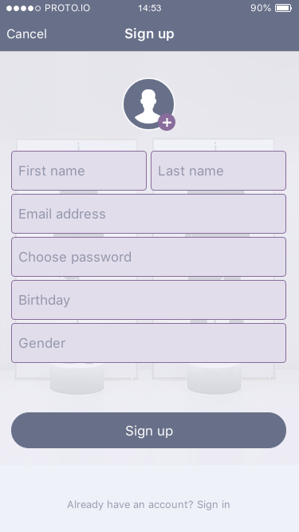
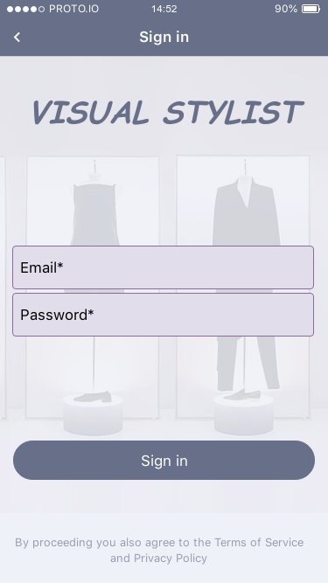
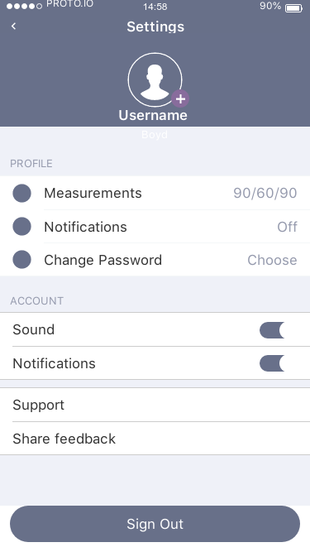
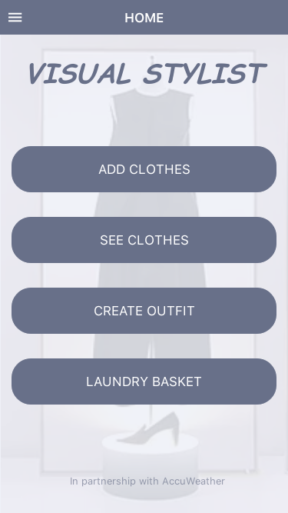

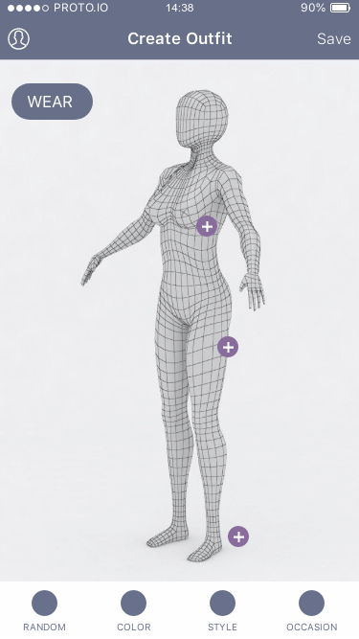
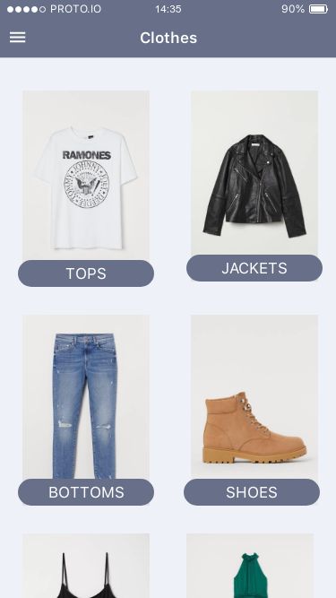
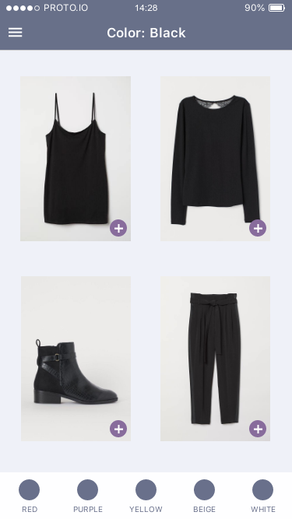

Hardware Interfaces
In order to achieve full system functionality the system needs the hardware components listed below:
3.2.1 A PC or mobile device that fulfills the requirements mentioned in 2.4. and 2.5.
3.2.2 Holographic technology by MDH Hologram
3.2.3 Measuring device by SFM (Scan Fit & Measure)

Software Interfaces
3.3.1 The server’s operating system mentioned in 1.5.
3.3.2 System’s cloud server which holds all the information of the application and its copies
3.3.3 Software which converts SFM information for the system’s 3D figure
3.3.4 Software which transfers system’s information to the holographic technology

Communications Interfaces
3.4.1 The communication between the user and the platform is implemented through web browser or application. The web browser connects with the system’s server using HTTP.
3.4.2 HTTPS will be used for secure communication over a computer network.
The principal motivations for HTTPS are authentication of the accessed website, protection of the privacy and integrity of the exchanged data while in transit.

System Features

Users must be registered in order to enter the system.

Entering the system requires username and password.

In order to achieve more accurate representation of his own figure, the registered user can:
4.3.1 Scan himself.
4.3.2 Provide information about his measurements (weight, height, etc.)

If the user does not provide information about his measurements, there will be default 3D figure.

The registered user has an option to upload a picture (in .jpg format) of his face which will be placed on the user’s 3D figure

The system will detect the registered user’s favorite style and favorite color from what he/she has worn the most. Thus the recommender’s algorithm improves.

The system uses information about the weather from AccuWeather.com

The system provides the user the opportunity to add clothes. It separates them in different categories, such as tops, jackets, bottoms, shoes, dresses, bras and etc.

The system provides the user the opportunity to see added clothes by categories.

The system provides the user the opportunity to search for a piece of clothing.

The system provides the user the opportunity to create outfits. The user can choose from options, such as color, occasion, style and the recommender’s random pick.

The system provides the user the opportunity to save favorite outfits and to select whether the outfit is worn or not.

The system saves how many times a piece of clothing is worn and displays message (needs to be washed) when it is worn 3 times.

The system provides the user the opportunity to check laundry basket to see used clothes or to remove them if they are washed.

A hologram option is available when the device is supported by MDH Hologram technology.

Other Nonfunctional Requirements

Performance Requirements
5.1.1. The platform must perform equally fast nonetheless the workload.
5.1.2. The system should response within 3 milliseconds.
5.1.3. The system should be capable of supporting 40 000 customers concurrently.
5.1.4. The platform will remain supported through monthly quality updates.

Safety Requirements
5.2.1. Information transmission should be securely transmitted to server without any changes in information.

Security Requirements
5.3.1. System should have login mechanism in order to avoid hacking.
5.3.2. System should notify the user when other device logs into the system.

Software Quality Attributes
5.4.1. If the Internet service gets disrupted while sending information to the server, the information can be send again for verification.
5.4.2. Guaranteed compatibility with iOS and Android.
5.4.3. Guaranteed compatibility with Windows.
5.4.4. The system should provide direct access to the main functionalities of the system (such as login, create outfits, see clothes, etc.)
5.4.5. System’s recovery should be provided within 24 hours.
5.4.6. The system provides suitable interface for different devices, such as mobile devices, PC, tablets.
5.4.7. The system provides database support: maintenance plan which makes copies of database – registered user’s information. Thus the system’s functionality is guaranteed and is able to recover in critical situations.

Business Rules
5.5.1. The system should consider General Data Protection Regulation (GDPR).

Other Requirements

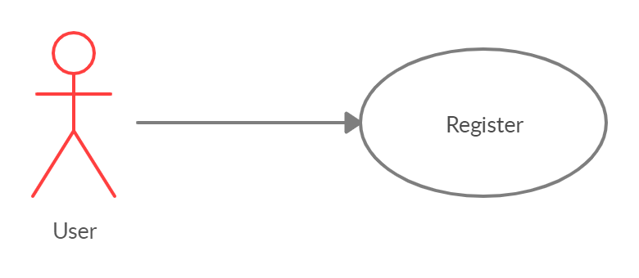

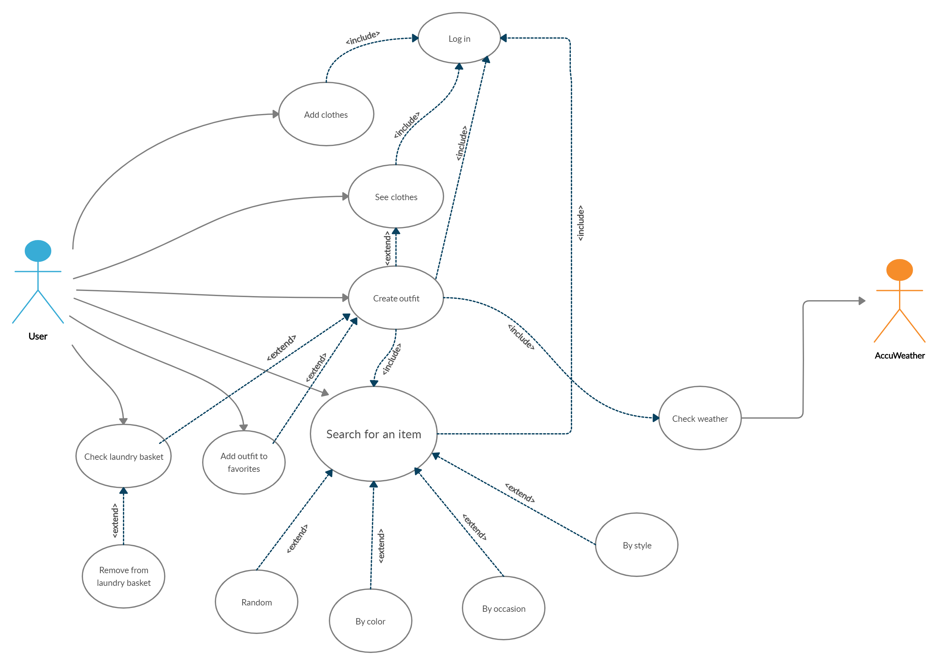
Fig.6.1. Use Case Diagram

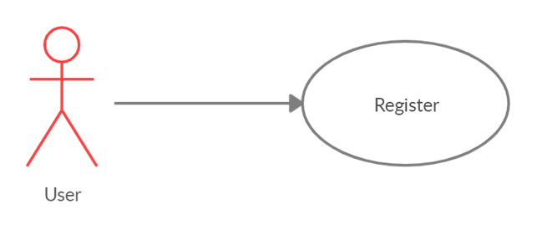

Fig.6.2. Register Use Case Diagram

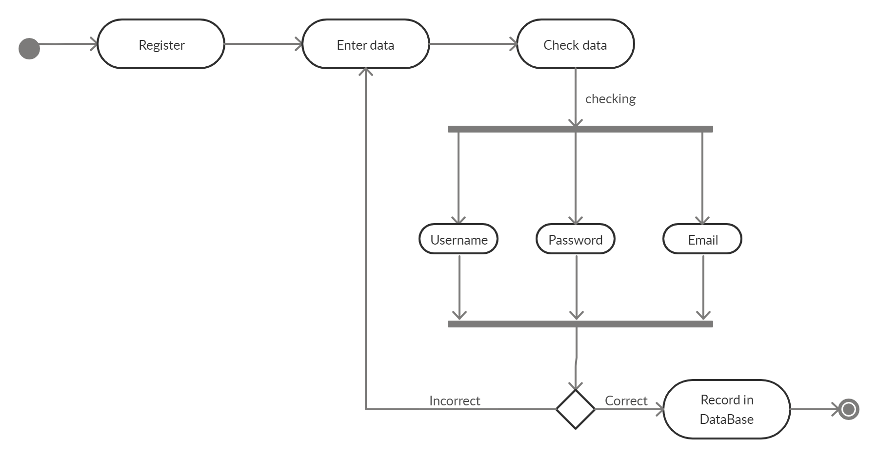
Fig.6.3. Register Activity Diagram
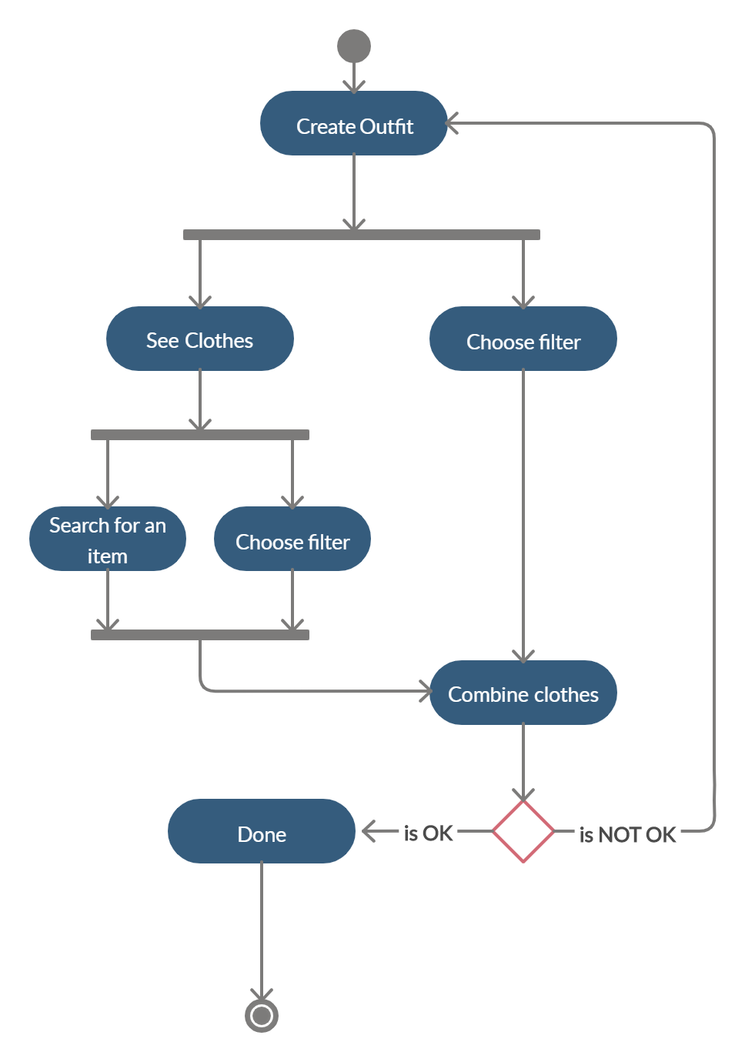
Fig.6.4. Create outfit Activity Diagram
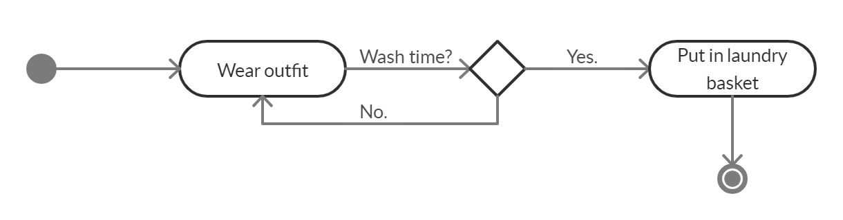 Fig.6.5. Laundry basket Activity Diagram
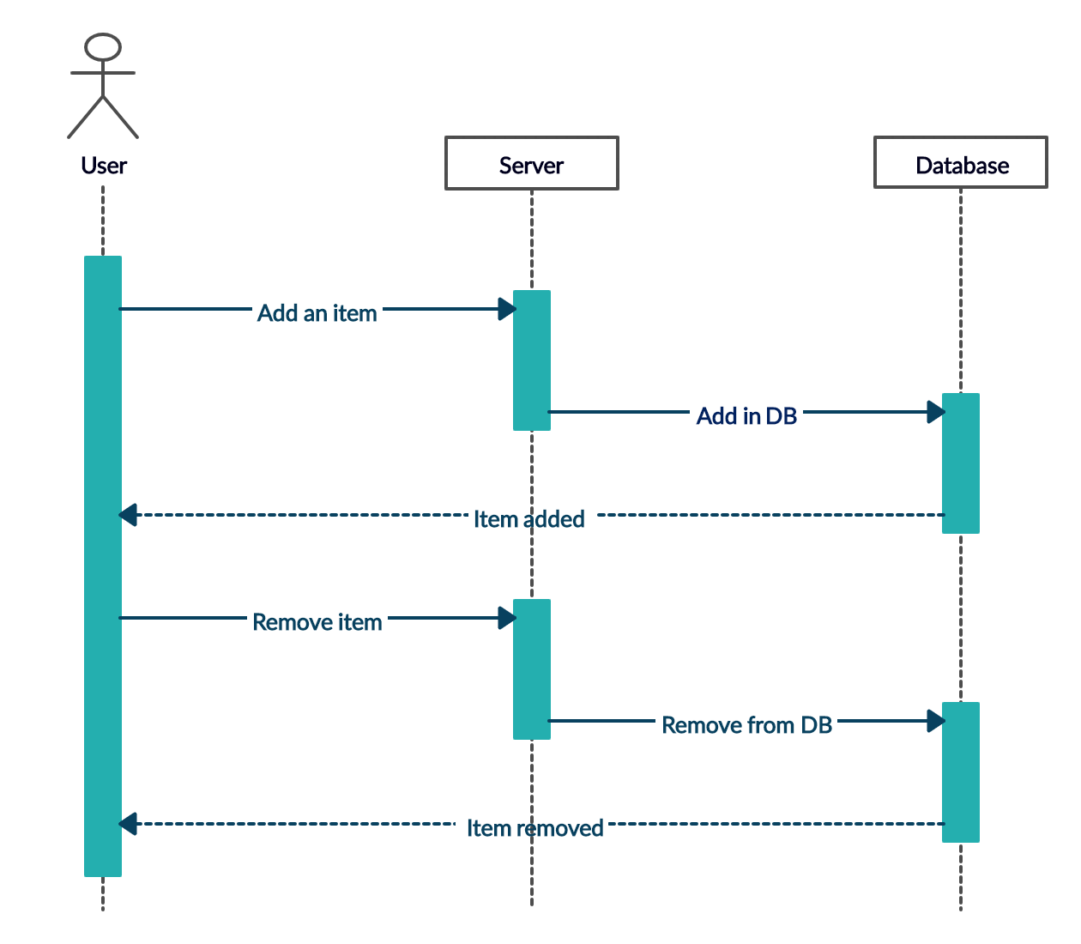
Fig.6.6. Add piece of clothing Sequence Diagram
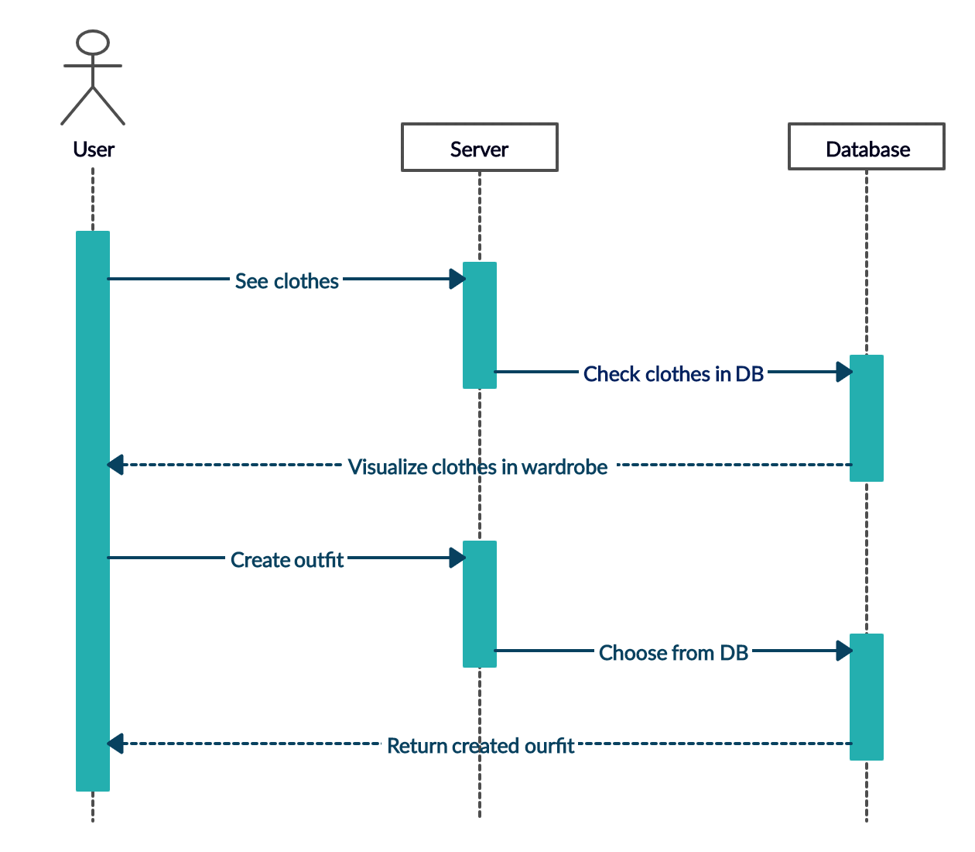
Fig.6.7. Create outfit Sequence Diagram
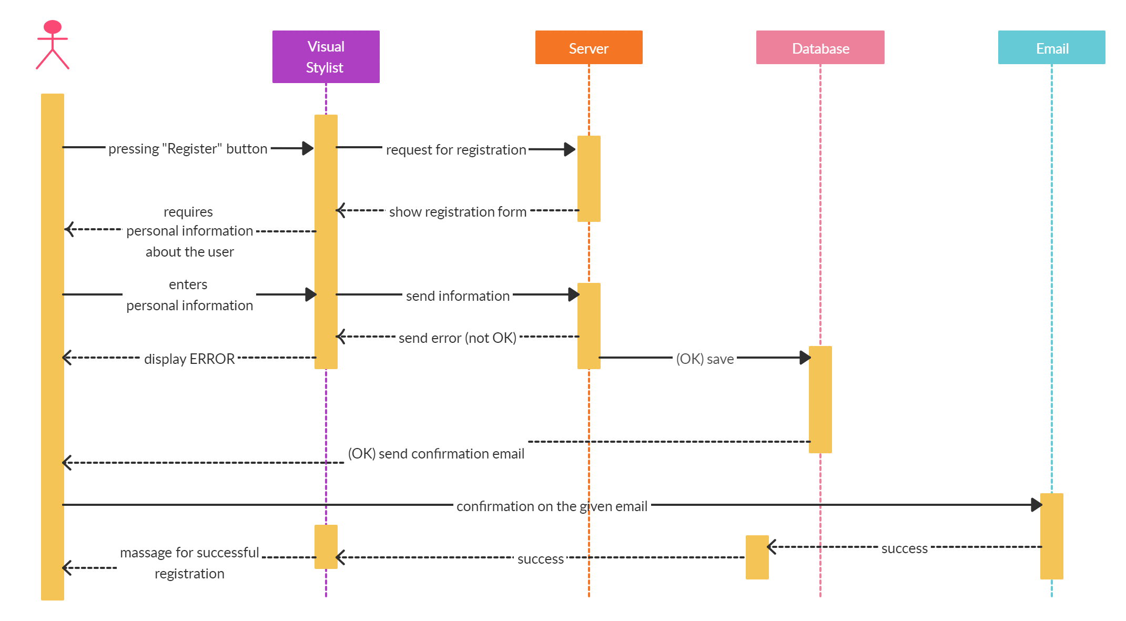

Fig.6.8. Register Sequence Diagram
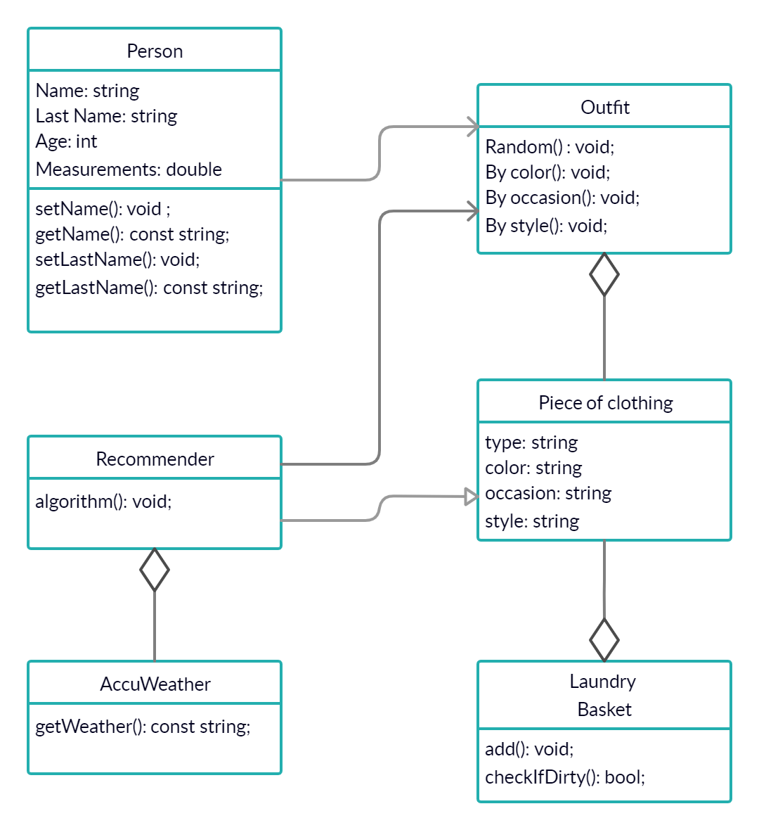

Fig.6.9. Class Diagram

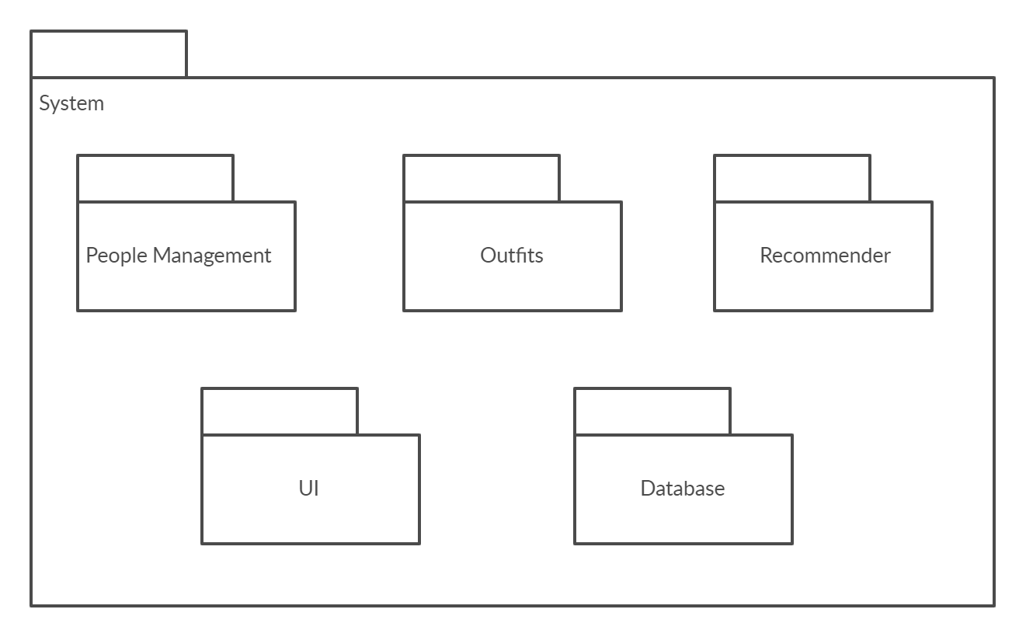
Fig.6.10. Package Diagram

