

1. Create a GitHub account   
   **\*Note: ma’am naka-gawa na po kami dati pa ng github account po kaya eto na lang screenshot ko po\***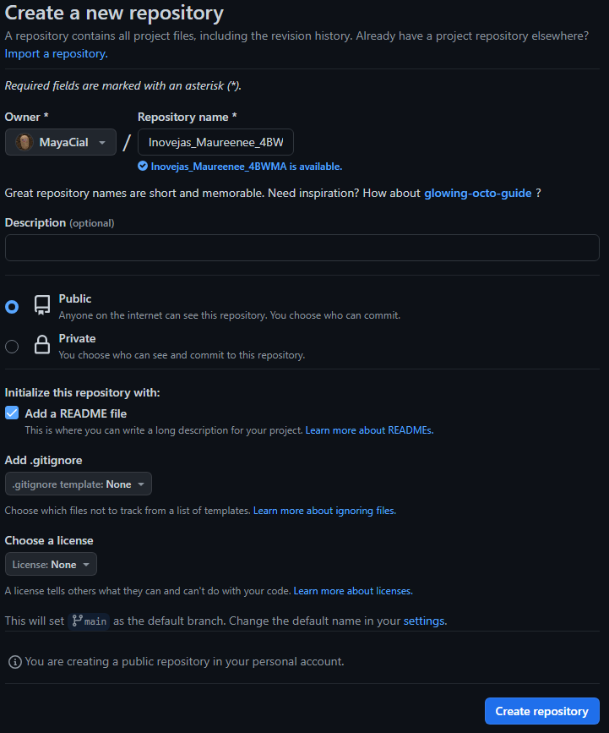









1. Create a repository name, make a short description, should be public and check README



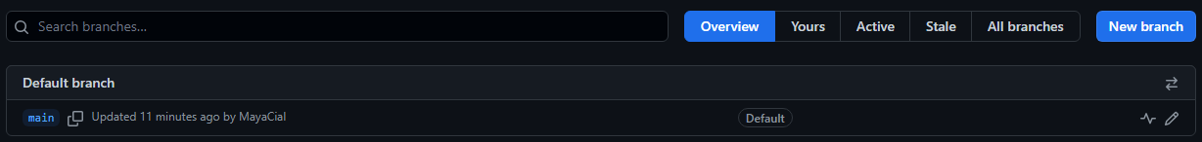



1. Click new branch, Branch name will be September 22 2023 IPT2 Activity then create new branch

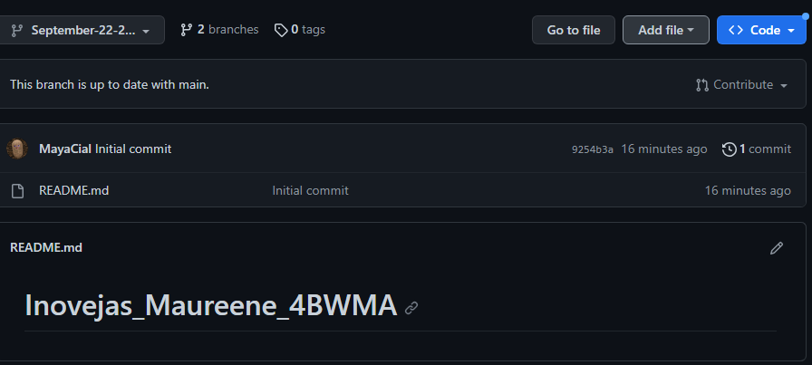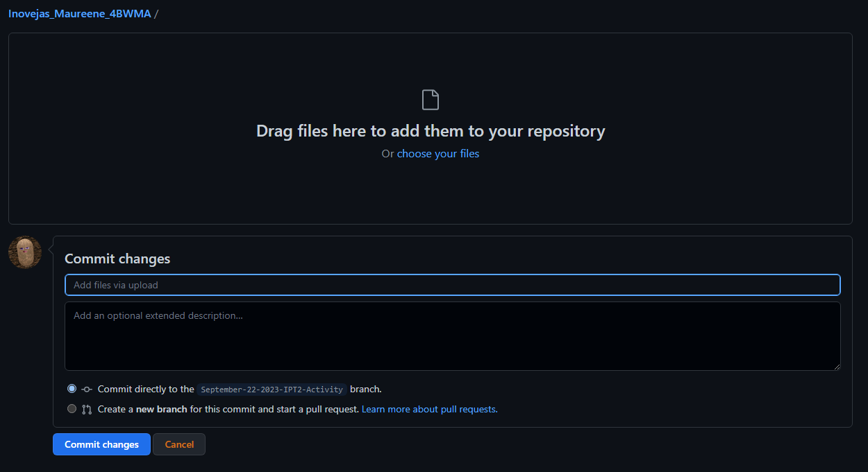



1. Add file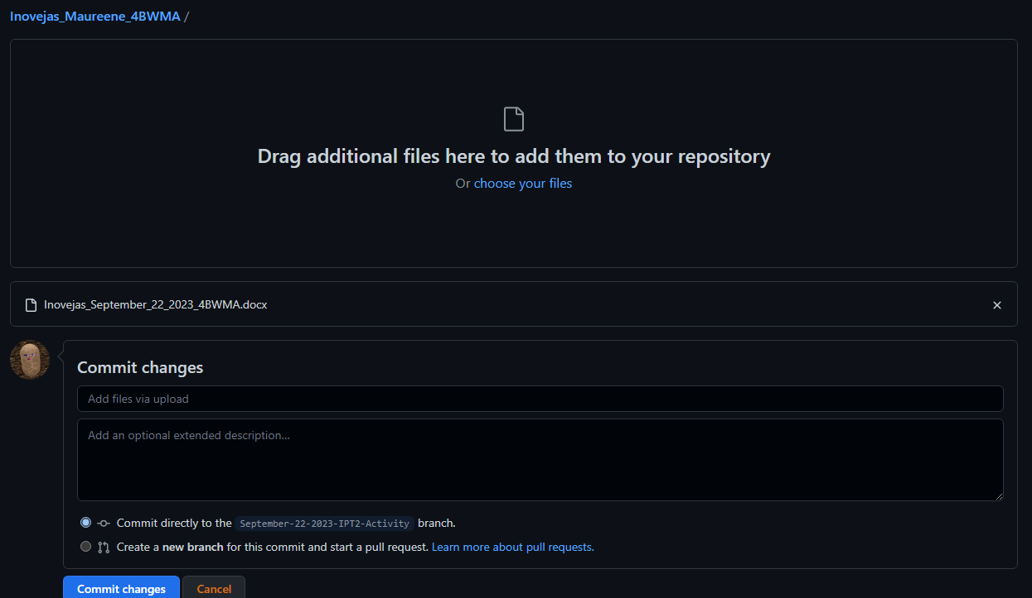

4. Add File