**GREENHOUSE GAS FLUXES IN URBAN WETLANDS: LARGE SCALE METHODS AT SMALL SCALES.** M. Croome1, A. Kessler2 and 3R. Reef, 1Monash University (mcro0015@student.monash.edu), 2Monash University ([adam.kessler@monash.edu](mailto:adam.kessler@monash.edu)), 3Monash University ([ruth.reef@monash.edu](mailto:ruth.reef@monash.edu)).

**Introduction:** Urban wetlands are critical ecosystems and play significant roles in carbon sequestration and climate regulation in built up areas (Mitsch and Mander 2018). They are frequently built into streams, and stormwater drains as passive water quality remediation (Scholz and Lee 2007). While providing a natural environment optimal for the storage and sequestration of atmospheric carbon dioxide (CO2), these wetlands are also substantial greenhouse gas (GHG) sources, particularly of CO2 and methane (CH4) (Mitsch and Mander 2018). There are many uncertainties around the seasonality and scale of CO2 and CH4 emissions from wetlands. Additionally, flux determinants, including a range of environmental factors such as water temperature and wind speed, and their relative importance vary significantly from wetland to wetland, yet remain largely unmonitored (Delwiche et al. 2021). To clarify future carbon budgets, a greater understanding of the role of urban wetlands in the global carbon cycle is needed.

Two main sampling methods are used to assess GHG fluxes in urban wetlands. The first method utilises conventional sampling techniques, including the use of flux chambers and discrete concentration measurements. These methods can be time and labor intensive, and offer only a limited representation of ecosystem scale fluxes. The second is eddy covariance (EC), a micrometeorological technique that measures energy and mass fluxes between the Earth and the atmosphere across a range of spatial and temporal scales (Rodrigues et al. 2024).

In this study, CO2 and CH4 fluxes in an Urban Wetland in Melbourne, Australia were measured using a combination of conventional sampling techniques and measurements from an EC tower. The aims of this research were: 1. To assess the ability of EC to deliver precise ecosystem scale CH4 and CO2 flux measurements, and 2. To assess the potential factors that determine CH4 and CO2 fluxes in urban wetlands.

**Methods:** Princess Freeway Melbourne Water Retarding Basin on Troups Creek is a Melbourne Water-managed Urban Wetland in Narre Warren, in South East Melbourne. To assess the fluxes of CO2 Troups Creek, an EC tower was deployed for six weeks, from the 17/02/2025 until the 07/04/2025. During this time, seven manual sampling trips were taken to record concurrent flux data using conventional sampling techniques. During these trips flux data was sampled using a flux chamber. Water quality parameters (pH, dissolved oxygen, electrical conductivity, and water temperature), chlorophyll, nutrient levels (APN), carbon isotopes, and total suspended solids (TSS) were all measured during these trips to provide information on flux determinants at Troups Creek.

**Results:** Using python, select flux and environmental data recorded by the EC tower was analysed to assess correlations and potential influence of CO2 efflux at Troups Creek.

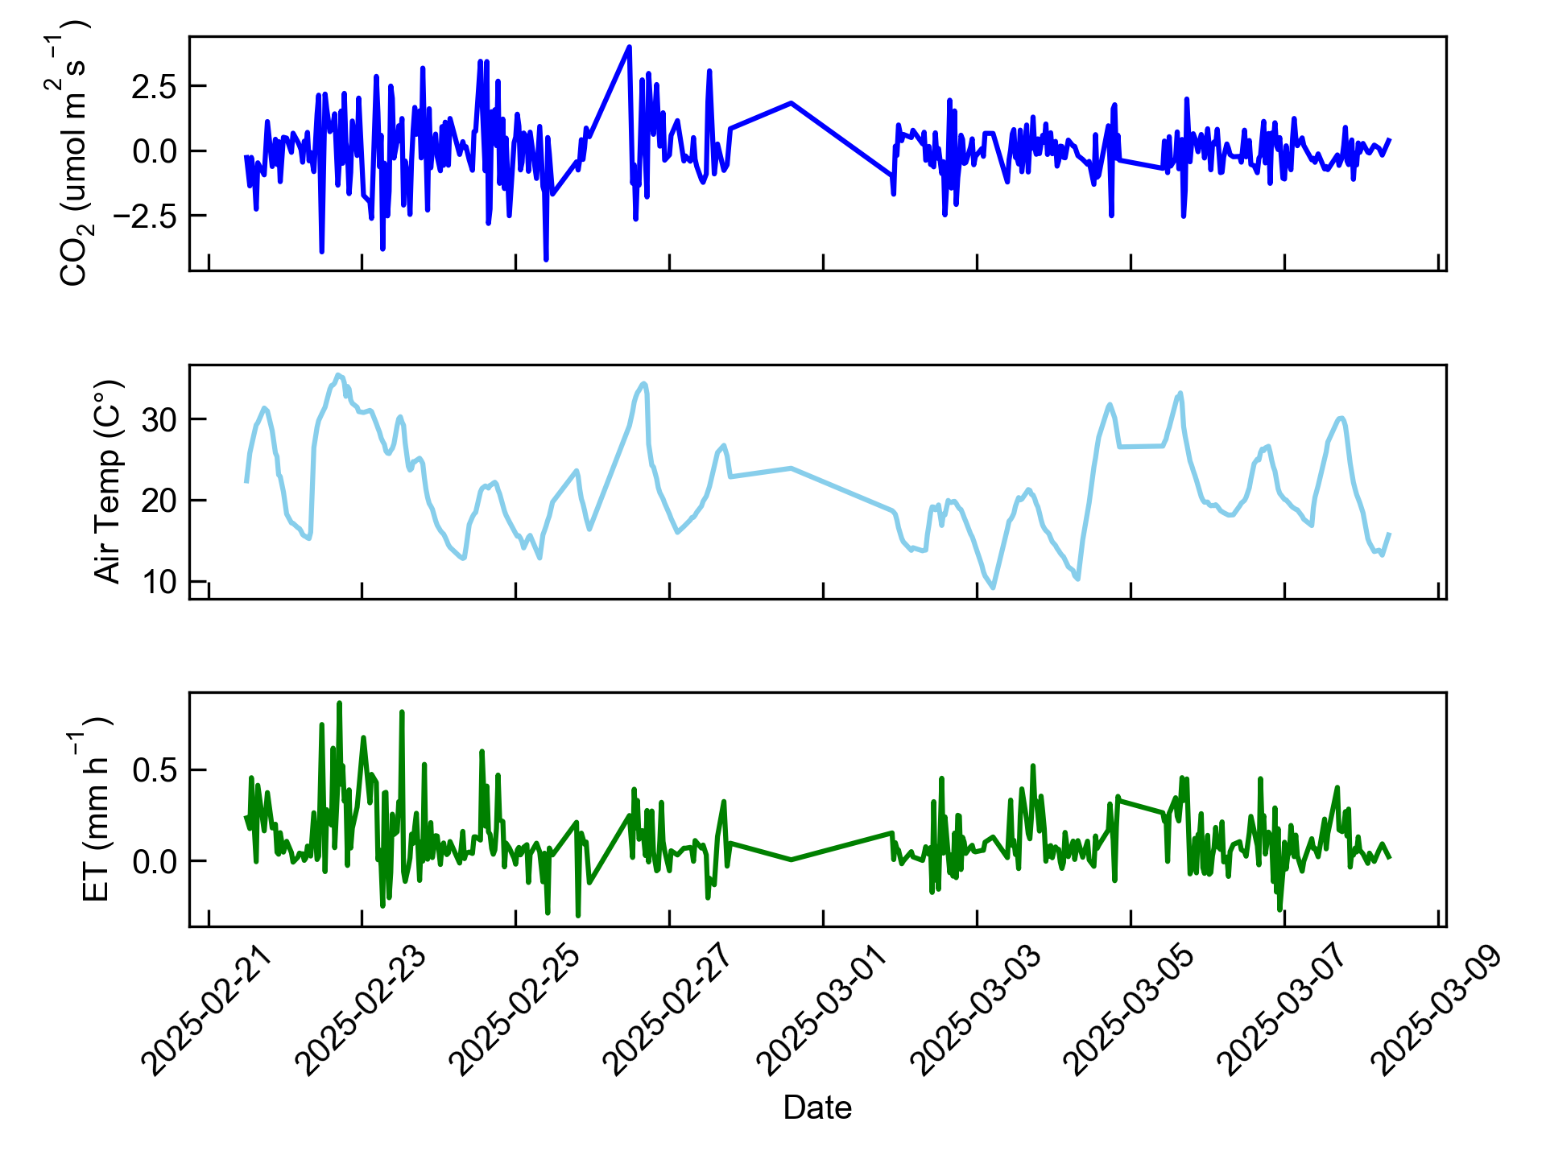

Figure 1: Timeseries of CO2 flux, air temperature, and evapotranspiration (ET) from the EC tower over the period 21/02/2025-08/03/2025.

Raw flux data from the EC tower (CO2 and ET) was noisy (Figure 1). Trends were difficult to assess without further analysis.

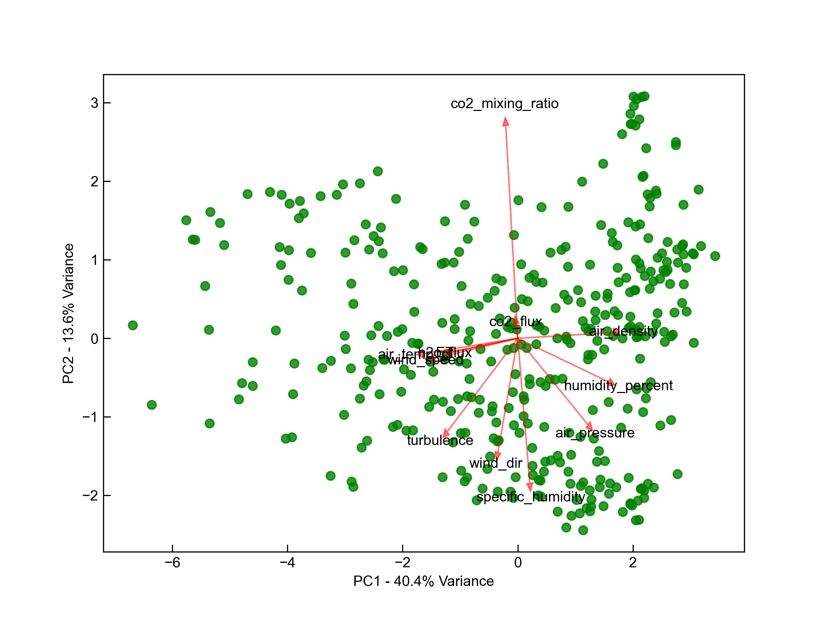

Figure 2: Principal component analysis of EC data for the variables CO2 flux, H2O flux, wind speed, wind direction, turbulence, air temperature, air pressure, ET, relative humidity, CO2 mixing ratio, and air density.

The PCA analysis in figure 2 revealed a strong correlation between CO2 flux and the CO2 mixing ratio. CO2 flux is not likely correlated with air temperature, wind speed, H2O flux, ET, or air density. There is likely a negative correlation between CO2 flux and specific humidity, wind direction, and air pressure. The PCA also suggests a weaker negative correlation between CO2 flux and turbulence and relative humidity.



Figure 3: panels a) and b) depict Windrose plots for CO2 flux and windspeed respectively. Panel c) shows the correlation between CO2 flux and windspeed (correlation coefficient r = 0.049).

The wind rose plots show that the majority of wind is coming from the south easterly direction. The fastest winds are coming from the directly north of the tower (Figure 3, panel b). Correlation between wind speed and CO2 flux was low (r=0.049), suggesting the variance in flux measurements cannot be explained by wind speed. This is consistent with the PCA plot in figure 2.

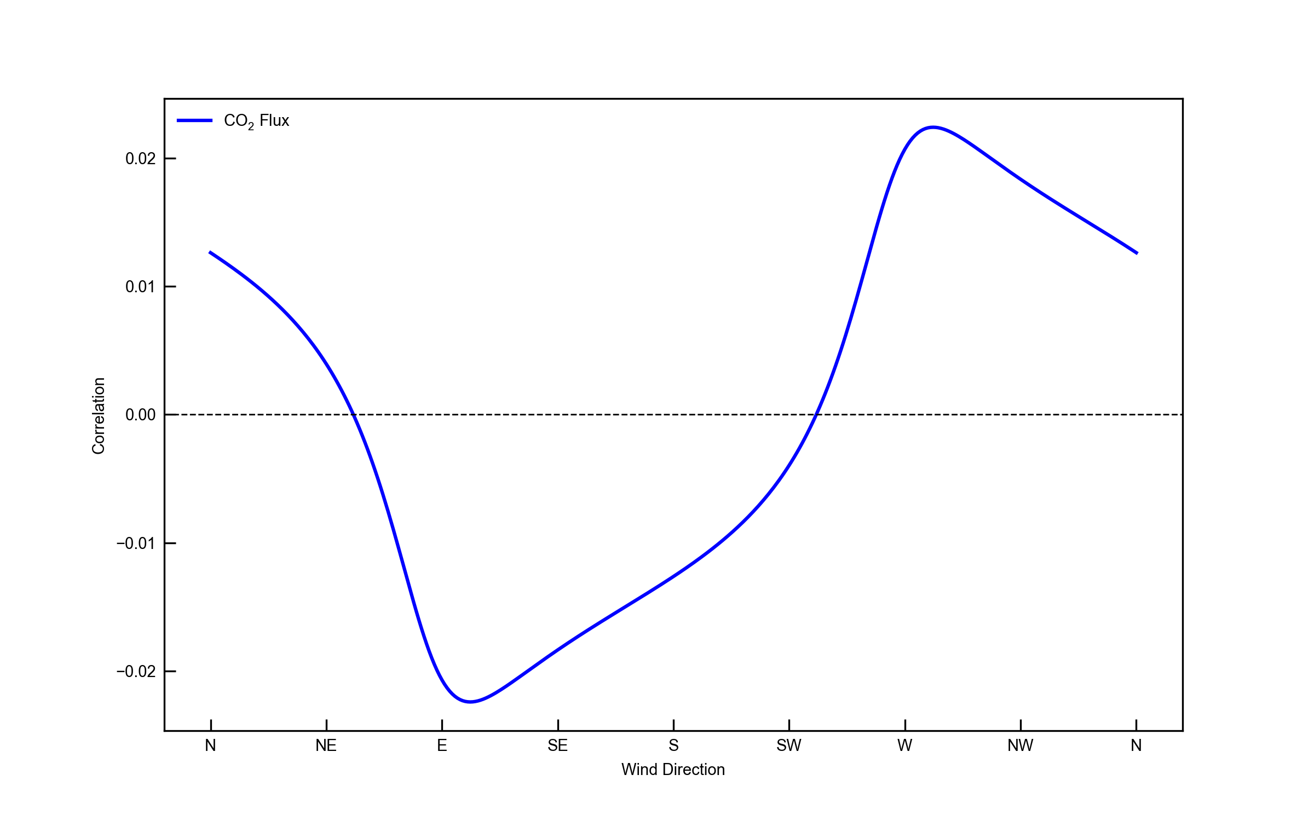

Figure 4: Correlation between wind direction and CO2 flux.

Correlation between wind direction and CO2 flux was found to be low. Figure 4 shows that Easterly/south easterly winds bring negative CO2 fluxes. The area east/southeast from the EC tower is predominantly grass, suggesting that the CO2 signal from these directions is dominated by photosynthesis from the grass. This implies that the signal from the water (directly north and south) is low.

**Discussion:** The correlation between wind direction and CO2 flux was measured to determine if an area outside of the wetland was being overrepresented in the data collected by the EC tower. There was a weak negative correlation between easterly winds and CO2 flux, and no correlation in the north/south direction suggesting that production or consumption of CO2 from the direction of the open water is less important than from the surrounding vegetation. This larger study is interested in the fluxes for the net system, including surrounding vegetation

Wind speed did not correlate with CO2 flux at Troups creek, in contention with findings by Morin et al. (2018) who found a strong correlation between wind speed and flux using EC at a freshwater lake. A potential reason for this disparity could be explained by the seasonal and spatial variation in key CO2 flux drivers (Mitsch and Mander 2018). The lack of comprehensive flux data from urban wetlands in Australia, but also globally make it difficult to apply preexisting trends to data collected at Troups Creek (Delwiche et al. 2021) To fully understand the drivers behind CO2 efflux at Troups creek further analysis of other environmental variables collected through EC and conventional sampling techniques is required.

**Data Availability:** Data can be found at: <https://doi.org/10.5281/zenodo.15108343>

**Code Availability:** Code used to generate the plots in this extended abstract can be found at: <https://doi.org/10.5281/zenodo.15108343>

**Acknowledgements:** I would like to thank Adam Kessler and Ruth Reef for their assistance in deploying the EC tower, collecting the data from the tower, and assisting in data interpretation for analysis.

**References:** [1] Mitsch W. J. and Mander U. (2018) *Ecological Engineering, 114*, 1-6. [2] Scholz M. and Lee B. (2007) Constructed Wetlands: A Review, *International Journal of Environmental Studies, 65,* 421-447. [3] Delwiche K. B. et al. (2021) *Earth System Science Data, 13*, 3607–3689. [4] Rodrigues C. C. F. et al. (2024) *Journal of Marine Systems, 243,* 103949. [5] Morin T. H. et al. (2018) Carbon Dioxide Emissions from an Oligotrophic Temperate Lake: An Eddy Covariance Approach, *Ecological Engineering, 114*, 25-33.