Iteration 5

CIS 320-01

Team: Insight Architects

Alexis De Jesus, Becca Gossett, Yogesh Timshina, Stuti Khatiwada, Maya Harden

Table of Contents

1. Class Diagram 3

1.1 Class Diagram Narrative 3

1.2 Class Diagram 6

2. Database Design 7

2.1 Database Diagram Narrative 7

2.2 Database Diagram 8

2.3 Database Definitions 10

3. User Interface Design 19

3.1 User Interface Diagram Narrative 19

3.2 User Interface Navigation Diagram 20

3.3 Screen Layouts 20

3.3.A Data Capture Forms 20

3.3.B Data Presentation 25

4. Gantt Chart 30

4.1 Gantt Chart Narrative 30

4.2 Gantt Chart 31

5. User Interface Prototypes 33

5.1 Use Case 6: Conduct Background Checks 33

5.2 Use Case 9: Direct to the Interest Form 33

5.3 Use Case 15: Submit Donations 34

5.4 Use Case 18: Manage Calendar Entries 35

5.5 Use Case 22: Add Contact to Mailing List 36

5.6 Use Case 28: Manage Fundraising Campaigns 36

5.7 Use Case 33: Visit on Multiple Devices 37

# Class Diagram

## 1.1 Class Diagram Narrative

The following Class Diagram shows all the necessary and major classes needed for our website. This diagram contains relationships, functions, connectivity, and attributes for the classes in this system. The best place to start in this diagram is the colored classes specifically the green User class. In the center, the User class is all users (limited access user and administrator/client) that have access to all tabs on a website which are the volunteer stories and opportunities, contact form, the donation widget, newsletter, and fundraiser. The yellow classes are the sub/child classes of the User class which are Limited Access User and Administrator/Client which are located in the center. These subclasses will have all of the User attributes as well as their attributes that the other subclass can’t have. The grey classes are also parent classes that have their subclasses; these classes are the Interest Form Widget, Volunteer, Contact, Donation Widget, Newsletter, and Content Management System.

Starting in the top left, the Administrator/Client and Limited Access User class have relationships with the Interest Form/Google Form which is a subclass of the Interest Form Widget. The Administrator/Client can create an interest form/Google Form, then post the form’s URL to the Interest Form Widget. A Limited Access User is a user intending to become a volunteer, so there will be a relationship between this class and the Google Form class. A Limited Access User will be able to fill out and submit an interest form/Google Form. The Admin/Client will also be able to view interest form submissions and conduct background checks for Limited Access Users who want to become a volunteer.

As mentioned before, the User (parent) class has access to all tabs on a website. The Volunteer parent class contains Volunteer Story and Opportunity subclasses that a user can access; a user can read Volunteer Stories and view Volunteer Opportunities. Specifically, the Opportunities class associated with the Interest Form/Google Form which integrates with the Google Form. Users can fill out a Contact Form which will be submitted to the Admin/Client who has access to view requests and respond to submitted requests.

Moving toward the right side of the diagram, the Donation Widget integrates to Helcim when a User clicks this widget. The Helcim class also connects to the Fundraiser class that Users can visit. In contrast, the Admin/Client manages the Fundraiser page conveying information regarding campaigns and users can integrate to Helcim.

Users and Admin/Client have relationships with the Newsletter class. The Newsletter will send updates of the organization to all subscribed users. A User can subscribe to this Newsletter and their contact information will be stored in the Mailing List which is a subclass of the Newsletter. The Admin/Client has a relationship with the Mailing List; the Admin/Client manages the Mailing List, updating this list if it is needed.

The Admin/Client manages the Content Management System class (parent) of the subclasses Social Media Widget, Device Layout, and Analytics Widget showing the relationships between all five classes located in the bottom left. Through the Admin/Client, the CMS manages the Social Media Widget which will allow integration into a social media platform. The CMS class has a relationship with the Analytics Widget; the CMS handles data and the integration of the Analytics Widget. Lastly, the Device Layout is the different ways the website and content are presented on different devices, so in this case, the CMS class controls the Device Layout class. As said, the Device Layout class will be able to display content on different devices, so it will have relationships with the Volunteer Story and Opportunities. The Device Layout can display both the Volunteer Story and Opportunity classes.

Lastly, the Admin/Client class can provide information on Worth the Words in the About class giving a brief summary of the Organization and our Client.

Constructing this class diagram took teamwork from the whole team. The class diagram itself was derived using noun/verb analysis. First, we created all the system requirements using all the possible information each member found for our system, then using these requirements we created our use cases which used the verb/noun format (Create Interest Form). The classes were established using all the nouns that were in each use case. After gathering all the classes, they were given assigned attributes. The methods (operations) each class has were established from the verbs from the use cases. Using the operations, relationships will form describing the association between classes. As the diagram kept forming and getting larger, attributes were added to the table if it was needed. There were a few problems when building this diagram; some classes and their attributes had to be either removed or done again due to some classes having incorrect attributes, classes that weren’t relevant, and required associations that weren’t included. Though this is only the first draft of the class diagram, we will make changes over time using the comments from our project sponsor and add the changes to our Elaboration Phase Specification.

## [Class Diagram](https://lucid.app/lucidchart/e7bba53b-a72c-46f2-ad47-894314ea2b97/edit?crop=content&page=0&signature=40aaac13099c8e69736488e244b61c42c018f25b4a89d0fe41395351f049461a)1.2 Class Diagram

# Database Design

## 2.1 Database Diagram Narrative

The database design for Worth the Words is built to organize and manage all the important data the system needs to function. We included key entities like Users, Administrators, Volunteers, Newsletter Subscribers, and Fundraising Campaigns, making sure each table has all the necessary attributes to support their roles. This design focuses on keeping the data accurate and making everything run smoothly. We made sure the relationships between tables reflect how different parts of the system work together. For example, Users are connected to Volunteer Opportunities so they can view and apply for roles. Similarly, the design integrates with tools like Helcim for donations and Google Forms for interest submissions, ensuring everything works together seamlessly. The goal was to create a design that not only meets the project requirements but also makes it easy to manage user interactions and administrative tasks. Plus, we kept scalability in mind so the system can grow and improve over time.

## A diagram of a computer flowchart Description automatically generated2.2 Database Diagram

## 2.3 Database Definitions

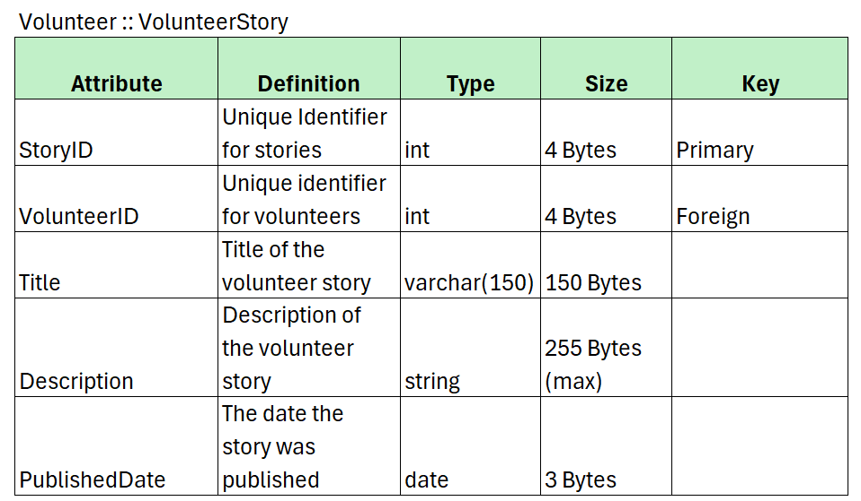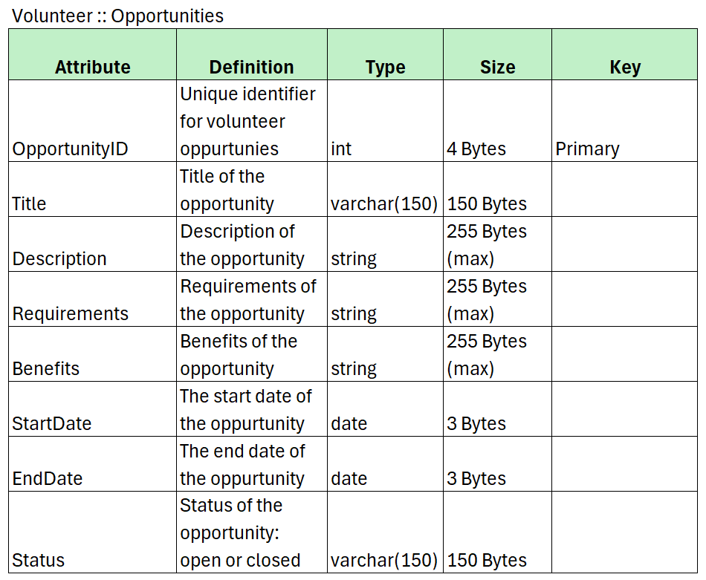

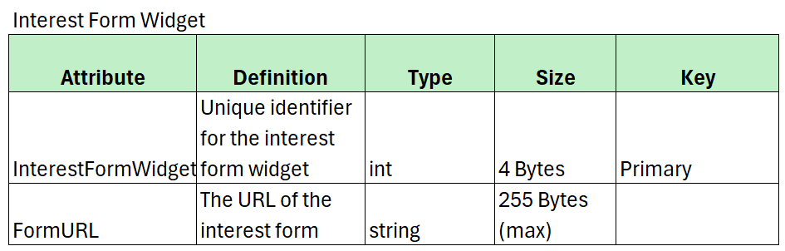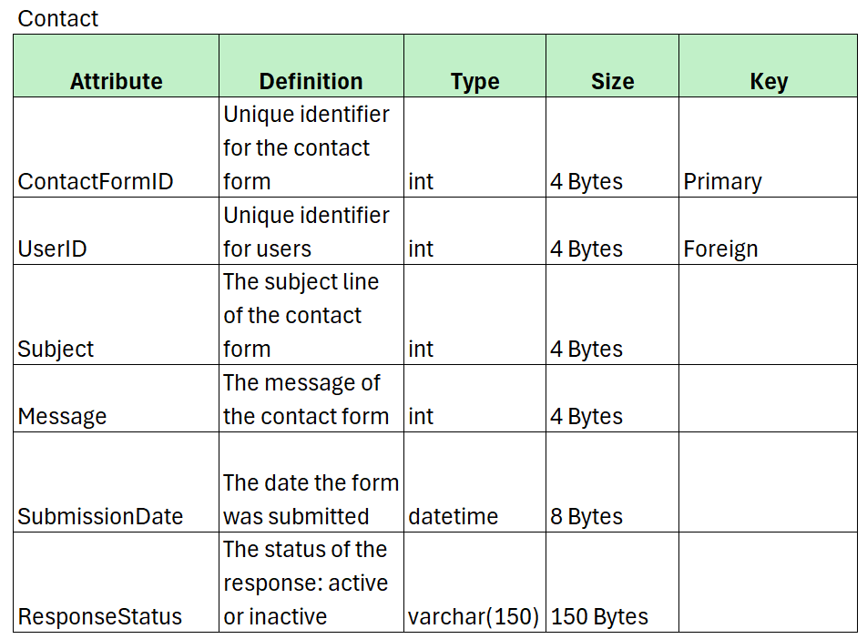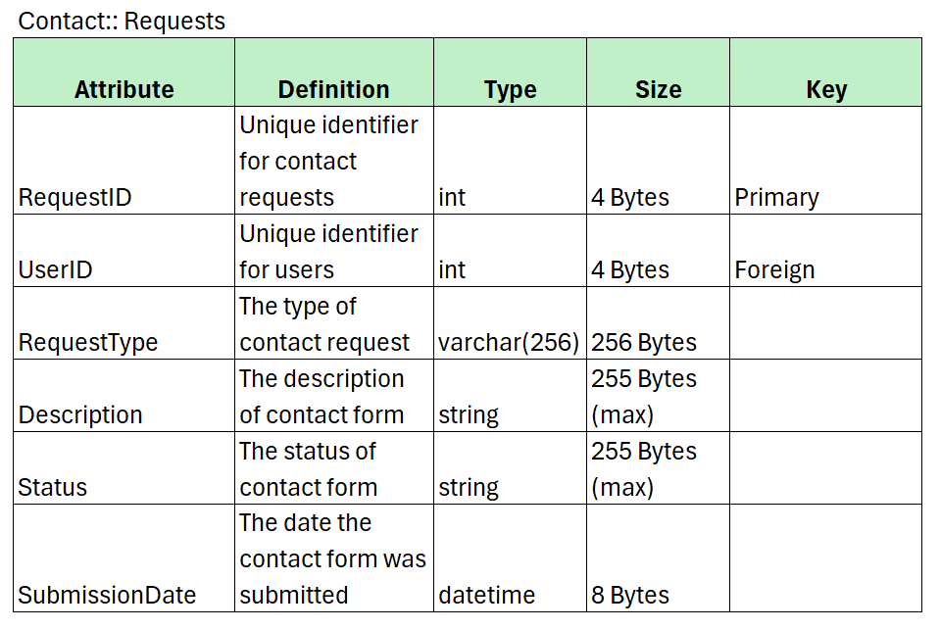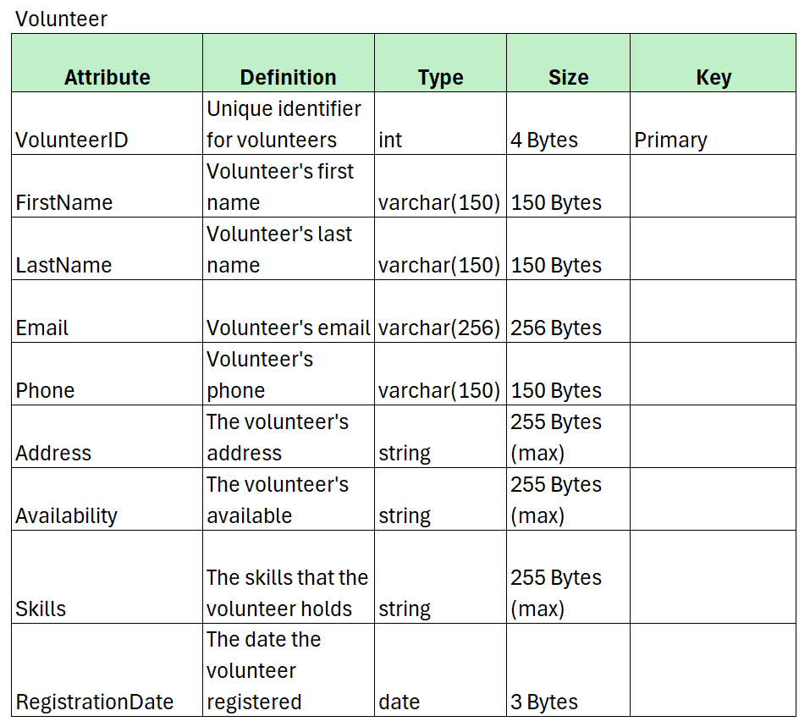

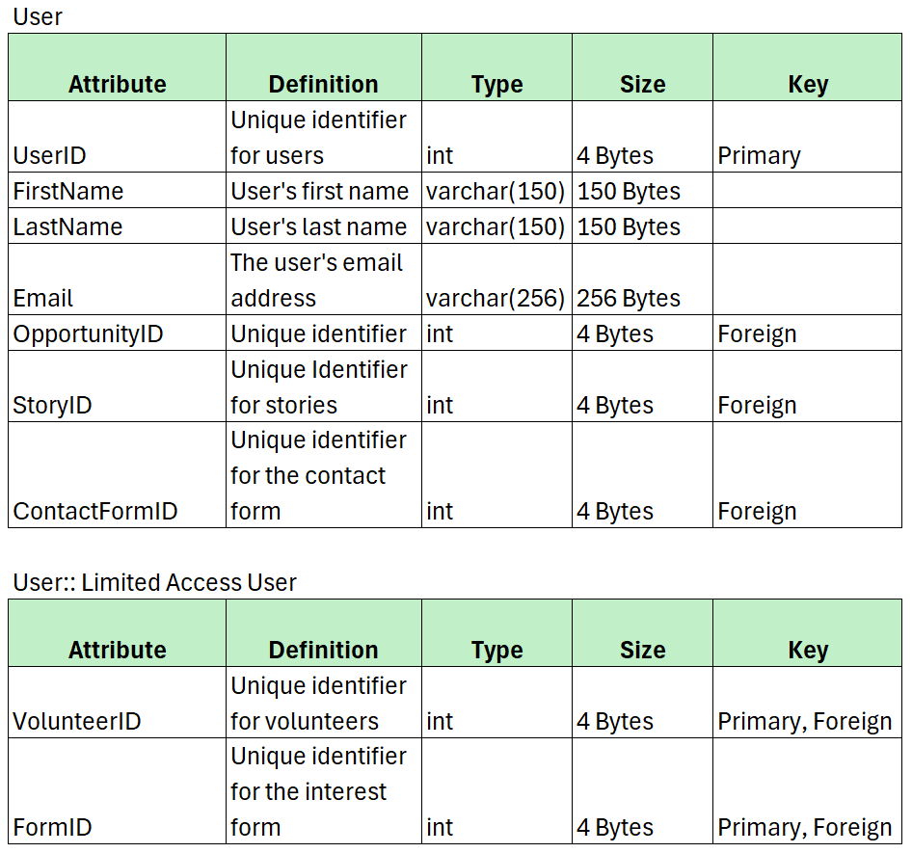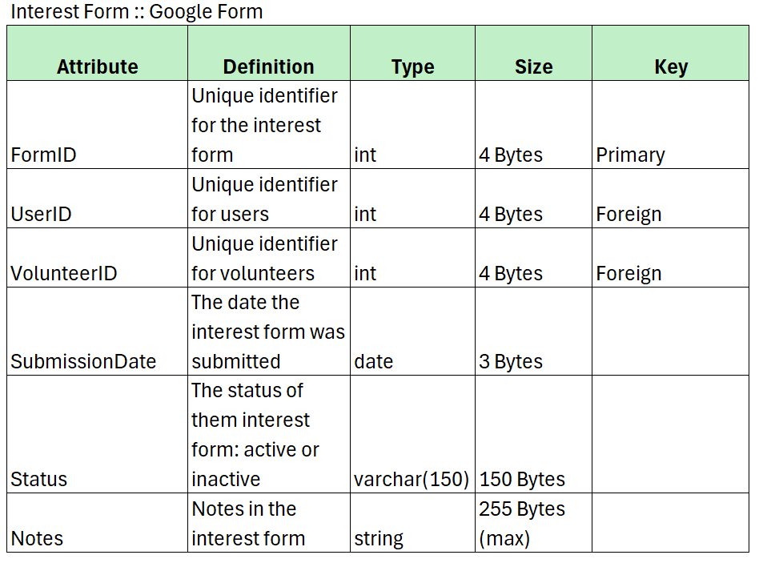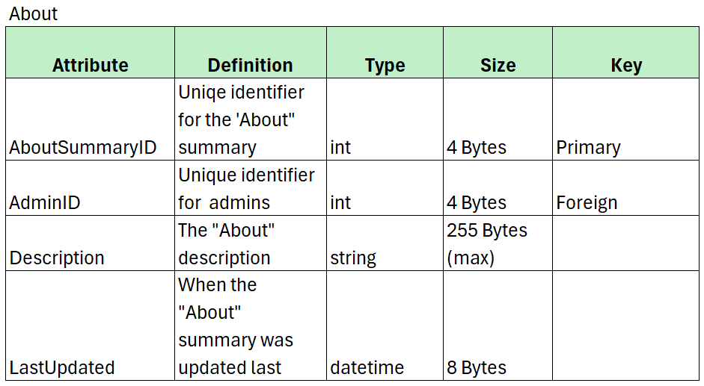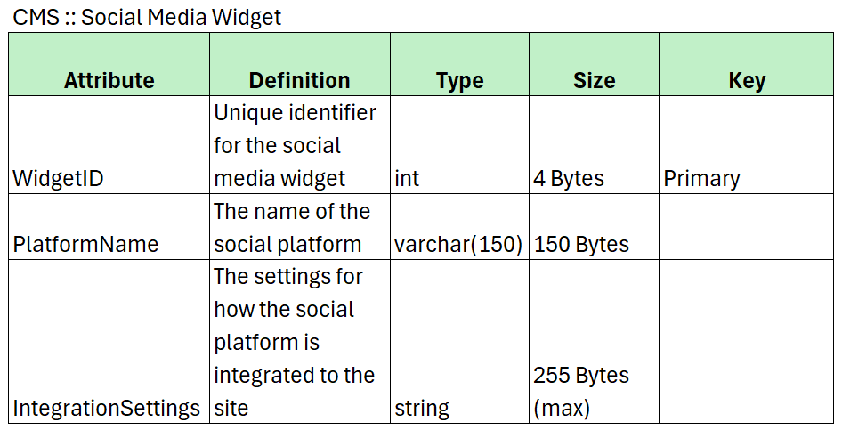

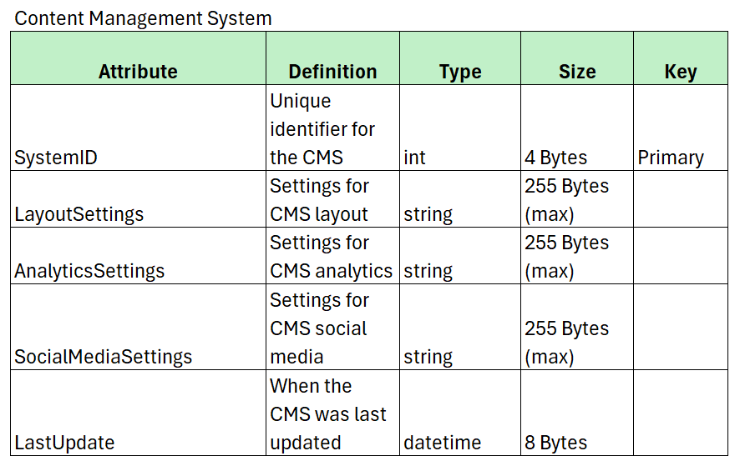

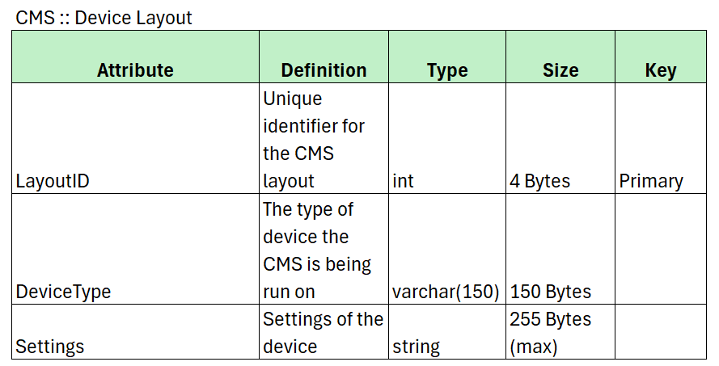

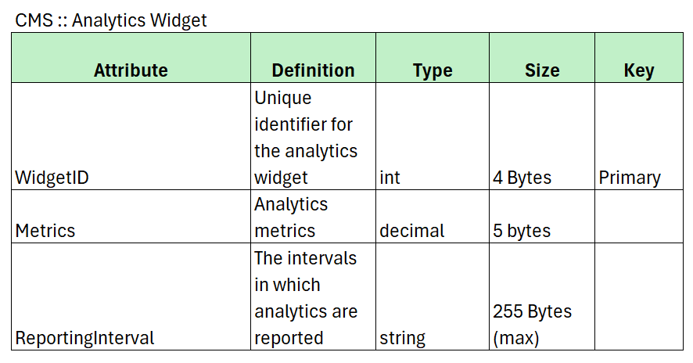

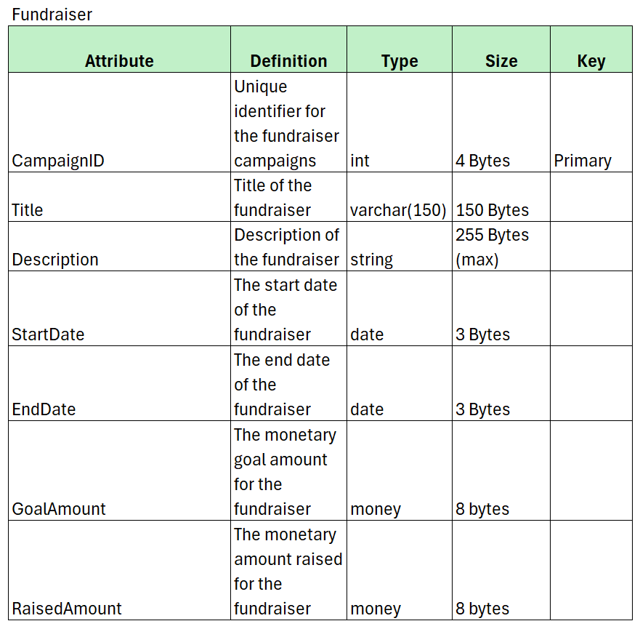

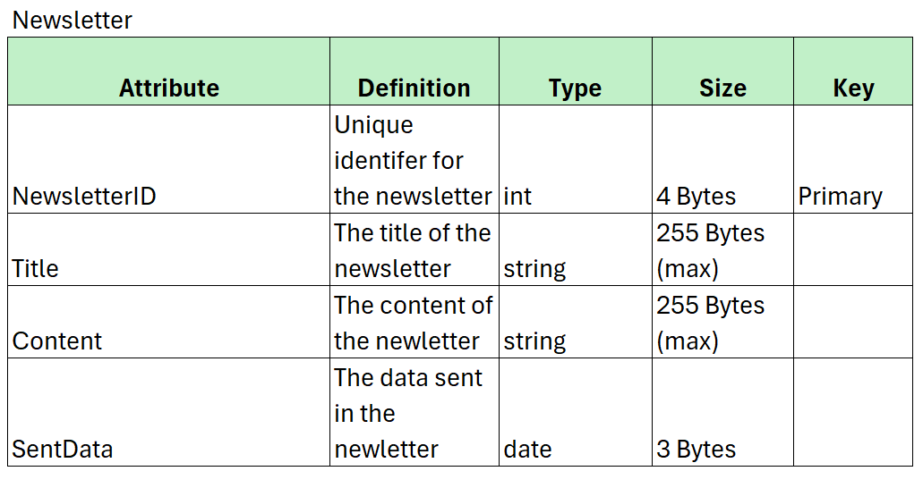

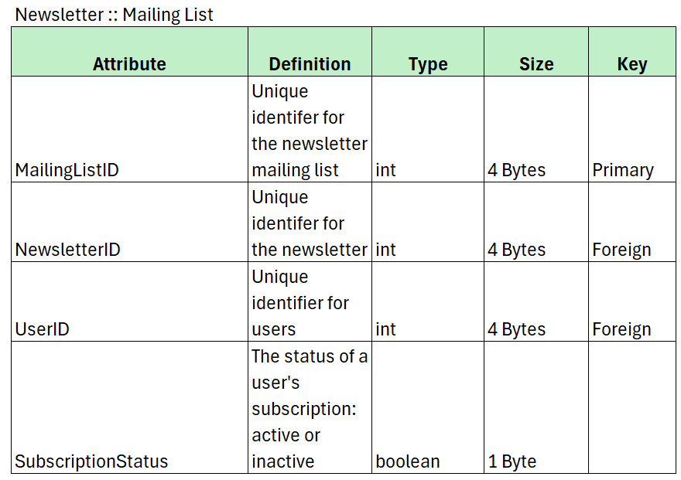

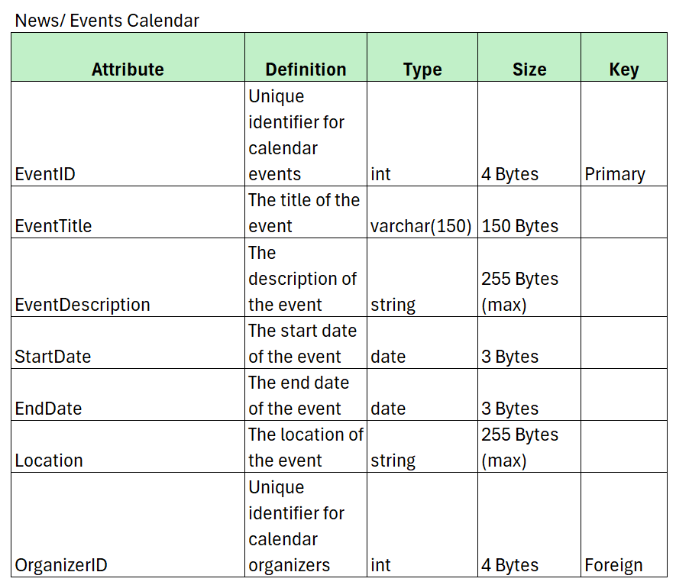

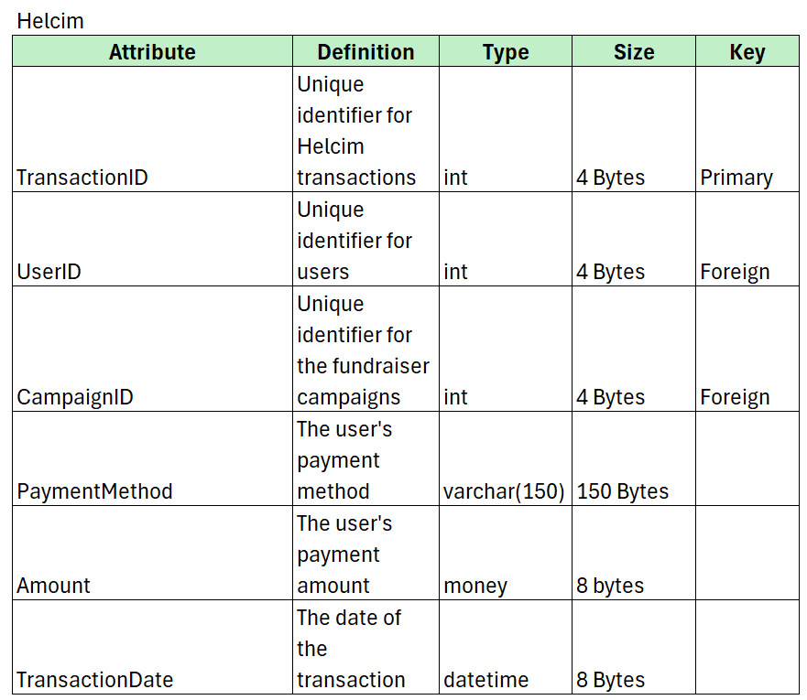

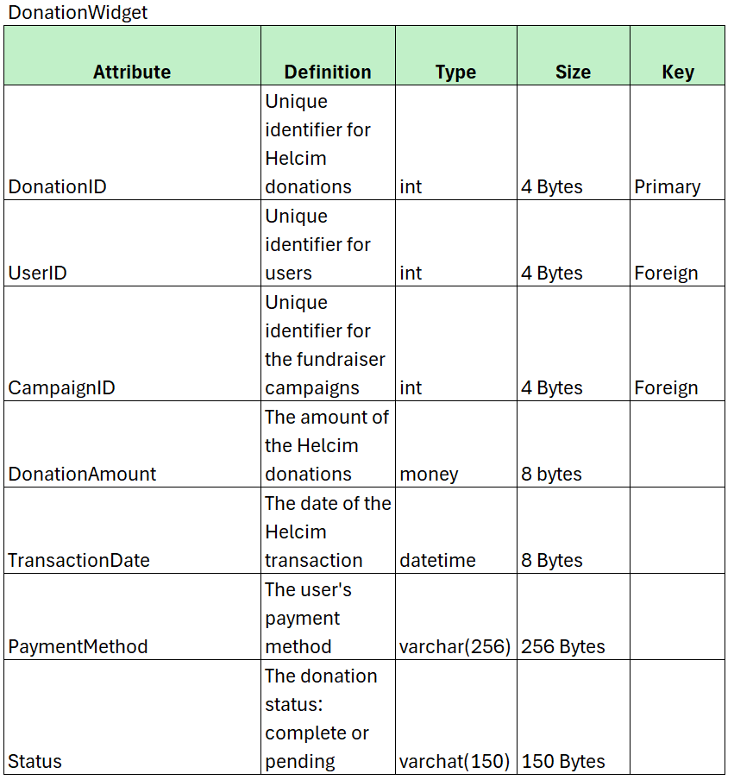

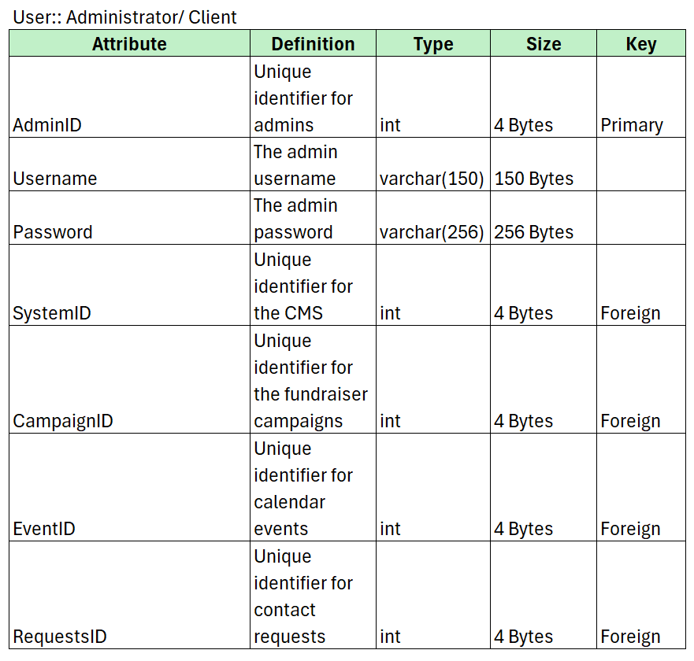

›

# User Interface Design

## 3.1 User Interface Diagram Narrative

This diagram portrays the movement a user of Worth the Words can take through the website. The elements within the “window” box are the main pages the user can begin at after being directed to them through a sub address or the header tabs on every page. Due to the “Donate” button and social media widgets being ubiquitously available, these main windows all directly link to these two elements. The transition from one <<window>> element directly to another should be interpreted as scrolling through the same page to a subsection.

## 3.2 User Interface Navigation Diagram

## 3.3 Screen Layouts

### 3.3.A Data Capture Forms

**Helcim**

This shows the displayed Helcim donation input that is accessed upon selection of the website’s Dontate button and the Fundraisers Page’s integrate widget. It includes a way to easily enter the payment amount, payment information, and billing address.

**Interest Form**

This is the interest form users will be presented with to apply to volunteer. It utilizes Google Forms to present relevant information at the top, followed by input boxes requesting information from the applicant. As noted at the start of the form, red asterisks mark data requests that the administrator deems to be required.

**Contact Form**

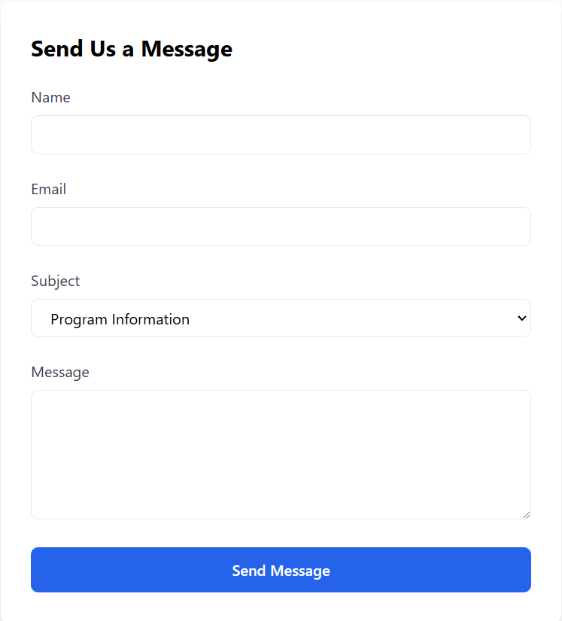

The Contact Form includes a series of input boxes directly integrated into the webpage to receive a user’s contact information for the administrator to later utilize, followed by the main message the user wishes to send. Data is captured following use of the Send Message button.

**Calendar Events**

The calendar accepts inputted events and their related date and locations. Visibility options are also present to manage who will receive this information once saved. Tasks can be edited to provide additional details or notes.

**Newsletter Subscription**

This form allows the user to provide contact information that they would like Worth the Word’s to send their newsletter to. Checkboxes for interests are provided so that users are able to specify what categories of letter they will receive. The final checkbox is consent for the reception of repeat emails and the ability to cancel in the future.

### 3.3.B Data Presentation

**Website Analytics**

WordPress’ “Jetpack Stats” provides the administrator with statistical data collected by the website through its use over periods of time. It allows for limiting the presented data chart to a range of time or a specific date.

**Received Interest Forms**

Google Forms presents all submitted forms and their information from users. Captured forms can be printed and deleted, and an overall counter of forms received is presented to the administrator. An additional function of ending requests is able to be toggled.

**Contact Request Inbox**

This is a simple inbox that allows the viewing of contact requests and their messages. Messages filtered to Spam or sent to Trash can be switched to via the tabs placed at the top.

**Posted Events**

This presents posted events and their placement on the calendar to website visitors. Users have the option to view a range of dates in a table display, as well as the category they fall under.

**Newsletter Subscriber List**

This table displays captured data from the Newsletter Signup, with checkboxes to manage the individuals, and columns to view their personal information, as wells as tags assigned for filtering.

# Gantt Chart

## Gantt Chart Narrative

A Gantt Chart is important in managing and monitoring a project’s progress. The following Gantt Charts below display the combination of I3 and I5 as well as I5 and Elaboration Specification Phase. The spreadsheets show each task and its starting and ending dates (duration), the members responsible for each task, and any dependencies that are required for certain tasks. The spreadsheet and chart allow our members to understand what roles/assignments they have, durations, and any dependencies.

Iteration 3 goes into the tasks for the Use Cases and their diagrams along with high-level prototypes. Iteration 5 specifically dives deeper into the bigger diagrams which are the Class, Database (database definitions as well), and User Interface Diagrams. This iteration also requires screen layouts and a user interface prototype. Also shown is the Elaboration Specification Phase which is the final phase of the project will bring everything that Insight Architects have worked on these four months into one last document which includes all use cases and their prototypes, class, sequence, and database diagrams to create one final product for our client.

## 4.2 Gantt Chart

**I3 and I5**

**I5 and Elaboration Phase Specification**

# User Interface Prototypes

## Use Case 6: Conduct Background Checks

## Use Case 9: Direct to the Interest Form

## Use Case 15: Submit Donations





## Use Case 18: Manage Calendar Entries

## Use Case 22: Add Contact to Mailing List

## Use Case 28: Manage Fundraising Campaigns

## Use Case 33: Visit on Multiple Devices

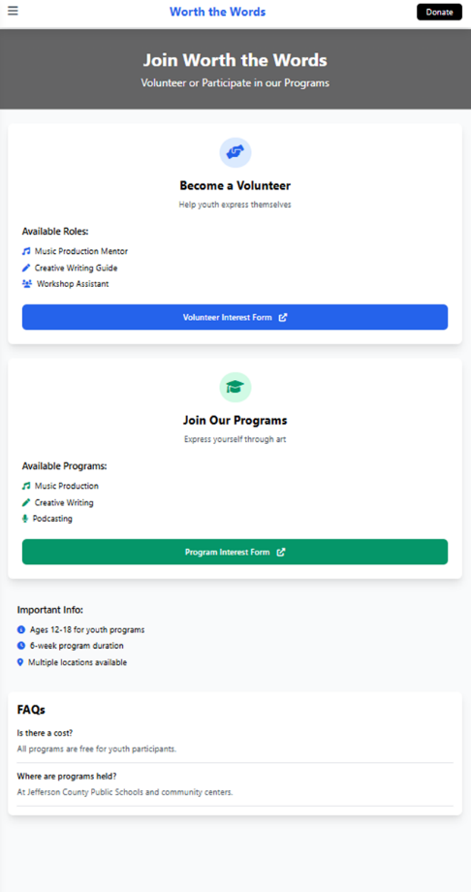

Dropdown Menu

