**Diabetes Data SQL Analysis**

1. Display any 10 random DM patients.

Query:

select "Firstname"||' '||"Lastname" as fullname

from "Patients"

order by random()

limit 10;

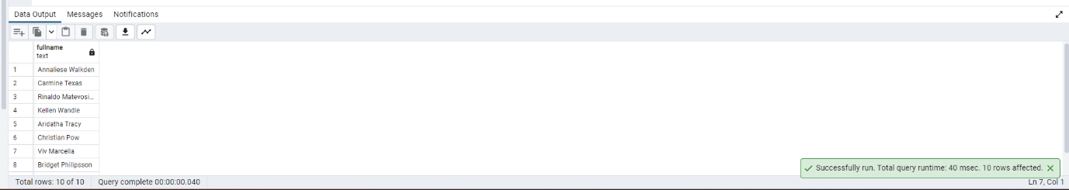

1. Please go through the below screenshot and create the exact output.

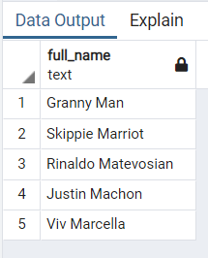

Query:

select "Firstname"||' '||"Lastname" as full_name

from "Patients"

where "Lastname" LIKE 'Ma%';

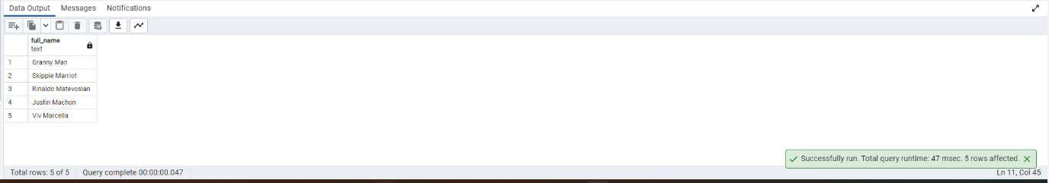

1. Write a query to get a list of patients whose RPE start is at moderate intensity.

Query:

select "Firstname"||' '||"Lastname" as fullname

from public."Patients" as p

join public."Walking_Test" as w

on p."WalkTest_ID" = w."WalkTest_ID"

where "Gait_RPE_Start " between 4 and 6;

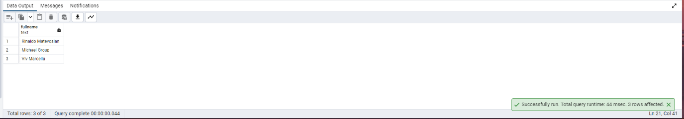

1. Write a query by using common table expressions and case statements to display birthyear ranges.

Query:

WITH birthyear_range as (

select "Patient_ID", (DATE_PART('year',"Visit_Date")-"Age") as Birthyear,

(CASE

WHEN (DATE_PART('year',"Visit_Date")-"Age") <= 1930 THEN '1920-1930'

WHEN (DATE_PART('year',"Visit_Date")-"Age") <= 1940 THEN '1931-1940'

WHEN (DATE_PART('year',"Visit_Date")-"Age") <= 1950 THEN '1941-1950'

ELSE '1951-1960'

END) BirthyearRange

from public."Patients")

select "Patient_ID", BirthyearRange

from birthyear_range;

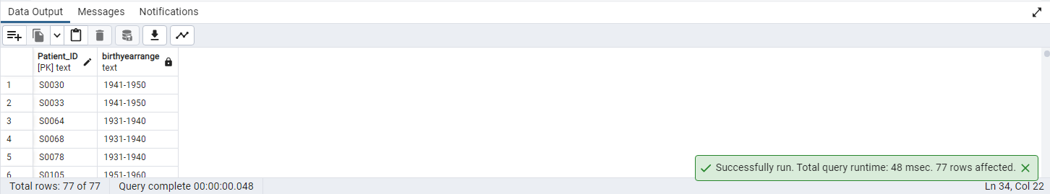

1. Display DM patient names with highest day MAP and night MAP (without using limit).

Query:

WITH MAP_table AS (

SELECT p."Firstname"||' '||p."Lastname" as Patientname,

(b."24Hr_Day_DBP" + (b."24Hr_Day_SBP" - b."24Hr_Day_DBP")/3) AS dayMAP,

(b."24Hr_Day_DBP" + (b."24Hr_Day_SBP" - b."24Hr_Day_DBP")/3) AS nightMAP

FROM public."Patients" AS p

JOIN public."Blood_Pressure" AS b

ON b."BP_ID" = p."BP_ID"

)

SELECT Patientname

FROM MAP_table

WHERE dayMAP = (

SELECT MAX(dayMAP)

FROM MAP_table

) OR

nightMAP = (

SELECT MAX(nightMAP)

FROM MAP_table

);

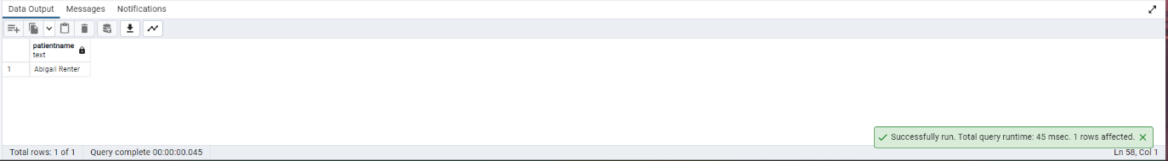

1. Create view on table Lab Test by selecting some columns and filter data using Where condition.

Query:

CREATE OR REPLACE VIEW Lab_view AS

SELECT "Lab_ID", "Patient_ID","Hb_A1C","Fasting_Glucose","Insulin"

FROM public."Lab_Test"

WHERE "Hb_A1C" >5.7

AND "Fasting_Glucose" >100

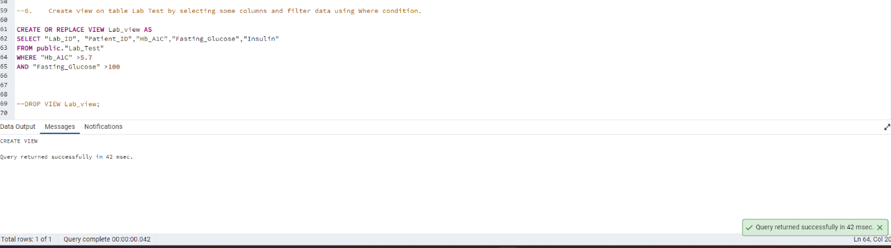

SELECT * FROM public.lab_view

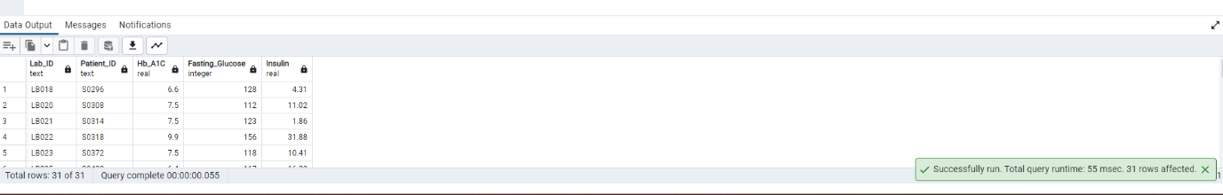

DROP VIEW Lab_view;

1. Display a list of Patient IDs and their Group whose diabetes duration is greater than 10 years.

Query:

SELECT "Patient_ID","Group"

FROM public."Patients",public."Group"

WHERE public."Patients"."Group_ID"=public."Group"."Group_ID"

AND "Diabetes_Duration" >10;

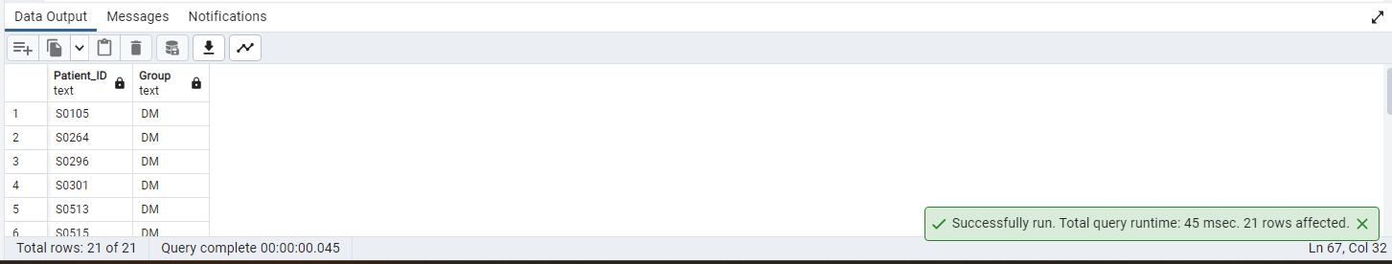

1. Write a query to list male patient ids and their names who are above 40 years of age and less than 60 years and have Day BloodPressureSystolic above 120 and Day BloodPressureDiastolic above 80.

Query:

SELECT p."Patient_ID", p."Firstname"||' '||p."Lastname" as Fullname

FROM public."Patients" as p,public."Blood_Pressure" as b

WHERE p."BP_ID" = b."BP_ID"

AND p."Age" BETWEEN 40 AND 60

AND b."24Hr_Day_SBP" > 120

AND b."24Hr_Day_DBP" > 80

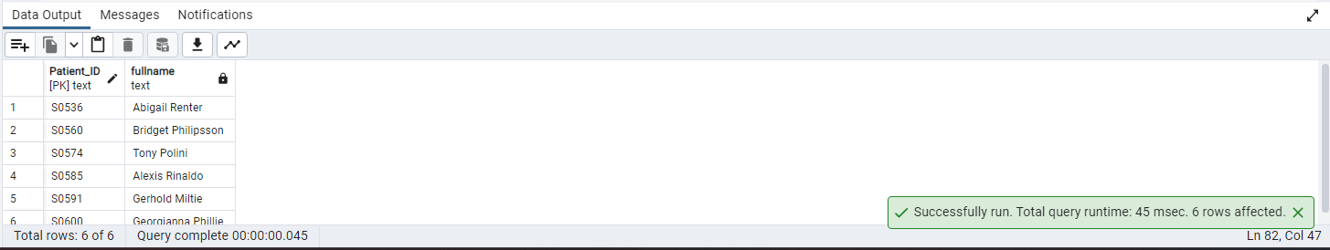

1. Use a function to calculate the percentage of patients according to the lab visited per month.

Query:

CREATE OR REPLACE FUNCTION lab_pct(pt_count real) returns numeric AS

$$ select pt_count * 100/77;

$$ Language SQL;

SELECT "Lab_names",

DATE_PART('month',"Lab_Visit_Date") AS MONTH,

COUNT(*) AS pt_count,

lab_pct(COUNT(*)) AS pt_pct

FROM public."Lab_Visit"

GROUP BY 1,2

ORDER BY 2;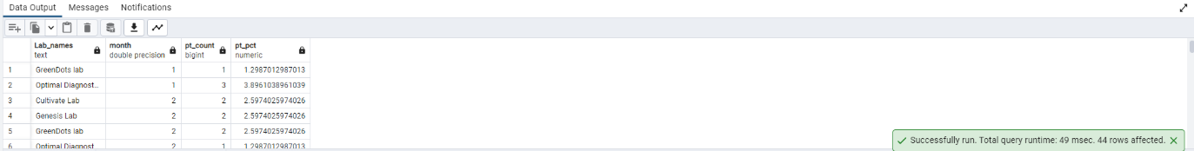

1. Count of patients by first letter of firstname.

Query:

SELECT LEFT("Firstname",1),COUNT(*)

FROM public."Patients"

GROUP BY 1

ORDER BY 1;

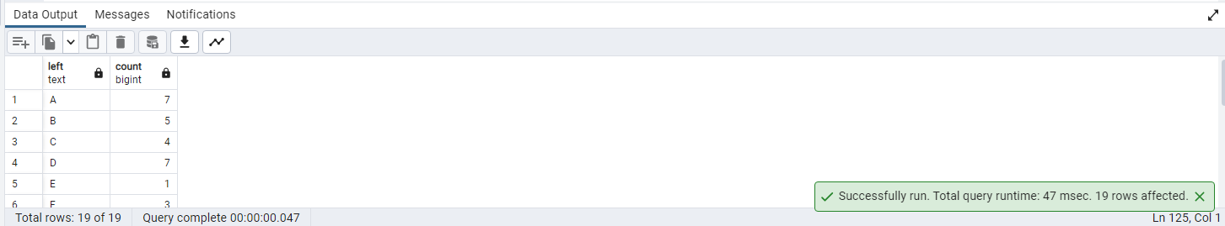

1. write a query to get the list of patients whose lipid test value is null.

Query:

SELECT p."Firstname"||' '||p."Lastname" AS patientname

FROM public."Patients" p

LEFT JOIN public."Link_Reference" l

ON p."Link_Reference_ID"= l."Link_Reference_ID"

LEFT JOIN public."Lipid_Lab_Test" ll

ON l."Lipid_ID" = ll."Lipid_ID"

WHERE "Fasting_Cholestrol" IS NULL

OR "Fasting_Triglyc" IS NULL

OR "Fasting_HDL" IS NULL

OR "Fasting_LDL" IS NULL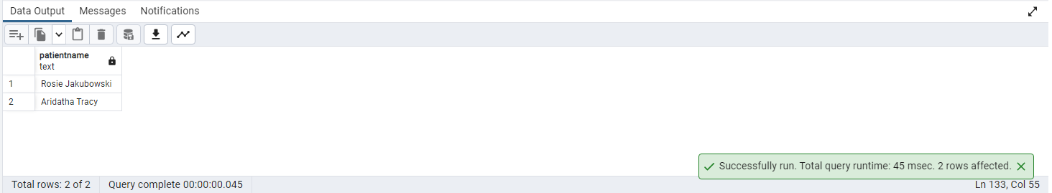

1. Create a stored procedure to make user ids for the given patient id.

Query:

CREATE OR REPLACE PROCEDURE patient_userid(patientid text, INOUT val refcursor)

LANGUAGE plpgsql

AS $BODY$

BEGIN

OPEN val FOR

SELECT LOWER(LEFT("Firstname",1)||"Lastname") AS username

FROM public."Patients"

WHERE "Patient_ID" = patientid;

END

$BODY$;

CALL patient_userid('S0531','ref');

FETCH ALL IN "ref";

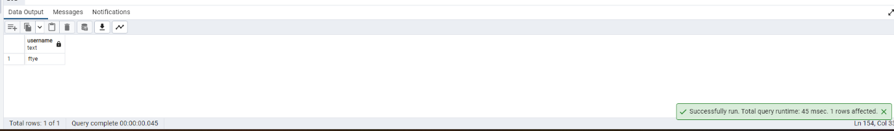

1. Display Patients With LastName contains 'Po' and replace it with 'Be'.

Query:

SELECT "Firstname","Lastname",REGEXP_REPLACE("Lastname",'Po','Be') AS newLastname

FROM public."Patients"

WHERE "Lastname" LIKE '%Po%'

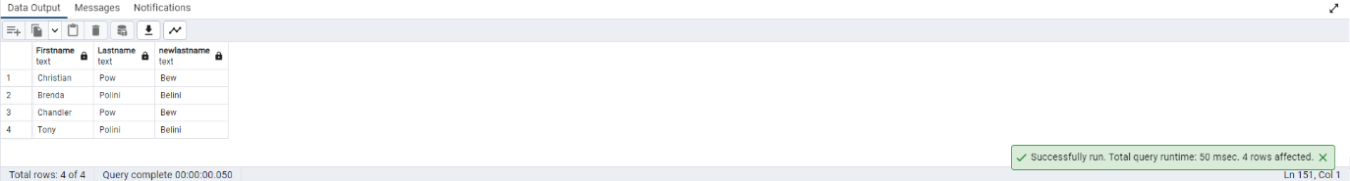

1. Calculate the patient's birth year in descending order.

Query:

SELECT "Firstname","Lastname",(DATE_PART('year',"Visit_Date")-"Age") AS Birthyear

FROM public."Patients"

ORDER BY 3 DESC;

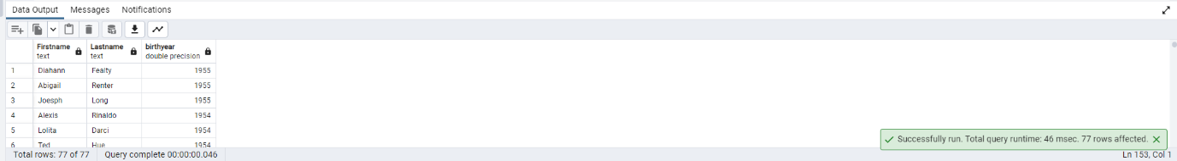

1. Find the patients that have eye damage due to diabetes

Query:

SELECT

p."Firstname",

p."Lastname",

o."Diabetic_Retinopathy",

o."Macular_Edema"

FROM public."Patients" AS p,public."Opthalmology" AS o

WHERE p."Opthal_ID" = o."Opthal_ID"

AND (o. "Diabetic_Retinopathy">0 OR o."Macular_Edema" >0);

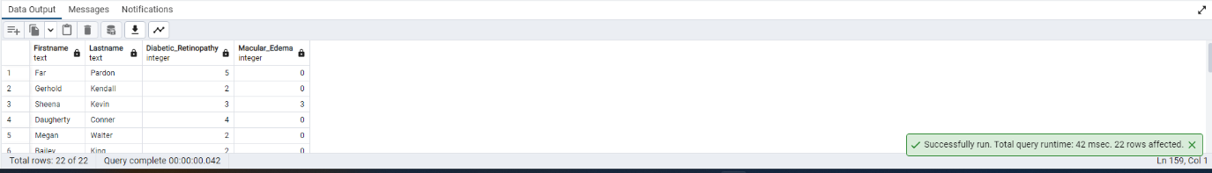

1. Query to classify Gait RPE End into 5 categories as per the intensity. (Hint: Use of CASE statement)

Query:

SELECT

p."Firstname",

p."Lastname",

w."Gait_RPE_End ",

(CASE

WHEN w."Gait_RPE_End " = 0 THEN 'Rest'

WHEN w."Gait_RPE_End " BETWEEN 1 AND 3 THEN 'Easy Intensity'

WHEN w."Gait_RPE_End " BETWEEN 4 AND 6 THEN 'Moderate Intensity'

WHEN w."Gait_RPE_End " BETWEEN 7 AND 9 THEN 'Hard Intensity'

ELSE 'Max Effort intensity'

END) AS Intensity

FROM public."Patients" AS p,public."Walking_Test" AS w

WHERE p."WalkTest_ID" = w."WalkTest_ID";

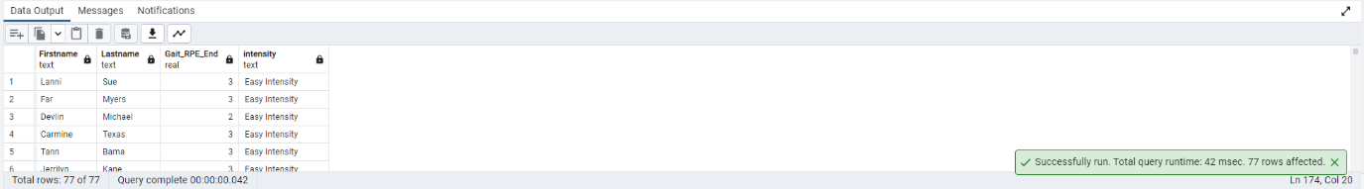

17. Create view on patient table with check constraint condition.

Query:

create or replace view patients_view

as select "Patient_ID","Age" from "Patients" with check option;

update patients_view set "Patient_ID" =1;

1. Calculate the patient's current age.

Query:

select "Patient_ID", (DATE_PART('year',"Visit_Date")-"Age") as Birthyear,

(date_part('year',current_date)-(DATE_PART('year',"Visit_Date")-"Age")) as current_Age

from public."Patients";

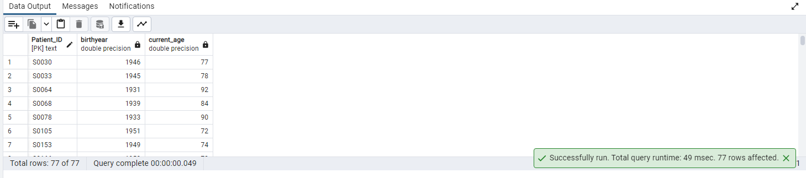

1. Write a query to display Mr. or Ms. as prefix to patients’ names with respect to gender.

Query:

select concat(case

when "Gender"."Gender"='Male' then 'Mr.'

when "Gender"."Gender"='Female' then 'Ms.' end , "Patients"."Firstname" ),"Gender"."Gender"

from "Patients","Gender" where "Patients"."Gender_ID"="Gender"."Gender_ID";

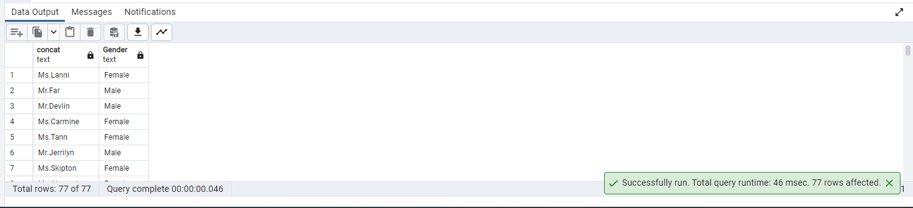

1. Write a query to get DM patient names whose distance is greater than 400 and speed is greater than 1.

Query:

select concat(pat."Firstname",' ',pat."Lastname") Patients,w."Gait_DT_Distance",w."Gait_DT_Speed"

from "Patients" pat join "Walking_Test" w on pat."WalkTest_ID"=w."WalkTest_ID"

join "Group" grp on pat."Group_ID"=grp."Group_ID"

where grp."Group"='DM' and w."Gait_DT_Distance">400 and w."Gait_DT_Speed">1;

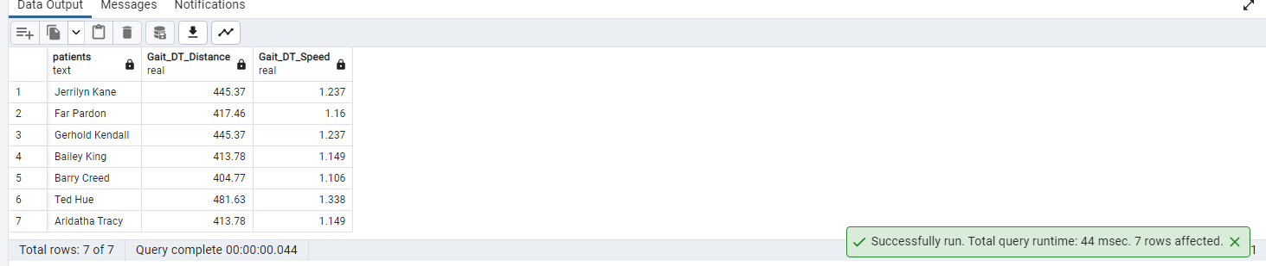

21.Create a trigger to raise notice and prevent the deletion of a record from a view.

Query:

create view race_view as

select * from "Race";

---------------------------------------------------

create or replace function delete_race_view()returns trigger as $DonotDelete$

begin

if (TG_OP = 'DELETE') then

Raise exception 'STOP AND THINK ABOUT WHAT YOURE DOING';

end if;

return null;

end;

$DonotDelete$ language plpgsql;

----trigger---

create trigger DonotDelete

instead of delete on public.race_view

for each row

execute function delete_race_view();

-------------------

delete from public.race_view;

22. Select the patient's full name with a name starting with 's'

followed by any character, followed by 'r', followed by any character, followed by b.

Query:

select concat("Firstname","Lastname") as "fullname"

from "Patients" where concat("Firstname","Lastname") like 'S_r_b%';

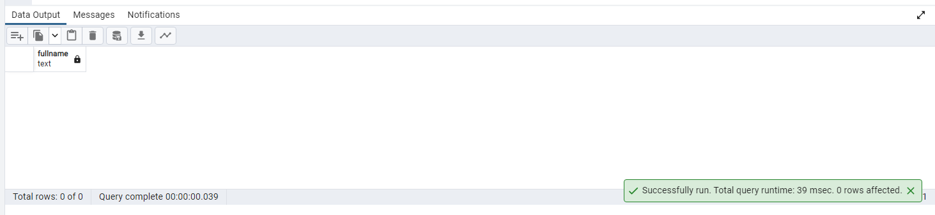

23. Write a query to get which race has the maximum number of Diabetic patients.

Query:

--(Patients having Fasting_Glucose >=120 are diabetic)

select ra."Race" ,count(pat."Patient_ID") Diabetic

from "Patients" pat join "Race" ra on ra."Race_ID"=pat."Race_ID"

join "Link_Reference" lr on pat."Link_Reference_ID"=lr."Link_Reference_ID"

join "Lab_Test" lt on lt."Lab_ID"=lr."Lab_ID"

where lt."Fasting_Glucose">=120

group by ra."Race" order by Diabetic desc limit 1;

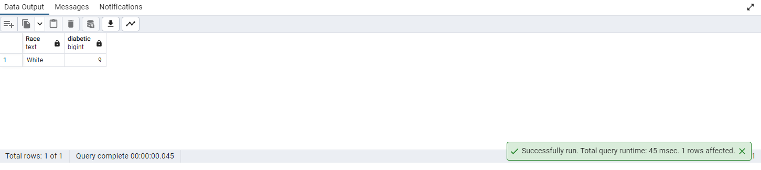

24. Find the list of Patients who has leukopenia.

Query:

select concat(pat."Firstname",pat."Lastname") as Patients_Name,lt."WBC" as with_leukopenia from "Patients" pat

join "Link_Reference" lr on pat."Link_Reference_ID"=lr."Link_Reference_ID"

join "Lab_Test" lt on lt."Lab_ID"=lr."Lab_ID"

where lt."WBC" in (select "WBC" from "Lab_Test" where "WBC" not between '4.5' and '11');

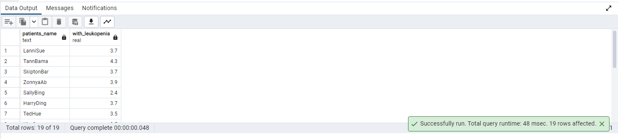

25. Get the number of patients in the year 2005 in each of the Genesis and Cultivate labs.

Query:

select lv."Lab_names",count(pat."Patient_ID")as no_of_Patients,

date_part('year',pat."Visit_Date") as visited_year from "Patients" pat

join "Link_Reference" lr on pat."Link_Reference_ID"=lr."Link_Reference_ID"

join "Lab_Visit" lv on lv."Lab_visit_ID"=lr."Lab_visit_ID"

where lv."Lab_names" in ('Genesis Lab','Cultivate Lab') and date_part('year',pat."Visit_Date")=2005

group by date_part('year',pat."Visit_Date"),lv."Lab_names";

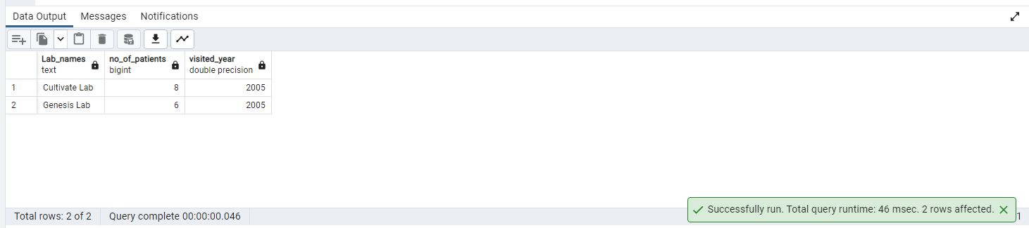

26. Write a query to get a list of patient IDs' and their Fasting Cholesterol in February 2006

Query:

select "Lipid_Lab_Test"."Patient_ID","Lipid_Lab_Test"."Fasting_Cholestrol",

concat(date_part('year',"Visit_Date"),'-',date_part('month',"Visit_Date"),'-',date_part('day',"Visit_Date"))

from public."Lipid_Lab_Test"

join "Link_Reference" on "Lipid_Lab_Test"."Lipid_ID"=public."Link_Reference"."Lipid_ID"

join "Patients" on "Link_Reference"."Link_Reference_ID"="Patients"."Link_Reference_ID"

where "Patients"."Visit_Date" between '2006-2-1' and '2006-2-28';

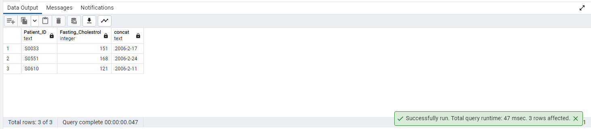

27. Write a query to get a list of patients whose first names is starting with the letter T.

Query:

select "Firstname" from "Patients" where "Firstname" like 'T%';

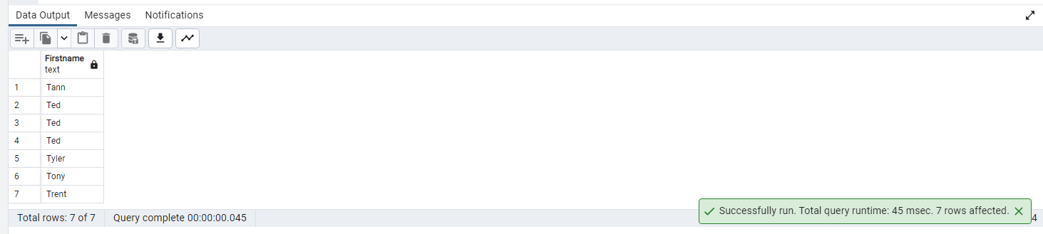

28. Find a list of Male patients whose age is more than 60 whose, BMI is more than 18.5, and whose height is more than e 1.5 M.

Query:

select concat("Firstname",' ',"Lastname") Patients,"Age","BMI","Height","Gender_ID" from "Patients"

where "Age">60 and "BMI">18.5 and "Height" >1.5

and "Gender_ID" in (select "Gender_ID" from "Gender" where "Gender"='Male') ;

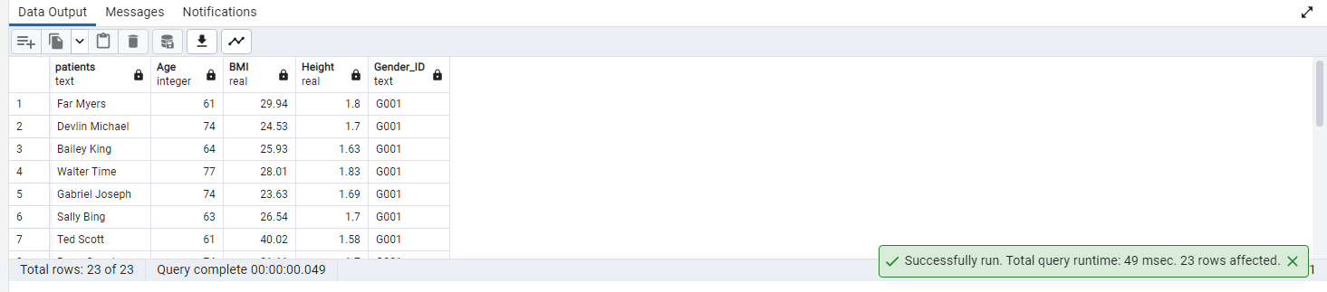

29. Write a query to get ceiled creatinine levels for male who age is greater than 35 and levels are abnormal.

Query:

select concat(pat."Firstname",' ',pat."Lastname") Patients,ceil(ut."Creatinine") creatinine_level from "Patients" pat join

"Link_Reference" lr on lr."Link_Reference_ID"=pat."Link_Reference_ID"

join "Urine_Test" ut on ut."Urine_ID"=lr."Urine_ID"

where ut."Creatinine" not between '65.4' and '119.3' and pat."Gender_ID"='G001' and pat."Age" >35;

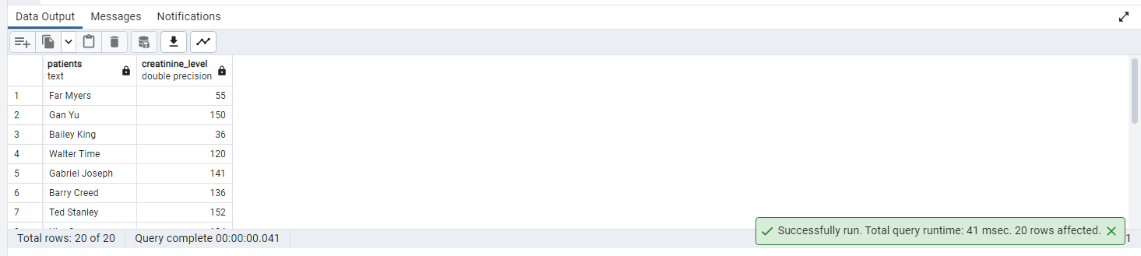

30. Write a query to get the number of patients who visited the Lab between 9 am to 12 am.

Query:

select count(*) from "Patients" pat

join "Link_Reference" lr on pat."Link_Reference_ID"=lr."Link_Reference_ID"

join "Lab_Visit" lv on lv."Lab_visit_ID"=lr."Lab_visit_ID"

where date_part('hour',lv."Lab_Visit_Date") between 9 and 24 ;

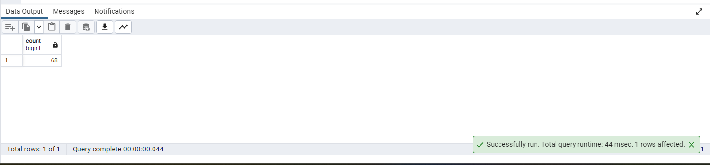

31. Write a trigger that calls a function, for checking space and case for

two columns or more before you add new data to a table.

Query:

create or replace function checking_space_case() returns trigger as $tgr_insert$

begin

-- checking for spaces and case while adding a row

if substring(new."Race_ID",' ') is not null then

raise exception 'cannot have spaces ';

end if;

if initcap(new."Race_ID") <> new."Race_ID" then

raise exception 'Please check Title case';

end if;

if substring(new."Race",' ') is not null then

raise exception 'cannot have spaces ';

end if;

if initcap(new."Race") <> new."Race" then

raise exception 'Please check Title case';

end if;

return new;

end;

$tgr_insert$ language plpgsql;

----trigger---

CREATE TRIGGER tgr_insert

BEFORE INSERT ON "Race"

FOR EACH ROW

EXECUTE function checking_space_case();

------------------------------------------

INSERT INTO "Race" ("Race_ID","Race")

VALUES(' R053','abcD');

32. Write a query to calculate the running moving averages of diabetes_duration

for Group 2 using the moving windows/sliding dynamic average windows.

Query:

select pat."Visit_Date"::date,

avg(pat."Diabetes_Duration") over

(order by pat."Visit_Date"::date rows between 3 preceding and current row ) moving_Avg

from "Patients" pat

where pat."Group_ID"='GRP_02';

33. Write a query to create a table to get patients’ demographic details whose birth year is 1939. Name the table as “Patient_Detail

Query:

create table patient_detail(patient_id varchar,first_name varchar,last_name varchar,age int, gender varchar,race varchar);

insert into patient_detail  
(select "Patients"."Patient_ID" , "Patients"."Firstname" ,"Patients"."Lastname", "Patients"."Age", "Gender"."Gender","Race"."Race"  
from "Patients" inner join "Gender" on "Patients"."Gender_ID"= "Gender"."Gender_ID"  
inner join "Race" ON "Race"."Race_ID" = "Patients"."Race_ID"  
WHERE EXTRACT(YEAR FROM "Patients"."Visit_Date") - "Patients"."Age" = 1939);

# 34. Convert and display Timestamp and date into visit time from Patient table on visit dates

Query:

SELECT "Firstname","Lastname","Visit_Date"::date as Visit_Date,  
"Visit_Date"::time(0) as Visit_Time  
from "Patients";

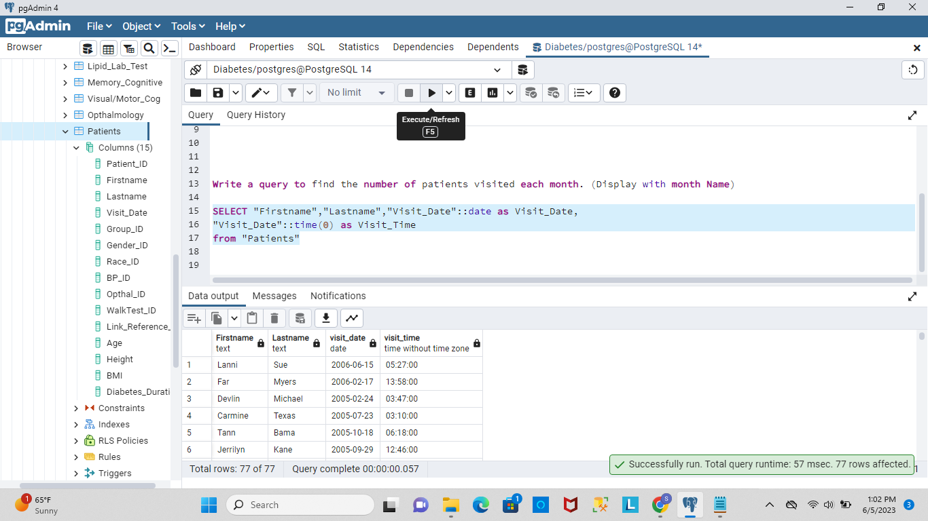

35. Write a query to find the number of patients visited each month. (Display with month Name)

Query:

SELECT TO_CHAR("Visit_Date", 'Month'),count("Patient_ID") from "Patients"  
group by TO_CHAR("Visit_Date", 'Month');

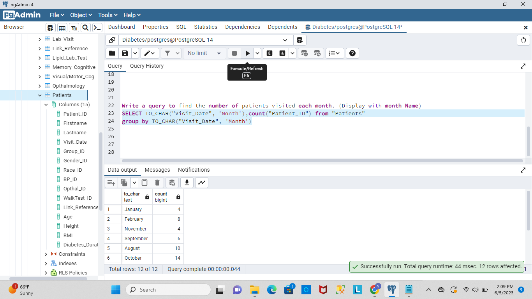

36. Write a query to get a number of visual/motor dementia patients who have any 2 abnormal conditions. (Display with condition name). (dementia/cognitive impairment: any patient who has any two abnormal test results).

Query:

select "Patient_ID",  
case  
when "TM">=42 and "Clock"<2 then  'Cognitive Impairment and Dementia'  
when "TM">=42 and "RCFT_IR"<71 then  'Cognitive Impairment and Rey Complex'  
when  "Clock"<2 and "RCFT_IR"<71 then  'Dementia and Rey Complex'  
END AS abnormal_conditions  
from "Visual/Motor_Cog"  
where ("TM">=42 and "Clock"<2) or ("TM">=42 and "RCFT_IR"<71) or  
("Clock"<2 and "RCFT_IR"<71);

37. Write a query to get a list of patient IDs whose fasting glucose is 80, 85, and 89.

Query:

select "Patients"."Patient_ID" from "Patients" inner join "Lab_Test" on "Patients"."Patient_ID"= "Lab_Test"."Patient_ID"  
where "Lab_Test"."Fasting_Glucose" IN(80,85,89);

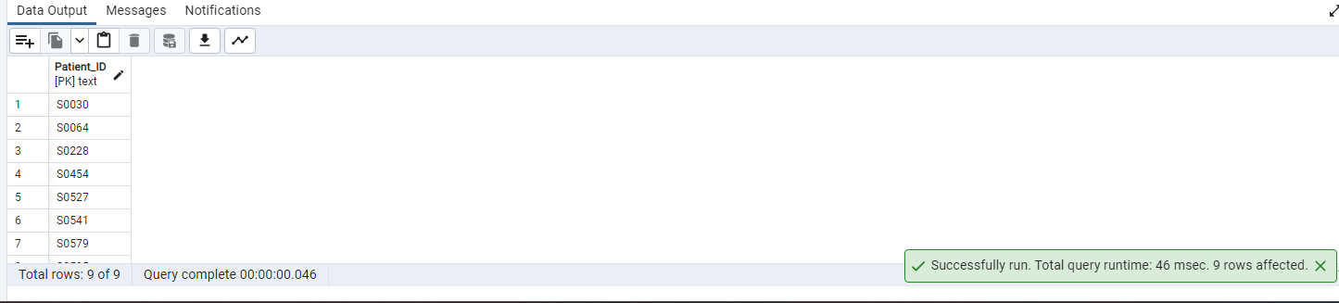

# 38. calculate the difference between Day and night HR. (Display 2 decimal only)

Query:

select "Patient_ID",cast(("24Hr_Day_HR"-"24Hr_Night_HR")as numeric(10,2)) as diff_day_night_HR from "Blood_Pressure";

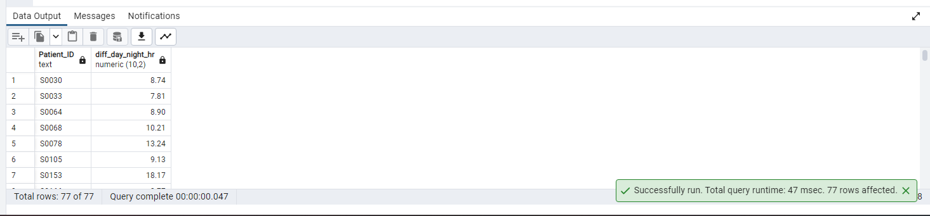

39. Find out the tables where column Patient_ID is present. (Display column position number with respective table also)

Query:

select table_name, column_name,  
ordinal_position PositionOfColInTable from information_schema.columns where column_name = 'Patient_ID';

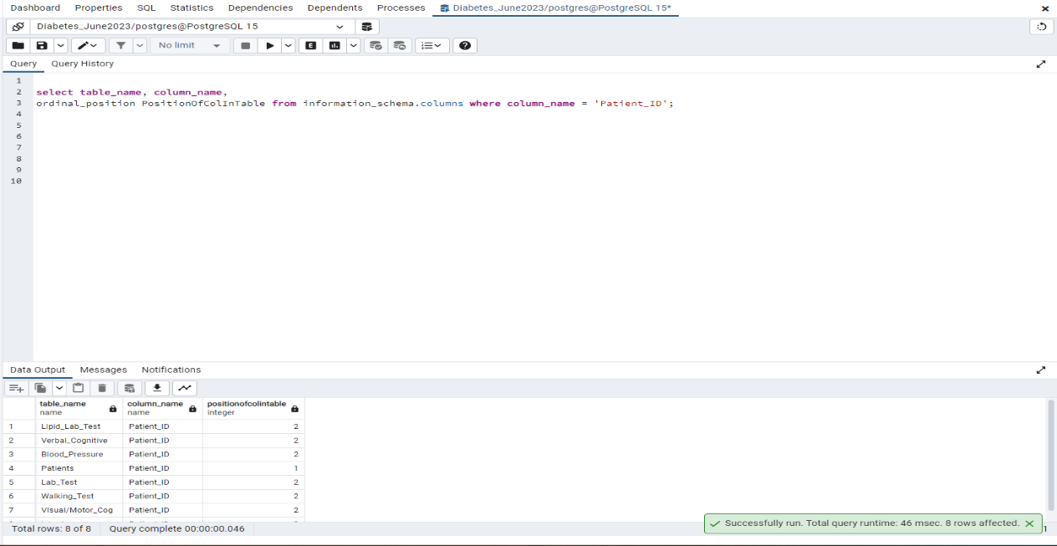

40. Write a query to calculate Creatinine ALbumin Ratio (uCAR) For DM Patients.

Query:

SELECT "Patients"."Group_ID","Patients"."Firstname","Patients"."Lastname",("Urine_Test"."Creatinine" /"Urine_Test"."Albumin")  
AS Creatinine_ALbumin_Ratio from "Patients" inner join "Link_Reference"  
ON "Link_Reference"."Link_Reference_ID" = "Patients"."Link_Reference_ID"  
inner join "Urine_Test" on "Urine_Test"."Urine_ID" = "Link_Reference"."Urine_ID"  
inner join "Group" on "Group"."Group_ID" = "Patients"."Group_ID"  
where "Group"."Group" = 'DM';

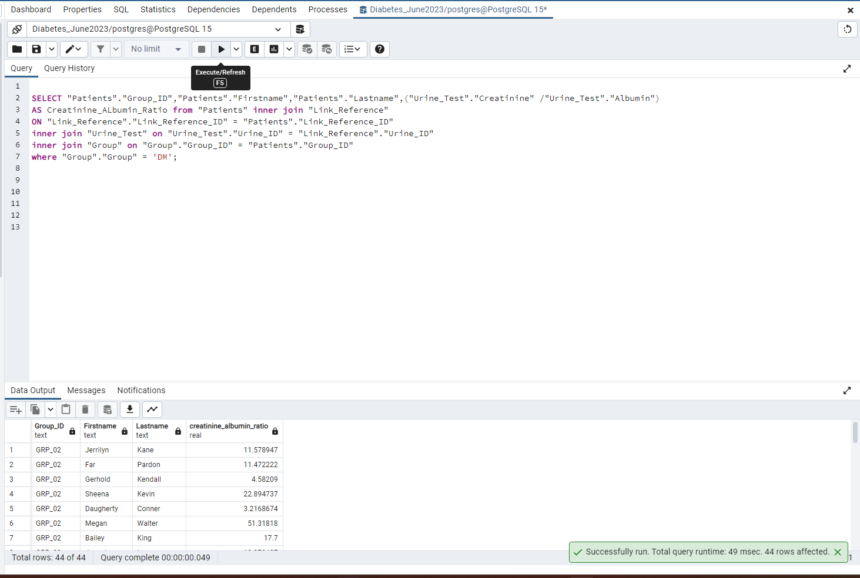

41. write a query to get the number of patients whose urine creatinine is in a normal range (Gender wise).  
  
Query:

select "Gender"."Gender",count("Patients"."Patient_ID") from "Patients" inner join public."Link_Reference"  
on "Patients"."Link_Reference_ID"= "Link_Reference"."Link_Reference_ID"  
inner join "Urine_Test" on "Link_Reference"."Urine_ID"="Urine_Test"."Urine_ID"  
inner join "Gender" on "Gender"."Gender_ID" = "Patients"."Gender_ID"  
where ("Gender"."Gender"= 'Male' and  "Urine_Test"."Creatinine" between 65.4 and 119.3)  
OR  
("Gender"."Gender"= 'Female' and  "Urine_Test"."Creatinine" between 52.2 and 91.9)  
group by "Gender"."Gender";

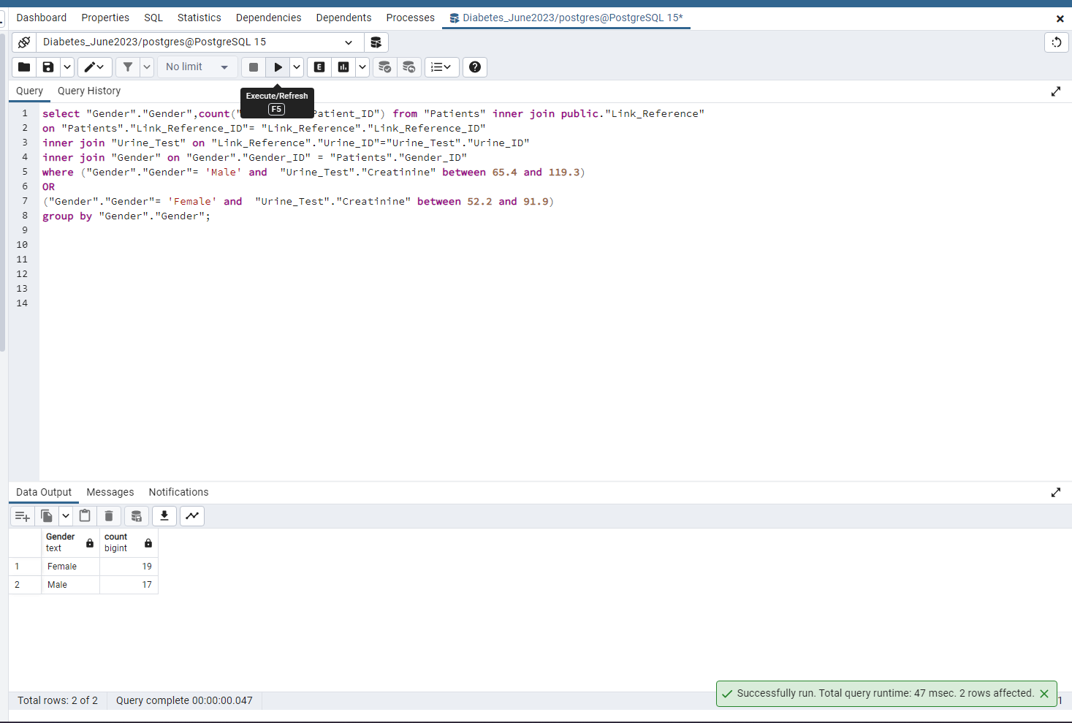

# 42. Write a query to update id LB002 with the lab name Cultivate Lab.

Query:

update "Lab_Visit" set "Lab_names" ='Cultivate Lab' where "Lab_visit_ID"= 'LV002';  
select * from "Lab_Visit";

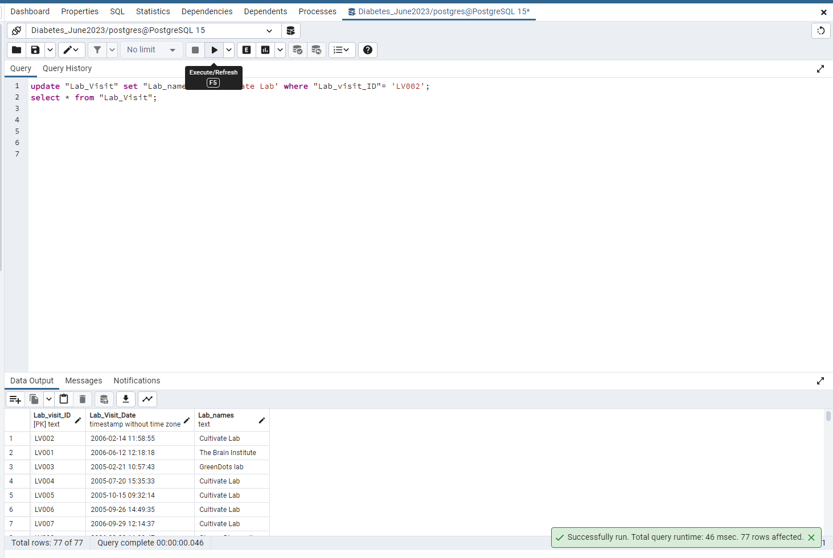

# 43. Create an index on any table and use explain analyze to show differences if any.

Query:

CREATE INDEX idx_Race ON "Patients"("Race_ID");  
EXPLAIN ANALYZE SELECT * FROM "Patients" where "Race_ID"='R002'

44. Write a query to split the lab visit date into two different columns lab_visit_date  and lab_visit_time.

Query:

SELECT "Lab_Visit_Date"::date as lab_visit_date,  
"Lab_Visit_Date"::time(0) as lab_visit_time  
from "Lab_Visit";

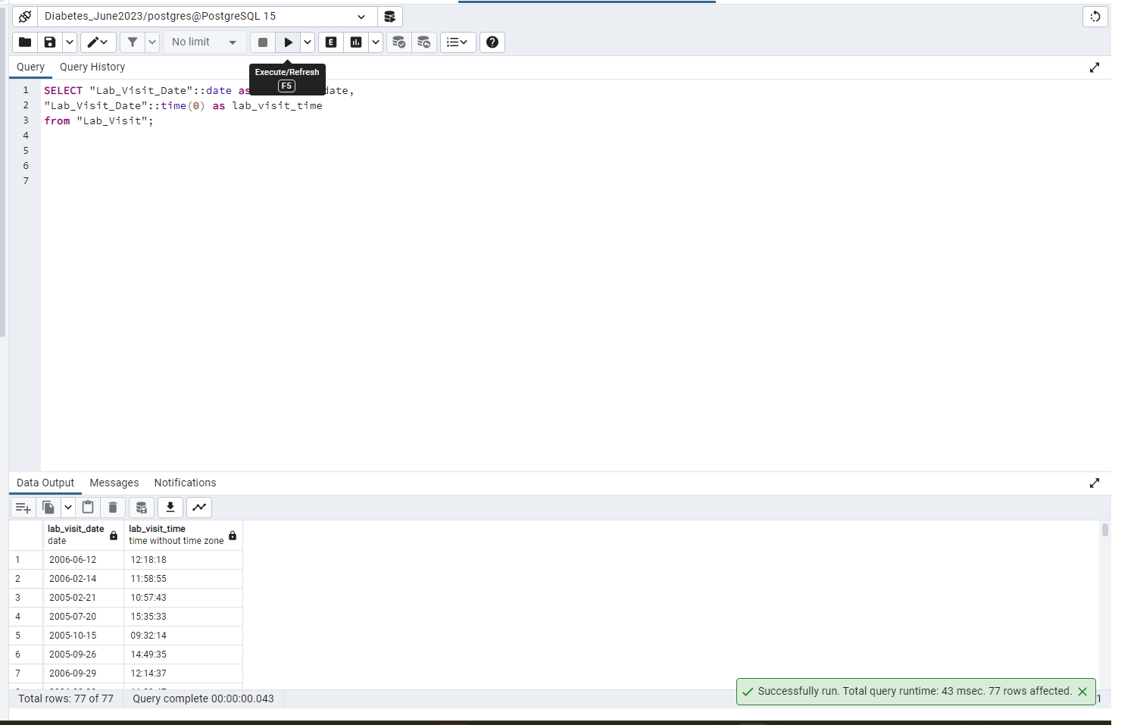

45. Please go through the below screenshot and create the exact output.



Query:

select SUBSTRING("Patient_ID",POSITION('0' IN REVERSE("Patient_ID"))+1,LENGTH("Patient_ID"))::INTEGER pat_id,

CASE WHEN CAST( SUBSTRING("Patient_ID", 3, 3) AS int)%2 = 0 THEN 'true'::boolean ELSE 'false'::boolean END as even,

CASE WHEN CAST( SUBSTRING("Patient_ID", 3, 3) AS int)%2 != 0 THEN 'true'::boolean ELSE 'false'::boolean END as odd

FROM "Patients"

ORDER BY RANDOM();

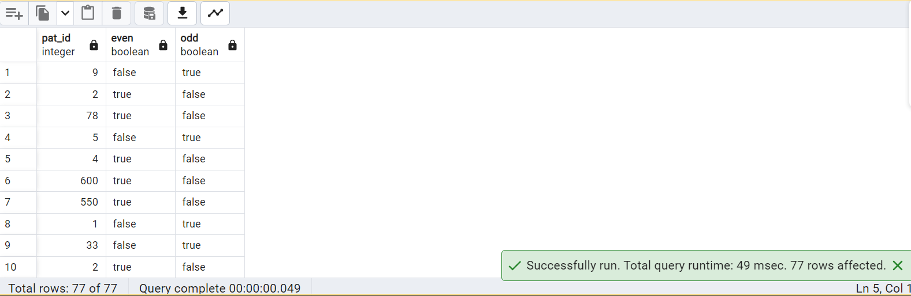

46. Calculate the Number of Diabetic Male and Female patients who are Anemic.

Query:

select "Gender"."Gender",count ("Patients"."Patient_ID") from "Patients"  
inner join "Lab_Test" on "Patients"."Patient_ID"= "Lab_Test"."Patient_ID"  
inner join "Gender" on "Gender"."Gender_ID" = "Patients"."Gender_ID"  
where (("Gender"."Gender"='Male' and "Lab_Test"."Hgb"<13.2 )  
or("Gender"."Gender"='Female' and "Lab_Test"."Hgb"<11.6))  
group by "Gender"."Gender" having MAX("Lab_Test"."Hb_A1C") >= 6.5;

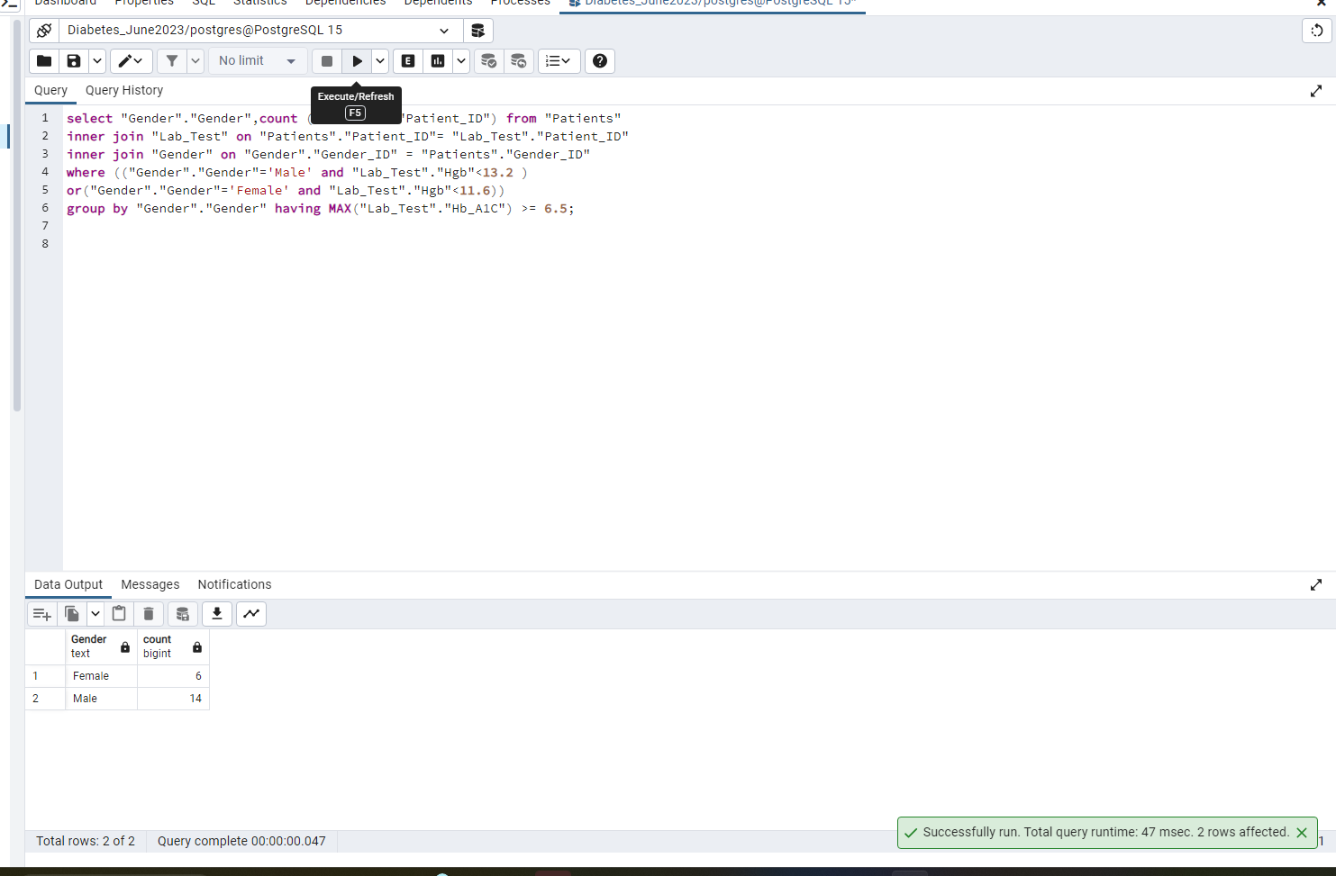

47. Write a query to display the Patient_ID, last name, and  
the position of the substring 'an' in the last name column for those patients who have a substring 'an'.

Query:

select "Patient_ID", "Lastname", position('an' in "Lastname") from "Patients"  
where "Lastname" like '%an%';

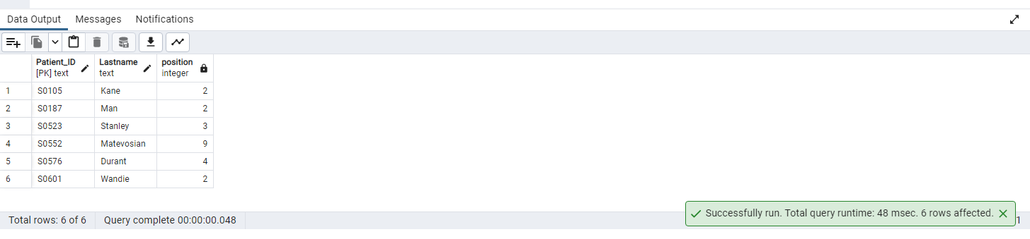

# 48. List of patients from rows 30-40 without using the where condition

Query:

# SELECT * FROM "Patients" LIMIT 11 OFFSET 29;

# 

# 49.Write a query to find Average age for patients with high blood pressure.

Query:

select avg(p."Age") from "Patients" p , "Blood_Pressure" bp

where bp."Patient_ID" = p."Patient_ID" and bp."24Hr_Day_SBP" > 130 and bp."24Hr_Day_DBP" > 80;

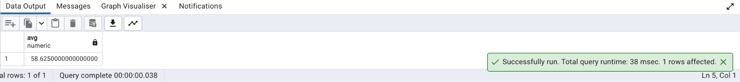

50. Create materialized view with no data, to display no of male and female patients.

Query:

CREATE MATERIALIZED VIEW patient_geneder_count

AS

select g."Gender" , count(*) from "Gender" g , "Patients" p where g."Gender_ID" = p."Gender_ID" group by g."Gender"

WITH NO DATA;

REFRESH MATERIALIZED VIEW patient_geneder_count;

Drop MATERIALIZED VIEW patient_geneder_count;

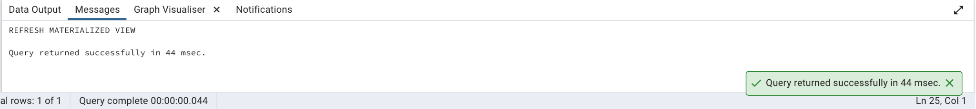

51.Get a list of unique lab names whose names is starting with G and end with b.

Query:

select "Lab_names" from "Lab_Visit" where "Lab_names" like 'G%b' Group By 1;

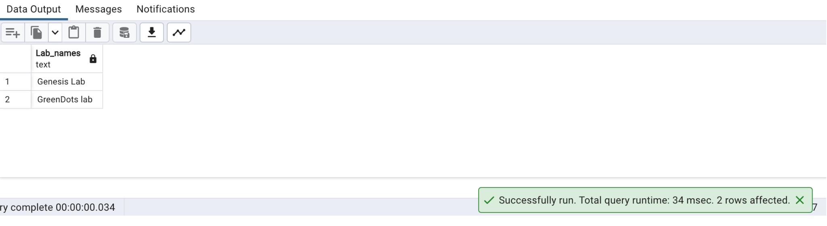

52. Write the query to create an Index on table Verbal_Cognitive by selecting a column and also write the query drop the same index.

Query:

Create Index Verbal_Cognitive_patient On "Verbal_Cognitive" ("Patient_ID");

SELECT

tablename,

indexname,

indexdef

FROM

pg_indexes

WHERE

schemaname = 'public'

AND tablename = 'Verbal_Cognitive'

ORDER BY

tablename,

Indexname

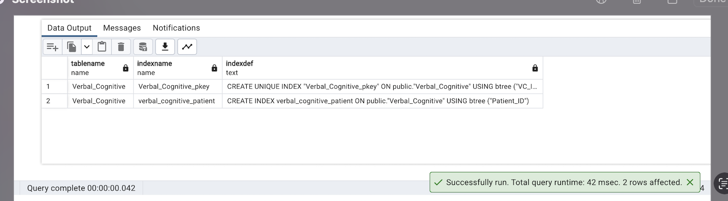

Drop Index Verbal_Cognitive_patient;

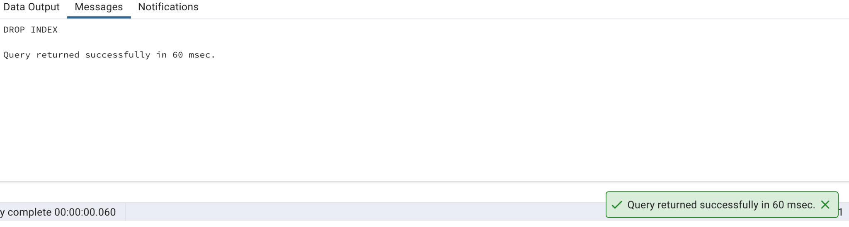

53. Get the number of patients born in a leap year.

Query:

create function is_leap_year (double precision)

returns boolean as $$

begin

return date_part(

'day',

make_date($1::int, 3, 1) - '1 day'::interval

) = 29;

end

$$ language plpgsql;

drop function is_leap_year;

select count(*) from "Patients" where is_leap_year(DATE_PART('year',"Visit_Date") - "Age")

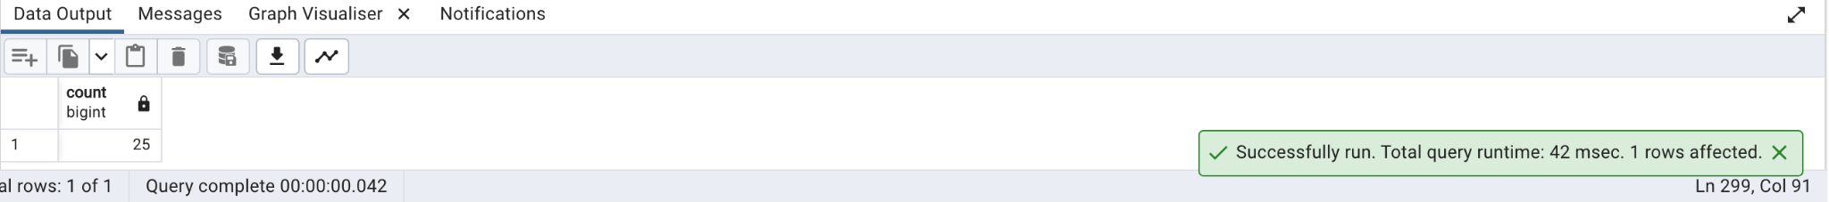

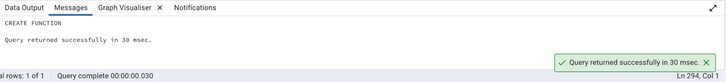

# 54. Write a query to get a list of patient IDs from the DM group and above age 60 in sequence.

select "Patient_ID","Age" from "Patients"

where "Age">60;

Query:

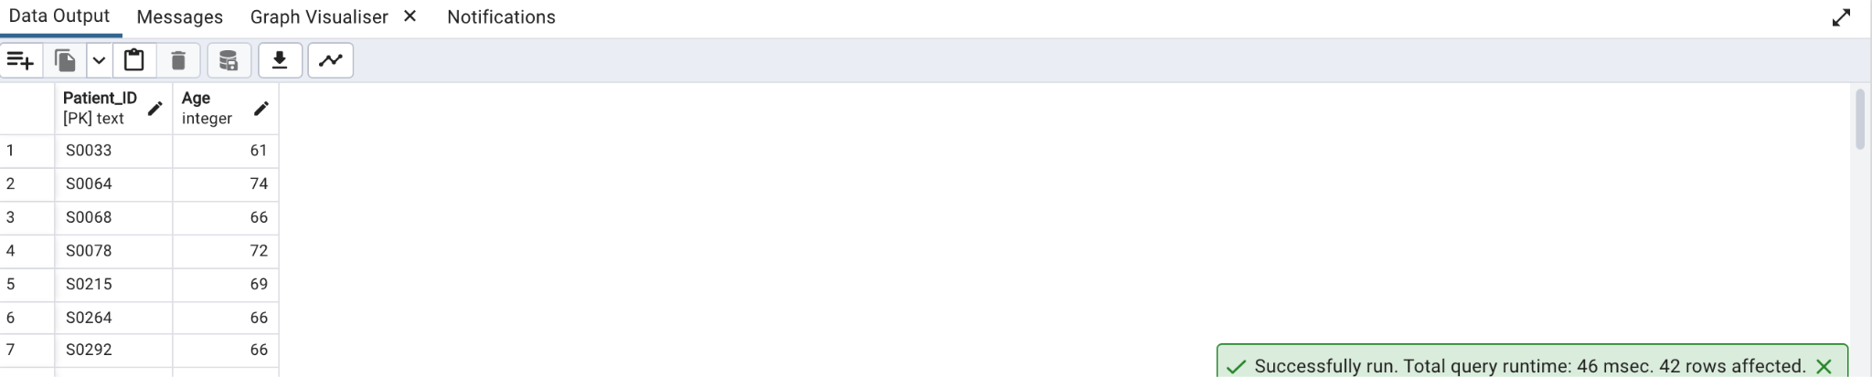

55.Find the patient who has the most damage in the eyes with the use of a max function.

Query:

select "Firstname"||' '||"Lastname" Patients

from "Patients" as pat , "Opthalmology" AS opt where pat."Opthal_ID" = opt."Opthal_ID" and

opt. "Diabetic_Retinopathy" = ( select max( "Diabetic_Retinopathy") from "Opthalmology" )

and opt."Macular_Edema" = (select max("Macular_Edema" ) from "Opthalmology" );

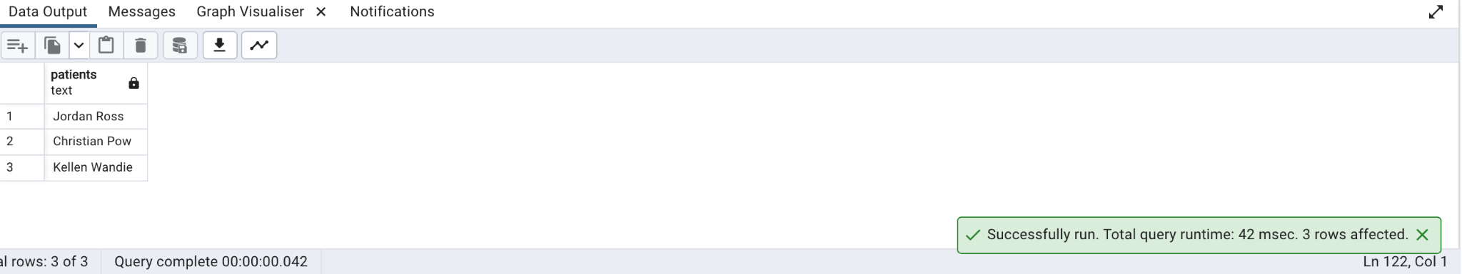

# 

# 56. Create a procedure for checking if Race exists using an if else statement.

Query:

CREATE OR REPLACE PROCEDURE public.chkrace(

IN _inrace text)

LANGUAGE 'plpgsql'

AS $BODY$

declare raceout bigint;

begin

raceout= (select count(*) from public."Race"

where "Race"=_inrace);

RAISE notice 'No. Of Races Found: %', raceout;

end;

$BODY$;

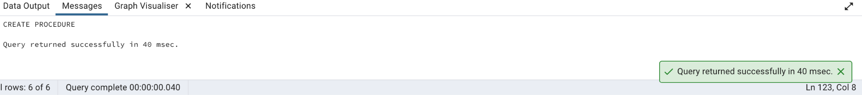

57.Write a query to display the DM patients and their high fasting triglycerides based upon their age ,gender and race.

Query:

Select concat(pt."Firstname" ,' ',pt."Lastname"),pt."Gender_ID",pt."Race_ID",pt."Age" from

"Patients" pt, "Lipid_Lab_Test" l,"Link_Reference" lr

Where l."Lipid_ID"=lr."Lipid_ID" and lr."Link_Reference_ID"=pt."Link_Reference_ID"

And l. "Fasting_Triglyc" > 200

And pt."Group_ID" ='GRP_02';

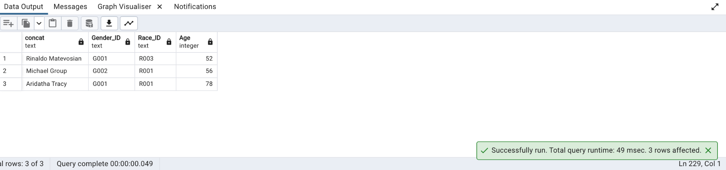

58. Create a pie chart based on race vs age.

Query:

SELECT A."Race",avg(pat."Age") from public."Race" A, public."Patients" pat where pat."Race_ID"=A."Race_ID" group by 1

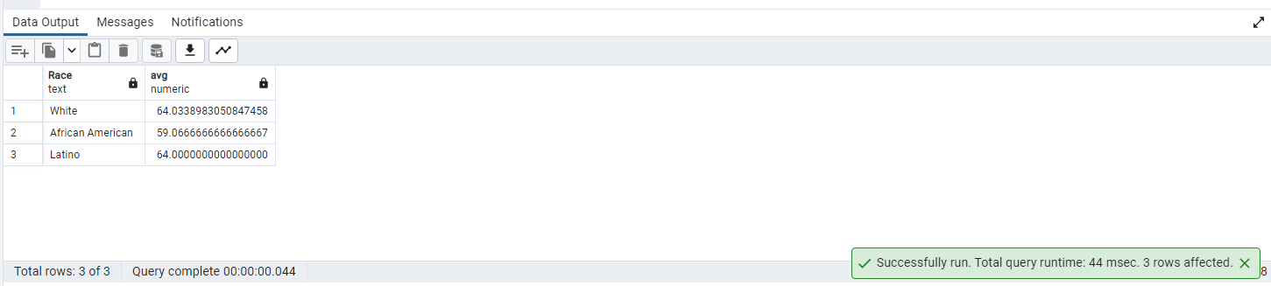

59. Write a query to create a master Patient table and its child table. Make sure that the child table inherits all the fields from the parent Patient table.

Query:

CREATE TABLE PatientsMaster (

Patient_ID text,

Age Int

);

CREATE TABLE PatientsGender (

Gender text

) INHERITS (PatientsMaster);

select * from PatientsGender

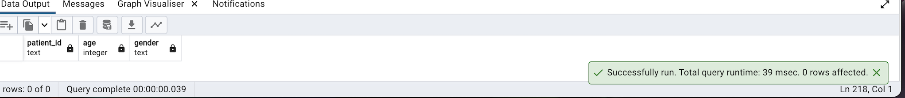

60. Write a query using the trigger after insert on the lab test table. If the patient has abnormal HbA1C and fasting glucose values.

Query:

CREATE OR REPLACE FUNCTION Lab_Test_view() RETURNS TRIGGER AS $$

BEGIN

--write function

if (New."Hb_A1C">6.4)then

raise notice 'HBAc high';

end if;

if (New."Fasting_Glucose">120)then

raise notice 'Fasting Glucose high';

end if;

RETURN NULL;

END;

$$ LANGUAGE plpgsql;

Create trigger Lab_tgr

After insert ON public."Lab_Test"

for each row Execute function Lab_Test_view();

insert into public."Lab_Test" ("Lab_ID", "Patient_ID" ,"Hb_A1C","Fasting_Glucose") Values('3','5','6.6','71');

insert into public."Lab_Test" ("Lab_ID", "Patient_ID" ,"Hb_A1C","Fasting_Glucose") Values('5','7','6.2','131');

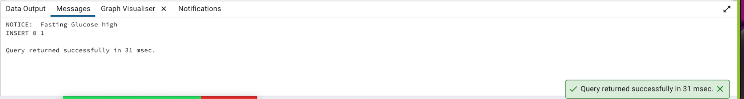

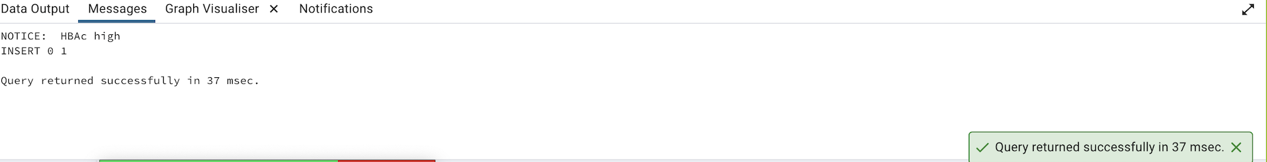

61. write a query to get the number of patients for each age bin without using the CASE statement.(Bin size - 5)

Query:

with AgeInt as (

select "Age"::int Age, "Patient_ID" PID from public."Patients"

)

select width_bucket(Age,0,100,20) as Agebucket,

int4range(min(Age),max(Age),'[]') as range,

count(PID) as NumPatients

from AgeInt

group by 1

order by 1

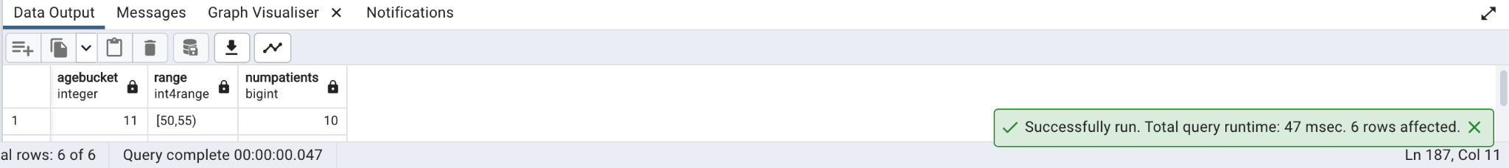

62.Write a query to get the number of patients who have normal platelets for each group.

Query:

select g."Group", count(p."Patient_ID") from "Patients" p, "Group" g where p."Group_ID" = g."Group_ID" and "Patient_ID" in (

select "Patient_ID" from "Lab_Test" where "Platelets" between 150 and 450)

group by g."Group"

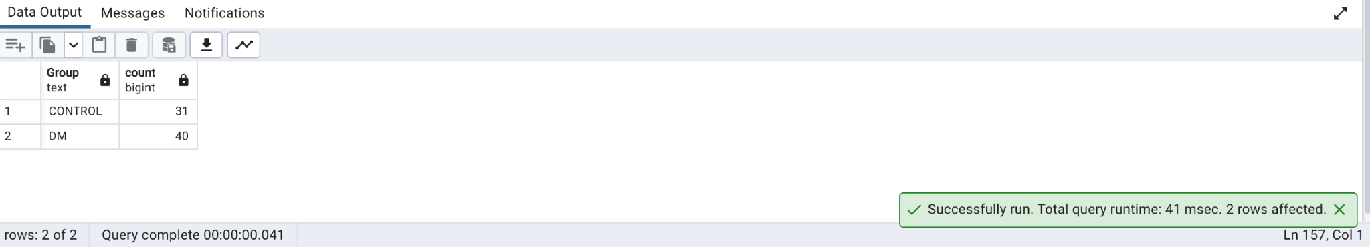

63.Create a trigger on a view of the Blood Pressure table.

Query:

Create view blood_pressure_view as

(

Select * from "Blood_Pressure"

)

Create trigger tgr_view

instead of delete ON public.Blood_Pressure_view

for each row Execute function Blood_Pressure_view();

CREATE OR REPLACE FUNCTION Blood_Pressure_view() RETURNS TRIGGER AS $$

BEGIN

--write function

if (tg_op='DELETE') then

raise notice 'for delete';

end if;

RETURN NULL;

END;

$$ LANGUAGE plpgsql;

Delete from public.Blood_Pressure_view

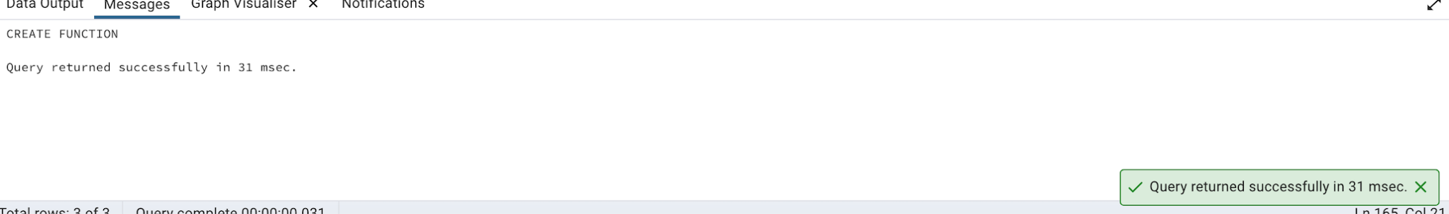

64.Write a query to find the number of Patients whose Gait RPE start is greater than the end and vice versa. (Display exact output as shown below)

Query:

select max(start_greater_than_end) start_greater_than_end, max(end_greater_than_start) end_greater_than_start from (

select count(wt."Patient_ID") as start_greater_than_end, 0 as end_greater_than_start from "Walking_Test" wt where (wt."Gait_RPE_Start ") > wt."Gait_RPE_End "

union all

select 0 as start_greater_than_end,count(wt."Patient_ID") as end_greater_than_start from "Walking_Test" wt where wt."Gait_RPE_Start " < wt."Gait_RPE_End "

) A

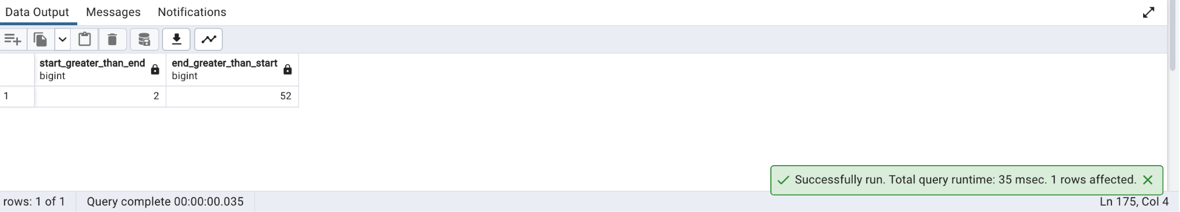

65.Create a view without using any schema or table and check the created view using a select statement.

Query:

Create or Replace View NoTabView

as

(

Select 1 Col1, 2 Col2, 3 Col3

);

select * from NoTabView;

66.Display patients names who have the same last name.

Query:

select pat."Firstname"||' '||pat."Lastname" from public."Patients" Pat

where

upper(pat."Lastname") in

(

select

upper("Lastname") lastname from public."Patients" group by upper("Lastname")

having count(1)>1)

order by pat."Lastname";

67.Write a query to get the Sum of Diabetes Duration for Group id 'GRP_02'.

Query:

select sum(pat."Diabetes_Duration") DiabetesDuration ,dgroup."Group_ID"

From public."Patients" Pat

left join public."Group" dgroup

on pat."Group_ID"=dgroup."Group_ID"

where dgroup."Group_ID"='GRP_02'

group by 2;

68.Write a query to get a patient name who has a chance to have kidney disease with Albumin

Query:

select pat."Firstname"||' '||pat."Lastname" PatientName, ut."Albumin" AlbuminOver30mg

from public."Patients" pat

join public."Link_Reference" lref

on pat."Link_Reference_ID"=lref."Link_Reference_ID"

left join public."Urine_Test" ut

on lref."Urine_ID"=ut."Urine_ID"

where ut."Albumin">30;

69.Get the patient's name who has a max speed.

Query:

with TopSpeed as

(

select pat."Firstname"||' '||pat."Lastname" PatientName, rank() over (order by wt."Gait_DT_Speed" desc) speedrank from public."Patients" pat

left join public."Walking_Test" wt

on pat."WalkTest_ID"=wt."WalkTest_ID"

)

select * from TopSpeed where speedrank=1;

70.Write a query to find out the percentage of Lab visits by Lab names.

Query:

SELECT "Lab_names",

COUNT("Lab_visit_ID") "CountLabVisits",

COUNT("Lab_visit_ID") / SUM(COUNT("Lab_visit_ID")) OVER () * 100 PercentageLabVisits

FROM public."Lab_Visit"

GROUP BY 1;

71.Write a query to get Patient IDs for verbally cognitively impaired who satisfy any 2 conditions. (HINT: dementia/cognitive impaired: any patient who has any two abnormal test results).

Query:

With AtLeastTwoConditions as

(

select "Patient_ID", 'Two Markers Of Dementia' as PatientCondition from

public."Verbal_Cognitive"

where ("DS"<13 and "HVLT"<14)

group by "Patient_ID",PatientCondition

Union All

select "Patient_ID", 'Low Fluency & Adult Reading Scores' as PatientCondition from

public."Verbal_Cognitive"

where ("VF"<42 and "WTAR"<=20)

group by "Patient_ID",PatientCondition

Union All

select "Patient_ID", 'Mixed Markers:verbal-cognitive Imp ' as PatientCondition from

public."Verbal_Cognitive"

where ("VF"<42 and "HVLT"<14) or

("DS"<13 and "VF"<42) or ("WTAR"<=20 and "HVLT"<14) or

("DS"<13 and "WTAR"<=20)

group by "Patient_ID",PatientCondition

)

select "Patient_ID", string_agg(PatientCondition,' & ') as PatientCondition from AtLeastTwoConditions group by 1;

72.Display a list of patients who are memory cognitively impaired with the GDS test and whose diabetes duration is between 5 to 30.

Query:

select pat."Firstname"||' '||pat."Lastname" PatientName,mcog."GDS", pat."Diabetes_Duration"

from public."Patients" pat

join public."Link_Reference" lref

on pat."Link_Reference_ID"=lref."Link_Reference_ID"

join public."Memory_Cognitive" mcog

on lref."MC_ID"=mcog."MC_ID"

where

mcog."GDS">15 and pat."Diabetes_Duration" between 5 and 30;

73.Write a query to the get number of Patient_IDs who visited between March 2005 and March 2006

Query:

WITH NameVisit as

(

select Count("Patient_ID") NumPatients, Cast((concat(Extract(YEAR FROM "Visit_Date"),to_char(Extract(MONTH FROM "Visit_Date"),'FM00'))) as Integer) VisitMonthYear

from public."Patients"

group by 2

)

SELECT NumPatients,

Case

when VisitMonthYear=200503 Then 'Mar-2005'

when VisitMonthYear=200504 Then 'Apr-2005'

when VisitMonthYear=200505 Then 'May-2005'

when VisitMonthYear=200506 Then 'Jun-2005'

when VisitMonthYear=200507 Then 'Jul-2005'

when VisitMonthYear=200508 Then 'Aug-2005'

when VisitMonthYear=200509 Then 'Sep-2005'

when VisitMonthYear=200510 Then 'Oct-2005'

when VisitMonthYear=200511 Then 'Nov-2005'

when VisitMonthYear=200512 Then 'Dec-2005'

when VisitMonthYear=200601 Then 'Jan-2006'

when VisitMonthYear=200602 Then 'Feb-2006'

when VisitMonthYear=200603 Then 'Mar-2006'

end VisitMonYear

FROM NameVisit WHERE VisitMonthYear BETWEEN 200503 AND 200603 ORDER BY VisitMonthYear;

74.Get the number of patients who visited each lab using the windows function.

Query:

SELECT labv."Lab_names",

sum(COUNT(*)) over (Partition by labv."Lab_names") NumberVisits

FROM

public."Patients" pat

join public."Link_Reference" lref

on pat."Link_Reference_ID"=lref."Link_Reference_ID"

left join public."Lab_Visit" labv

on labv."Lab_visit_ID"=lref."Lab_visit_ID"

GROUP BY 1;

75.Find the number of control and DM patients who visited each lab.

Query:

CREATE EXTENSION IF NOT EXISTS tablefunc;

SELECT * FROM CROSSTAB

(

'select dgroup."Group" CGroup,labv."Lab_names" LabNames, count(labv."Lab_names") from

public."Patients" Pat

join public."Link_Reference" lref

on pat."Link_Reference_ID"=lref."Link_Reference_ID"

left join public."Lab_Visit" labv

on labv."Lab_visit_ID"=lref."Lab_visit_ID"

left join public."Group" dgroup

on pat."Group_ID"=dgroup."Group_ID"

group by 1,2

ORDER BY 1,2') AS CT (CGroup text,"Cultivate Lab" bigint,"The Brain Institute" BIGINT,"Optimal Diagnostics" bigint,"Genesis Lab" bigint,"GreenDots lab" bigint,"Stream Diagnostix" bigint);

76.Please go through the below screenshot and create the exact output.

Query:

select pat."Firstname"||' '||pat."Lastname" PatientName, length(pat."Firstname")+length(pat."Lastname")+2 unknown

from public."Patients" pat;

77.Write a query to get comma-separated values of patient details .(Use a maximum of 6 columns from different tables)

Query:

--Solution 1: Input Patient Number and get details for that patient. Function output is comma separated by default.

CREATE OR REPLACE FUNCTION getPatientDet(_patid text)

RETURNS TABLE(FirstName text,LastName text, race text,Age int,BMI real) AS

$$

BEGIN

RETURN QUERY

select pat."Firstname" ,

pat."Lastname" ,

race."Race" ,

pat."Age" Age,

pat."BMI" BMI

from public."Patients" pat

join public."Race" race on

pat."Race_ID"=race."Race_ID"

join public."Link_Reference" lref

on pat."Link_Reference_ID"=lref."Link_Reference_ID"

join public."Lab_Test" labt

on labt."Lab_ID"=lref."Lab_ID"

and pat."Patient_ID" = _patid;

END

$$

LANGUAGE plpgsql;

SELECT getPatientDet('S0030');

--Solution 2: Use a simple concatenate operation

select pat."Firstname"||','|| pat."Lastname"||','||race."Race"||','||pat."Age"||','|| pat."BMI" PatientDetails

from public."Patients" pat

join public."Race" race on

pat."Race_ID"=race."Race_ID"

join public."Link_Reference" lref

on pat."Link_Reference_ID"=lref."Link_Reference_ID"

join public."Lab_Test" labt

on labt."Lab_ID"=lref."Lab_ID";

--Solution 3: Use string_agg()

select pat."Firstname"||','|| pat."Lastname" PatientName, string_agg(race."Race"||' , '||pat."Age"||' , '|| pat."BMI",',') RaceAgeBMI

from public."Patients" pat

join public."Race" race on

pat."Race_ID"=race."Race_ID"

join public."Link_Reference" lref

on pat."Link_Reference_ID"=lref."Link_Reference_ID"

join public."Lab_Test" labt

on labt."Lab_ID"=lref."Lab_ID"

group by 1;

78.Write a query to determine get the Patient IDs ,in DM and Control groups ,that are in prediabetic stage and label them accordingly.

Query:

select string_agg(pat."Patient_ID",', ') PreDiabeticPatients, count(pat."Patient_ID"), dgroup."Group"

from

public."Patients" Pat

join public."Lab_Test" labt

on pat."Patient_ID"=labt."Patient_ID"

left join public."Group" dgroup

on pat."Group_ID"=dgroup."Group_ID"

where labt."Hb_A1C" between 5.69 and 6.49

group by 3;

79.Calculate the Patient's Daytime MAP and Nighttime MAP.

Query:

select pat."Firstname"||' '||pat."Lastname" PatientName, ("24Hr_Day_DBP")+("24Hr_Day_SBP"-"24Hr_Day_DBP")/3 DaytimeMAP,

("24Hr_Night_DBP")+("24Hr_Night_SBP"-"24Hr_Night_DBP")/3 NighttimeMAP

from public."Patients" pat

join public."Blood_Pressure" bp

on bp."Patient_ID"=pat."Patient_ID";

80.Write a query using recursive view.

Query:

CREATE OR REPLACE RECURSIVE VIEW RunningTotal(n, totals) AS

(

SELECT 1 as n, 9 as totals

union all

SELECT n+1, totals+n from RunningTotal where n<9

);

select * from RunningTotal;

