-- Number of Movies and TV Shows

SELECT type, COUNT(*) AS count

FROM netflix.netflix_titles

GROUP BY type;

-- Most Common Rating

SELECT rating, COUNT(*) AS count

FROM netflix.netflix_titles

GROUP BY rating

ORDER BY count DESC

LIMIT 1;

-- Top 5 Directors with Most Titles

SELECT director, COUNT(*) AS count

FROM netflix.netflix_titles

WHERE director IS NOT NULL

GROUP BY director

ORDER BY count DESC

LIMIT 5;

-- Average Release Year

SELECT AVG(release_year) AS avg_release_year

FROM netflix.netflix_titles;

-- Top 5 Most Recent Movies Added

SELECT title, date_added, release_year, rating

FROM netflix.netflix_titles

WHERE type = 'Movie'

ORDER BY date_added DESC

LIMIT 5;

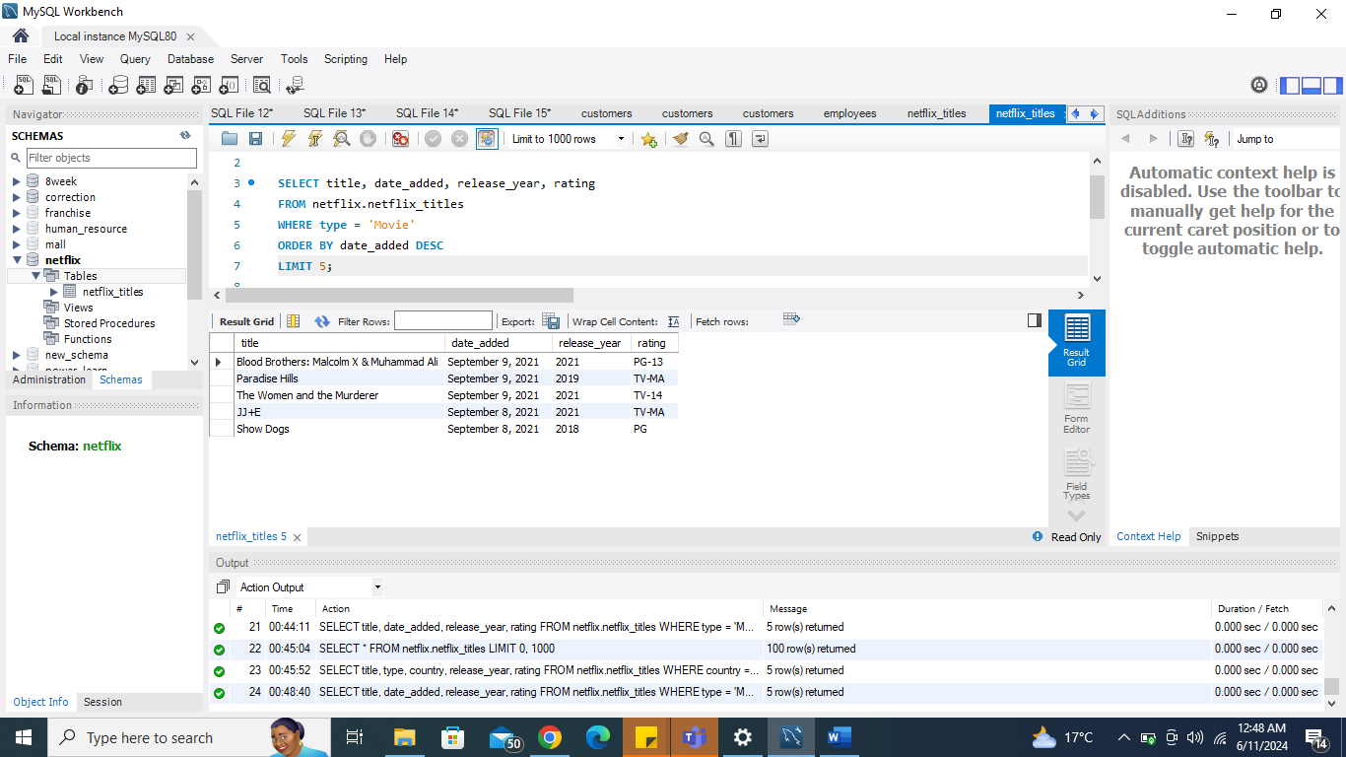

-- Top 5 Most Popular Shows in USA

SELECT title, type, country, release_year, rating

FROM netflix.netflix_titles

WHERE country = 'United States'

ORDER BY release_year DESC, date_added DESC

LIMIT 5;

