***WEBSITE PLANNING DOCUMENT***

**Site Purpose**:

The site purpose is to manage specialized hotel accommodations near temple locations of The Church of Jesus Christ of Latter-Day Saints around the world. It is a company that caters to temple workers, patrons, and their families by providing specialized services and accommodation that meet the needs of those patrons. The overall goal for the website is to promote and provide information about the specialized services that this hotel chain offers to meet the needs of the temple patrons who come to serve in the temple or who participate in events such as sealings, weddings, receptions, and youth trips. It will reflect the Church culture and be a support for temple-oriented themes as well as the concept of being a haven of comfort and accessibility.

**Target Audience**:

The target audience for this would really be anyone in the age range that is endowed and/or holds a temple recommend, this can be men, women, teenagers, and in the event of it, sometimes children. It will be for those that are interested in needing special accommodations while attending or at the closest temple to the Inn. It should meet the needs of patrons and will be for those that participate in events such as sealings, weddings, receptions, and youth trips.

**Site Map**:

**Color Scheme**: 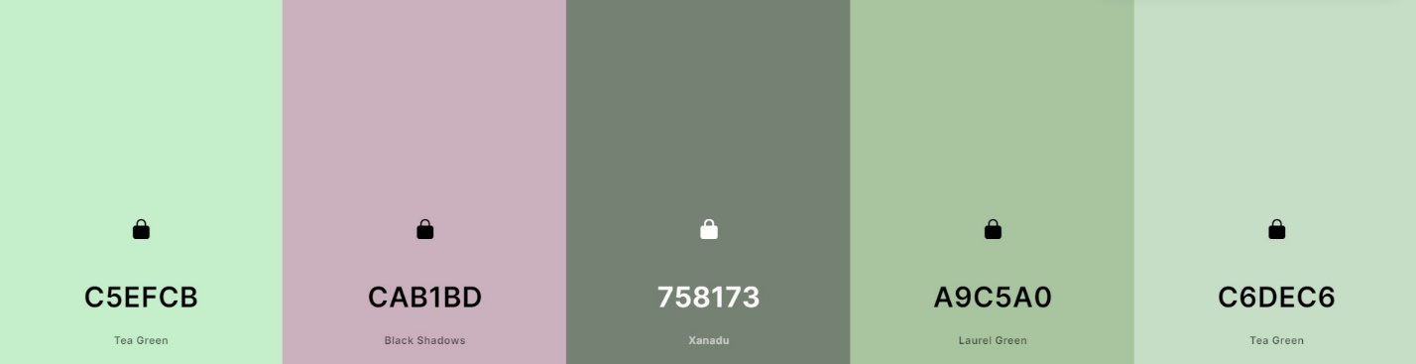

**Typography:**

Lobster Two

Edu SA Beginner

DM Serif Display

@import url('https://fonts.googleapis.com/css2?family=**DM+Serif+Display**&family=**Edu+SA+Beginner**&family=**Lobster+Two**&display=swap');

font-family: 'DM Serif Display', serif; *(bigger headings, header)*

font-family: 'Edu SA Beginner', cursive; *(paragraphs)*

font-family: 'Lobster Two', cursive; *(smaller headings)*

**Wireframe Sketches:**

Laptop: Tablet:

Smartphone:

