Lab 6 — Peer UI Critique Report

1. Review Metadata
Reviewing Team: DU_VibeCoders
Reviewed Team: Team_DevOps
Product Name: Digital Knowledge Platform For CSEDU
Review Date: 26 April 2026

2. Task Walkthrough Results
Task ID | Task Description | Completed | Issue Observed | Evidence
T-01 | Login with credentials | Yes | Password autofill overrides email field; users must manually clear it | 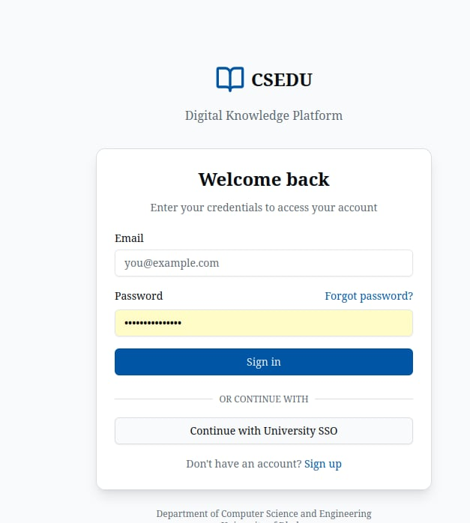
T-02 | Upload a file/project | Partial | No clear upload option visible; upload section appears empty.  In mobile view | 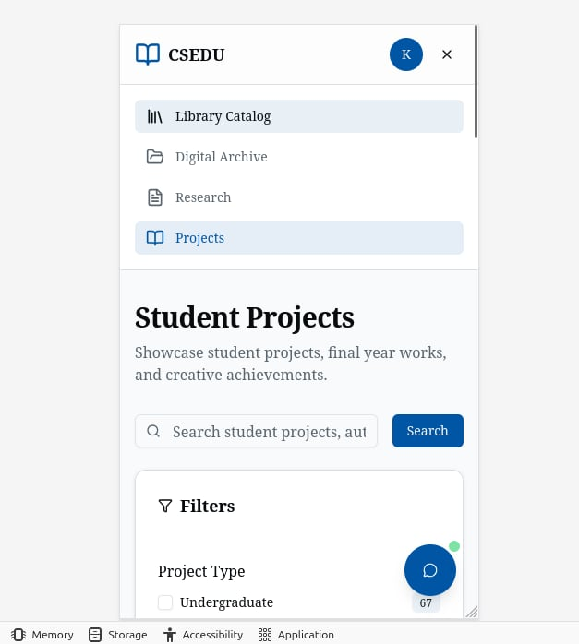
T-03 | Search for student projects | No | Search bar non-functional; no filtering option available | 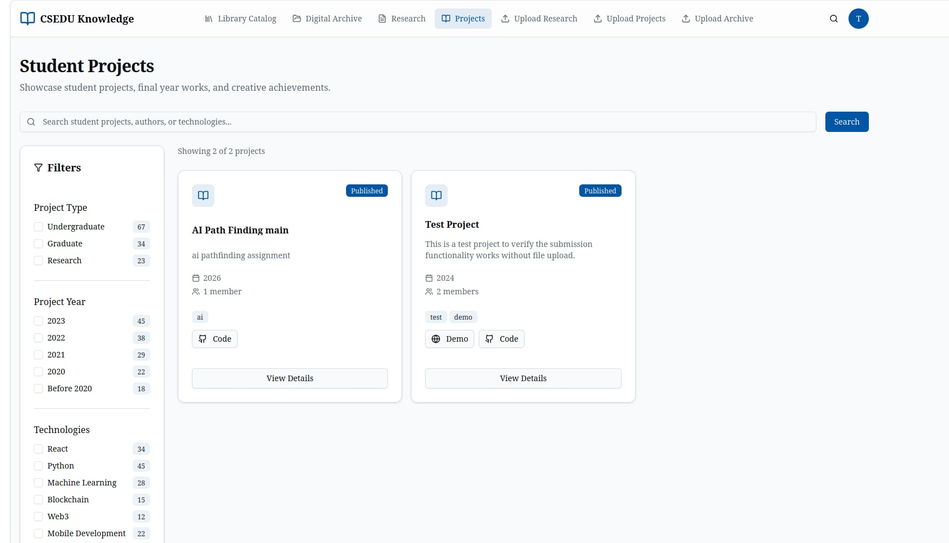
T-04 | Edit user profile | No | Edit profile option missing/unclear; Upload Media shows Access Denied | 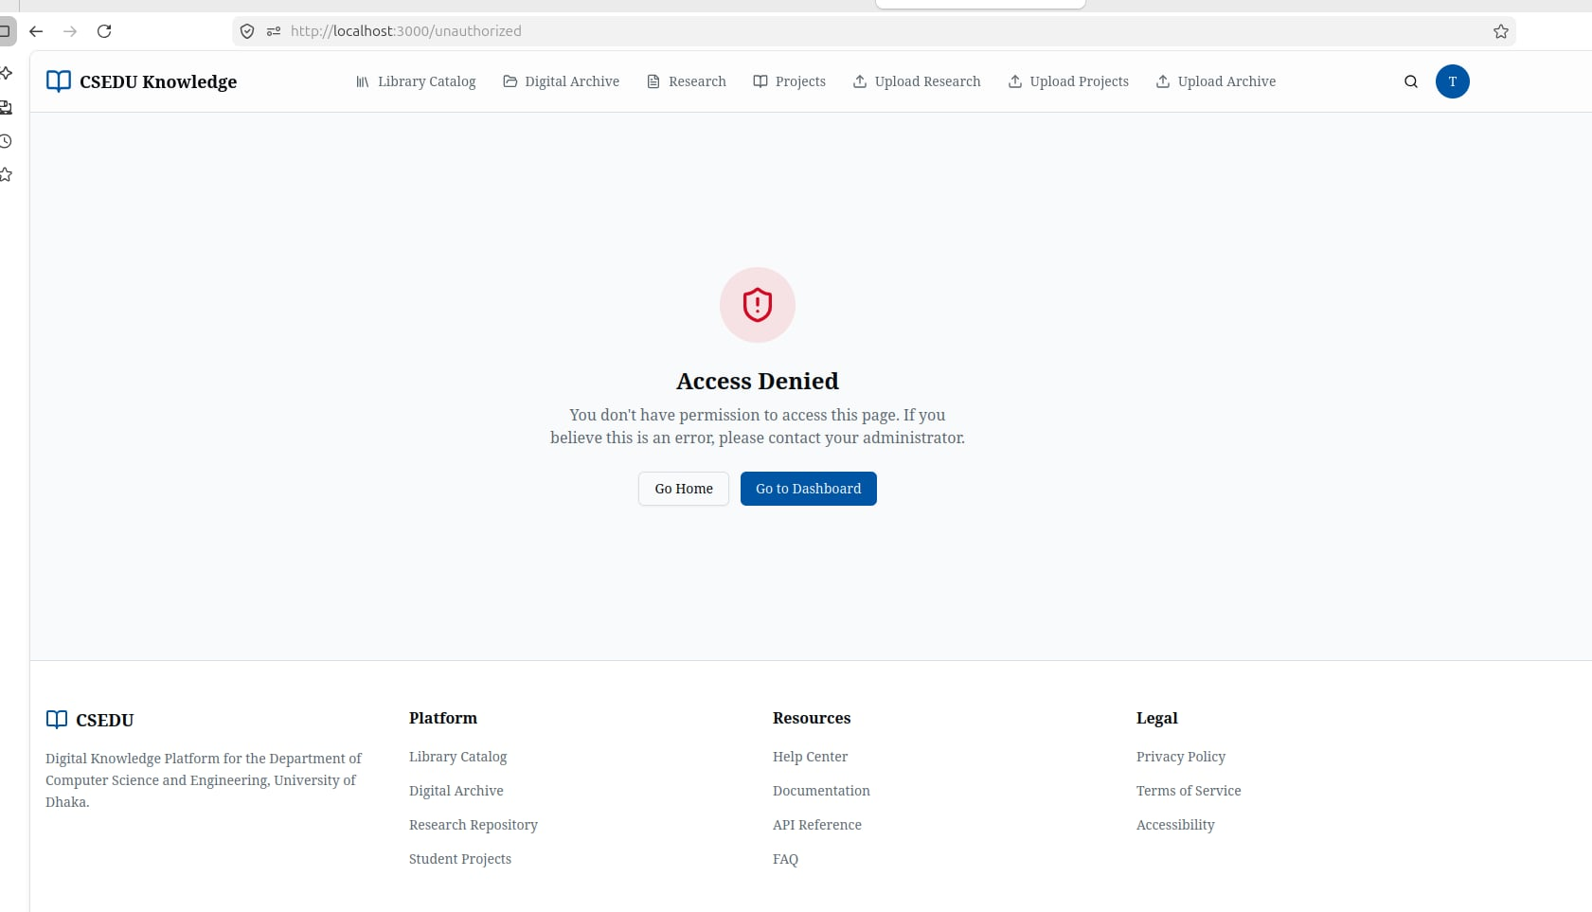
T-05 | Browse on mobile device | Partial | Filter takes too much space'; Publish/Unpublish broken; search missing | 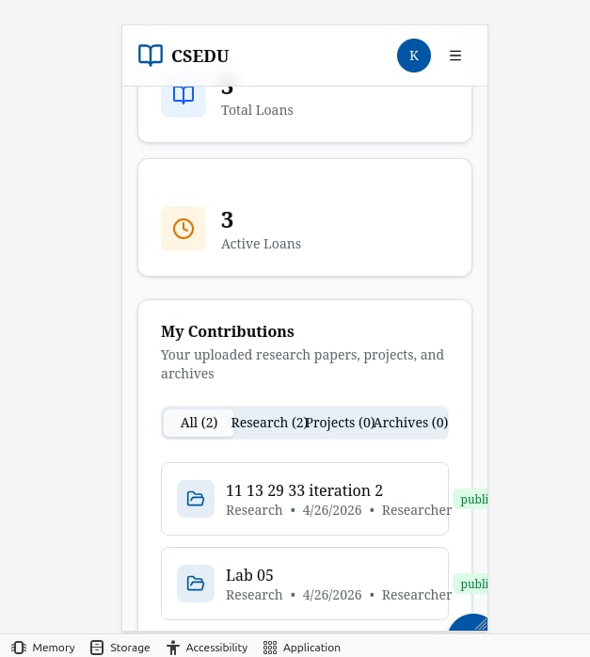

3. Top Usability Issues
Issue ID | Severity | Problem | Impact | Suggested Fix | Evidence
U-01 | High | Password autofill breaks email login | Users cannot log in without manually clearing the password field | Disable autofill or fix field order | 
U-02 | High | No delete option for uploaded files | Users are stuck with incorrect/unwanted uploads | Add delete/remove button per uploaded file | 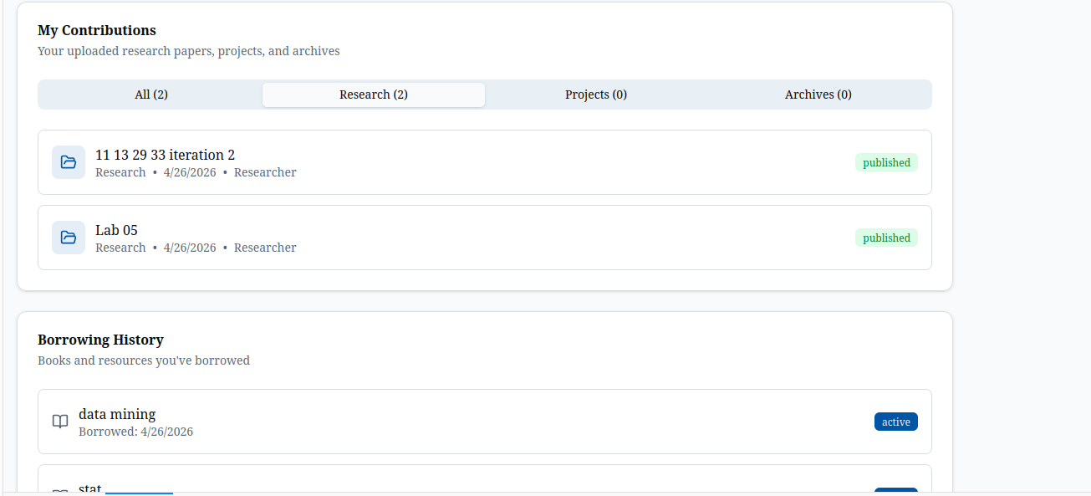
U-03 | High | Search bar non-functional (desktop & mobile) | Core discovery feature is broken; users cannot find content | Fix search endpoint; add mobile search button | 
U-04 | Medium | Upload Media shows Access Denied | Profile → Upload Media triggers a session error blocking content upload | Fix session/auth check before redirecting to upload | 
U-05 | Medium | Navigation bar overcrowded; redundant catalog sections | Library Catalog and Browse Catalog appear on same page; nav is cluttered | Merge redundant sections; reduce nav items | 

4. UI Improvement Suggestions
ID | Category | Suggestion | Expected Benefit | Priority
S-01 | Accessibility | Add show/hide password toggle on login and profile pages | Reduces login friction and password errors | High
S-02 | Navigation | Move profile edit section to top; consolidate redundant catalog links | Faster access to key features; cleaner nav | High
S-03 | Layout | Reduce search bar size (laptop view); fix alert message position after search | Better visual balance; clearer user feedback | Medium
S-04 | Button position | Improve “go back” button positioning. | Users can use the “go back” clearly without unnecessary scrolling. | High
S-05 | Layout/Design | Improve color combination, font style, and use icons only (no icon+text together) in buttons | Cleaner, more professional UI appearance | Medium

5. Reviewer Summary
Criteria | Rating (1–5)
Overall UI Maturity | 3.5 / 5
Mobile Readiness | 3 / 5
Accessibility Baseline | 2.5 / 5
Must-Fix Before Lab 7:
- Fix login autofill bug and implement proper session management
- Add delete option for uploaded files and fix Access Denied error in Upload Media
- Improve the “pop up” screen .
- Add a verification system for registration in every role( Student , Researcher etc.).
- Fix color combination, font, button.

6. Reviewer Contributions

Reviewer: Farzana Tasnim (14)

Tasks Tested:
- Login flow and credential entry
- File upload process
- Profile edit functionality
Findings:
- Password autofill prevents proper email entry; manual clearing required (High)
- No delete option available after file upload (High)
- Profile edit option is missing or not clearly visible (Medium)
- Upload Media in profile shows Access Denied / session error (High)
- No download option on the student page (Medium)

Reviewer: Md. Tauseef -Ur- Rahman (24)

Tasks Tested:
- Search functionality on desktop
- Navigation bar usability
- History and catalog sections
Findings:
- Search bar in navigation is completely non-functional (High)
- Navigation bar has too many items, making it cluttered (Medium)
- History section occupies excessive space; should be a separate page (Low)
- Library Catalog and Browse Catalog appear redundantly on the same page (Medium)
- No archive option available anywhere in the app (Medium)

Reviewer: Amina Islam(36)

Tasks Tested:
- Mobile view – navigation and filter access
- Mobile view – profile section
- Publish/Unpublish flow on mobile
Findings:
- Filter option hidden under 'See More' in mobile view; hard to discover (High)
- Excessive scrolling required to reach important options on mobile (Medium)
- Contribution-related options overlap in mobile profile section (Medium)
- Publish/Unpublish buttons not working properly on mobile (High)
- Search button missing entirely in mobile view (High)

Reviewer: Tamzid Bin Tariq (48)

Tasks Tested:
- Student project browsing and filtering
- UI design, color, and typography
- Button and icon usage across pages
Findings:
- No proper filtering option for student projects (Medium)
- Color combination across the app needs significant improvement (Medium)
- Font style is inconsistent and requires improvement (Low)
- Buttons use both icons and text together; should prefer icons only (Low)
- Upload section for research/projects remains empty with no clear action (High)

