**Q6. Design a java code to accept 5 strings from the user and print them in lexicographical order.**

**Program:**

public class Lex {

public static void main(String[] args) {

String[] name = new String[5];

System.out.println("Enter 5 strings");

Scanner sc = new Scanner(System.in);

for(int i=0; i<5; i++)

{

name[i] = sc.nextLine();

}

int n = 5;

System.out.println("Before Sorting");

for(int i = 0; i < n; i++) {

System.out.println(name[i]);

}

for(int i = 0; i < n-1; ++i) {

for (int j = i + 1; j < n; ++j) {

if (name[i].compareTo(name[j]) > 0) {

String temp = name[i];

name[i] = name[j];

name[j] = temp;

}

}

}

System.out.println("\nAfter performing lexicographical order: ");

for(int i = 0; i < n; i++) {

System.out.println(name[i]);

}

}

}

**Output:**

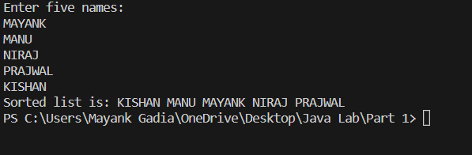

**Github link: https://github.com/Mayank-Gadia/Java.git**