**Q7. Design a java code for implementing Binary Search, pass array as parameter to the method.**

**Program:**

class Binary{

// Returns index of x if it is present in arr[].

int binarySearch(int arr[], int x)

{

int l = 0, r = arr.length - 1;

while (l <= r) {

int m = l + (r - l) / 2;

// Check if x is present at mid

if (arr[m] == x)

return m;

// If x greater, ignore left half

if (arr[m] < x)

l = m + 1;

// If x is smaller, ignore right half

else

r = m - 1;

}

// If we reach here, then element was

// not present

return -1;

}

// Driver code

public static void main(String args[])

{

Binary ob = new Binary();

int arr[] = { 2, 3, 4, 10, 40 };

int n = arr.length;

int x = 10;

int result = ob.binarySearch(arr, x);

if (result == -1)

System.out.println(

"Element is not present in array");

else

System.out.println("Element is present at "

+ "index " + result);

}

}

**Output:**

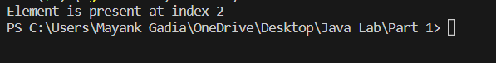

**Github link: https://github.com/Mayank-Gadia/Java.git**