

MAHARAJA AGRASEN INSTITUTE OF TECHNOLOGY
Department of Computer Science and Engineering
MINOR PROJECT SYNOPSIS
MindMesh
A Semantic Knowledge Management Platform

Programme: B.Tech. Computer Science and Engineering — VII Semester
Batch: 2023 – 2027 · Category: Software-Based Minor Project

(Team ID - MNP113)

SUBMITTED BY
Shrey Garg
Mayank Prince Narang
Devansh Sharma

PROJECT GUIDE
Dr. Deepak Gupta

1. TITLE OF THE PROJECT
MindMesh: A Semantic Knowledge Management Platform
2. PROBLEM STATEMENT
Conventional personal knowledge management (PKM) tools such as Notion, Obsidian, Evernote, Google Keep and Roam Research organise retrieval around exact keyword matching, manually assigned tags, or manually created backlinks. This model breaks down as a user's note collection grows, since it requires the user to recall the precise surface-level wording of a note rather than the underlying concept it represents.
This limitation is compounded by two further issues. Plain-text notes, Markdown documents and saved links are typically handled by separate tools or sections, with no unified retrieval layer spanning all formats — a saved URL, in particular, is usually stored as an opaque string with no attached semantic content. Tag- and folder-based organisation, in turn, requires the user to correctly predict every future retrieval need at the moment a note is created, an upfront categorisation burden that becomes unsustainable as the collection scales.
Core Problem: Traditional keyword-based retrieval requires users to remember the exact wording of stored information, whereas MindMesh retrieves information according to semantic relevance — so a query such as “what did I write about brightness?” correctly surfaces a note on adjusting Linux screen brightness, even though the word “brightness” never appears in it.

3. WHY IS THE PARTICULAR TOPIC CHOSEN?
Existing note-taking systems rely on keyword matching or manual organisation, both of which fail to scale as accumulated knowledge grows. Tools such as Obsidian and Roam Research move beyond simple folder hierarchies through manual backlinking, but still depend entirely on the user to create connections between notes rather than the system inferring conceptual relationships automatically from content. This gap between how information is stored and how it is naturally recalled motivated the team to explore semantic, concept-based retrieval as the core topic for this project.
The recent availability of native vector-search capability inside general-purpose databases such as MongoDB Atlas has made this approach practical to implement without provisioning a separate, dedicated vector-database service, lowering the barrier to building a lean, self-contained semantic-retrieval system — giving the team a technically achievable yet substantive problem to solve within a single-semester timeline.
4. OBJECTIVE(S) AND SCOPE OF THE PROJECT
OBJECTIVES
01 To design a unified note-storage schema supporting plain-text, Markdown and URL-based notes within a single organised collection (“brain”).
02 To implement semantic search using vector embeddings and MongoDB Atlas Vector Search, ranking results by conceptual relevance rather than keyword overlap.
03 To build an automatic URL metadata-extraction pipeline that converts saved links into semantically searchable content.
04 To implement brain- and note-level sharing with configurable read-only and collaborator permission tiers, secured through JWT-based authentication.
05 To implement an AI-assisted question-answering feature that generates answers grounded in the user's own retrieved notes, streamed to the client in real time.
06 To implement supporting background processing, including brain summarisation and periodic housekeeping of orphaned data.
SCOPE
The scope of the project is limited to the design, development and deployment of a working web-based platform that allows a user to capture plain-text, Markdown and URL notes into one or more brains; retrieve those notes through semantic, embedding-based search; share notes and brains with configurable access levels; and optionally query retrieved notes through an AI-assisted question-answering interface with streamed responses. The system is built and evaluated within a single-semester minor-project timeline, using the technology stack described in Section 6.
5. METHODOLOGY
The project follows an Agile development methodology, structured across five sequential sprints of two weeks each, spanning a total development period of ten weeks.
S1 | REQUIREMENTS & SCHEMA DESIGN — Weeks 1–2  Definition of the unified note schema (text / Markdown / URL); design of metadata, embedding storage and sharing-permission structures; finalisation of the REST API contract.

S2 | EMBEDDING & VECTOR SEARCH PIPELINE — Weeks 3–4  Integration of the Gemini Embedding 001 model; generation of note embeddings; configuration of MongoDB Atlas Vector Search; validation using paraphrase and near-synonym test queries.

S3 | BACKEND API DEVELOPMENT — Weeks 5–6  JWT authentication and rate limiting; note CRUD operations; URL metadata scraping; semantic search API; brain/note sharing; CRON cleanup job; unit testing.

S4 | FRONTEND DEVELOPMENT — Weeks 7–8  React.js and Tailwind CSS interface; note editor with live Markdown rendering; semantic search interface; brain and sharing management interface.

S5 | INTEGRATION, TESTING & DEPLOYMENT — Weeks 9–10  End-to-end integration and testing of the capture → embed → retrieve → synthesise pipeline; background JSON memory-state extraction; user-acceptance testing; production deployment.

6. HARDWARE, SOFTWARE, TECHNOLOGY STACK TO BE USED
Component | Technology | Purpose
Frontend | React.js + Tailwind CSS | Component-driven note editor and search interface
Backend | Node.js + Express.js | REST API layer and server-side logic
Authentication | JWT + API rate limiting | Secure, stateless session management
Database | MongoDB Atlas | Unified storage for notes and metadata
Vector Search | MongoDB Atlas Vector Search | Semantic retrieval over note embeddings
Embeddings | Gemini Embedding 001 | Converts notes and queries into vectors
AI / LLM | Gemini 2.5 Pro / Cerebras LLM | RAG-based question-answering synthesis
Link Processing | metascraper / cheerio | Open Graph metadata extraction from URLs
Real-Time Layer | Server-Sent Events (SSE) | Token-by-token streaming of answers
Background Jobs | Node.js worker + CRON | Brain summarisation and data cleanup
Deployment | Vercel (frontend) / Render (backend) | Production hosting and delivery
Table 1 — Technology stack used in MindMesh.
HARDWARE AND SOFTWARE REQUIREMENTS
- A development machine with a modern multi-core processor and a Node.js runtime environment.
- A modern web browser for accessing and testing the frontend interface.
- Internet connectivity for MongoDB Atlas, the embedding API and the LLM API.
- Git and a code editor (e.g., VS Code) for source-code development and version control.
7. WHAT CONTRIBUTION WOULD THE PROJECT MAKE TOWARDS THE SOCIETY?
MindMesh makes a practical contribution by improving the way individuals retrieve and make use of their own accumulated knowledge. By replacing keyword-dependent search with semantic, concept-based retrieval, the platform reduces the time and cognitive effort required to locate previously captured information, particularly in large note collections where relevant material could otherwise remain effectively lost.
For students, the platform assists in managing and rediscovering lecture notes, reference material and saved resources, supporting more effective study and revision practices. The brain- and note-level sharing functionality further supports collaborative knowledge sharing, allowing curated sets of notes to be shared with peers or small teams under clearly defined access permissions, without requiring a heavyweight collaboration platform.

8. THE SCHEDULE OF THE PROJECT (GANTT CHART)
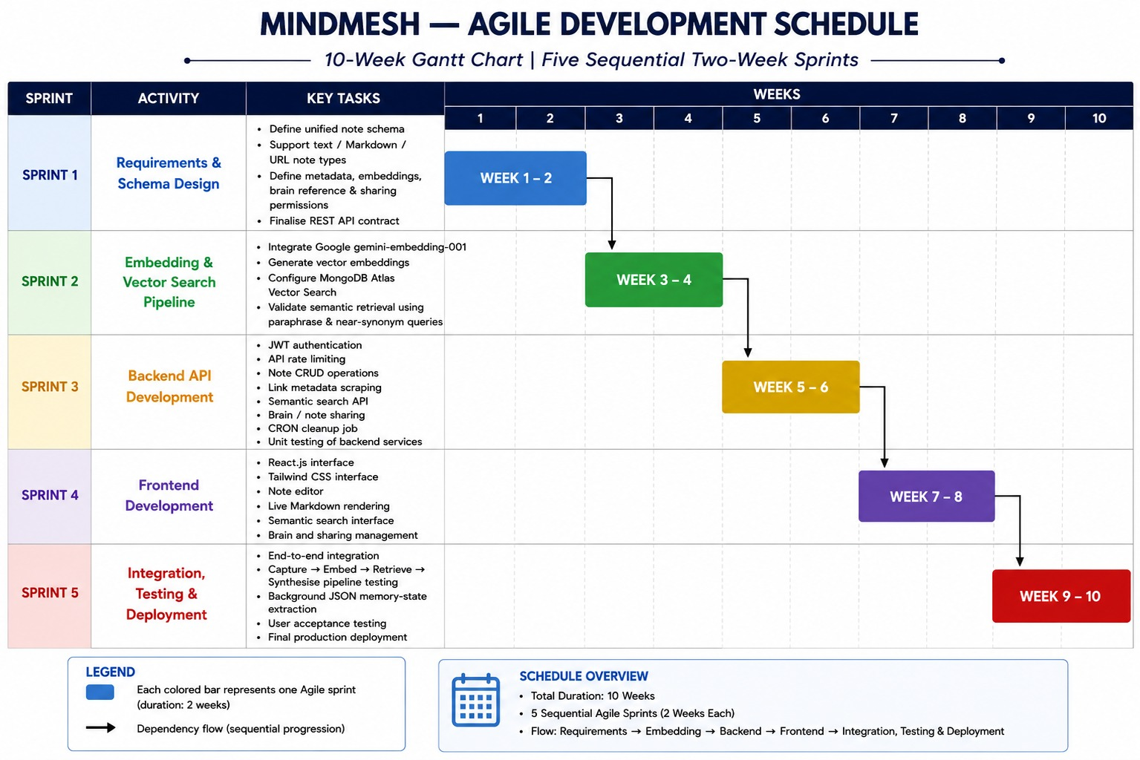
Fig. 1 — MindMesh Agile Development Schedule (10-Week Gantt Chart).
The project follows a 10-week Agile development plan organised into five sequential two-week sprints. Sprint 1 covers requirements gathering and schema design; Sprint 2 covers the embedding and vector-search pipeline; Sprint 3 covers backend API development; Sprint 4 covers frontend development; and Sprint 5 covers integration, testing and final deployment.
9. REFERENCES / BIBLIOGRAPHY
[1] IEEE Technology Navigator — Semantic Search. [Online]. Available: https://technav.ieee.org/topic/semantic-search/
[2] MongoDB — Vector Search Documentation. [Online]. Available: https://www.mongodb.com/docs/vector-search/
[3] Google AI — Gemini API Embeddings Documentation. [Online]. Available: https://ai.google.dev/gemini-api/docs/embeddings
[4] OpenSearch — Semantic Search Documentation. [Online]. Available: https://docs.opensearch.org/latest/vector-search/ai-search/semantic-search/
[5] D. Chandrasekaran and V. Mago, “Evolution of Semantic Similarity — A Survey,” 2020. [Online]. Available: https://arxiv.org/abs/2004.13820

