**UNIVERSITY OF MUMBAI**



**Master Of Computer Application**

**Mini Project Report on**

**Online Quiz Portal**

**Submitted By**

**Abhishek Chilka -8**

**Mathew Melvin -39**

(Semester-I)

Year 2017-18

Under the Guidance Of

Mr. Gajendra Dixit.

(As per Semester Based Credit and Grading System of University of Mumbai)

**Acknowledgement**

In writing this project report, it has been our endeavor to present the subject in simple and lucid manner to those who wish to refer it for enhancement or improving the existing features. The knowledge that we have gathered, study of relevant literature for understanding our project, planning of details and suitable software platform by itself and acknowledgement to the industry zeal and technical competence of those many individuals who have contributed to it with profound gratitude, We wish to acknowledge them.

We sincerely thank Thakur Institute of Management Studies, Career Development & Research for training us in the MCA course. We express our deep gratitude to our honorable director Dr.Vinita Gaikwad and we would also express our deep gratitude to our guide Mr. Gajendra Dixit. Their expertise and insight was invaluable to us during our project development period.

.

*Certificate*

*This is to certify that the project entitled* ***Online Quiz Portal*** *has been carried out by* ***Abhishek Chilka and Melvin Mathew*** *under my guidance during the academic year (August –December) 2017.*

---------------------------- -------------------------

Internal Guide Director, TIMSCDR

---------------------------------------

External Guide

**Table of Contents**

**Chapter 1 Introduction Page No.**

1.1 Short Description ..............................................................5 1.2 Need of project..................................................................5 1.3 Project Objective...............................................................5

1.4 Project Application...........................................................6

**Chapter 2 Project description**

2.1 E R Diagrams...................................................................7

2.2 Data Flow Diagram..........................................................8

2.3 Data Schema Diagram.....................................................9

2.4 Feasibility Studies..........................................................10

**Chapter 3 Project Methodology**.............................................................11

**Chapter 4 Data Dictionary**................................................................12-13

**Chapter 5 Screen Shots**.....................................................................14-19

**Chapter 5 Proposed Platform /Tool description**

3.1 Hardware requirement...................................................20

3.2 Software tool details......................................................20

3.3 Technology used............................................................20

3.4 Testing method..............................................................20

**Conclusion**...............................................................................................21

**Chapter 1 Introduction**

* 1. **Short Description:**

The ONLINE QUIZ PORTAL is a web application for students to take online test in an efficient manner and no time wasting for checking the paper. The main objective of ONLINE QUIZ PORTAL is to efficiently evaluate the candidate thoroughly through a fully automated system that not only saves lot of time but also gives fast results.Online Quiz Portal is platform for students to test their knowledge. This can be used in educational institutions as well as in corporate world. Can be used anywhere any time as it is a web based application(user location doesn’t matter).

**1.2 Need of project:**

* To provide student a platform to review their knowledge.
* Will be helpful for students before going for examination to test their knowledge.
* For students who cannot afford education can learn from internet and test their knowledge on this platform.
* To provide student with quick results.
* To reduce human intervention in assessing student’s knowledge.
* To reduce the use of paper and pen.

**1.3 Project Objectives.**

## User-friendly system

## User-friendly systems are not only needed for the creator, but also for participants. “Intuitive” is key. To make the system simple and user should able to use it without any problem or prior knowledge.

**Offering several types of questions**

Provide students/users questions related to different programming languages.

**Automatically checked answers**

Having to check all answers is very time-consuming. So, having the answers checked automatically and instantly will eventually pay off. It’s less work for the creator of the quiz and participants don’t have to wait too long for getting the results of their exams. Catching two birds with one stone.

**Provide Students a scenario of entrance exams which are much like quiz test(MCQ).**

**1.4 Projects Application**

This Web Application provides facility to conduct online quiz world wide.

 It saves time as it allows number of students to give the exam at a time and displays the results as the test gets over, so no need to wait for the result. It is automatically generated by the server.  Administrator has a privilege to create, modify and delete the testpapers and its particular questions. User can register, login and give the test with his specific id, and can see the results as well.

Modules :

1. Admin Module – To add /delete questions and categories/subject.
2. User Module – To give quiz test and get result.

**Chapter 2 Project description**

**2.1 E R Diagram:**

New User

User

Questions/Users

Login

Admin

Quest, Result

**E-R Diagram of Online Quiz Portal Fig 1.1**

**2.2 Data Flow Diagram**:

Add/Delete Questions Get Results

Admin

User

Vie View User/Result Give Quiz

**Level 0 DFD Fig 1.2**

Give Quiz Give Questions quest

User

Get Result Save Results user_results

**Level 1 DFD of User Fig 1.3**

Add/Del quest/cat Save Questions

Admin

Send questions quest

View User Results Send Results user_results

**Level 1 DFD of Admin Fig 1.4**

**2.3 Data Schema Diagram:**

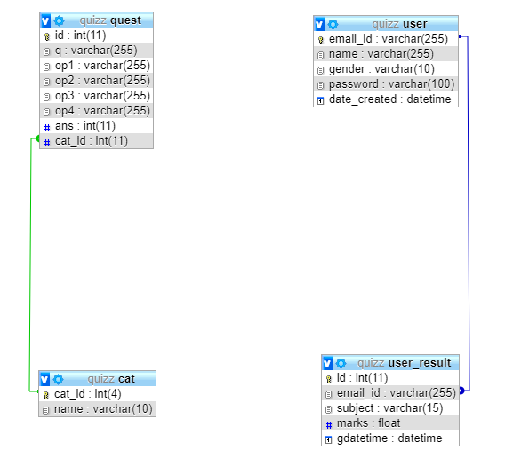

**2.4 Feasibility Studies**

Technical Feasibility:

The current system developed is technically feasible. It provides an easy access to users. It provides technical guarantee of accuracy, reliability and security. As the administrator is well versed in using a computer, so no extra knowledge needs to be imparted. Since, the administrator already has a PC with the necessary system requirements , it does not require any additional hardware or software

Economic Feasibility:

The system is economically feasible. Since, the administrator already has a PC with the necessary system requirements , it does not require any additional hardware or software. So, no extra costs are needed to be incurred.

Operational Feasibility:

The proposed system will be convenient to search the records as well as to update and maintain them. The users can also easily access all the information.

Schedule Feasibility:

The project will be completed within the specified period of time, since given deadline is reasonable. The website will be fully adequate and error–free.

**Chapter 3 Project Methodology**

[**Agile**](http://www.seguetech.com/blog/2013/04/05/what-is-agile-software-development) is an iterative, team-based approach to development. This approach emphasizes the rapid delivery of an application in complete functional components. Rather than creating tasks and schedules, all time is “time-boxed” into phases called “sprints.” Each sprint has a defined duration (usually in weeks) with a running list of deliverables, planned at the start of the sprint. Deliverables are prioritized by business value as determined by the customer. If all planned work for the sprint cannot be completed, work is reprioritized and the information is used for future sprint planning.

As work is completed, it can be reviewed and evaluated by the project team and customer, through daily builds and end-of-sprint demos. Agile relies on a very high level of customer involvement throughout the project, but especially during these reviews.

Some**advantages of the Agile approach**are easy to see:

* The customer has frequent and early opportunities to see the work being delivered, and to make decisions and changes throughout the development project.
* The customer gains a strong sense of ownership by working extensively and directly with the project team throughout the project.
* If time to market for a specific application is a greater concern than releasing a full feature set at initial launch, Agile can more quickly produce a basic version of working software which can be built upon in successive iterations.
* Development is often more user-focused, likely a result of more and frequent direction from the customer.

**Chapter 4 Data Dictionary**

**Table Name:** user

**Database Name:** quizz

|  |  |  |  |  |
| --- | --- | --- | --- | --- |
| **Field Name** | **Data Type** | **Field Size** | **Required** | **Allow Zero Length** |
| email_id(PK) | VARCHAR | 255 | Yes | No |
| name | VARCHAR | 255 | Yes | No |
| gender | VARCHAR | 100 | Yes | No |
| date_created | Datetime |  | Yes | No |

**Table Name:** user_result

**Database Name:** quizz

|  |  |  |  |  |
| --- | --- | --- | --- | --- |
| **Field Name** | **Data Type** | **Field Size** | **Required** | **Allow Zero Length** |
| email_id | VARCHAR | 255 | Yes | No |
| subject | VARCHAR | 15 | Yes | No |
| marks | FLOAT |  | Yes | No |
| gdatetime | Datetime |  | Yes | No |

**Table Name:** cat

**Database Name:** quizz

|  |  |  |  |  |
| --- | --- | --- | --- | --- |
| **Field Name** | **Data Type** | **Field Size** | **Required** | **Allow Zero Length** |
| cat_id | INT | 11 | Yes | No |
| name | VARCHAR | 10 | Yes | No |

**Table Name:** ques

**Database Name:** quizz

|  |  |  |  |  |
| --- | --- | --- | --- | --- |
| **Field Name** | **Data Type** | **Field Size** | **Required** | **Allow Zero Length** |
| id | INT | 11 | Yes | No |
| q | VARCHAR | 255 | Yes | No |
| op1 | VARCHAR | 255 | Yes | No |
| op2 | VARCHAR | 255 | Yes | No |
| op3 | VARCHAR | 255 | Yes | No |
| ans | INT | 11 | Yes | No |
| cat_id | INT | 11 | Yes | No |

**Chapter 5 Screen Shots**

**Home Page**

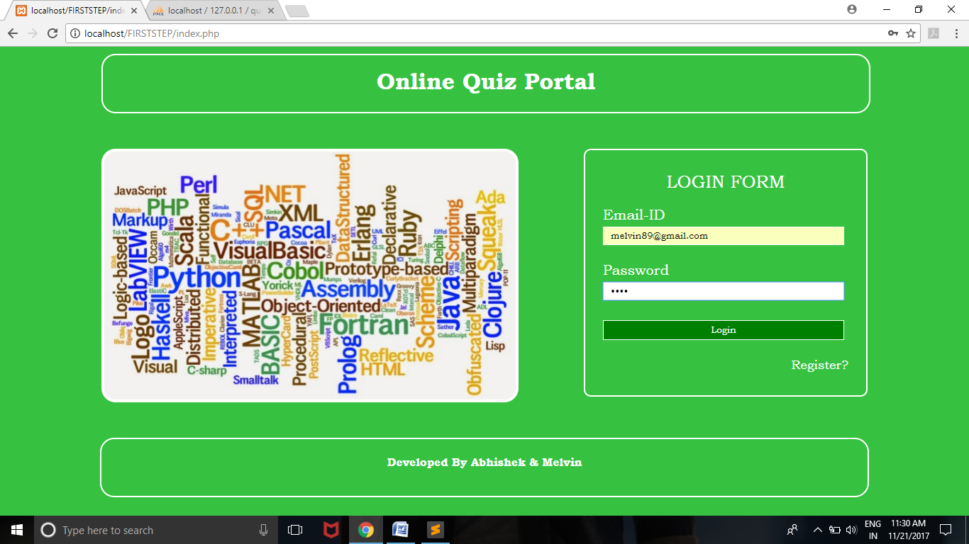

**User Registration Page**

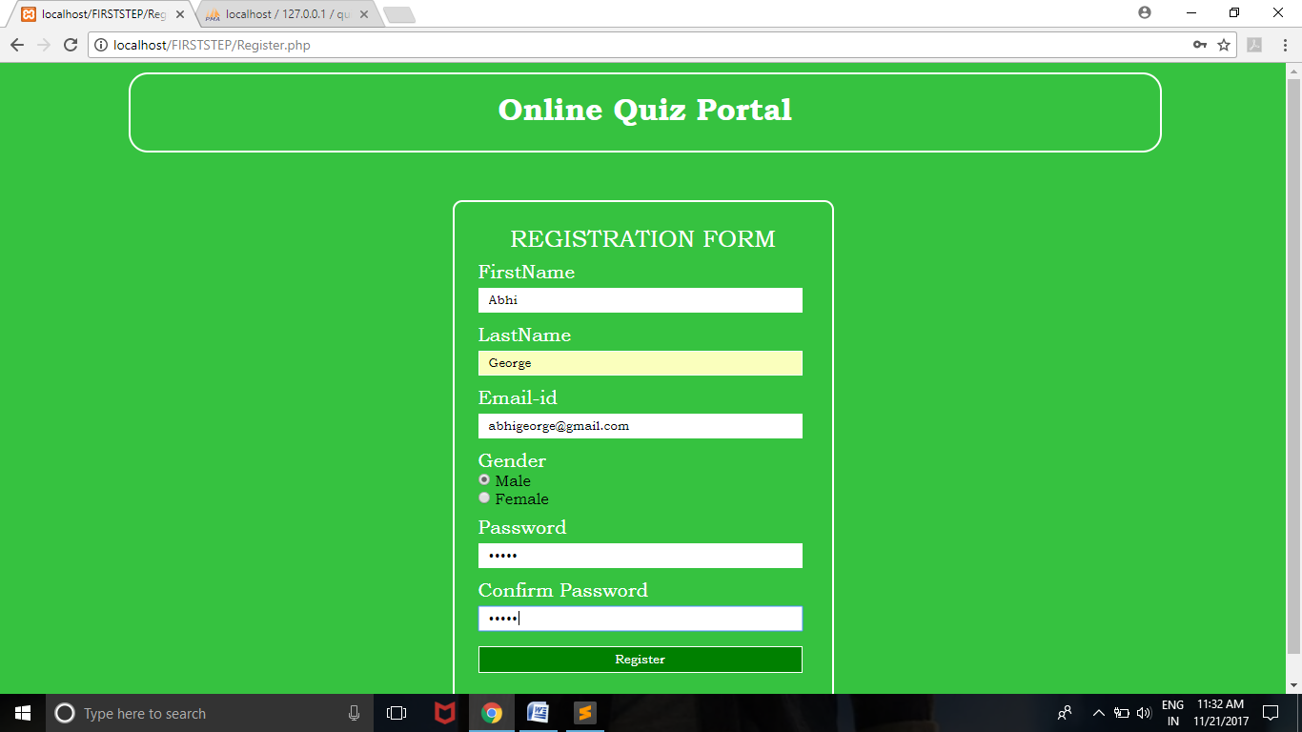

**User Welcome Page**

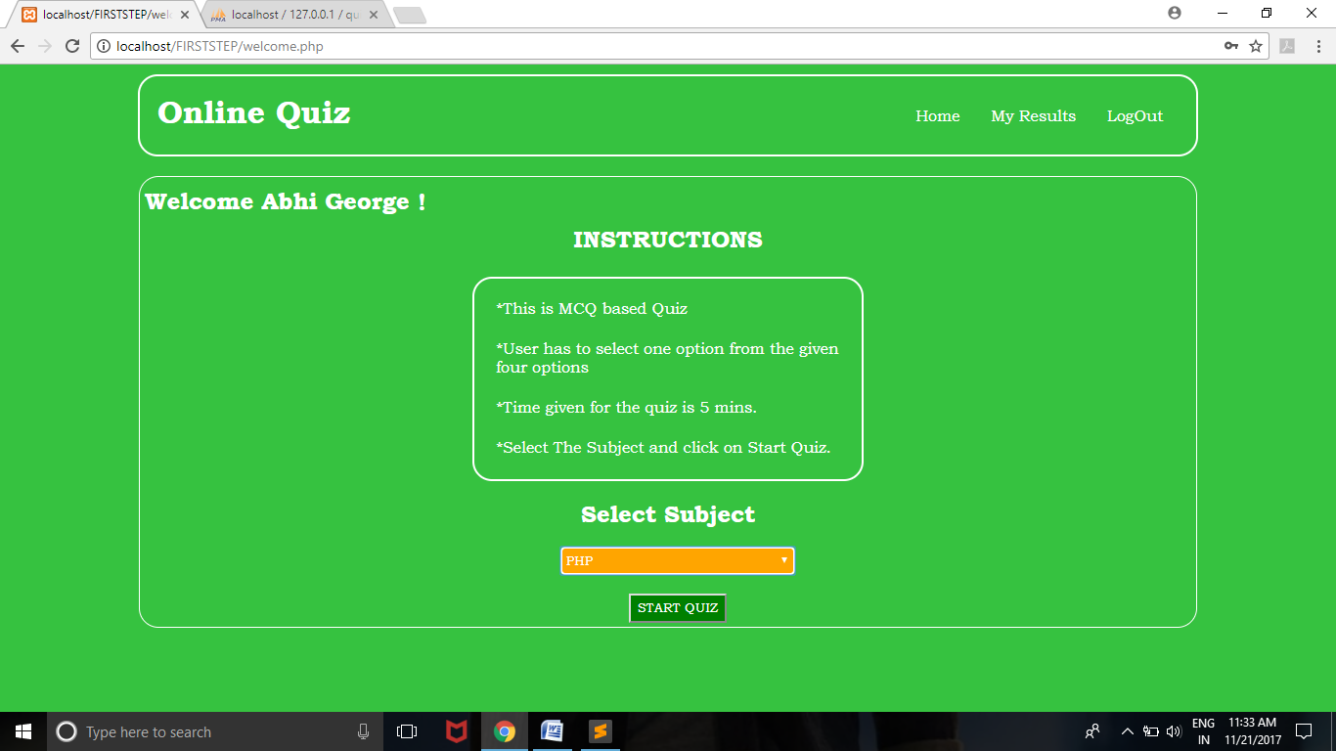

**Quiz Page**

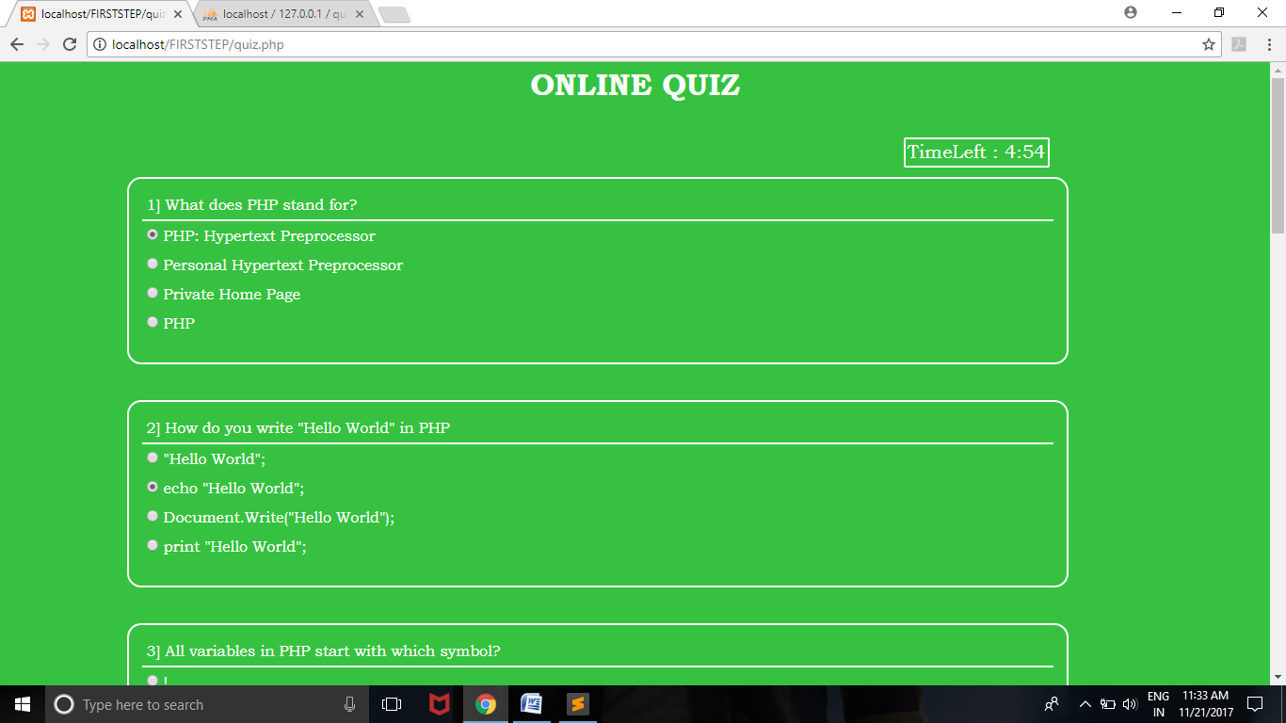

**User Result Page After Quiz**

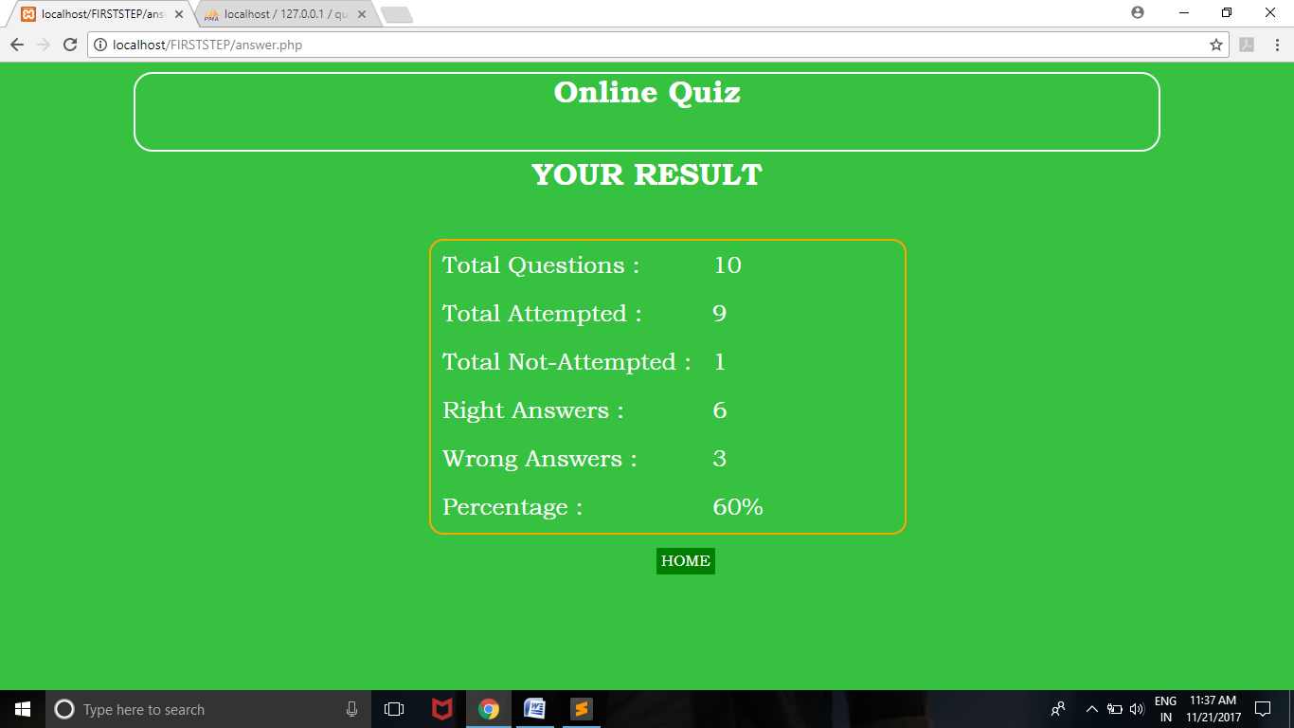

**User Result History**

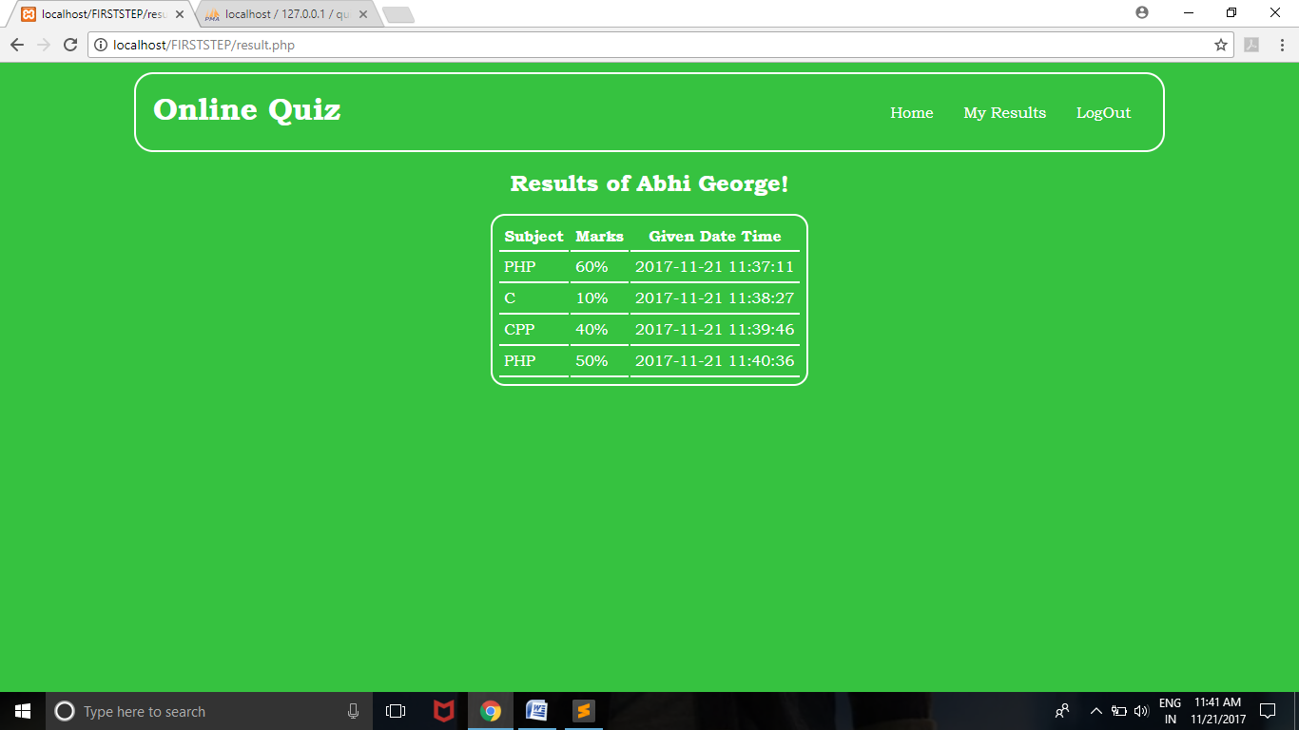

**Admin Welcome & Add Questions Page**

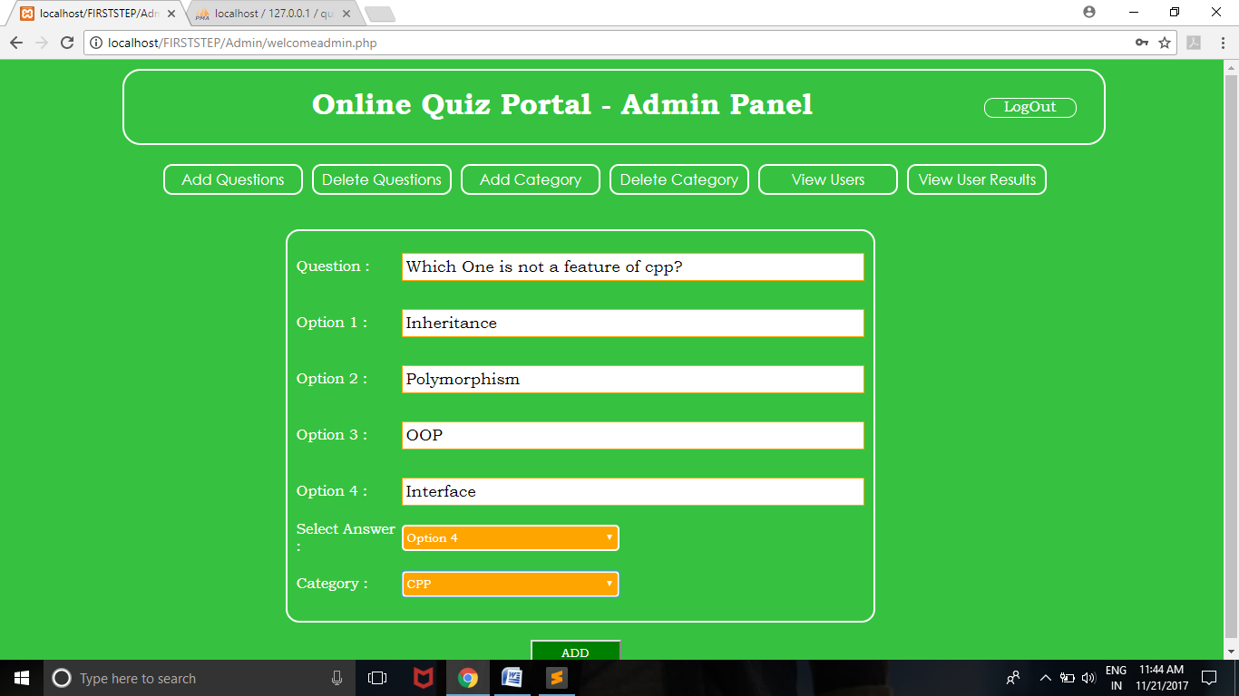

**Admin-Delete Question Page**

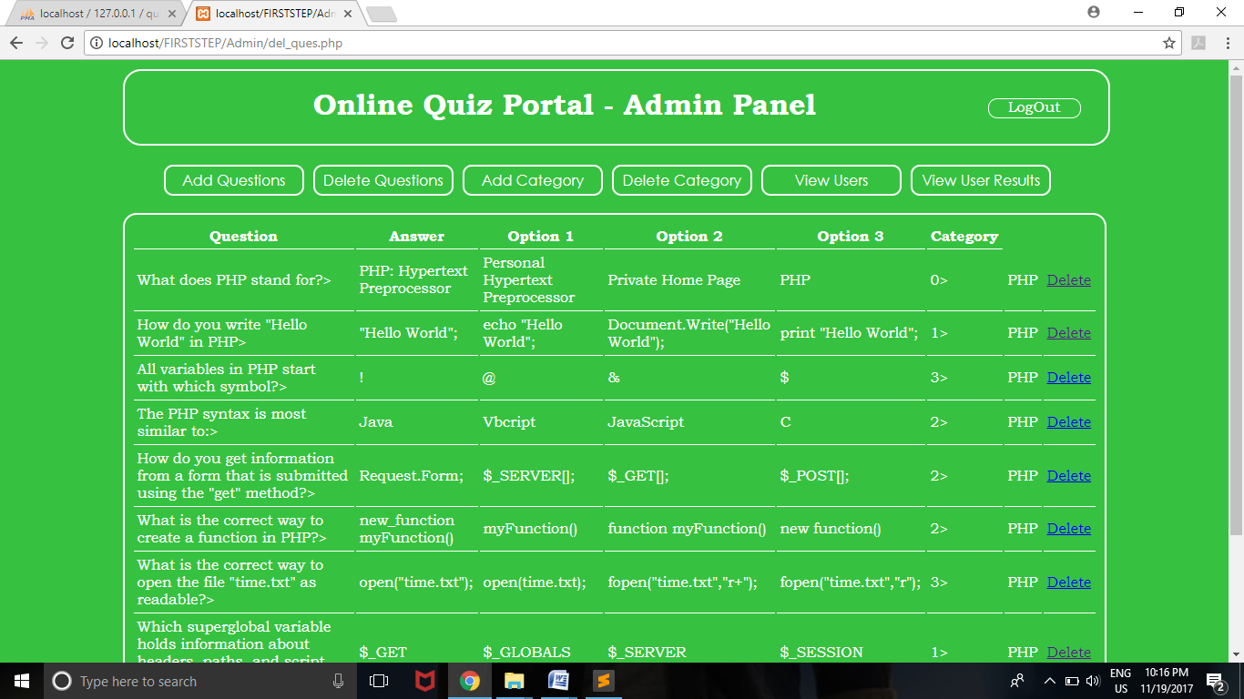

**Admin-Add Category**

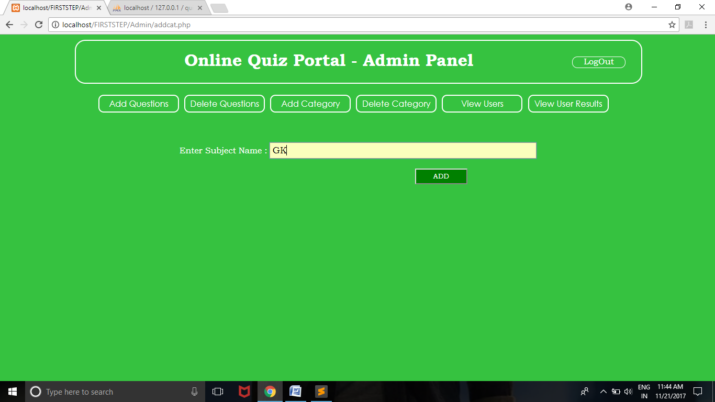

**Admin-Delete category**

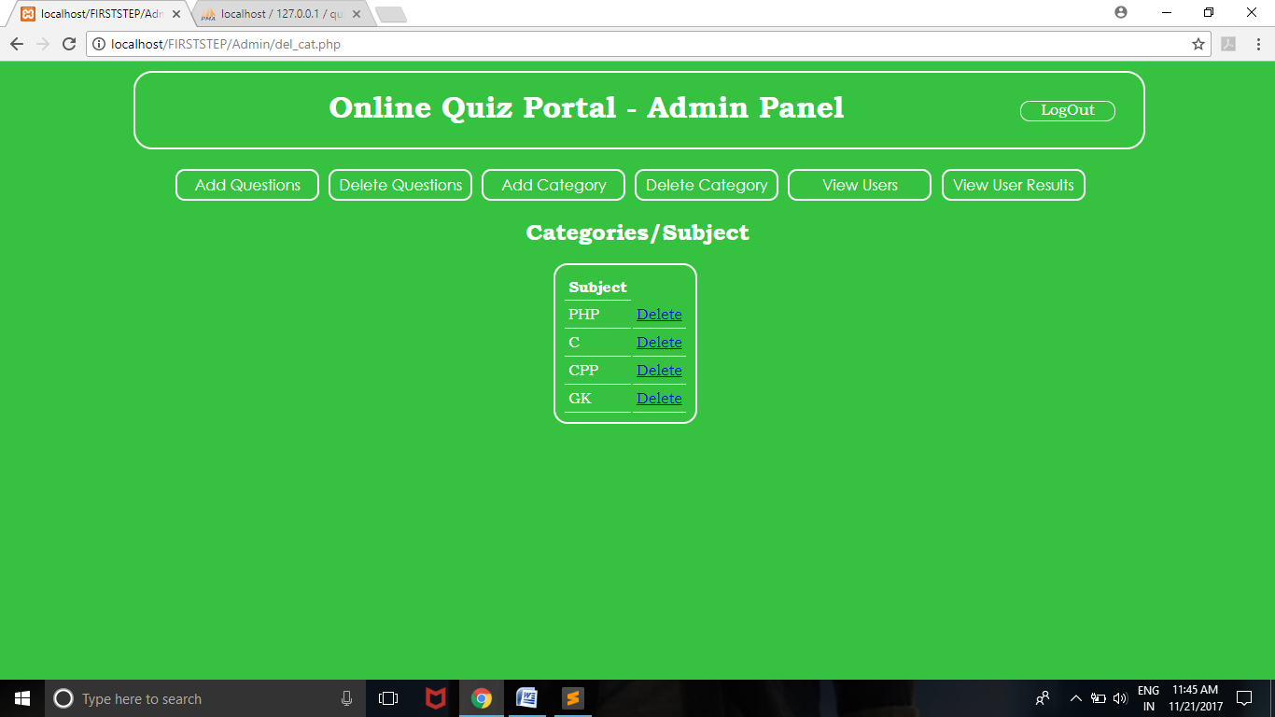

**Admin-view users**

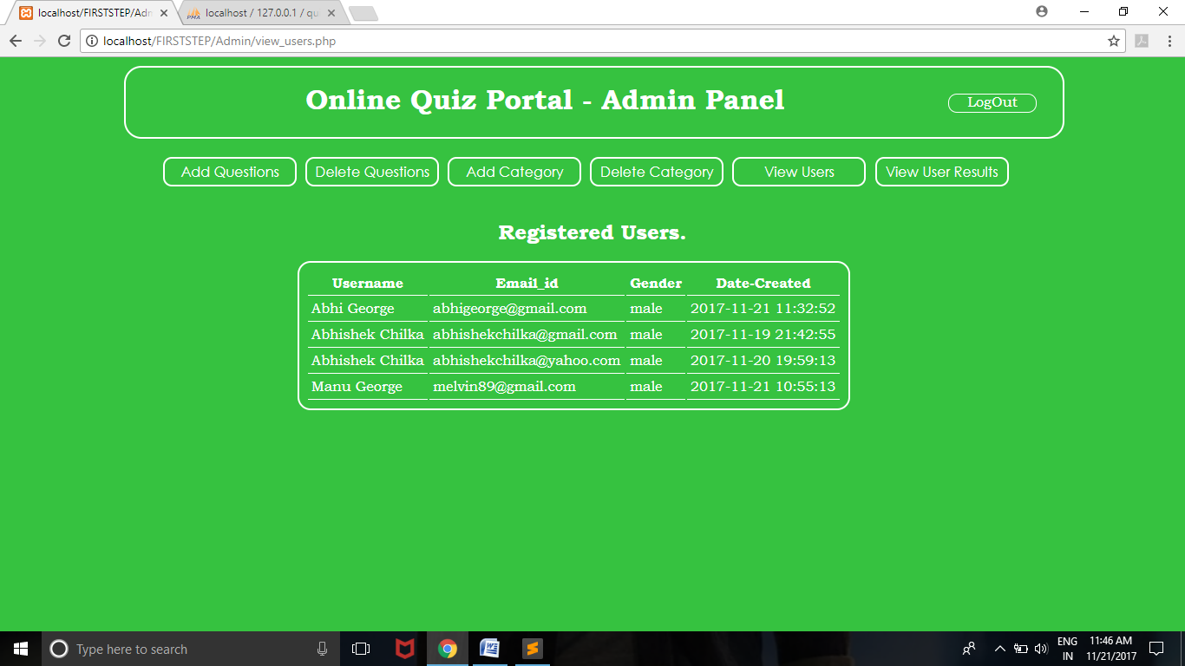

**Admin-View User Results**

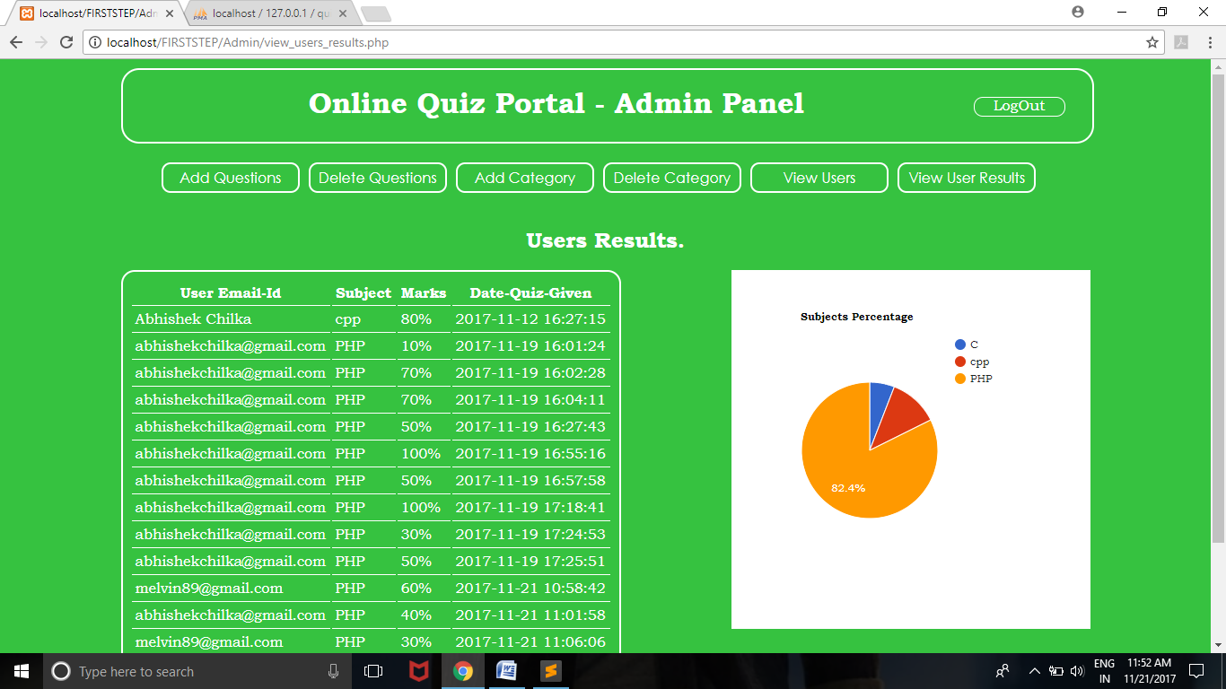

**Chapter 5 Proposed Platform /Tool description**

* 1. **Hardware requirement:**
* Pentium IV or higher processor
* 2 GB RAM.
* Modem
* 1280*720 at 250 colours display.

**3.2 Software tool details:**

* Company side server connected to World Wide Web(WWW).
* Client side: - Internet connection is required for supported web.
* Browser (I.E.3x, NC 3.x).

**3.3 Technology used:**

* Front End: - HTML, CSS, JavaScript.
* Back End: - MySQL.

**3.4 Testing method:**

* Black Box testing was used in the development of the project.

**Conclusion and References.**

**Conclusion:**

The project will be beneficial for all the students/users to review their knowledge. The project will be kept updated with new versions thus improving its functionalities. Also institutions can adopt this web application to assess their students.

**References:**

* The complete Reference PHP –Steven Holzner
* www.w3schools.com
* www.google.com
* www.youtube.com