INTRODUCTION
This project analyses customer shopping data to understand purchasing patterns, spending behaviour, product performance, and the impact of discounts, subscriptions, and shipping types.
The goal is to generate actionable business insights that can help improve:
- Revenue
- Customer retention
- Product strategy
- Marketing campaigns

OBJECTIVES
- Compare revenue across customer demographics.
- Identify high-value customers.
- Analyse the impact of discounts and subscriptions.
- Determine top-rated products.
- Compare spending across shipping types.
- Provide business recommendations.

Dataset Summary
- Rows: 3,900
- Columns: 18
- Key Features:
- Customer demographics (Age, Gender, Location, Subscription Status)
- Purchase details (Item Purchased, Category, Purchase Amount, Season, Size, Colour)
- Shopping behaviour (Discount Applied, Promo Code Used, Previous Purchases, Frequency of Purchases, Review Rating, Shipping Type)
- Missing Data: 37 values in Review Rating column
Tools & Technologies Used
- Python (Pandas, Matplotlib/Seaborn) – Data Cleaning & EDA
- SQL – Business Queries
- Power BI – Dashboard & Visualisations

Exploratory Data Analysis using Python
We began with data preparation and cleaning in Python:
● Data Loading: Imported the dataset using pandas
● Initial Exploration: using df.info()
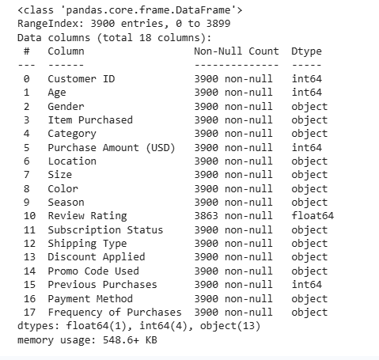
now using df.describe(include = 'all')
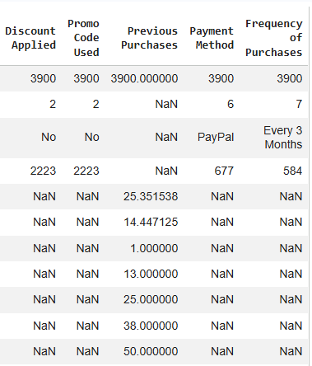

Now, Handling the Missing Values
Checked for the null values and assign the median rating of each product to them.
Standardization of the Columns
Renamed columns to snake case for better readability and documentation.
Perform the Feature Engineering
  - Created age_group column by binning customer ages.
  - Created purchase_frequency_days column from purchase data.
Now, Checking the Consistency of the Data
Checked if discount_applied and promo_code_used were redundant and then dropped the promo_code_used.
Now after performing Exploratory Data Analysis, we exported the cleaned CSV file for the further analysis using mysql.
Data Analysis using SQL (Business Transactions)
- Total revenue generated by male vs female customers
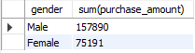
- Customers who used discounts but still spent above the average purchase amount
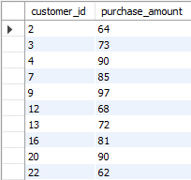
Total customers who used discounts but still bought the items with a price that is above the average purchase price = 839
- The top 5 products with the highest average review rating
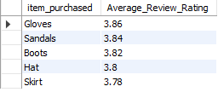
- The average purchase amount between Standard and Express Shipping
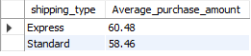
- Compared average spend and total revenue across subscription status.
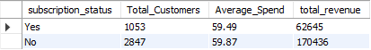
- The 5 products that have the highest percentage of purchases with disounts applied
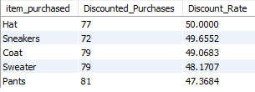
- Classified customers into New, Returning, and Loyal segments based on purchase history.
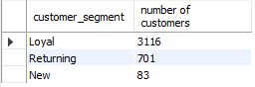
- The top 3 most purchased products within each category
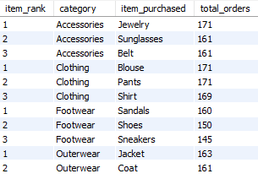
- Checked whether the customers with more than 5 purchases are more likely to subscribe.
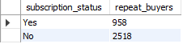
10) The revenue contribution of each age group .
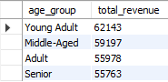

Dashboard in Power BI
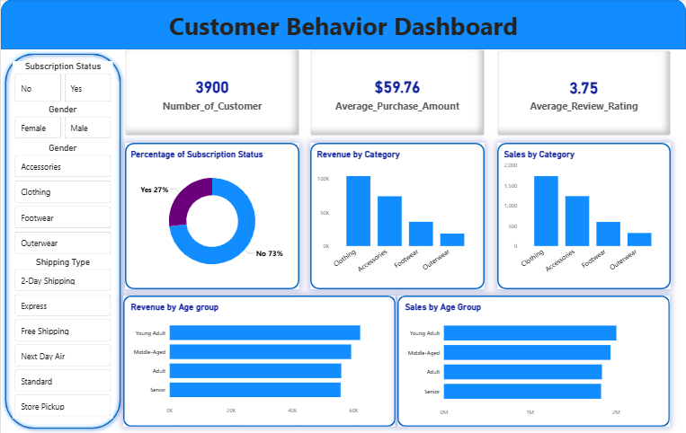
Business Recommendations
- Strengthen Subscription Adoption – Introduce and promote exclusive incentives for subscribed customers to increase retention and long-term value.
- Implement Customer Loyalty Initiatives – Design reward programs that encourage repeat purchases and gradually transition customers into the “Loyal” segment.
- Optimise Discount Strategies – Carefully evaluate discount policies to ensure they stimulate sales while maintaining healthy profit margins.
- Enhance Product Positioning – Prioritise high-rated and top-selling products in marketing campaigns to maximise visibility and conversion rates.
- Adopt Targeted Marketing Approaches – Direct promotional efforts toward high-revenue age groups and customers who prefer express shipping to improve campaign efficiency.

