**‘Budget Approval Process’ of Marketing Activities in an MNC**

Khoi Nguyen

Neha Savardekar

Mayank Sundriyal

Ganesh Babu Bamdhamravuri

MS in Business Analytics and Project Management, University of Connecticut

OPIM 5272: Business Process Modeling and Data Management

Professor Shu He

December 14, 2021

Contents

1. Process Description: 3

a) Interrelated tasks: 3

b) Triggering event 4

c) Specific Result 4

d) Customer 4

e) Stakeholders 4

2. Process Improvements and Reports required for this process: 4

a) Process Improvements: 4

b) Some reports and information we can pull out from this business process: 5

1. The total budget request and total approved budget by brand wise 5

2. The total budget request and total approved budget of marketing activities 5

3. The number of requests pending for approval, current approvers, and pending time until current system date (days) 6

4. The total value of purchase requests per marketing activities 7

5. The total time (in days) required for a request to be finally approved 8

# Process Description:

This is a budget approval process for marketing function in a multinational enterprise with a portfolio of more than 10 beverage brands. Every year, Finance and Marketing will agree upon budget allocation for each brand based on their annual volume targets and required resource. These funds will be used for a wide range of campaigns to support brand strategic priorities, including, but not limited to, media advertisement, digital advertising, consumer promotion, consumer research or event sponsorship.

When Marketing wants to invest in new campaigns or want to increase the amount on specific activities, they will have to get approval from not only MKT managers, but also Finance Managers, who will review the nature of the expense or the validity of requested amount. Even if MKT managers pass the plan, but Finance Managers do not find the amount requested for a particular expense reasonable, the request can still be rejected.

The process is triggered when requesters, Marketing Executives, create a budget request on system. After the budget is approved, Marketing executives will inform Procurement Admin to create a Purchase Request on system so that they can purchase a service or products for their campaigns. The Purchase Request is the result of this process. Once having the Purchase Request, expense can be made to vendors or suppliers which deliver services for Marketing function. No contract can be made without having Purchase Request in advance.

This process has all the essential elements of a business process. Detailed information is as below:

## Interrelated tasks:

* Create budget request
* IT Admin creates new code for the activity/campaign on system if they are new activities.
* Budget Approval module checks budget request vs. total available budget of the brand.
* Requesters send request for approval.
* Marketing and Finance managers review necessary documents, activity nature and expense.
* Once project is approved, IT Admin update budget on system and inform requester
* Marketing requestors send email to a Purchase Request (PR) admin to create Purchase Request (this is a must-have document for purchasing a service or spending budget on anything)
* PR admin create PR requests on Procurement module.
* Procurement module will check PR amount vs. budget amount, using information from Budget module. If the condition is met, it will automatically update to Procurement system.

## Triggering event

* There is a need for increasing Marketing budget, e.g., Marketing wants to sponsor a new fashion event, or needs to cover higher expense of producing a video clip etc.

## Specific Result

* The Purchase Request is created successfully on Procurement system.

## Customer

* Marketing department

## Stakeholders

* Marketing, Finance, IT, Procurement
* Suppliers/Vendors (without PR on system, they won’t be billed for their services to company).

# Process Improvements and Reports required for this process:

## Process Improvements:

There are a couple of things we can improve on this process:

* IT Admin has to update the approved budget manually and inform requesters. This can be subject to human errors and not an efficient practice. Setting up a function on system to automatically update budget and send announcement emails to related parties is more productive.
* If Finance Managers find that the request misses some key finance-related documents and return the request back to requesters. The budget request will have to go through the whole flow again. This is redundant since Marketing Managers already approve it.
* Some budget requests are pending for a long time at Manager level. This issue will hamper the progress of marketing campaigns or swift market reaction. A reminder should be triggered on the system to alert approvers that have not processed a specific request for over 1 week.
* Once the budget is approved, marketing team can create Purchase Request. Though there is a control gateway on system to ensure Purchase Request is not higher than the budget, there is no review from Finance to guarantee that Marketing is using the budget following strictly the activities approved before. For instance, they can request $10k for Advertising on Facebook, then use this additional amount for Advertising on Instagram. Since both activities are recorded under the same activity on system: Social Media Advertising, such a violation is unlikely to be revealed easily.

## Some reports and information we can pull out from this business process:

### The total budget request and total approved budget by brand wise

Below query and report gives the total budget requested and total budget approved for each brand and for each year. This report serves as a snapshot of the budget details of each brand, year-wise so that the marketing associates or managers can look at the report before requesting for new budget requests for other marketing activities.

### The total budget request and total approved budget of marketing activities

With this query we can find the total budget requested and the total budget approved for various marketing activities along with the activity code.

### The number of requests pending for approval, current approvers, and pending time until current system date (days)

With this query we would be able to identify the bottle neck in the approval process. As an expense owner, we can see where the request is pending for approval and contact that person to expedite approval. Additionally, we can also see on an average how long it takes for the request to get approved.

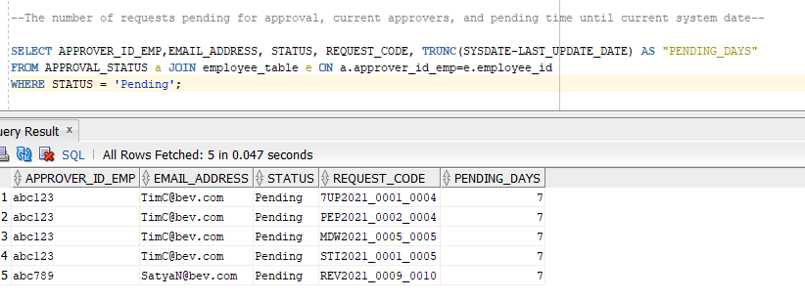

### The total value of purchase requests per marketing activities

Purchase Request is the required document to make payment to vendors or agencies. Thus, this report will let us know how Marketing team is actually using their approved budget. For example, up to now 7Up has spent roughly 92% of its approved budget on media advertising.

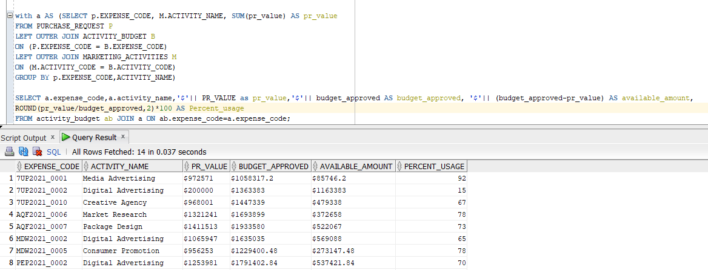

### The total time (in days) required for a request to be finally approved

This query and report give the total time duration in days taken for a budget request to get approved and total. This report is useful in providing the time taken by the approver in approving the budget request. So, that employees have an idea how long a budget request takes depending upon the approver and the budget amount requested.

