***AI/ML Internship – Week 1 Assignment***

**Intern Name:** Mayank Jain

**Internship ID:**INTERNSHIP_174099535967c57b1f336c3

**College Name**: Arya College of Engineering & IT

**Project Title:** Crop and Fertilizer Recommendation System using ML.

**Date of Submission:** 30 April, 2025

**INTRODUCTION**

* This document summarizes key topics discussed in Week 1 of the AI/ML Internship, conducted by Edunet Foundation in collaboration with AICTE. In this session, we were introduced to foundational concepts of Machine Learning, with a focus on Supervised Learning algorithms including Regression and Classification.
* These concepts are highly relevant to my project titled **"Crop and Fertilizer Recommendation System using Machine Learning"**, which uses agricultural data to suggest suitable crops and fertilizers.

**CONTENT**

1. **What is Machine Learning?**

Machine Learning is a branch of Artificial Intelligence where we train a machine to understand data, find relationships between the data, and use that understanding to predict new outcomes.

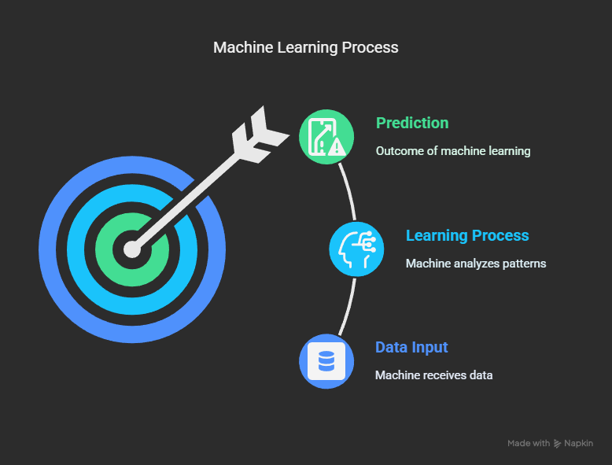

1. **What is Supervised Learning Machine Learning Algorithm.**

Supervised Learning is a type of Machine Learning where the algorithm is trained on a labelled dataset — that means each input is paired with the correct output. The model learns by comparing its predictions with the actual answers and improving its performance over time.

It is mainly used to solve two types of problems: **Classification** (predicting categories) and **Regression** (predicting continuous values).

1. **What is Regression & Classification?**

Supervised Learning is mainly divided into two types:

**🔹 1. Classification**

* **Definition**: Classification is used when the output variable is a **category or label**.
* **Purpose**: To classify input data into predefined classes.
* **Examples**:
  + Predicting whether a crop is **healthy or diseased**.
  + Classifying emails as **spam or not spam**.
  + Identifying **crop types** based on soil and climate data.

**🔹 2. Regression**

* **Definition**: Regression is used when the output variable is a **real or continuous value**.
* **Purpose**: To predict a quantity.
* **Examples**:
  + Predicting the **amount of fertilizer** needed for a field.
  + Estimating **crop yield** based on rainfall and soil quality.
  + Forecasting **temperature** or **market prices**.