**Email Communication**

**(Candidate)**

**Support Dashboard**

{User-Documentation}

1. As per the new functionality enabled, now the Flo-User can send the Email to the candidate from the Support Dashboard as well.  
     
   
2. In accordance with the current implementation, the following Email templates are designed under the INO section only in the Support Dashboard, although the Email icon will be present in all the sections of the Support Dashboard beside the Candidate details  
     
   a. Interviewer Delay Notification  
     
   b. Request to Reschedule  
     
   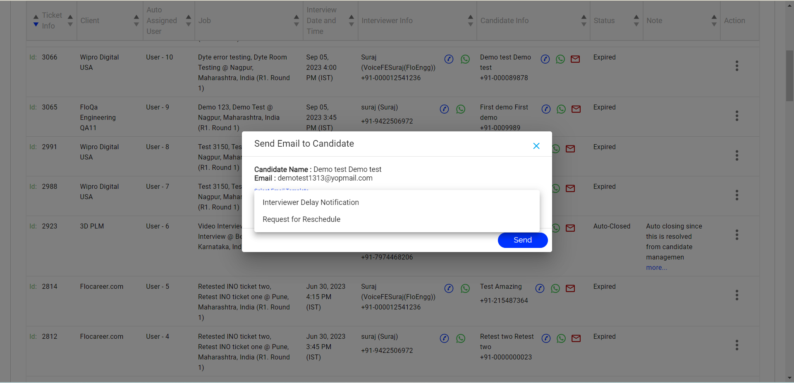

1. The Email template for “Interviewer Delay Notification” is as follows:

**Subject: Client Name_Flocareer Interview in Progress: Slight Delay - Please Await"**

**Dear [Recipient's Name],**

**We appreciate your patience as we get ready for your interview. Please remain in the interview room, as we are working to connect with the interviewer and will begin shortly. We apologize for the inconvenience caused due to the delay.**

**Regards**

**Team FloCareer**

**Note:**

From: no-reply@flocareer.com

CC: [interviews@flocareer.com](mailto:interviews@flocareer.com)

To: Candidate Email-ID

1. The Email Template for “Request for Reschedule” is as follows:

**Subject : Client_ FloCareer_Request for Interview Rescheduling**

**Dear [Recipient's Name],**

**We regret to inform you that, due to a personal emergency your interviewer was unable to join the interview room. We apologize for any inconvenience caused. To proceed, we kindly ask you to provide us with your preferred reschedule slots so that we can promptly arrange for your interview to take place.(*Link to update the slots to be added*)**

**Regards**

**Team FloCareer**

**Note:**

From: no-reply@flocareer.com

CC: [interviews@flocareer.com](mailto:interviews@flocareer.com)

To: Candidate Email-ID