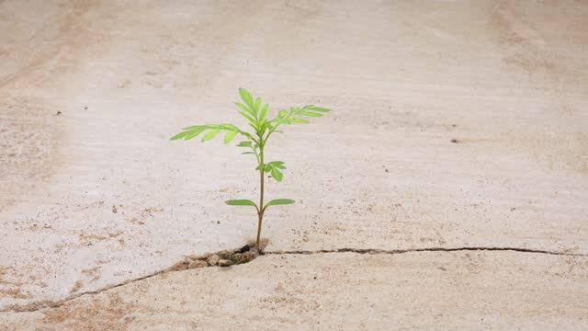
In the middle of a big, gray city where everything was hard and unyielding, there was a little sapling growing through the cracks in the concrete. It was like a tiny hero, saying, "Nature can thrive anywhere!" The green shoots stood out against the dull background, showing how strong and determined life can be, even in tough places.
The sapling's roots went into the small spaces between the concrete, searching for food where you wouldn't expect to find any. Each leaf that grew was like a small victory, telling a story of never giving up. In a busy city where people often forget about nature, the little tree became a symbol of strength, reminding everyone that life can be tough but also beautiful.
As the seasons changed, so did the sapling. It grew taller, reaching for the sunlight with a clear purpose. Its story was like a message written in the cracks of the concrete, showing that life is powerful and can find a way to grow, no matter what. In the middle of the city, the little tree became a sign of hope, telling everyone that even in hard times, we can keep going and make our own story.

