NATIONAL HACKATHON TECHNICAL REPORT
Sentinel AML
AI-Powered Suspicious Activity Detection
Ask the data. Trace every decision.
CORE PROPOSITION
A query-aware AML investigation workspace that transforms a natural-language instruction into a minimal analytical plan, selectively invokes governed tools, and returns explainable risk with a human-controlled escalation trail.

Team Leader: Devesh Raj | Team Member: Mayank Gupta
Technical architecture, algorithms, governance, UI and demo evidence
Executive Brief
What the platform solves, how it works, and why it stands out
30-SECOND PITCH
Traditional AML monitoring is noisy and rigid. Sentinel AML lets an investigator ask a question in plain language, builds the smallest defensible tool plan, analyzes only the relevant evidence, and returns ranked risk, transaction support, an explanation, an action recommendation and a trace of every decision.

Problem
- Static threshold rules generate large review queues and limited context.
- Structuring, smurfing, layering, rapid movement and behavioural change require different analytical evidence.
- Opaque scores are difficult to defend to investigators, model owners and auditors.
- Running every tool for every query wastes compute and can dilute targeted signals.

Implemented solution
- Natural-language intent, entity, date, amount, country, payment-format and typology extraction.
- Policy-constrained dynamic planning with selected tools, skipped tools and reasons.
- Hybrid rules, statistics, Isolation Forest and conditional graph analysis.
- Detector-aware score fusion, Low/Medium/High bands and Monitor/Review/Report actions.
- Evidence-linked explanations, SAR drafts, exports, investigations, alerts and audit records.
- Governed CSV/XLSX workspaces with inspection, fingerprinting, isolation and activation.
Verified project scale | Value
Operational HI-Small transactions | 5,078,345 rows
SAML-D knowledge/calibration table | 59,873 rows
Combined governed analytical rows | 5,138,218 rows
Primary planner tool registry | 11 tools
Reviewer application routes | 9 workspaces
Active anomaly-model baseline | 50,000 normal-behaviour rows

1. Platform Architecture
Active end-to-end runtime
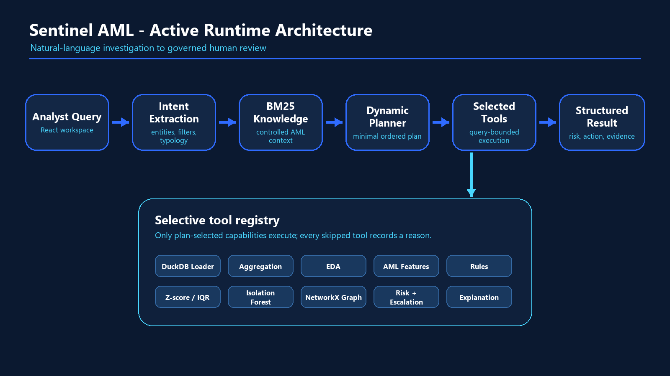
Figure 1. Active runtime from analyst query to structured, persisted review evidence.
The React workspace submits a QueryRequest to FastAPI. AgentRunner resolves the active dataset, extracts a validated intent, retrieves the top AML knowledge snippets, and asks DynamicPlanner for an ordered minimal plan. AgentRunner executes only those steps, records duration and rationale, then assembles a typed AgentResponse.
The response includes the original query, active dataset, extracted filters, plan reasoning, executed and skipped tools, summary statistics, ranked entities, risk contributions, supporting transactions, explanations, escalation actions and optional EDA or graph outputs.
IMPORTANT IMPLEMENTATION BOUNDARY
The live application uses agent.runner.AgentRunner, agent.intent_extractor.IntentExtractor, agent.planner.DynamicPlanner and the tools package. Additional contract-driven agents under agent/detection, interaction, knowledge_runtime, orchestration, reporting, risk, runtime and visualization are implemented and tested as extension modules, but are not all wired into api.main. Demo claims should focus on the active AgentRunner path.
2. Agentic Workflow and Dynamic Planning
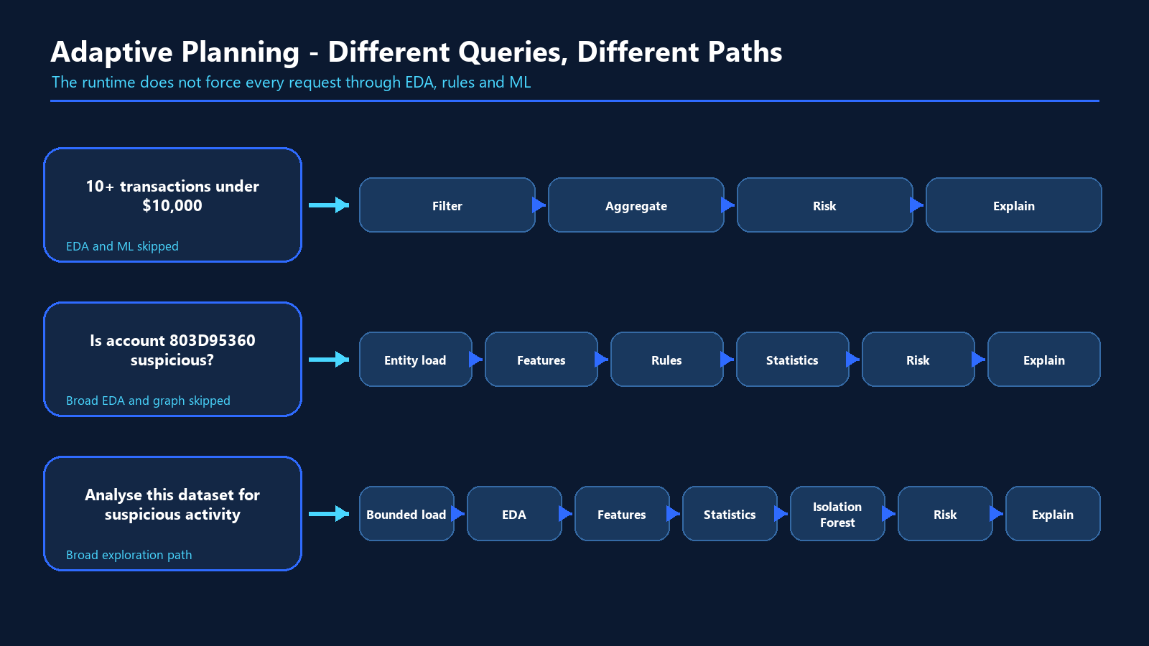
Figure 2. Query intent changes both the tool sequence and the evidence scope.

Intent extraction
The extractor classifies each request as pattern_search, aggregation, entity_lookup or broad_eda. It identifies supported AML patterns and extracts ISO date ranges, account identifiers, minimum and maximum amounts, minimum transaction counts, source countries and payment formats. Groq can produce the JSON contract; a deterministic parser provides an offline fallback.

Planner policy
- Data loading is always first and applies the extracted scope before expensive computation.
- Broad EDA invokes profiling, feature engineering, statistics and ML.
- Aggregation questions call the grouped threshold tool directly.
- Entity lookups compute targeted features, rules and statistics while skipping broad EDA.
- Graph analysis is selected only for network-dependent patterns such as cycles and layering.
- Risk scoring, escalation and explanation remain final decision stages.
- Unknown LLM-proposed tools are removed by an explicit allow-list validator.
3. Data Flow and Governance
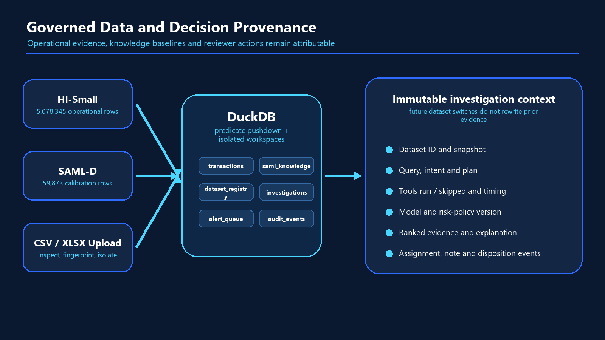
Figure 3. Separate evidence, knowledge and workflow tables preserve attribution.
Dataset | Implemented role | Key fields
HI-Small Transactions | Operational evidence used for customer and transaction investigation | time, accounts, banks, values, currencies, payment format, source label
SAML-D | Typology grounding, statistical baseline, model training and validation | sender, receiver, amount, countries, payment type, laundering type
Uploaded CSV/XLSX | Institutional evidence registered in an isolated DuckDB schema | canonical fields determined by schema inspection and mapping

The active DuckDB contains six primary tables: transactions, saml_knowledge, dataset_registry, investigations, alert_queue and audit_events. Uploaded datasets receive a fingerprint, workspace schema, row and label metadata, ingestion timestamp and activation state. Existing investigations retain their original dataset attribution after a future workspace switch.
LABEL DISCIPLINE
Source laundering labels are retained as dataset metadata and validation context. They are not presented to reviewers as model predictions. Operational evidence and SAML-D calibration data are not joined into one detection table.
4. AI and ML Pipeline
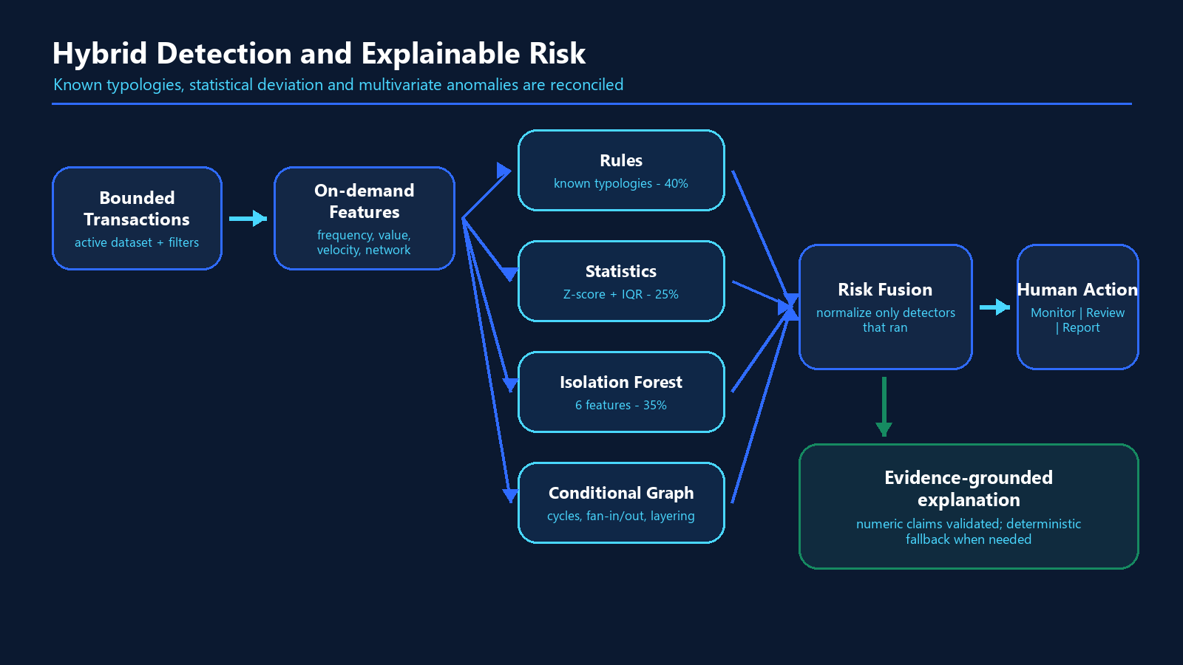
Figure 4. Complementary detectors feed a transparent, policy-controlled decision.

On-demand AML feature engineering
Feature | Meaning
txn_count_7d | Seven-day sending frequency
rolling_sum_7d | Seven-day aggregate transaction value
near_threshold_count | Repeated values between 8,000 and 10,000
amount_deviation | Deviation from an account's prior mean transaction value
velocity_1hr | One-hour transaction burst intensity
fan_in_count | Distinct inbound counterparties in the query window
Contextual families | fan-out, recent inflow, cross-border and rapid cash-out signals

DuckDB window functions compute rolling and velocity features while preserving row order. Feature families are selected by typology. When Isolation Forest is planned, the feature contract is completed even if the user asked for a narrower typology.
5. Analysis Algorithms
How suspicious behaviour is detected

Rule engine
- Structuring: repeated transactions from 8,000 to below 10,000 with at least three near-threshold events.
- Smurfing: concentrated fan-in from multiple senders or repeated cash deposits with material aggregate value.
- Rapid cash-out and deposit-send: outbound movement following recent inflow or concentrated activity.
- Single large, fan-in, fan-out and high-risk-country signals are independently attributable.
- Only rules compatible with the requested pattern are applied.

Statistical detector
Per-account amount deviation is measured with a Z-score. A second signal uses IQR limits calculated from SAML-D normal behaviour. The statistical score is the larger of normalized absolute Z-score and the IQR outlier flag.

Isolation Forest
Configuration | Implemented value
Algorithm | scikit-learn Isolation Forest
Training source | SAML-D normal-behaviour sample
Training rows | 50,000
Estimators | 200
Contamination assumption | 0.10%
Serving features | 6
Normalization | Min-max over training anomaly-score range
Drift indicator | Population Stability Index

Graph analysis
The optional NetworkX tool builds a directed account graph and reports bounded cycles of length two to four, fan-in, fan-out, bipartite structures, gather-scatter and scatter-gather patterns. Edge, result and cycle-search limits prevent unbounded graph work.
6. Risk Scoring, Explainability and Escalation

Detector-aware score fusion
Signal | Base weight | Decision behavior
Rule engine | 40% | Auditable known-typology evidence
Statistical detector | 25% | Deviation from account or normal-data baseline
Isolation Forest | 35% | Multivariate anomaly evidence
Country context | +0.10 maximum | Explicit policy uplift when supported by available country fields

Weights are renormalized over detectors that actually ran. A skipped detector contributes neither a zero nor its unused weight, preventing a focused rule-only plan from being artificially diluted. Scores are clipped to the interval from zero to one.
Score | Risk band | Operational action
Below 0.35 | Low | Monitor below 0.40
0.35 to below 0.70 | Medium | Review from 0.40; otherwise monitor
0.70 and above | High | Report recommendation

Grounded explanation
The explanation layer receives the user query, intent, tool decisions, computed features, rule and detector scores, risk contributions, top transactions and retrieved AML knowledge. Groq can produce the narrative. A numeric validator checks model-generated numbers against the supplied evidence and retries once when a claim is unsupported. Deterministic templates provide a safe fallback.
COMPLIANCE GUARDRAIL
Sentinel produces decision support and reviewer-ready SAR drafts. It does not determine that money laundering occurred and does not autonomously file a SAR or STR.
7. Backend, APIs and Database
Layer | Implementation
Service | FastAPI 0.111 with Uvicorn and Pydantic contracts
Analytical database | DuckDB with parameterized filters and predicate pushdown
Data processing | Pandas, NumPy, PyArrow and SciPy
AI integration | Groq JSON-mode calls with Tenacity retries and deterministic fallback
ML and graph | scikit-learn Isolation Forest and NetworkX
Exports | JSON, CSV, XLSX, Markdown, TXT and PDF
Deployment | Render blueprint, persistent disk bootstrap and frontend API proxy

Primary active API surface
Area | Representative endpoints
Operations | GET /health, GET /ready, POST /ingest
Agent | POST /query
Evidence | GET /customers, /customers/{id}, /transactions
Datasets | list, inspect, upload, activate and delete
Workflow | investigations, queue, assignment, notes and disposition
Governance | model card, drift, policy and audit
Exports | entities, investigation, trace, SAR draft, model card, audit and EDA

The React client adds request IDs, applies a 30-second timeout, retries idempotent GET requests on transient failures, and does not retry mutable POST requests. The Vite development server proxies /api to FastAPI; the hosted worker proxies the same path through API_BASE_URL.
8. User Interface Design
Investigator-first, evidence-first workflows
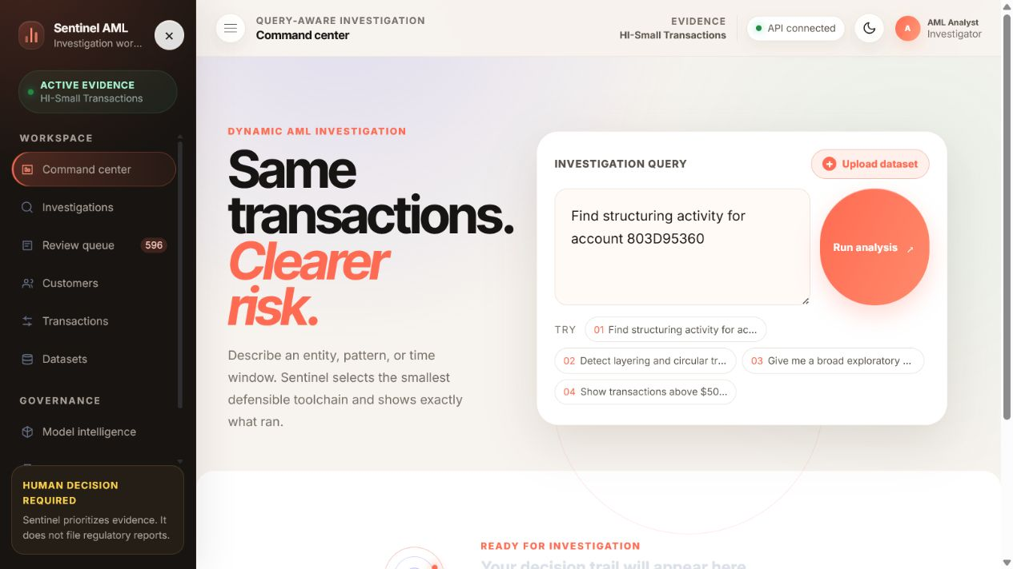
Figure 5. Query-aware Command Center with direct governed dataset upload.
- The landing surface centers the analyst question rather than model controls.
- Example queries communicate the four supported investigation modes.
- The active dataset and API state remain visible in the application shell.
- Results preserve the decision sequence: intent, plan, execution, risk, evidence and action.
- Entity drawers show supporting transactions without losing the ranked investigation context.
- Responsive navigation, theme control, readable typography and reduced-motion support improve accessibility.
9. Human Review and Dataset Workspaces
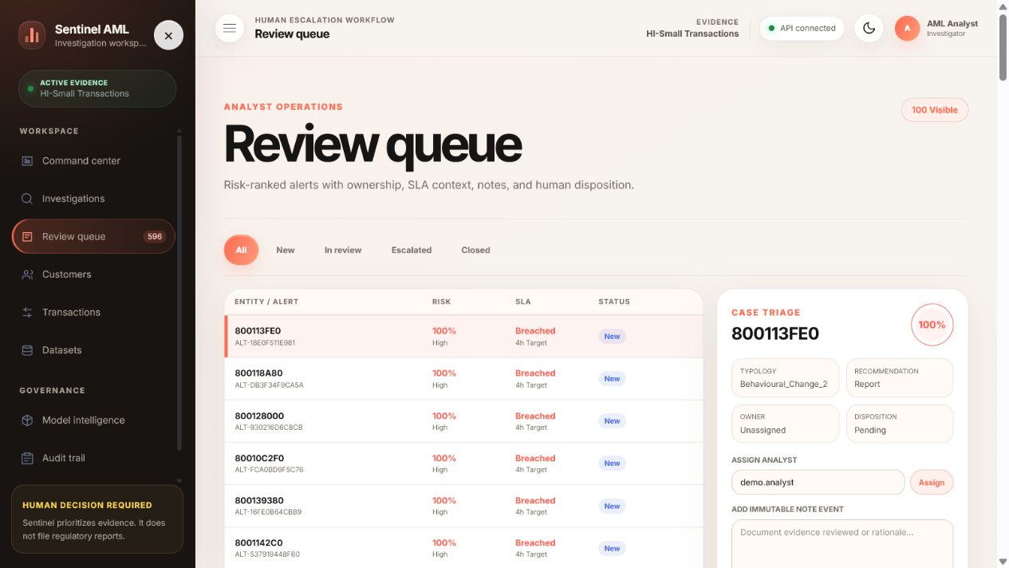
Figure 6. Review queue with ownership, SLA context, notes and disposition.
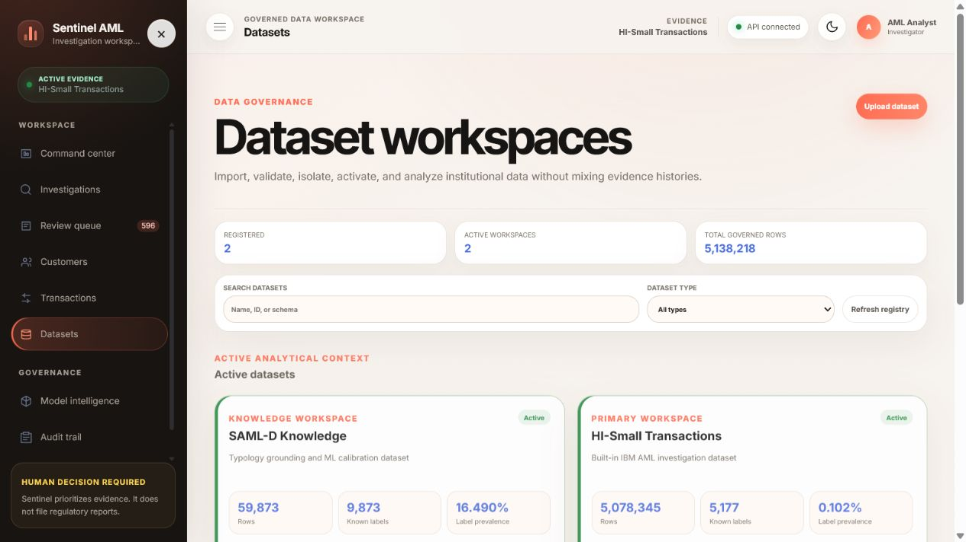
Figure 7. Isolated data workspaces with provenance and activation state.
10. Model Intelligence and Governance
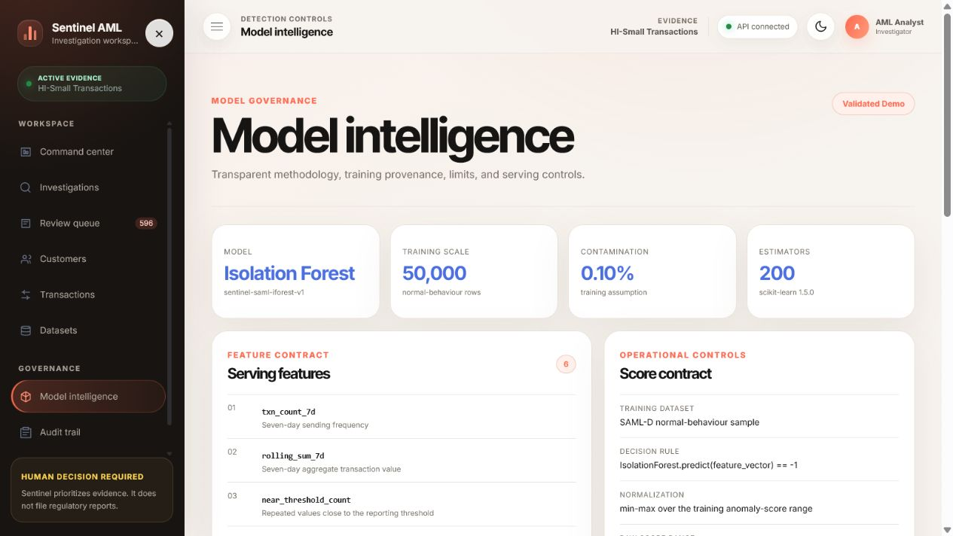
Figure 8. Active model metadata, serving contract and PSI drift monitoring.
- The model page exposes training source, scale, contamination, estimators, features and score normalization.
- PSI compares the exact training feature baseline with a current bounded investigation slice.
- The policy page publishes risk thresholds, detector weights, escalation boundaries and jurisdiction context as read-only configuration.
- Audit events retain the model version, risk-policy version, dataset snapshot, actor and event payload.
- Investigation and alert persistence is atomic, preventing a partial queue state without its parent record.
11. Security and Compliance Controls
Control | Implemented evidence
Secrets | .env is ignored; API-key presence is reported without returning its value
CORS | Credentialed origins are explicit; wildcard origins are rejected
Query safety | 2,000-character request cap and planner tool allow-list
SQL safety | User filter values are parameterized; workspace identifiers are validated
Upload safety | Extension allow-list, streaming size cap, empty-file rejection and fingerprinting
Export safety | Safe filenames, no-store headers and spreadsheet-formula protection
Session primitives | PBKDF2-SHA256 passwords, opaque hashed sessions, HttpOnly Strict cookies, rate limiting and origin checks
Human control | No automatic regulatory filing; audit and policy writes are not publicly exposed

CURRENT DEMO AUTHENTICATION STATUS
The frontend intentionally uses a pass-through ProtectedRoute and the active api.main exposes direct demo endpoints. Authentication and role-aware modular routes are implemented and tested, but router discovery is not mounted into api.main. Production deployment still requires wiring the authenticated router set, enterprise identity integration and institution-specific RBAC.
12. Performance, Scalability and Reliability
Operation | Observed | Target
Filtered load, 1,000 rows | 0.03 s | < 1.0 s
Feature engineering, 1,000 rows | 0.09 s | < 2.0 s
Rule engine, 1,000 rows | 0.01 s | < 0.5 s
Statistical scoring, 1,000 rows | 0.05 s | < 0.5 s
ML including initial model load | 1.39 s | < 5.0 s
Full pipeline, 500 rows | 0.16 s | < 10.0 s
Risk and escalation, 1,000 rows | 0.10 s | < 0.2 s
Risk-ranked customer page, 515,080 accounts | 1.96 s | < 3.0 s

- DuckDB applies filters before in-memory analysis and enforces a configurable maximum query-row boundary.
- Graph analysis caps source edges, results and cycle-search work.
- The model is lazily trained and cached by active knowledge context.
- Bounded executor modules define model-row, feature, explanation-count, text-length and total-time budgets.
- FastAPI query service primitives can limit concurrent investigations with a bounded semaphore.
- Frontend routes and Plotly are lazy-loaded; the Cartesian chart bundle is isolated from ordinary routes.
- Production bootstrap downloads a private DuckDB bundle, verifies SHA-256 and required tables, then installs atomically.
13. Validation, Known Limits and Honest Claims

Validation coverage
- Intent extraction, planner selectivity and canonical query differences.
- Feature windows, rule behavior, statistics, model outputs, score boundaries and escalation.
- Grounded explanations, unsupported-number rejection and deterministic fallback.
- Dataset lifecycle, schema mapping, fingerprints, activation, deletion and immutable attribution.
- Customer and transaction browsing, workflow persistence, audit, exports and governance contracts.
- Authentication primitives, origin enforcement, SQL parameterization and failure-message safety.
- React query, navigation, dataset, API, trace, investigation and authentication-disabled behavior.
- Backend unit CI and frontend test, lint and production-build CI.

Measured SAML-D rule recall
Typology | Recall | Interpretation
Structuring | 0.00% | Compact retained data cannot reconstruct the three-event account sequence
Smurfing | 46.89% | Partial signal coverage
Cash withdrawal | 70.69% | Strongest multi-event rule coverage
Single large | 100.00% | Direct amount rule
Deposit-send | 16.61% | Retention and sequence sensitivity
Fan-in | 42.86% | Partial topology coverage
Fan-out | 37.13% | Partial topology coverage

JUDGE-SAFE INTERPRETATION
These are rule-recall diagnostics on a compact SAML-D table, not end-to-end model precision or bank-production performance. Do not claim a measured false-positive reduction or production detection accuracy without a labelled evaluation protocol.
14. Production Readiness and Pre-Demo Checklist

Implemented production foundations
- Validated environment configuration and exact allowed origins.
- Liveness and data-aware readiness probes.
- Private data-bundle bootstrap with checksum and atomic installation.
- Persistent DuckDB disk configuration in the Render blueprint.
- Frontend runtime proxy that fails closed when the API origin is not configured.
- CI jobs for backend contracts and frontend tests, lint and build.
- Structured errors, no-store headers, typed API models and audit provenance.

Must be resolved before a production claim
- Mount the authenticated modular routers or protect the direct api.main endpoints.
- Connect an enterprise identity provider and institution-specific role model.
- Add maker-checker policy change controls and production secrets management.
- Reconcile the model-card limitation text that says drift monitoring is absent even though PSI monitoring is implemented.
- Benchmark detector precision, recall and false-positive rate using a defined labelled holdout.
- Calibrate thresholds, countries, currencies and reporting rules for the target institution and jurisdiction.
- Add central observability, backups, disaster recovery and multi-instance session persistence.
RECOMMENDED HACKATHON POSITIONING
Present Sentinel as a validated, production-oriented decision-support prototype with strong governance foundations - not as a deploy-tomorrow replacement for a regulated bank's existing AML program.
15. Winning Demo Playbook
Demo query | Expected active path | What it proves
Analyse this dataset for suspicious activity | Loader -> EDA -> features -> statistics -> ML -> risk -> escalation -> explanation | Broad autonomous exploration, charts and ranked results
Which customers made 10+ transactions under $10,000? | Loader -> aggregation -> risk -> escalation -> explanation | Direct answer without unnecessary EDA or ML
Find structuring activity for account 803D95360 | Entity load -> features -> rules -> statistics -> risk -> escalation -> explanation | Targeted entity analysis and explicit skip reasons
Detect layering and circular transfer patterns | Loader -> features -> statistics -> ML -> graph -> risk -> escalation -> explanation | Conditional network analysis

Recommended live proof sequence
- Start on the Command Center with API connected and HI-Small Transactions active.
- Run the broad suspicious-activity query and show intent, selected tools and skip reasons.
- Show 1,000 analyzed rows, 298 flagged entities and 175 high-risk results from the retained demonstration run.
- Open entity 8005FD390 to show score, evidence, explanation and Report recommendation.
- Show the EDA charts, then open the saved threshold-aggregation investigation.
- End on the review queue or audit trail to prove the human workflow and provenance.
NARRATIVE JUDGES SHOULD REMEMBER
Sentinel is not just an anomaly model. It is an adaptive investigation system that decides what to run, explains what ran, preserves what was skipped, and keeps the human reviewer in control.
16. Judging Criteria Evidence Map
Judging dimension | Demonstrable evidence
Agentic architecture | Distinct tool paths for broad EDA, aggregation, entity lookup and graph patterns
Functional coverage | Intent, filters, selective loading, features, detection, risk, explanation and action
Tool quality | Auditable rules, calibrated statistics, Isolation Forest, graph bounds and EDA charts
Output quality | Plan, trace, ranked entities, risk band, supporting transactions and exports
AML correctness | Known typologies, normal baselines, human-review language and documented limitations
Demo quality | Clean routed workspace, fast query flow, model page, queue, datasets, audit and policy
Differentiation | Detector-normalized scoring, numeric explanation validation and immutable provenance

Expected impact
- Reduce unnecessary computation by selecting tools according to the question.
- Help analysts prioritize evidence rather than manually tune one rigid pipeline.
- Improve reviewer confidence by reconciling each score with transactions and detector contributions.
- Accelerate triage through ranked results, action recommendations and retained investigations.
- Strengthen model and compliance governance through dataset, policy, model and workflow provenance.
Conclusion
FINAL POSITION
Sentinel AML demonstrates that suspicious-activity detection can be adaptive without becoming opaque. The system combines query-aware orchestration, governed data, complementary analytical methods, evidence-grounded explanations and human escalation in one inspectable workflow.

Core differentiators
- A real dynamic planner instead of a fixed EDA-to-model sequence.
- Risk fusion that accounts for which detectors actually executed.
- Explanations checked against numeric evidence with deterministic fallback.
- Operational and calibration datasets kept separate and attributable.
- A full analyst experience covering investigation, evidence, review, data, model, audit and policy.
- Transparent limitations and human decision authority.
Same transactions. Clearer risk. Every decision traceable.
Devesh Raj | Mayank Gupta

