DEVOPS PROJECT DOCUMENTATION REPORT
Student Name: Mayank Joshi
Registration Number: 24BCE10858
Project: VIT TechFest 2026
Course Area: DevOps

1. Project Overview

This project implements an end-to-end DevOps workflow for the VIT TechFest 2026 web application. It integrates GitHub, Maven, Jenkins, Docker, Kubernetes, Nagios, Graphite and Grafana.

2. Objectives

- Maintain source code in GitHub.
- Automate build, test, packaging, image creation and deployment.
- Containerize the application with Docker.
- Deploy and scale using Kubernetes.
- Monitor availability with Nagios.
- Store time-series metrics in Graphite.
- Visualize metrics with Grafana.

3. Technology Stack

Technology | Purpose
GitHub | Source control
Maven | Build and packaging
Jenkins | CI/CD automation
Docker | Containerization
Kubernetes | Orchestration
Nagios Core | Availability monitoring
Graphite | Metrics storage
Grafana | Visualization
Spring Boot / Java | Application platform

4. Repository and Access Details

GitHub Repository: https://github.com/Mayank251125/24BCE10858-DevOps-Project
Repository Name: 24BCE10858-DevOps-Project
Docker URL: http://localhost:8082
Kubernetes Node Port URL: http://localhost:30080

5. Jenkins Automation

Jenkins automates checkout, tool verification, clean, compile, unit testing, packaging, Docker image creation, Kubernetes deployment and deployment verification. Stage View and console output confirm a successful pipeline and application deployment.

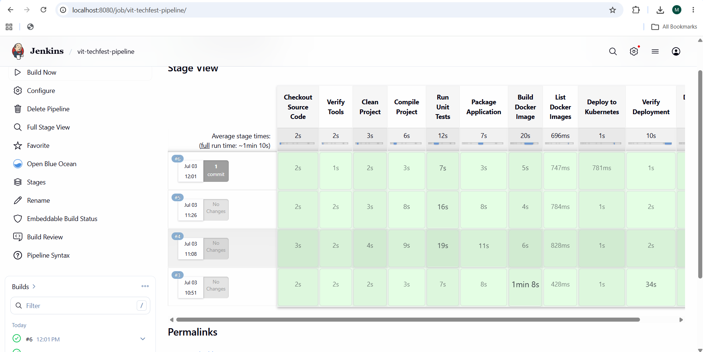
Figure 5.1: Jenkins Automation evidence
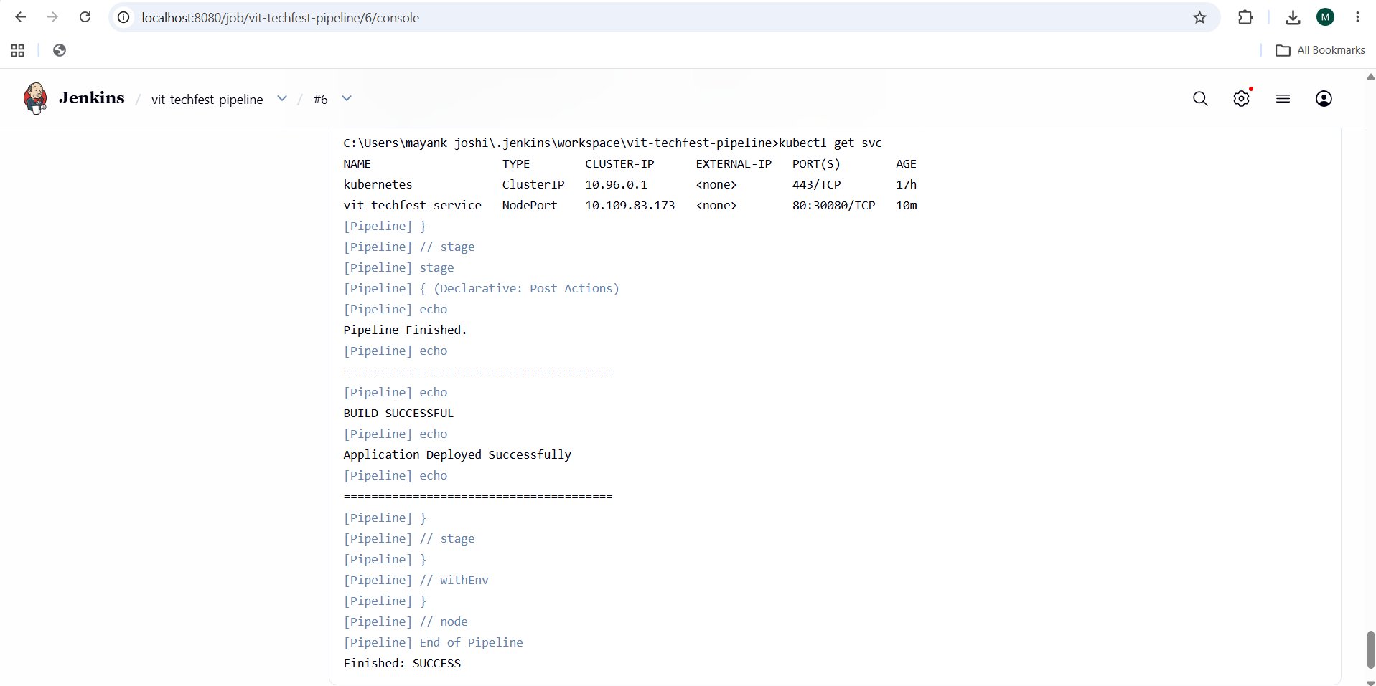
Figure 5.2: Jenkins Automation evidence

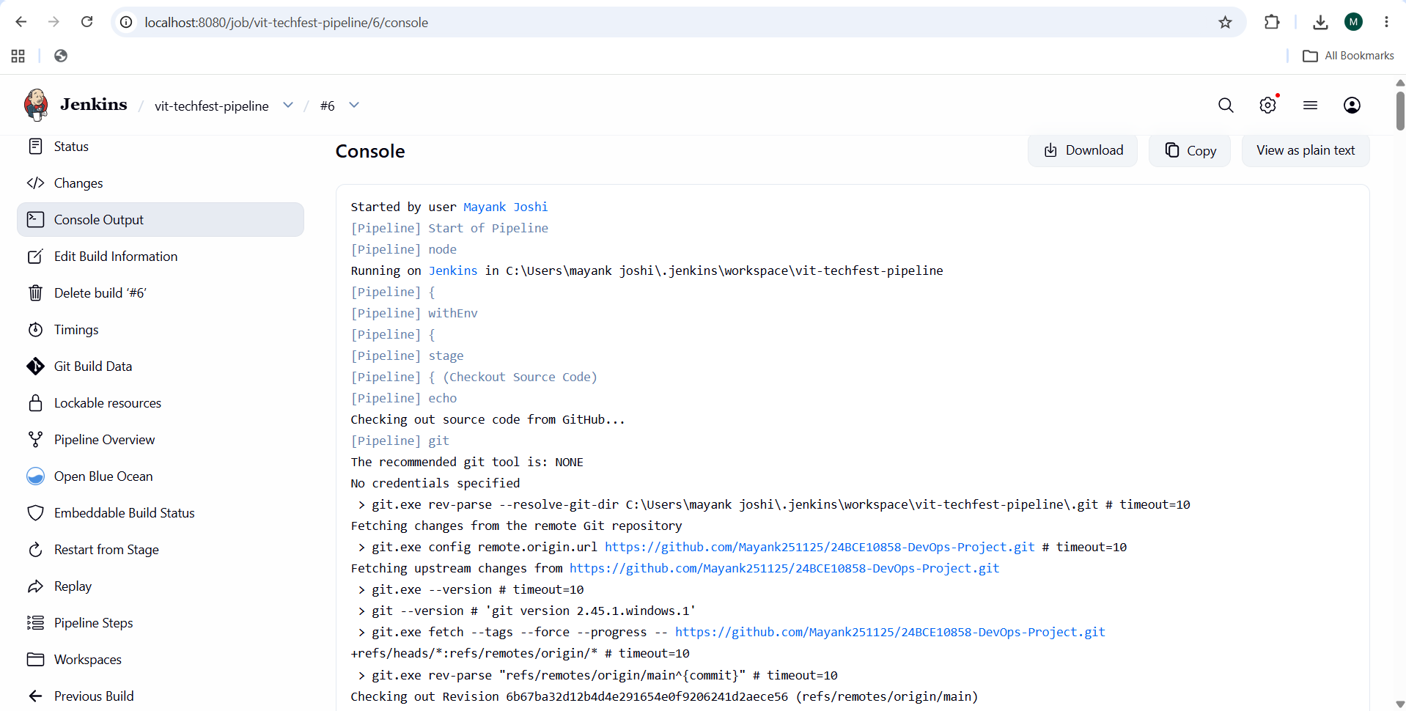
Figure 5.3: Jenkins Automation evidence
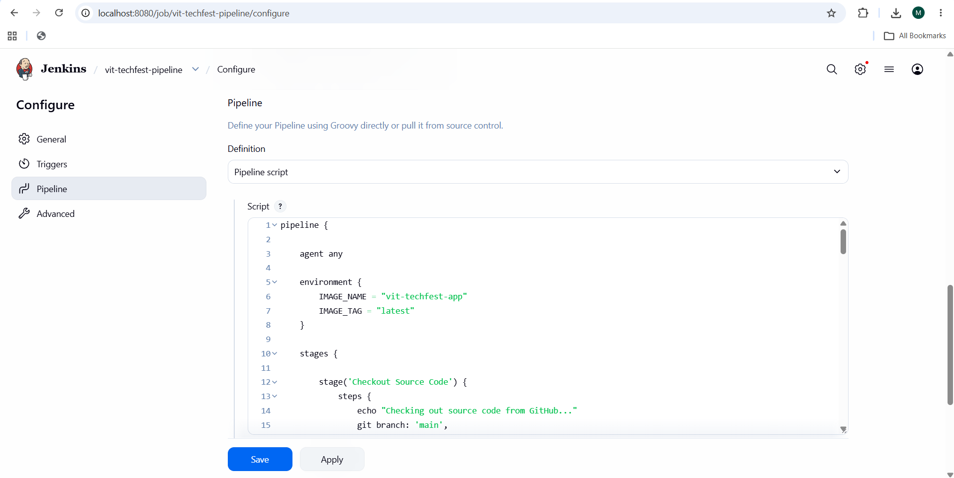
Figure 5.4: Jenkins Automation evidence

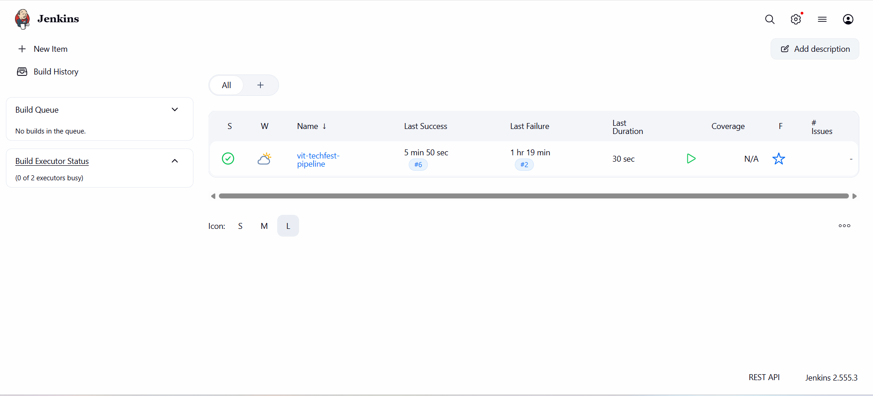
Figure 5.5: Jenkins Automation evidence

6. Maven Build
Maven build output shows BUILD SUCCESS, confirming successful compilation and packaging of the Spring Boot application.
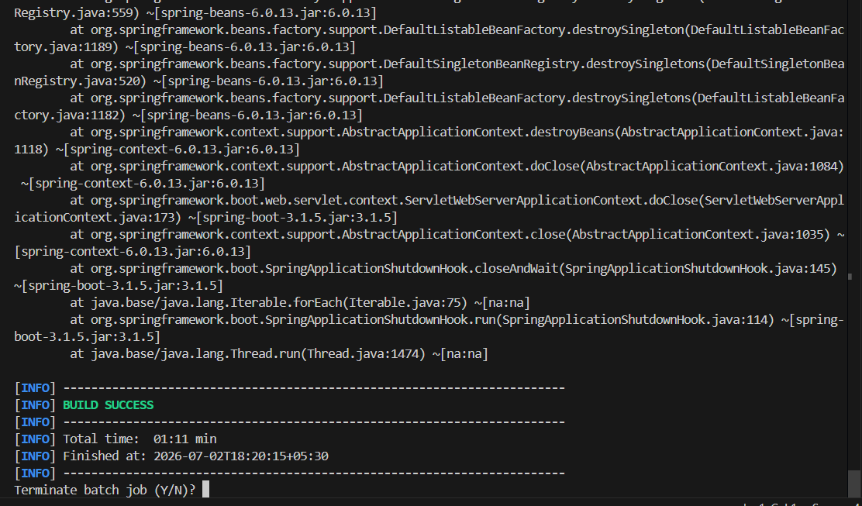Figure 6.1: Maven Build evidence
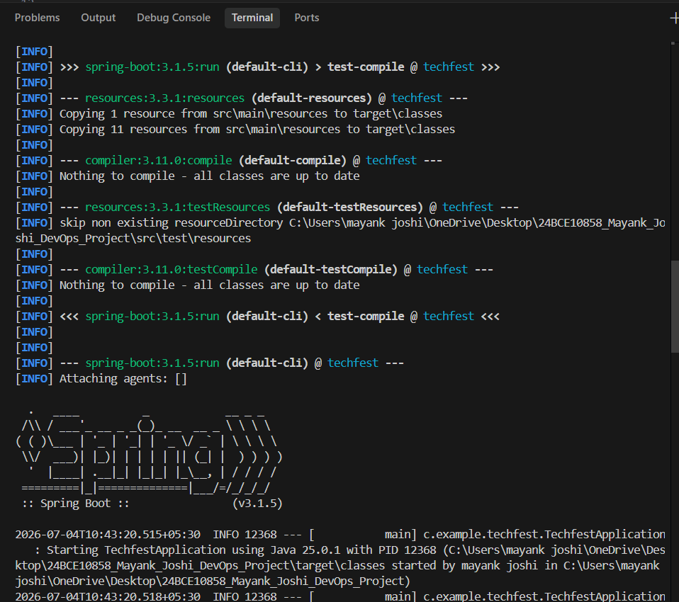
Figure 6.2: Maven Build evidence

7. Docker Build and Running Container

Docker Compose successfully builds the application image. The running-container output confirms the application container is active and mapped to port 8082. Browser access verifies successful container execution.
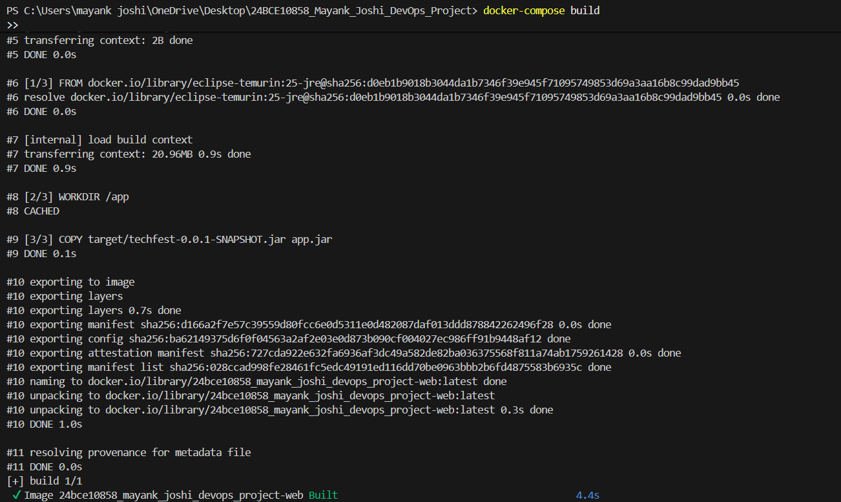
Figure 7.1: Docker Build and Running Container evidence

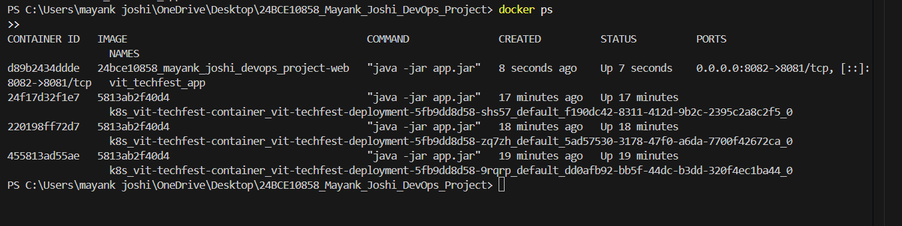
Figure 7.2: Docker Build and Running Container evidence
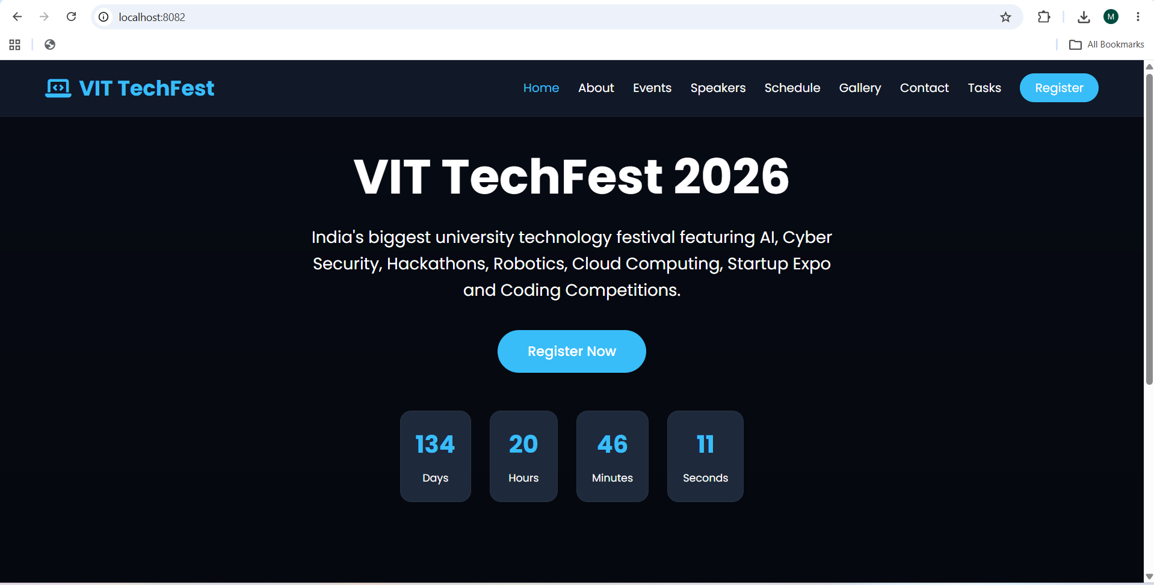
Figure 7.3: Docker Build and Running Container evidence

8. Kubernetes Deployment

kubectl confirms the deployment has 3/3 replicas ready, all three pods are Running with zero restarts, and a NodePort service exposes port 30080. Browser access through localhost:30080 verifies the deployment.
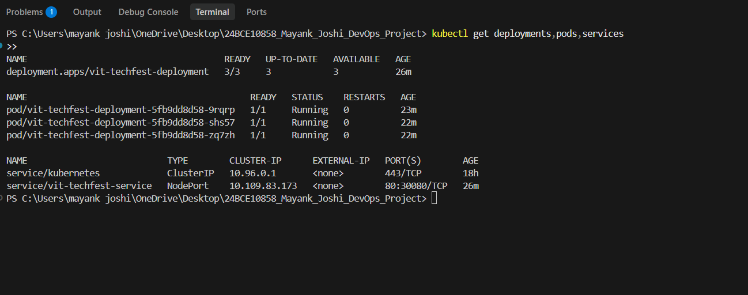
Figure 8.1: Kubernetes Deployment evidence
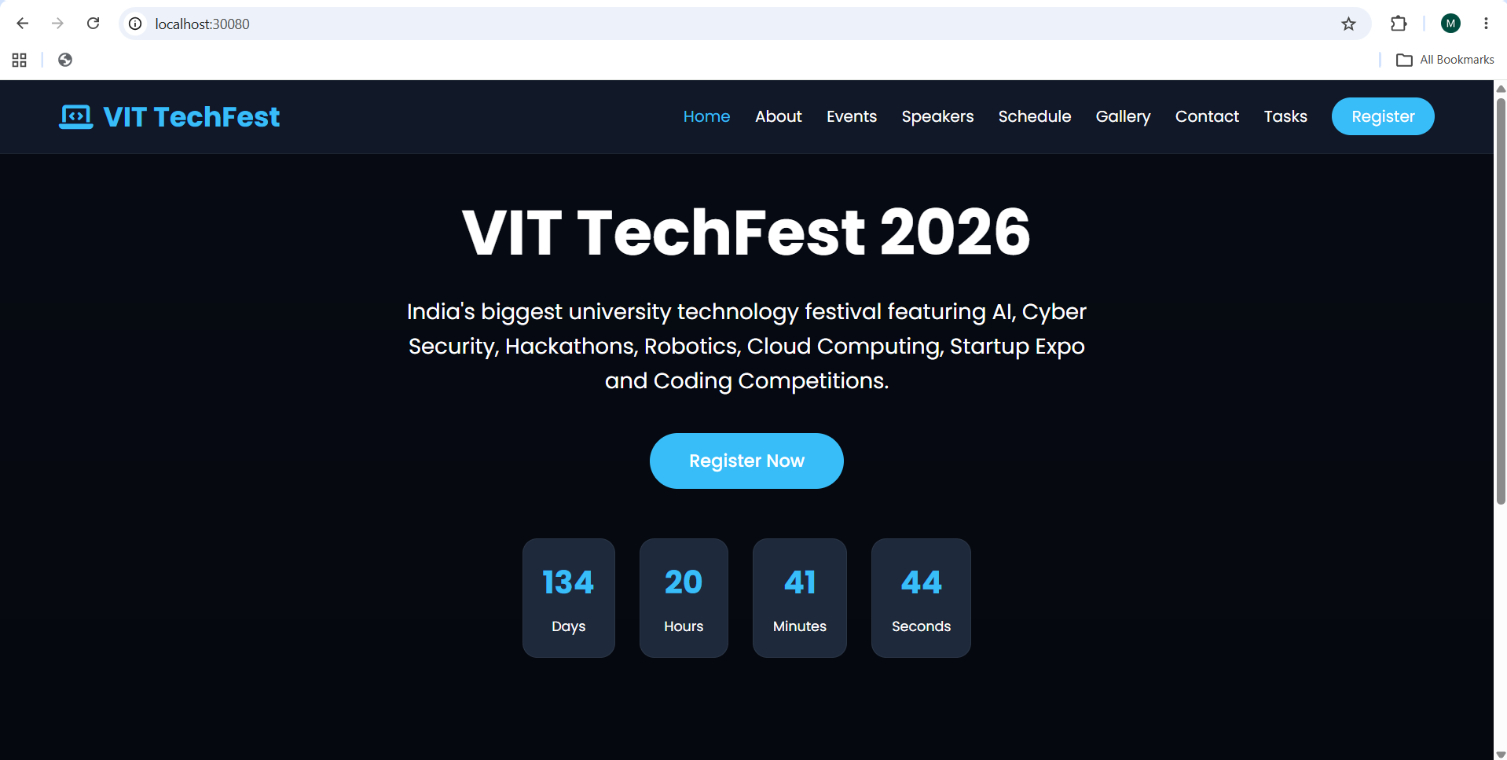
Figure 8.2: Kubernetes Deployment evidence

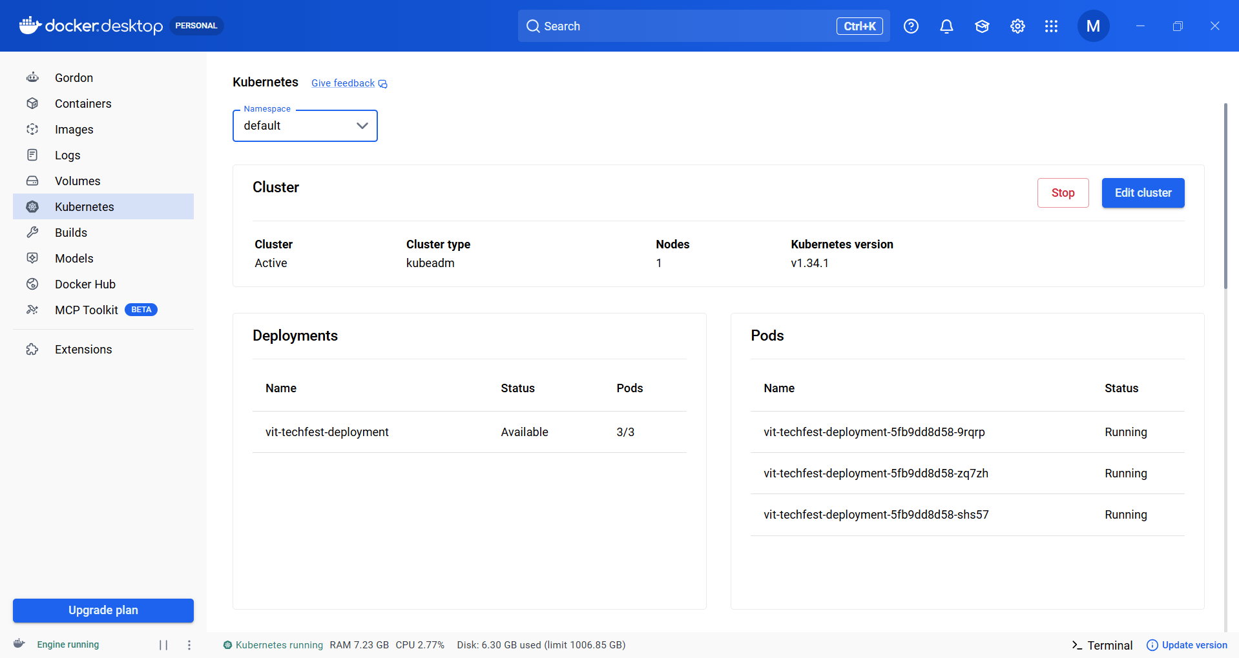
Figure 8.3: Kubernetes Deployment evidence

9. Graphite Metrics

Graphite acts as the time-series metrics backend. Composer views show metric trees and plotted series, demonstrating that application and tagged metrics are being received, stored and visualized.

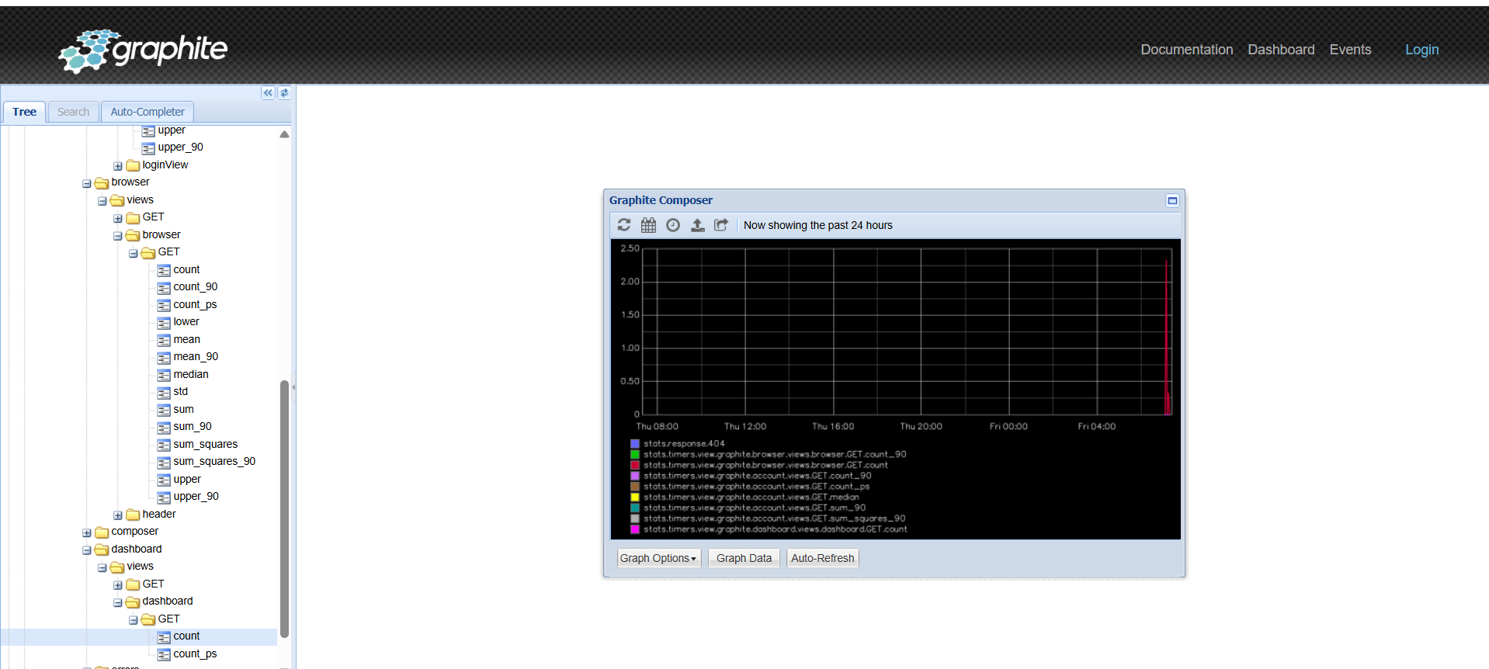
Figure 9.1: Graphite Metrics evidence
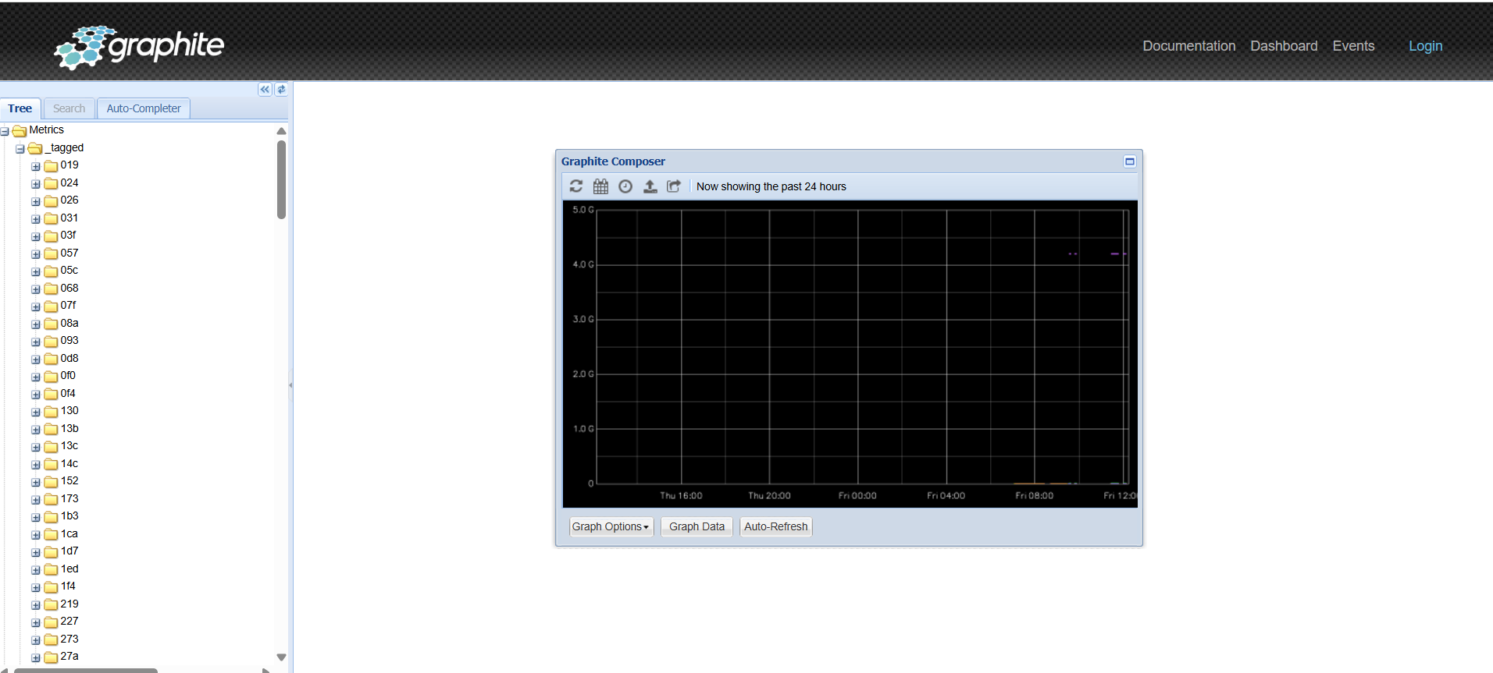
Figure 9.2: Graphite Metrics evidence

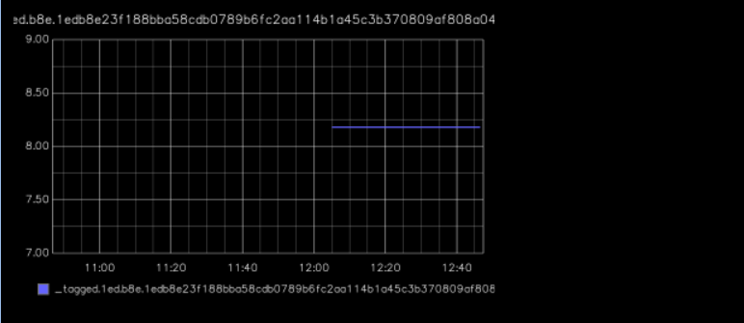
Figure 9.3: Graphite Metrics evidence
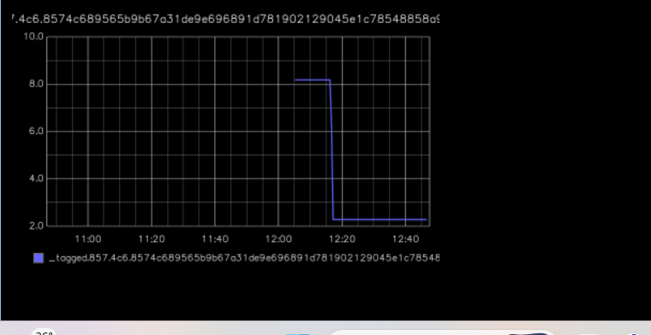
Figure 9.4: Graphite Metrics evidence

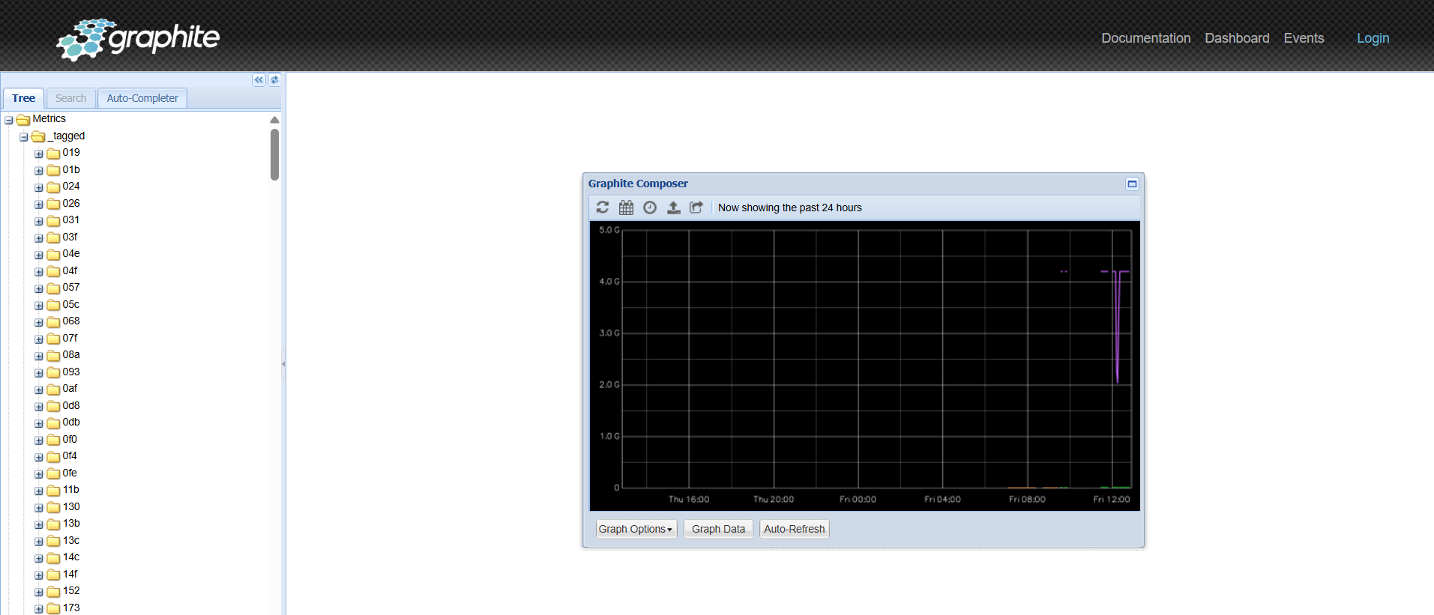
Figure 9.5: Graphite Metrics evidence

10. Grafana Dashboard Monitoring

Grafana provides the observability dashboard. Panels show HTTP availability, Tomcat sessions, CPU cores, CPU usage, JVM memory usage and application uptime. HTTP availability reports UP and time-series panels display runtime behavior.
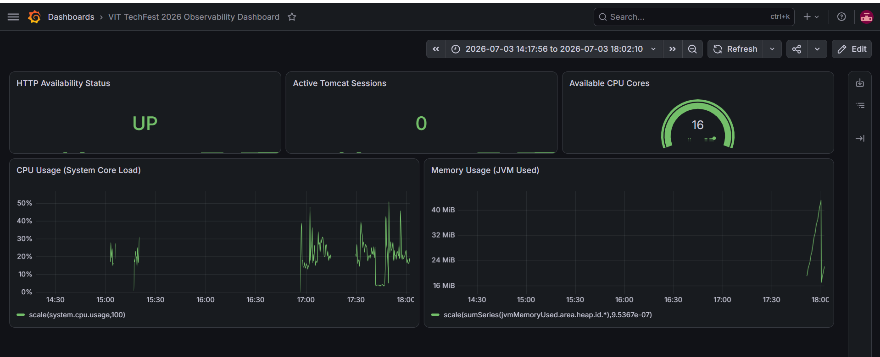
Figure 10.1: Grafana Dashboard Monitoring evidence
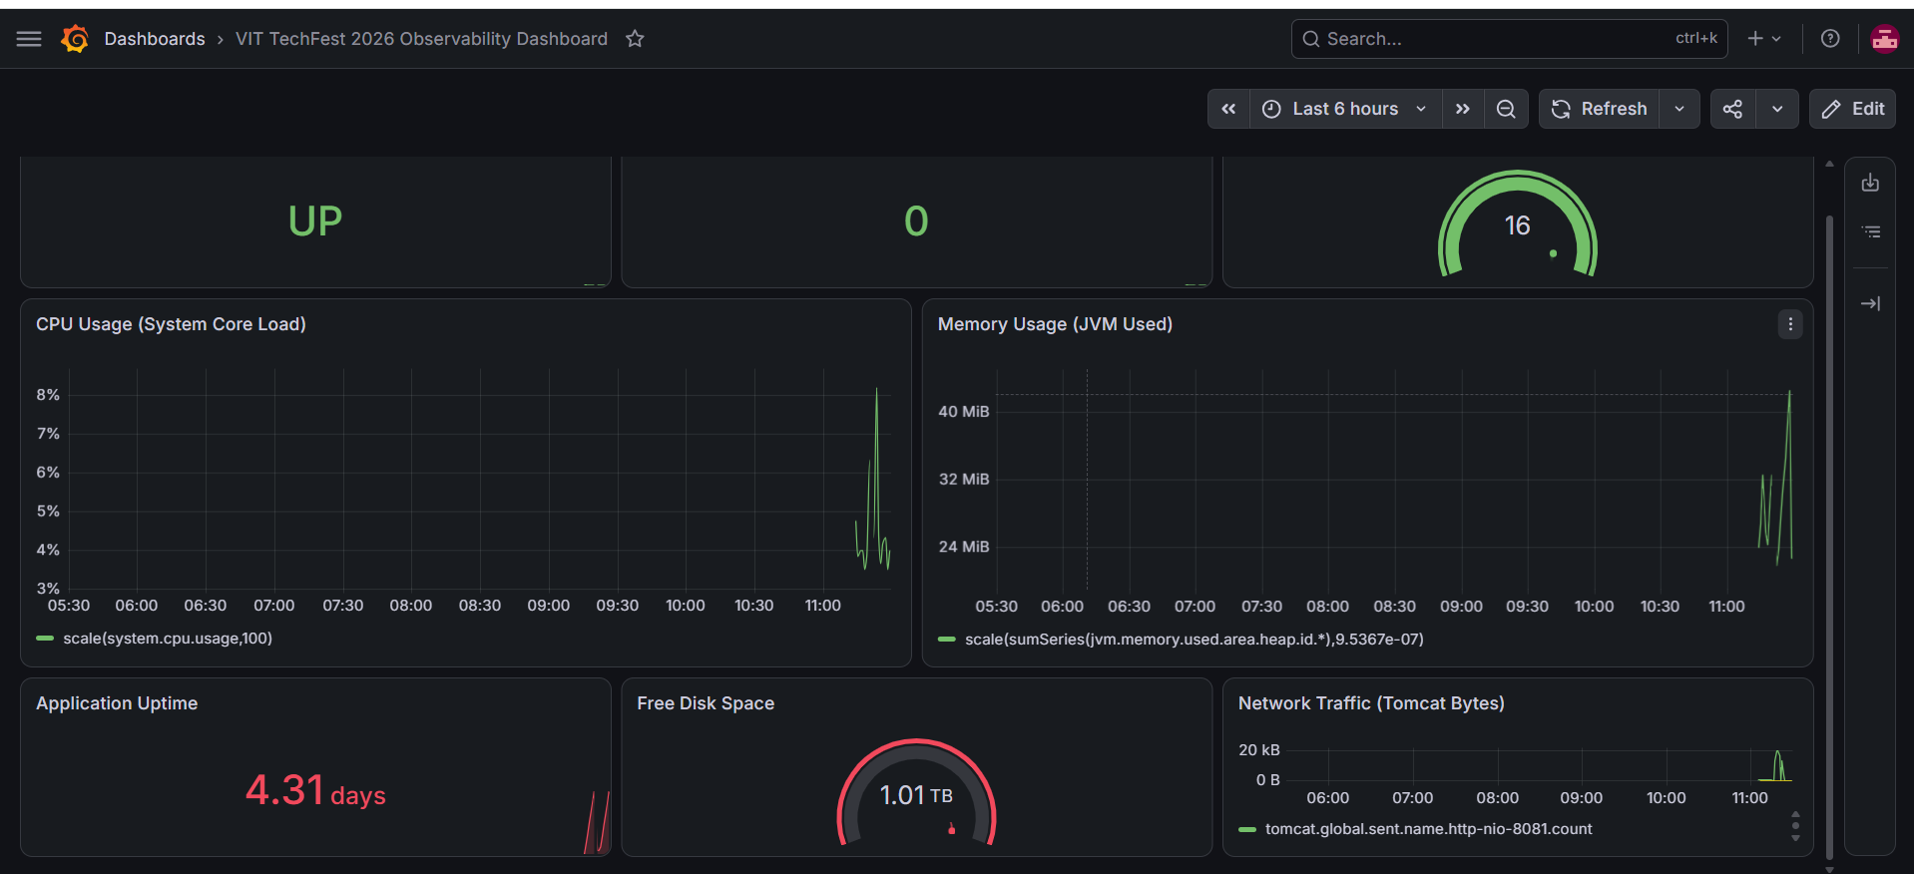
Figure 10.2: Grafana Dashboard Monitoring evidence

11. Nagios Monitoring

Nagios Core monitors host and service availability. Both localhost and vit-techfest-host are UP, and the VIT TechFest TCP check reports a successful response on port 8082.

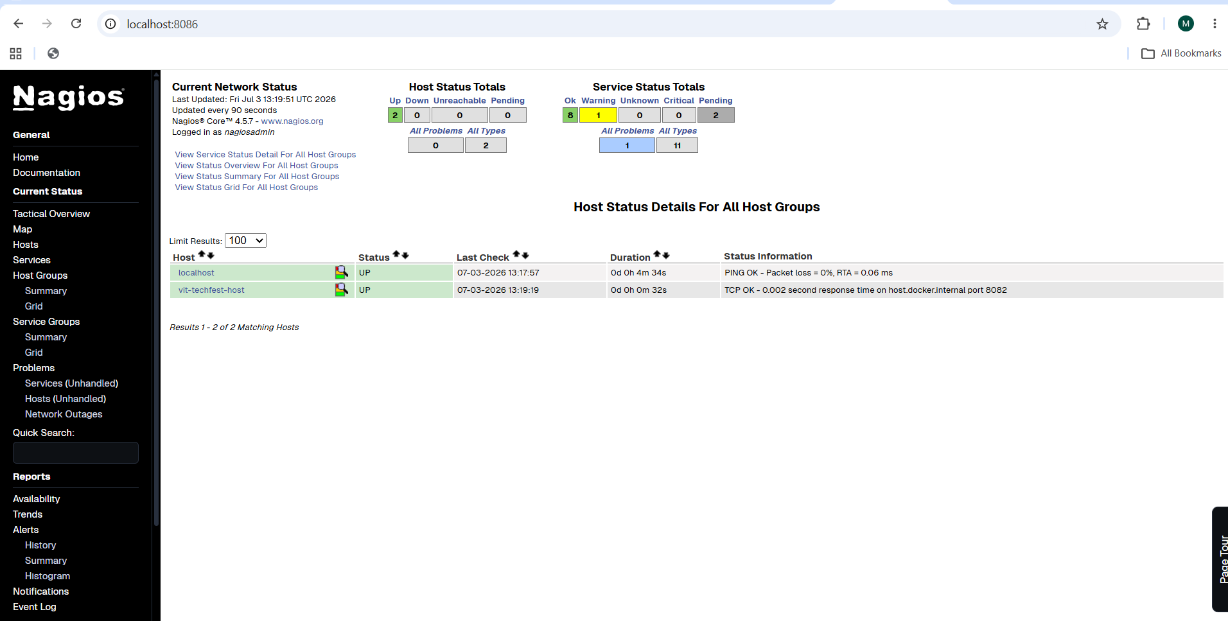
Figure 11.1: Nagios Monitoring evidence

12. Step-by-Step Implementation
1. Develop and maintain the application source code.
2. Push source code to the GitHub repository.
3. Configure Jenkins to fetch the main branch.
4. Run Maven clean, compile, unit-test and package stages.
5. Build and verify the Docker image.
6. Run the Docker container and validate port 8082.
7. Deploy three application replicas to Kubernetes.
8. Expose the application using Node Port 30080.
9. Configure Nagios host and TCP service checks.
10. Collect runtime metrics in Graphite.
11. Create Grafana panels for availability and performance.
12. Verify all pipeline stages, pods, services, checks and dashboards.

13. Final Verification Checklist
☑ GitHub repository is accessible.
☑ All source code has been pushed to GitHub.
☑ Jenkins build completed successfully.
☑ Maven build completed successfully.
☑ Docker image was created successfully.
☑ Docker container is running.
☑ Kubernetes Pods and Services are Running/available.
☑ Application is accessible in the browser.
☑ Nagios displays hosts as UP and monitored service as healthy.
☑ Graphite is receiving and plotting metrics.
☑ Grafana dashboard displays required metrics.
☑ Documentation contains implementation screenshots.
☑ Required links and access details are included.

14. Conclusion
The project demonstrates a complete DevOps lifecycle. The supplied evidence confirms successful source integration, Maven build, Jenkins automation, Docker containerization, Kubernetes deployment, browser accessibility, Nagios monitoring, Graphite metrics collection and Grafana visualization.

15. Application Interface Screenshots

The following screenshots demonstrate the implemented VIT TechFest 2026 web application pages and the integrated task management interface. Together, they verify browser accessibility, multi-page navigation, event information presentation, registration functionality, contact support, schedule visualization, gallery content, and task-management features.
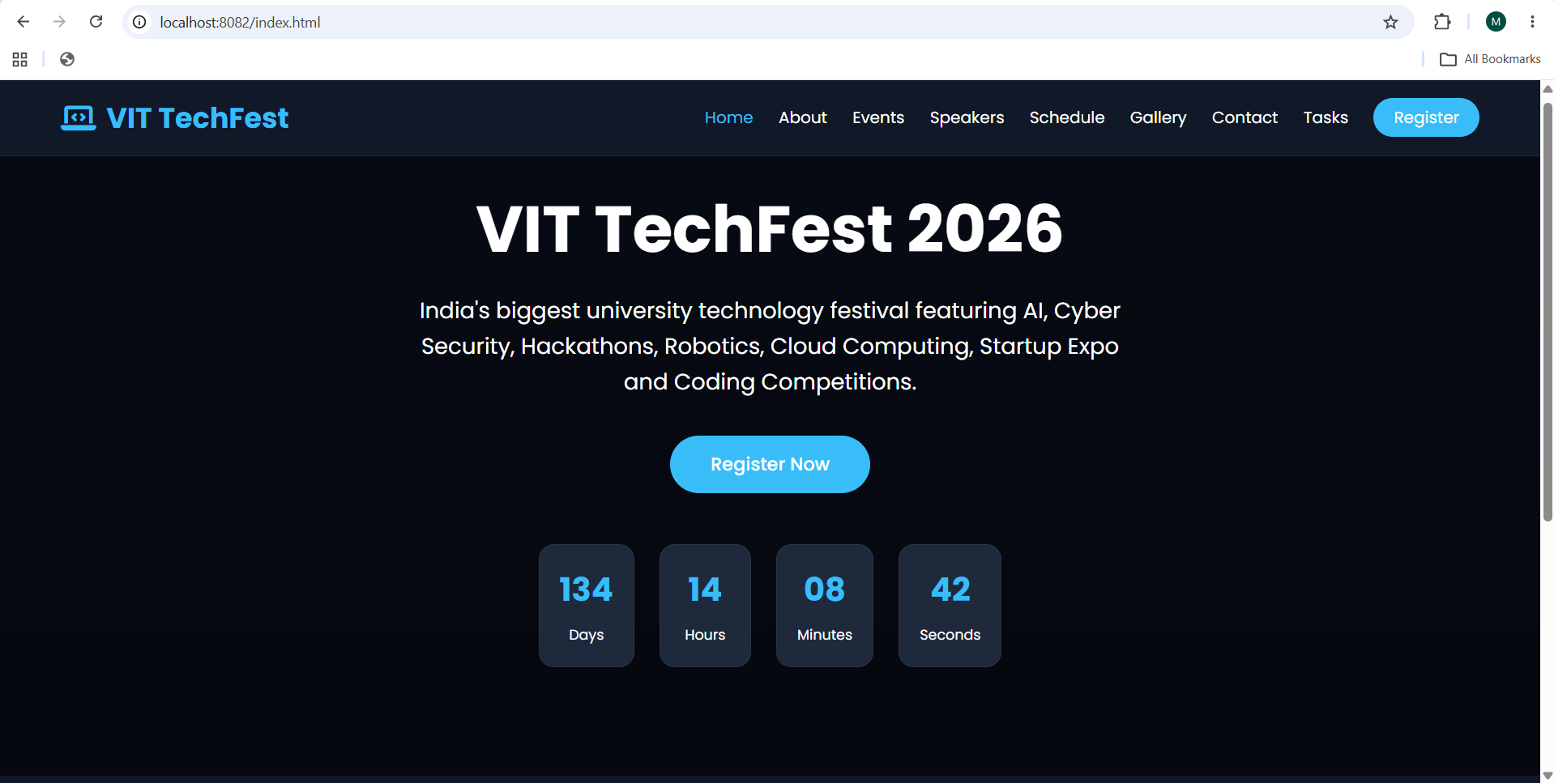
Figure 15.1: Home Page – VIT TechFest 2026 landing page with event overview, registration CTA, and countdown timer.

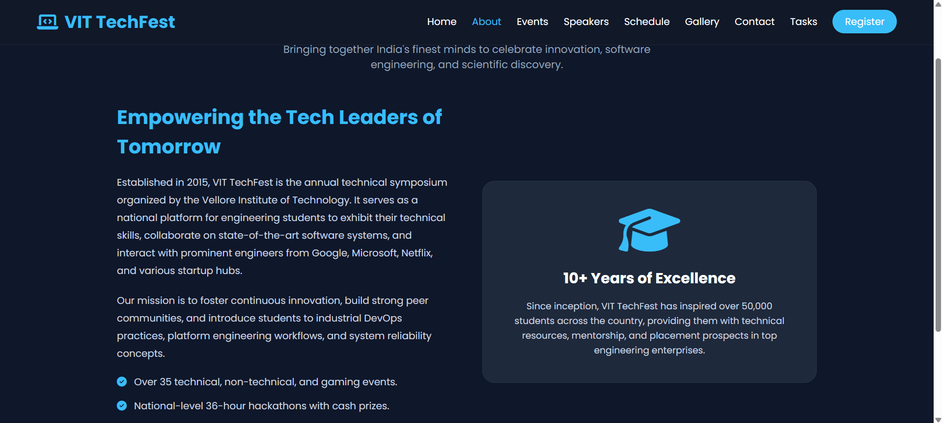
Figure 15.2: About Page – symposium background, mission, technical focus areas, and event highlights.

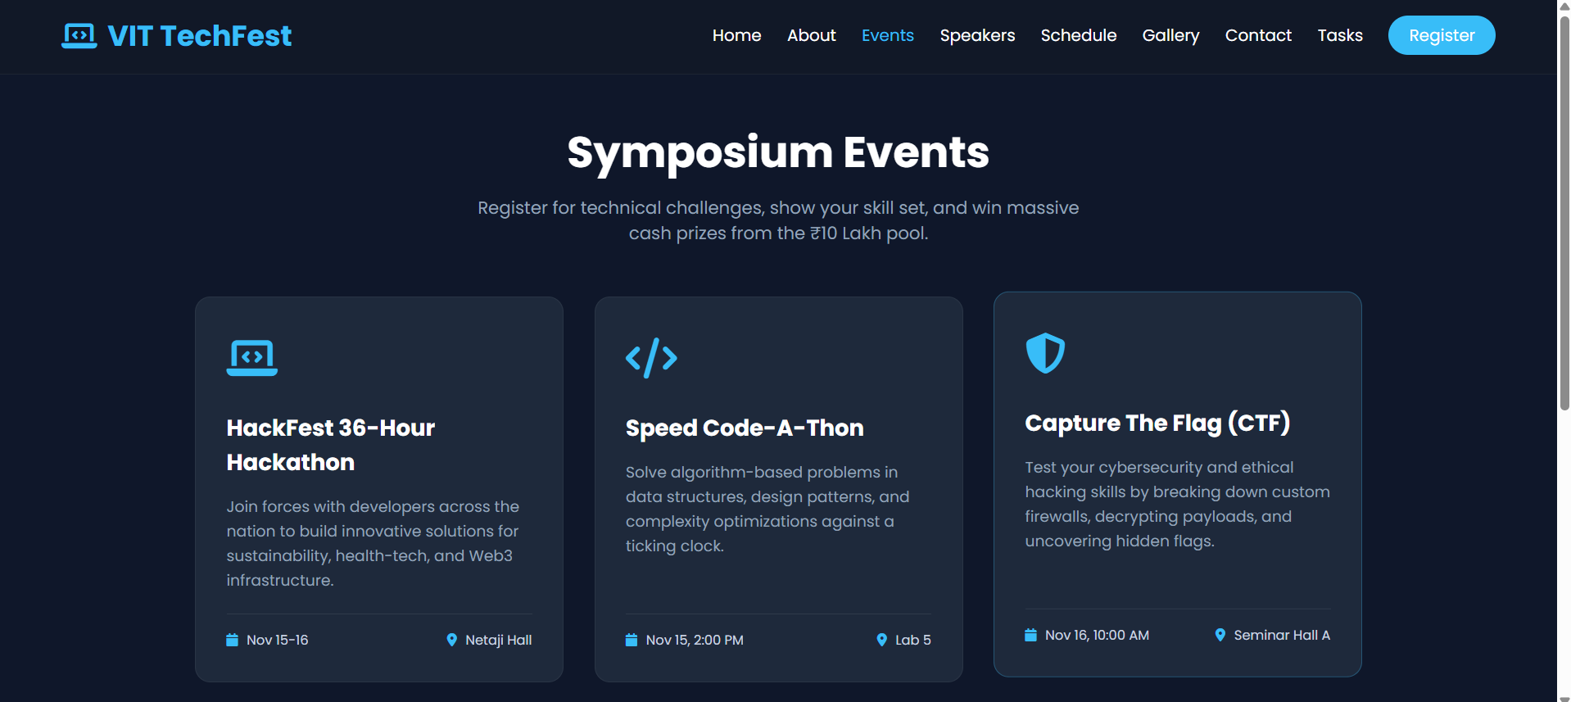
Figure 15.3: Events Page – technical event cards for HackFest, Speed Code-A-Thon, and Capture The Flag.

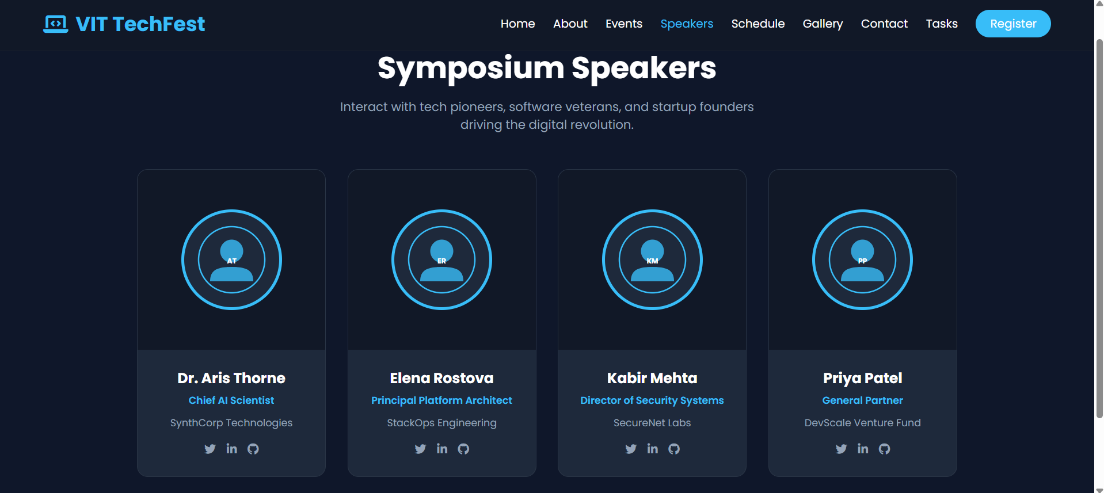
Figure 15.4: Speakers Page – symposium speaker profiles, roles, organizations, and social links.

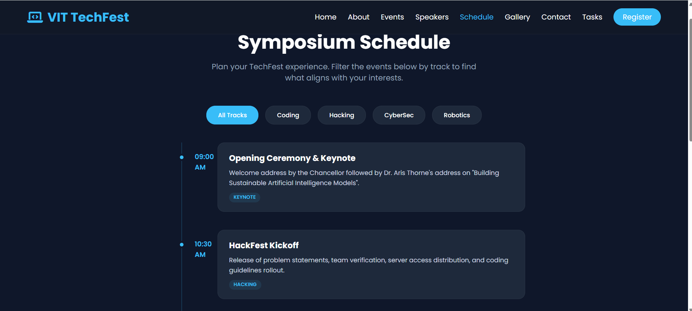
Figure 15.5: Schedule Page – event timeline and track-based filtering interface.

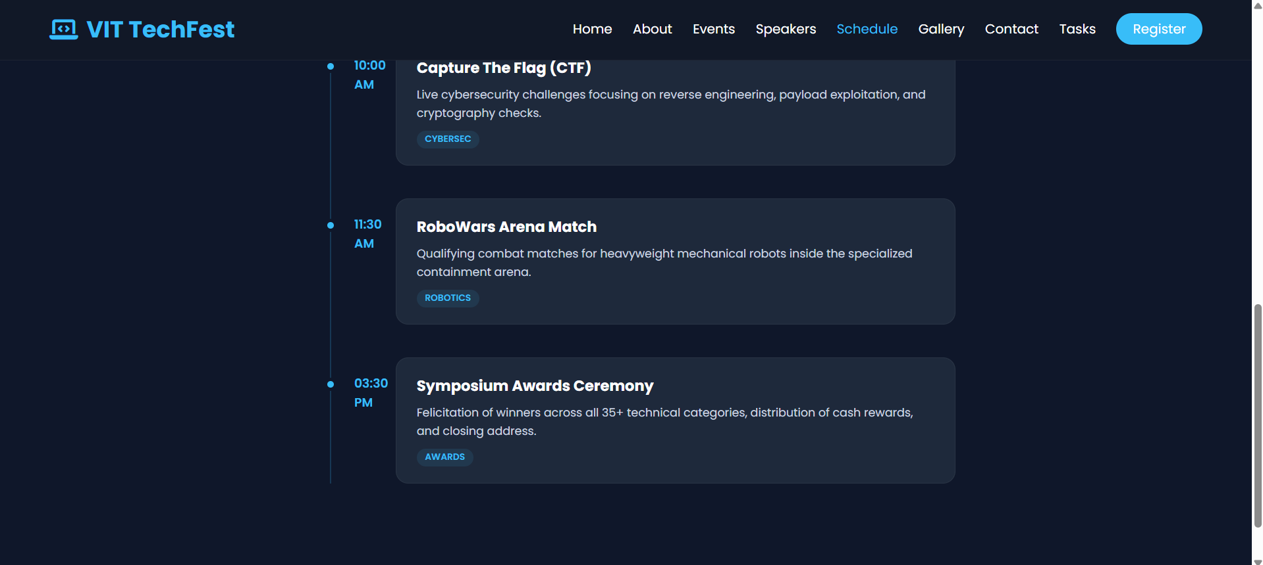
Figure 15.6: Schedule Page Continued – CTF, RoboWars, and awards ceremony timeline entries.

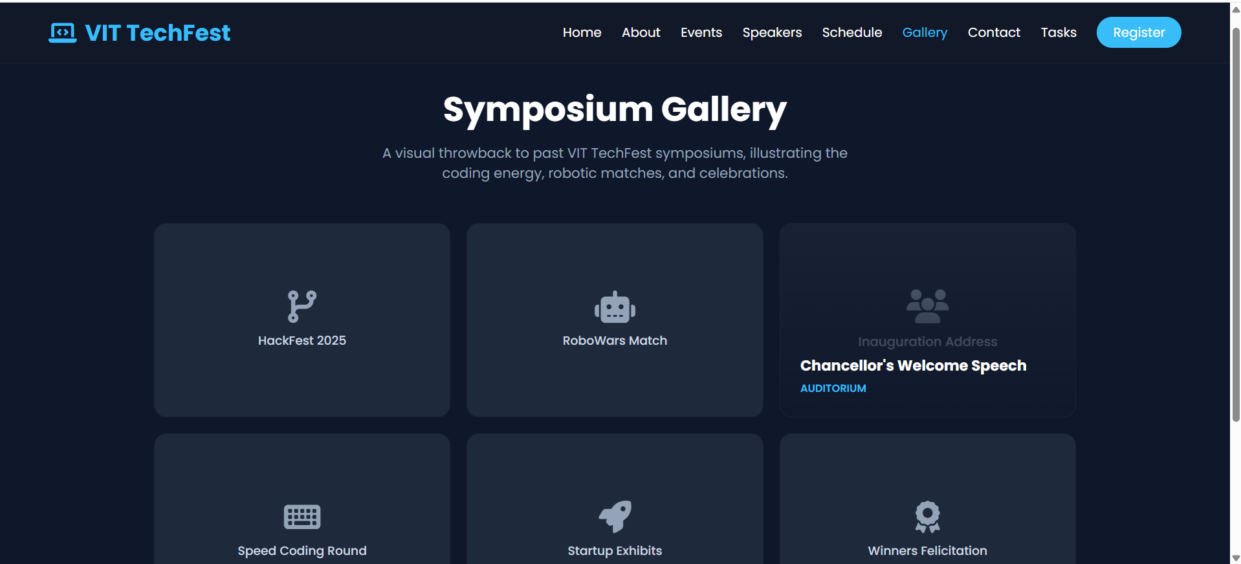
Figure 15.7: Gallery Page – visual showcase of HackFest, RoboWars, coding rounds, startup exhibits, and celebrations.

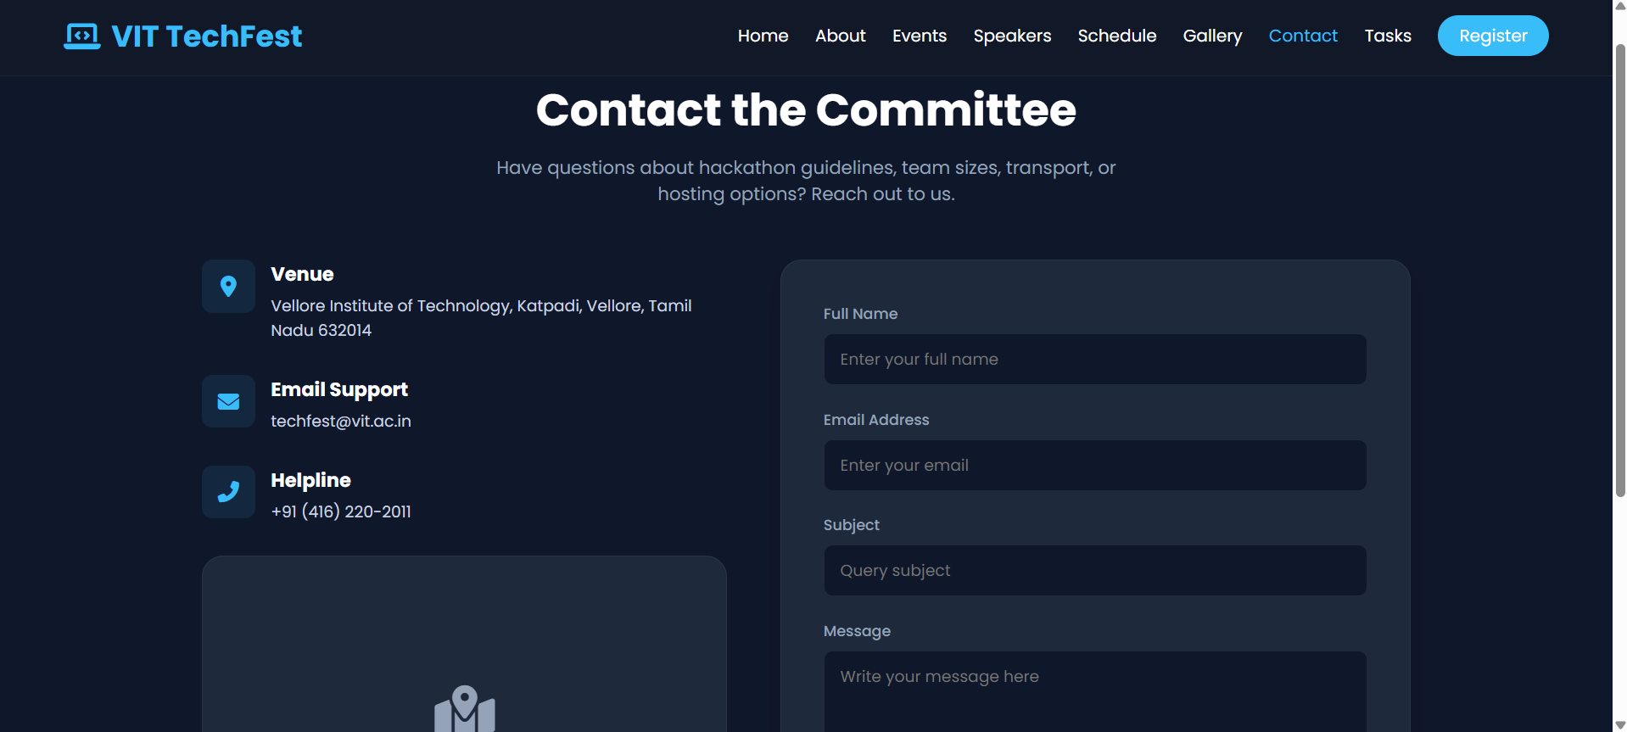
Figure 15.8: Contact Page – committee contact information, venue details, and enquiry form.

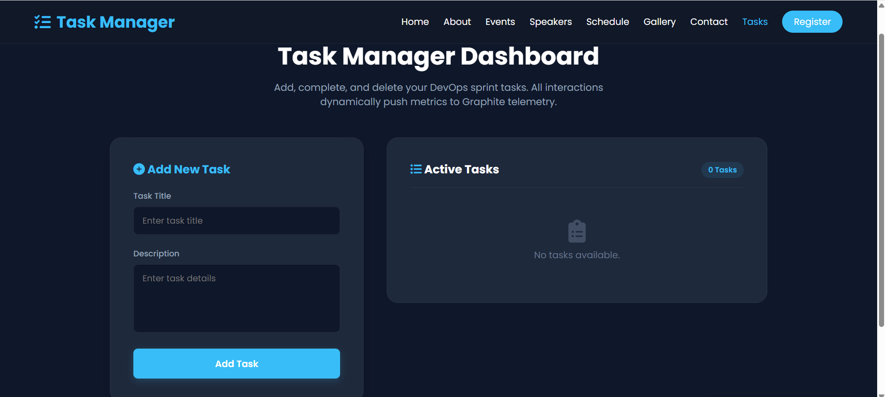
Figure 15.9: Task Manager Dashboard – add, complete, and delete DevOps sprint tasks with telemetry integration.

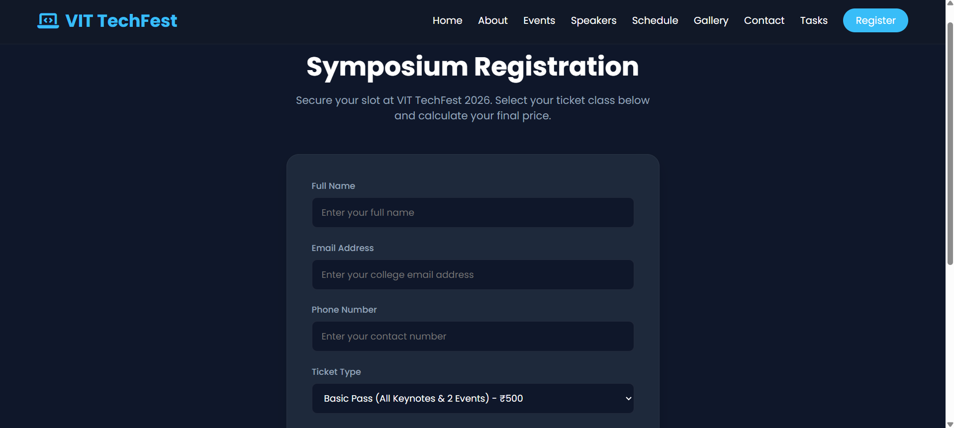
Figure 15.10: Registration Page – participant details form and ticket selection interface.

