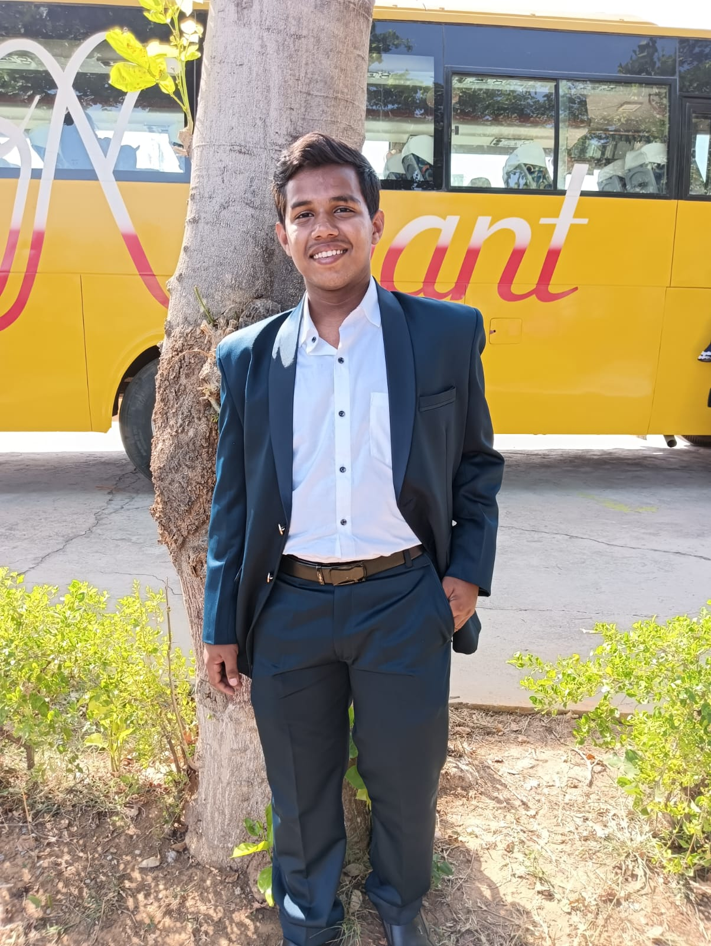**Mayank Srivastava**

**Address:** Sector-13, Dwarka, New Delhi-110075

**Mob:** 9625951982

**Email ID:** [cse.mayank123@gmail.com](mailto:cse.mayank123@gmail.com)

**CAREER OBJECTIVE**

To take up a challenging career and grows with honesty, loyalty, good relationship and best performance and translates my experience, knowledge, skills and abilities into value for an organization.

**ACADEMIC QUALIFICATION**

|  |  |  |  |
| --- | --- | --- | --- |
| Class | Board | Year | Percentage |
| 10th | CBSE Board | 2020 | 87% |
| 12th | CBSE Board | 2023 | 69% |

**TECHNICAL SKILLS**

Python, Tableau, Matplotlib, Seaborn, Excel, Pandas, Numpy, ML

**STRENGTH FACTOR**

Good strength of working with team, Strong ability to work with creativity & determination

**PERSONAL PROFILE**

Father Name : Rakesh Kumar Srivastava

Date of Birth : 02/09/2005

Marital Status : Single

Gender : Male

Religion : Hindu

Nationality : Indian

**DECELARATION**

I do hereby declare that the statements made in this document are true to the best of my knowledge and belief.

**Date –**  08/2/2025

**Place –** New Delhi

**(Mayank Srivastava)**