A
Practical activity Report submitted for AI for Engineers (UTA-321) On
AI-Based Malaria Detection Using Deep Learning
by
Name | Roll Number
Mayank Garg | 1024170442
Saksham Kansal | 1024031135
Sanshi | 1024031137
Ishaan Gupta | 1024031118
Vineet Kailay | 1024031147
Batch: 2Q41/2C82

Submitted to
Dr. Arun Singh Pundir


DEPARTMENT OF COMPUTER SCIENCE AND ENGINEERING

Thapar Institute of Engineering and Technology
Patiala, Punjab, India

Table of Contents

1. Introduction 1
2. Problem Statement 1
3. Objectives 2
4. Technologies Used 3
5. Data Analysis and Preprocessing 4
6. Model Architecture Detail 5
7. Workflow Of Project 6
8. Model Evaluation 7
9. Web Application 8
10. Conclusion and Future Scope 9

1. Introduction
Malaria remains one of the most significant public health challenges globally, particularly in tropical and subtropical regions. Caused by Plasmodium parasites and transmitted through the bites of infected Anopheles mosquitoes, the disease is responsible for hundreds of thousands of deaths annually. Early and accurate diagnosis is essential for effective malaria management.

In recent years, the integration of healthcare and Artificial Intelligence (AI) has enabled the development of automated diagnostic systems. This project proposes a deep learning-based approach using Convolutional Neural Networks (CNNs), specifically the MobileNetV2 architecture, to detect malaria parasites from blood smear images. The lightweight nature of MobileNetV2 ensures both high accuracy and computational efficiency.

2. Problem Statement
The core problem addressed in this project is the inefficiency and variability associated with manual malaria detection.

• Accessibility: High-quality diagnostic services are often limited to urban areas, leaving rural populations underserved.
• Latency: Manual diagnosis is time-consuming, often taking hours from sample preparation to result generation, whereas malaria requires rapid intervention.
• Cost: Maintaining a large workforce of trained microscopists is expensive for healthcare systems.
This project aims to address these challenges by developing an automated system that can accurately classify blood cell images as Infected or Uninfected using deep learning techniques.

3. Objectives
The project is guided by the following technical and functional objectives:
• Data Preprocessing:
To build a preprocessing and data augmentation pipeline for improving model performance and reducing overfitting.
• Model Development:
To implement and fine-tune a MobileNetV2-based CNN using transfer learning for accurate and efficient classification.
• Performance Improvement:
To achieve high diagnostic accuracy (around 95%) while reducing prediction time compared to manual methods.
• Deployment:
To develop an interactive web application using Streamlit for real-time malaria detection.
• Evaluation:
To evaluate the model using standard metrics such as Accuracy, Precision, Recall, F1 Score, and ROC-AUC.

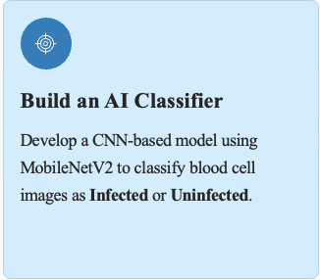
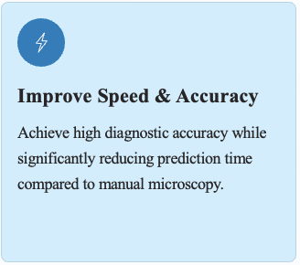

4. Technologies Used
Deep learning has significantly transformed medical image analysis by enabling automated and accurate disease detection. In this project, a lightweight and efficient deep learning architecture, MobileNetV2, is used for malaria detection. Unlike traditional deep learning models with large parameter sizes, MobileNetV2 uses depthwise separable convolutions to reduce computational cost while maintaining high accuracy. This makes it highly suitable for real-time and mobile-based applications.

Technologies:
- Python: The primary language for model development and interface.
- TensorFlow/Keras: Used to build, train, and evaluate the learning model.
- OpenCV: Used for image loading, resizing, and preprocessing of blood cell images.
- Matplotlib & Seaborn: Used for visualizing training results, confusion matrix, ROC Curve
- Streamlit: Used to build an interactive web application for malaria detection.
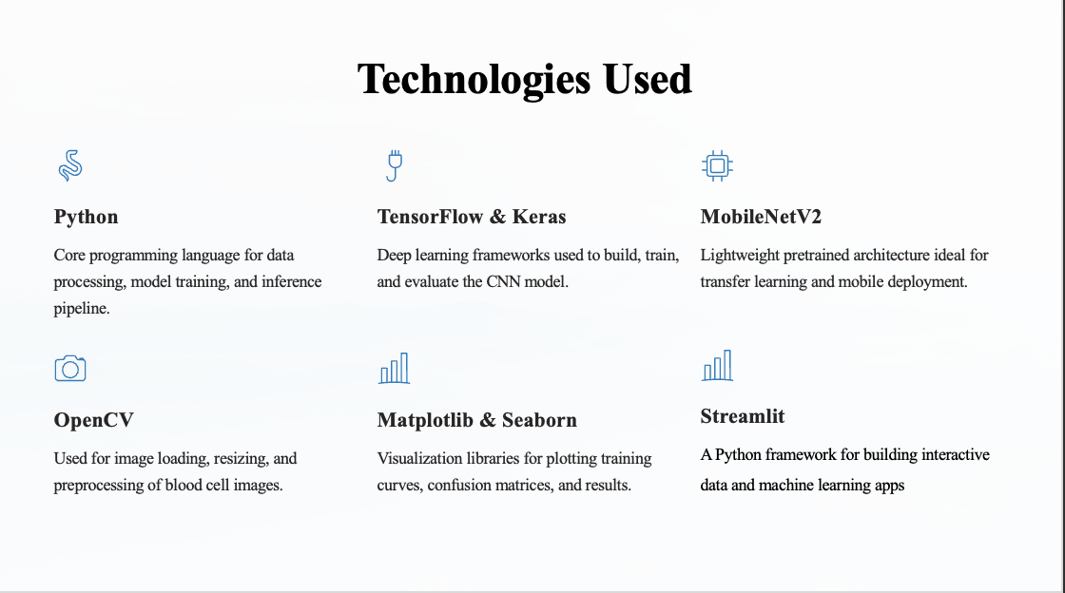

5. Dataset Analysis and Preprocessing
The project utilizes the widely-recognized Kaggle Malaria Cell Images dataset, consisting of over 27,000 images of thin blood smears. These images are categorized into two classes: parasitized (Infected) and uninfected. Before training, the data underwent the following transformations:
- Resizing: All images were normalized to a uniform size of 128x128 pixels to fit the model input requirements.
- Normalization: Pixel values were rescaled to the range [0, 1] to ensure stable gradient descent during training.
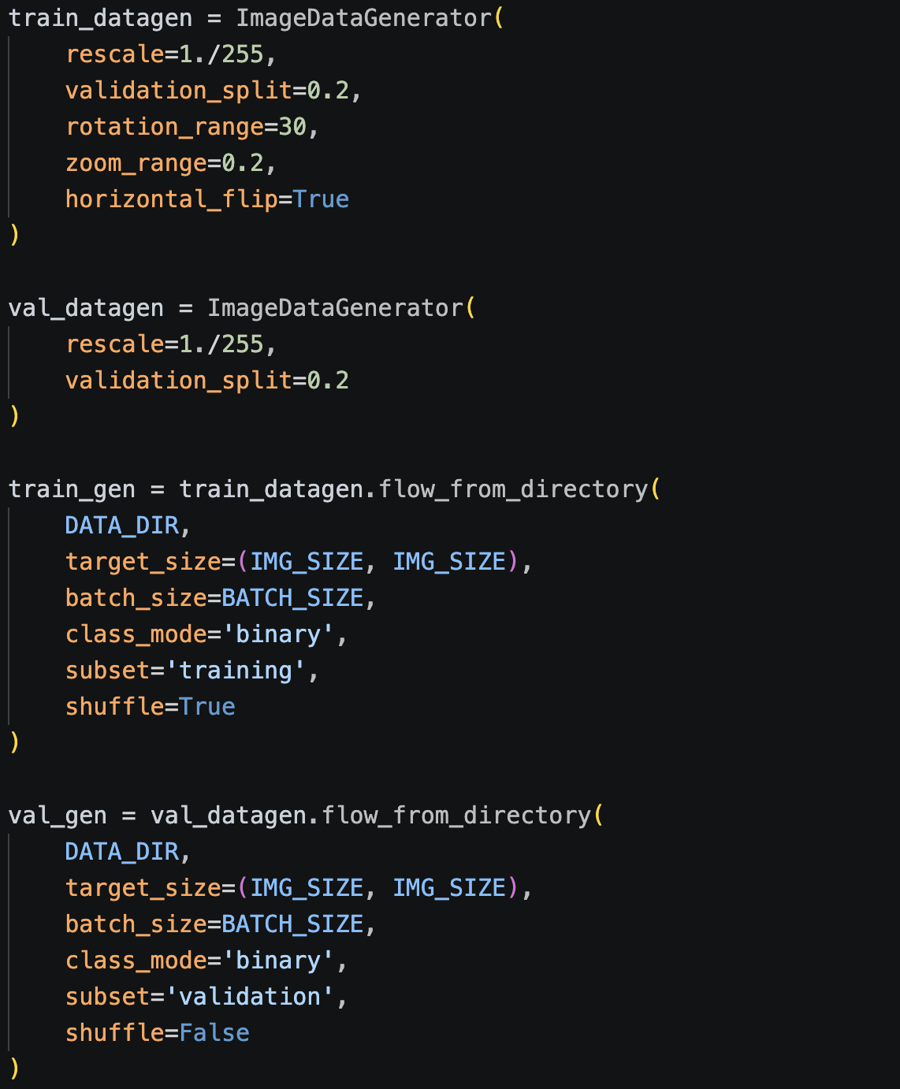
- Data Augmentation: Techniques such as rotation (up to 30 degrees), horizontal flipping, and zooming (0.2 range) were applied. This artificially increases the dataset size and helps the model learn invariant features.

6. Model Architecture Details
The proposed model is based on MobileNetV2, a lightweight convolutional neural network architecture designed for efficient computation and high performance. It is particularly suitable for mobile and real-time applications due to its low memory requirements.
In this project, transfer learning is used by leveraging a pretrained MobileNetV2 model trained on the ImageNet dataset. The top classification layers of the pretrained model are removed, and custom layers are added for malaria detection.

Model Configuration:
- Input Shape: 128 × 128 × 3
- Loss Function: Binary Crossentropy
- Optimizer: Adam
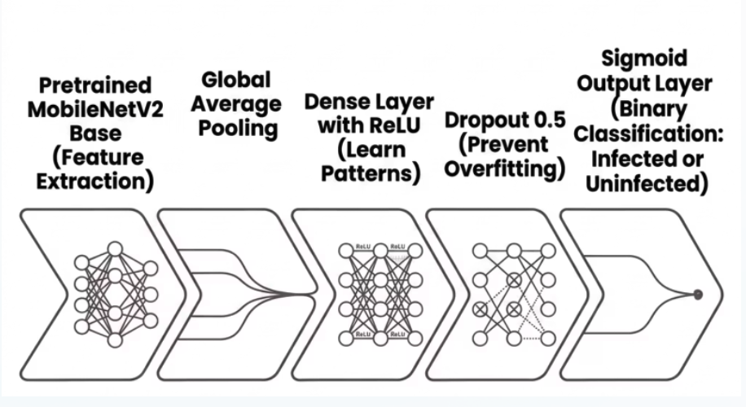
- Output: Binary Classification

7. Workflow Of Project
The proposed system follows a transfer learning approach using a pretrained MobileNetV2 model. Instead of training a model from scratch, pretrained weights from ImageNet are used. This significantly improves performance and reduces training time.
The complete workflow of the project is as follows:
- Data Preprocessing:
Input images are resized to a fixed size, normalized, and augmented using techniques such as rotation, flipping, and zooming to improve model generalization.
- Train-Validation Split:
The dataset is divided into training (80%) and validation (20%) sets to evaluate model performance effectively.
- Base Model Loading:
The MobileNetV2 model is loaded with pretrained weights, excluding the top classification layer.
- Model Training:
The model is trained using the Adam optimizer with a low learning rate to adjust weights effectively.
- Model Evaluation:
The trained model is evaluated using metrics such as accuracy, precision, recall, F1-score, confusion matrix, and ROC curve.
- Prediction / Inference:
The final model is used to classify new blood cell images as infected or uninfected with a confidence score.

8. Model Evaluation
The model’s performance was evaluated on a validation set representing 20% of the total dataset. The results demonstrate strong predictive capability:
• Accuracy: 95% – The model correctly classifies the majority of blood cell images.
• Precision: 95% – Indicates that most predicted infected cases are correct, minimizing false positives.
• Recall: 95% – Shows that the model successfully detects most infected cells, minimizing missed cases.
• F1 Score: 95% – Provides a balanced measure of precision and recall.
• ROC-AUC Score: 0.99 – Indicates excellent ability to distinguish between infected and uninfected classes.
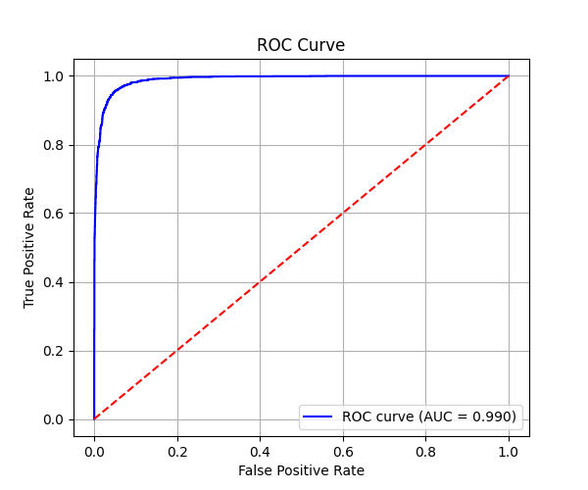
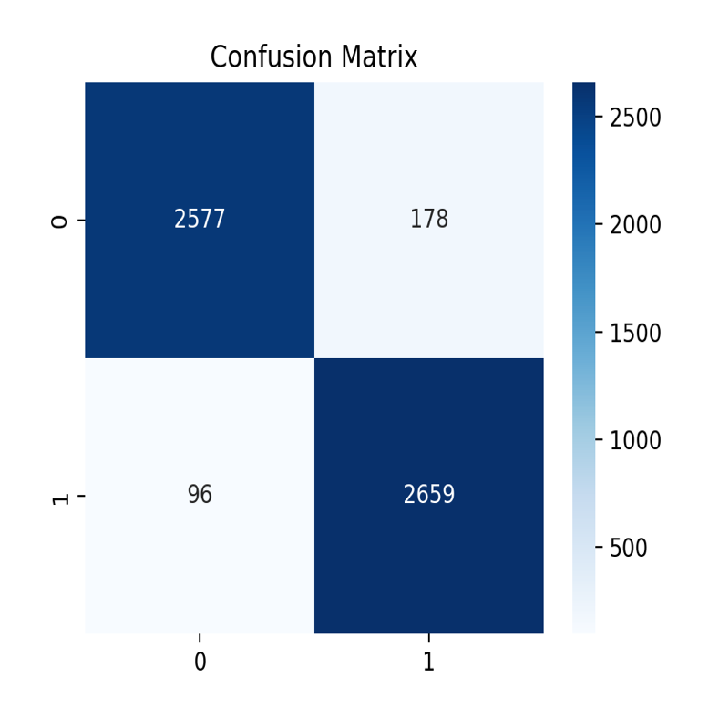

9. Web Application
A critical part of this project is making the AI model accessible to non-technical users. For this purpose, an interactive web application is developed using Streamlit, which provides a simple and user-friendly interface.
The application allows users to:
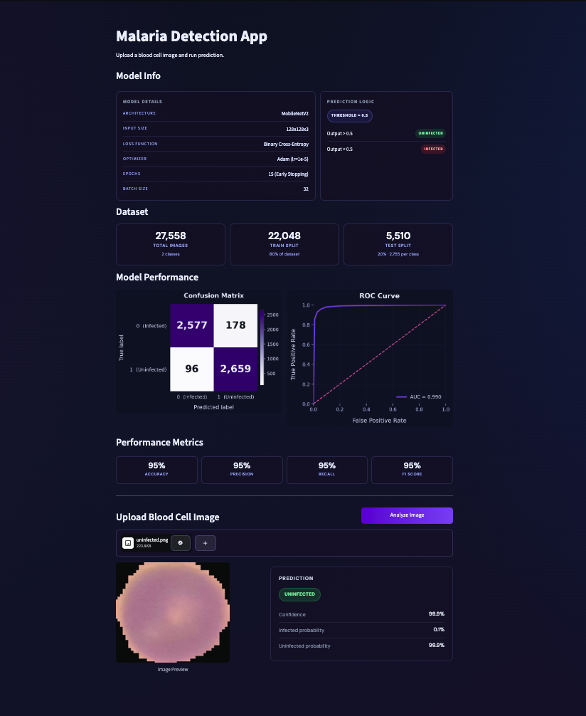
• Upload a blood cell image for analysis
• View the prediction result (Infected/Uninfected)
• See the confidence score of the prediction

10. Conclusion and Future Scope
This project successfully demonstrates the application of deep learning in medical image analysis. A MobileNetV2-based model was developed using transfer learning to classify blood cell images as infected or uninfected.
The model achieved high performance, with an accuracy of approximately 95%, showing its effectiveness in malaria detection. By automating the diagnostic process, the system reduces dependency on manual microscopy and enables faster and more reliable predictions.
Furthermore, the integration of the model into a Streamlit-based web application makes it accessible to non-technical users, thereby improving usability in real-world healthcare scenarios.

Future Scope:

The project can be further improved in several ways:
• Integration with real-time video feeds from digital microscopes for live detection
• Extending the model to classify multiple types of malaria parasites
• Deployment as a mobile application for wider accessibility
• Improving accuracy using larger and more diverse datasets
• Integration with cloud-based systems for scalable deployment

