12/5/2024

By Mayank Singh

Assignment 5a

# 

Contents

0

Mission Statement 2

Objective Statement 2

Source 3

Sink 4

Data Model 5

Cloud Architecture 6

Phase 1 6

Phase 2 6

Phase 3 7

Ingestion Layer 7

Storage Layer 8

Processing Layer 10

Final Phase: 11

Pipeline strategy 13

Pipe line failure strategy 13

Conclusion 15

## 

## Mission Statement

"To design and implement a scalable, robust, and integrated data architecture that seamlessly connects diverse data sources, processes real-time and batch data efficiently, and delivers actionable insights through automated reports, dashboards, and notifications, empowering informed decision-making and operational excellence."

## Objective Statement

1. **Unified Data Integration**:
   * Establish a centralized system to connect IoT devices, ERP systems, on-premises databases, streaming platforms, and web-scraped inputs, ensuring real-time and batch data ingestion.
2. **Scalability and Flexibility**:
   * Design an architecture capable of handling growing data volumes and accommodating diverse data types (structured, semi-structured, and unstructured).
3. **Real-Time Data Processing**:
   * Implement real-time data pipelines to ingest and analyze streaming data from sensors, energy consumption metrics, and workforce tracking.
4. **Data Accuracy and Consistency**:
   * Use robust ETL/ELT processes and data validation techniques to ensure high data quality for inventory, production, and customer-related datasets.
5. **Automated Insights Delivery**:
   * Enable timely decision-making through scheduled reports, dynamic dashboards, and automated alerts for critical business processes like production, inventory, and supplier evaluation.
6. **Interoperability**:
   * Ensure seamless data sharing with external systems through standardized formats like CSV, Excel, or APIs, fostering collaboration across teams and systems.
7. **Performance Monitoring**:
   * Implement tools for monitoring KPIs such as production efficiency, energy usage, and manpower utilization, driving continuous improvement.

## Source

To ensure seamless and comprehensive data integration across various sources, the following methods are employed:

1. **IoT Integration**:
   * Leverage IoT technologies to connect Customer Relationship Management (CRM) systems.
   * Automate the flow of data related to customer inquiries, sales orders, and feedback directly into the system.
   * Enhance customer experience through real-time updates and actionable insights derived from IoT-enabled devices.
2. **On-Premises Data Loading**:
   * Utilize Extract, Transform, Load (ETL) tools to import data from static sources, such as CSV files.
   * Focus on loading critical datasets like inventory levels and product specifications.
   * Ensure the accuracy and reliability of on-premises data by implementing validation checks during the ETL process.
3. **Streaming Data Integration**:
   * Employ streaming platforms like **Apache Kafka** to ingest real-time data streams.
   * Examples include monitoring energy consumption metrics, collecting sensor data from machinery, and tracking workforce activity.
   * Real-time insights enable proactive decision-making and optimization of operations.
4. **ERP System Connectivity**:
   * Establish direct integration with Enterprise Resource Planning (ERP) systems.
   * Access essential data such as Bills of Materials (BOM), production orders, operations sequences, and purchase entries.
   * Streamline workflows by ensuring consistent and synchronized data between ERP systems and other platforms.
5. **Web Scraping and Manual Data Capture**:
   * Use web forms and web scraping tools to gather external data, including market surveys and competitive intelligence.
   * Facilitate manual data entry processes, especially for non-structured data like images or forms that require human input and validation.

## Sink

To maximize the utility of the processed data, the following output mechanisms are implemented:

1. **Reports**:
   * Generate scheduled and automated reports covering critical business areas such as:
     + Dispatch details for logistics and supply chain management.
     + Supplier evaluation metrics to assess vendor performance.
     + Plant performance reports to analyze operational efficiency and productivity.
2. **Automated Notifications**:
   * Set up automated alerts and notifications for key triggers, such as:
     + Requests for quotations (RFQs) to suppliers or clients.
     + Production alerts for stakeholders to act on significant updates or deviations.
   * Ensure stakeholders remain informed without manual intervention, enhancing responsiveness.
3. **Dashboards**:
   * Create interactive and visually appealing dashboards for real-time monitoring of key performance indicators (KPIs).
   * Common KPIs include:
     + **Production Efficiency**: Compare actual production with planned targets.
     + **Inventory Levels**: Monitor stock availability to avoid overstocking or shortages.
     + **Energy Usage**: Track energy consumption trends for cost and sustainability management.
     + **Manpower Utilization**: Analyze workforce productivity to optimize labor allocation.
4. **Data Sharing**:
   * Facilitate data export to external systems or platforms as needed.
   * Supported formats include **CSV files**, **Excel sheets**, or via **APIs** for seamless integration.
   * Ensure the processed data is readily available for analysis, reporting, or further processing in other applications.

## Data Model

# 

## Cloud Architecture

### Phase 1

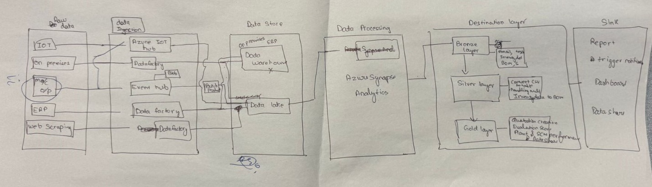

I have completed the initial phase of my cloud architecture, during which we explored the fundamentals of the destination layer and gained insights into how it will function within the project.

### Phase 2

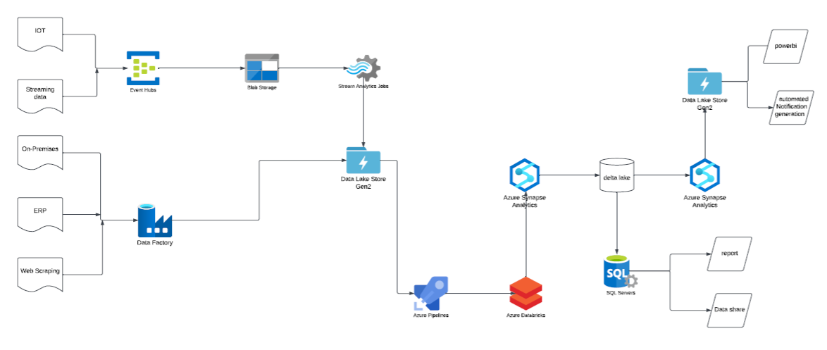

### Phase 3

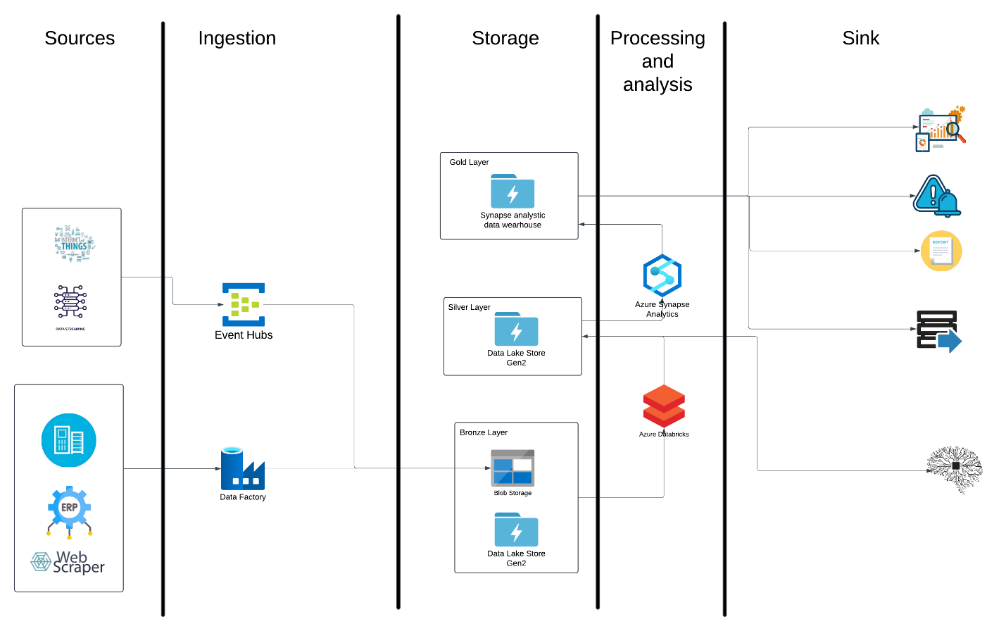

### Ingestion Layer

**Azure Data Factory** and **Event Hub** are used for **data ingestion** due to their unique roles in handling different types of data and workloads:

1. **Azure Data Factory**:

* **Purpose**: Used for **batch data ingestion** from structured or semi-structured sources like databases, ERP systems, or web scrapers.
* **Reasons for Use**:
  + **Extract, Transform, Load (ETL/ELT)**: Automates the movement and transformation of large amounts of data from various sources to the data lake (Bronze Layer) or other storage layers.
  + **Integration with Multiple Sources**: Can pull data from databases, REST APIs, SaaS applications, and file systems.
  + **Data Orchestration**: Allows you to define workflows and pipelines that control when, where, and how the data moves into the data lake.
* In this diagram:
  + It is handling data ingestion for **ERP systems**, **web scrapers**, or other similar structured data sources.
  + It moves this data into **Azure Blob Storage** or **Data Lake Store Gen2** in the **Bronze Layer**.

2. **Azure Event Hub**:

* **Purpose**: Used for **real-time data ingestion** from high-velocity, unstructured sources like IoT devices or streaming applications.
* **Reasons for Use**:
  + **Event Streaming**: Captures and ingests millions of events per second with low latency.
  + **Scalability**: Can handle large-scale, time-sensitive data from Internet of Things (IoT) devices, sensors, or other applications.
  + **Integration with Azure Ecosystem**: Works well with services like Azure Stream Analytics and Azure Functions to process events in real time.
* In this diagram:
  + It ingests **real-time streaming data** from IoT devices or data sources and places it in the **Bronze Layer** (Data Lake Gen2).

**Event Hub** focuses on real-time ingestion of high-velocity data (e.g., IoT and sensor data).

**Data Factory** specializes in orchestrating and ingesting large-scale batch data from diverse structured and semi-structured sources.

### Storage Layer

The design shown in the diagram represents a **modern data architecture** that leverages the capabilities of different Azure services. Here's why each component is used:

**1. Blob Storage for the Bronze Layer**

* **Purpose**: The Bronze Layer is often used as the **raw data ingestion layer** in a data lakehouse architecture. Blob Storage is cost-effective and designed for storing massive amounts of unstructured or semi-structured data.
* **Advantages**:
  + **Cost-effective storage**: Blob Storage offers a cheap way to store raw, unprocessed data.
  + **Scalability**: It can handle large amounts of data from various sources, such as IoT devices, web scraping, and ERP systems.
  + **Native integration**: It integrates well with Azure Data Factory, Azure Databricks, and Azure Synapse for further processing.

**2. Data Lake Store Gen2 for Bronze and Silver Layers**

* **Bronze Layer**:
  + Used for storing **raw data** in its original format (semi-structured or unstructured) to preserve its integrity and allow for reprocessing if necessary.
* **Silver Layer**:
  + Used for **cleansed and enriched data**. At this stage, data is processed, transformed, and normalized, making it easier to analyze and integrate with other systems.
* **Why Data Lake Store Gen2?**
  + **Hierarchical namespace**: Allows for improved performance and fine-grained access control over folders and files.
  + **Unified storage**: Supports both structured (CSV, JSON, Parquet) and unstructured data.
  + **Big data processing**: Optimized for use with big data frameworks such as Spark, Hive, and Databricks.

**3. Synapse Analytics for the Gold Layer**

* **Purpose**: The Gold Layer is designed for **curated, aggregated, and ready-to-consume data** for analytics, reporting, and business intelligence.
* **Why Azure Synapse Analytics?**
  + **Data warehouse capabilities**: Synapse is an enterprise-grade data warehouse optimized for structured, relational data.
  + **High performance**: It supports complex analytical queries with high speed using massive parallel processing (MPP).
  + **Integration**: Works seamlessly with Azure Data Lake and Databricks, making it easy to query the Gold Layer data.
  + **Built-in analytics**: Synapse can run both on-demand and provisioned queries using SQL or Spark, reducing latency for downstream applications like dashboards, predictive analytics, and reporting.

**How They Work Together**

* **Ingestion (Blob Storage)**: Raw data is collected and stored in the most cost-effective manner.
* **Processing (Data Lake Gen2)**: Data is refined and structured through ETL/ELT pipelines. The hierarchical namespace of Gen2 allows for better organization.
* **Consumption (Synapse Analytics)**: Transformed data is loaded into Synapse for business intelligence, machine learning, and advanced analytics.

**Summary**

* **Blob Storage** is for storing raw, unstructured data (low cost).
* **Data Lake Gen2** is for scalable, hierarchical storage for processing and intermediate datasets.
* **Synapse Analytics** is for high-performance querying and delivering insights to end users.

### Processing Layer

In the architecture shown in your diagram, **Databricks** and **Azure Synapse Analytics** are used together because they serve complementary purposes in the data pipeline, enabling efficient data processing, analytics, and insights.

1. **Databricks**

* **Purpose**: Databricks is a unified analytics platform built for big data processing and machine learning. It is particularly strong in handling unstructured and semi-structured data and providing tools for data scientists and engineers.
* **Uses in the Architecture**:
  + **Data Transformation**: Used to clean, preprocess, and transform raw data (bronze layer) into more structured and refined datasets (silver layer).
  + **Data Science and Machine Learning**: Provides a collaborative environment for data scientists to build machine learning models.
  + **Scalability**: Handles large-scale distributed data processing using Spark.
  + **Notebook Integration**: Offers a developer-friendly interface with notebooks for exploratory analysis.

2. **Azure Synapse Analytics**

* **Purpose**: Synapse is a fully integrated analytics service optimized for large-scale data warehousing and complex analytical workloads.
* **Uses in the Architecture**:
  + **Data Warehousing**: Acts as the **gold layer** where highly refined and aggregated datasets are stored for analytics and reporting.
  + **BI Integration**: Enables integration with tools like Power BI for creating dashboards and reports.
  + **SQL-Based Analytics**: Allows data analysts to query large datasets efficiently using SQL.
  + **Operational Reporting**: Stores structured data optimized for use cases like operational reporting or trend analysis.

### Final Phase:

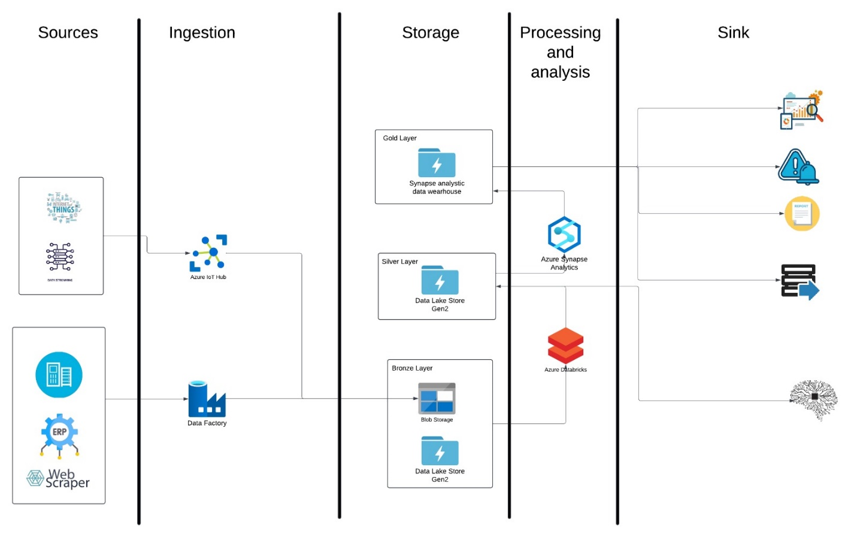

Replacing **Azure Event Hub** with **Azure IoT Hub** in the data pipeline shown in your updated diagram signifies a focus on handling **IoT-specific data** and managing devices rather than simply ingesting general event streams. Here's an explanation of how this change impacts the pipeline and the benefits:

**Key Explanation of the Change**

1. **IoT-Specific Data Ingestion**:
   * **Azure IoT Hub** is specifically designed to handle data from IoT devices, enabling two-way communication between devices and the cloud. This makes it a better choice for IoT-centric scenarios compared to Azure Event Hub, which is a general-purpose event ingestion service.
   * The diagram now emphasizes an **IoT-first architecture**, signaling that the pipeline is optimized for IoT workloads like sensor data, telemetry, and device state updates.
2. **Device Management**:
   * Unlike Event Hub, IoT Hub includes **device management capabilities**, such as:
     + Device provisioning.
     + Over-the-air updates.
     + Monitoring device connectivity and health.
   * This addition suggests the pipeline is designed not only for ingesting IoT data but also for managing and maintaining connected devices in the field.
3. **Seamless Integration with IoT Workloads**:
   * IoT Hub offers native features like **device authentication**, **per-device identity**, and **protocol support** (MQTT, AMQP, HTTP). These capabilities enhance security and ensure efficient communication between IoT devices and the ingestion layer.
4. **Real-Time and Batch Processing**:
   * With IoT Hub in place, the pipeline is well-suited for real-time data processing from IoT devices using **streaming analytics** or **real-time dashboards**. At the same time, batch processing of aggregated data can flow into the storage layers (Bronze, Silver, Gold) for further processing.
5. **Enhanced Monitoring and Alerts**:
   * IoT Hub's integration allows telemetry data to be monitored in near real-time. This is particularly valuable for applications where anomalies in device data (e.g., sudden temperature spikes or device failures) trigger alerts or automated actions.

## Pipeline strategy

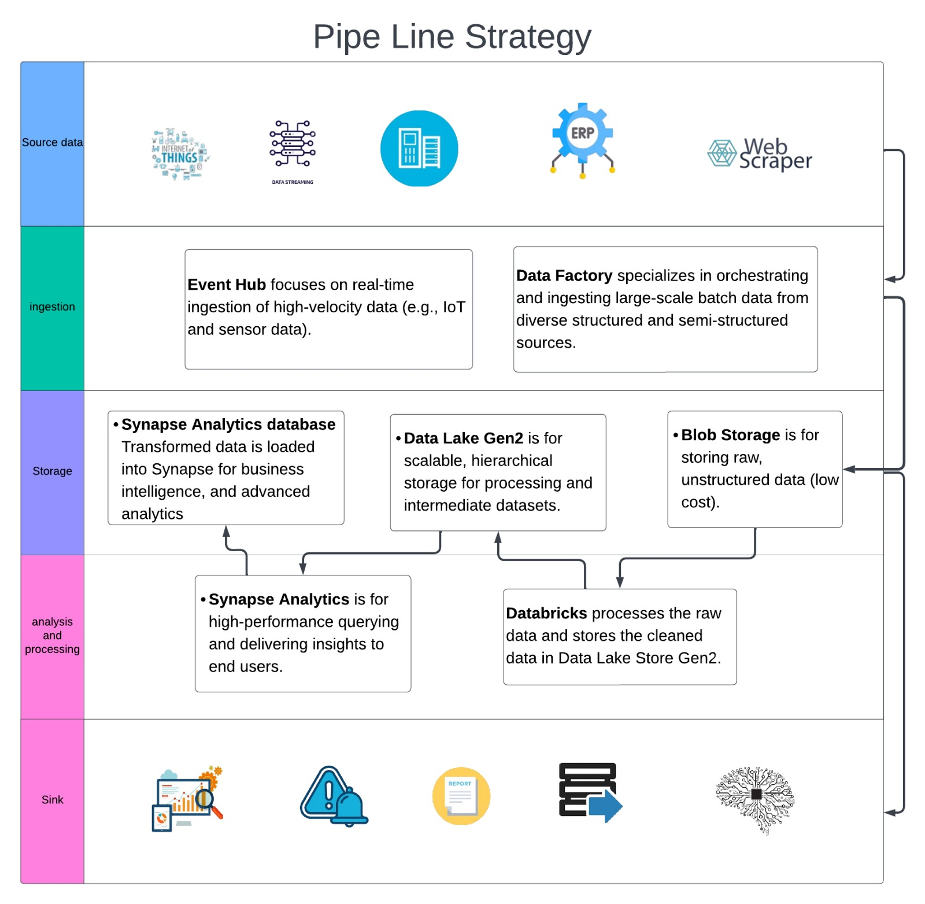

## Pipe line failure strategy

In this data architecture, a **timeout pipeline failure strategy** is crucial for ensuring the resilience, reliability, and efficiency of data workflows. It helps manage and recover from pipeline failures caused by delays or bottlenecks in data processing. Let’s explore how this strategy applies and benefits the given data structure:

**How It Helps in This Data Structure**

In the diagram, data flows through multiple layers and services (Bronze, Silver, Gold) involving various transformations and machine learning tasks. Here's how a timeout strategy benefits this structure:

**a. Prevents Resource Bottlenecks**

* **Scenario**: A data transformation job in the **Silver Layer** (e.g., cleaning or feature engineering) is taking too long due to large data volumes or inefficient code.
* **Solution**: A timeout strategy terminates the job, freeing up cluster resources in Azure Databricks or Azure Synapse to process other tasks.

**b. Improves Pipeline Resilience**

* **Scenario**: Data ingestion from IoT devices or web scraping may get stuck due to slow or unresponsive upstream sources.
* **Solution**: Timeout rules detect and handle these delays by skipping problematic data sources, ensuring that downstream processes (e.g., ML training in Databricks) are not blocked.

**c. Enables Early Failure Detection**

* **Scenario**: A long-running machine learning model training job in Databricks exceeds its expected runtime.
* **Solution**: The timeout strategy alerts engineers or triggers automated workflows to investigate or restart the task with smaller data batches or optimized parameters.

**d. Ensures Data Pipeline Continuity**

* **Scenario**: An aggregation job in the **Gold Layer** (e.g., creating business intelligence reports in Synapse) is delayed, causing downstream reporting systems to miss SLAs (Service Level Agreements).
* **Solution**: Timeout rules reroute partial data to reporting systems or escalate the issue, ensuring continuity of operations.

**Where It Applies in the Pipeline**

**Bronze Layer (Raw Data Storage)**

* **Use Case**: Timeout strategies prevent unprocessed raw data (e.g., from IoT sensors or web scrapers) from causing delays in ingestion pipelines.
* **Action**: Move problematic data to a quarantine storage area for manual review.

**Silver Layer (Refined Data)**

* **Use Case**: Timeout rules ensure that ETL (Extract, Transform, Load) jobs, data cleaning, and feature engineering tasks don’t block downstream ML pipelines.
* **Action**: If a job times out, log the failure and retry with smaller data chunks or fallback scripts.

**Gold Layer (Analytics Ready Data)**

* **Use Case**: Timeout strategies ensure that ML model predictions and analytics dashboards are not delayed due to upstream bottlenecks.
* **Action**: Send alerts or serve older cached results when new data fails to meet SLAs.

**Machine Learning Pipelines**

* **Use Case**: ML model training or hyperparameter tuning can be computationally expensive and prone to excessive runtimes.
* **Action**: Timeout rules terminate stalled training jobs and trigger alternative workflows (e.g., reduced parameter search spaces).

## Conclusion

In conclusion, the proposed data architecture establishes a unified, scalable system to seamlessly integrate diverse data sources, including IoT devices, ERP systems, and real-time streaming platforms. It ensures data accuracy and consistency through robust ETL/ELT processes while delivering actionable insights via automated reports, dashboards, and notifications. By focusing on interoperability, performance monitoring, and flexible data sharing, the architecture empowers stakeholders with real-time visibility and control over key operations such as production efficiency, inventory management, and workforce utilization. This comprehensive approach drives informed decision-making, operational excellence, and continuous improvement, fostering a data-driven culture across the organization.