🚀 Assessment: Implementing Azure Application Gateway (Layer 7 Load Balancing)
By: Mayank Sharma

1. 🎯 Assessment Objective
The objective of this lab is to deploy an Azure Application Gateway to manage and distribute incoming HTTP traffic across a pool of backend Virtual Machines. This demonstrates Layer 7 load balancing capabilities, ensuring high availability and efficient traffic distribution using a Round-Robin mechanism.

2. 🏗️ Architecture Overview
The architecture consists of:
- 🌐 User (Browser): Initiates requests via the Application Gateway's Public IP
- ⚡ Application Gateway: Acts as the entry point, operating at Layer 7 (Application Layer)
- 🖥️ Backend Pool: A collection of two Virtual Machines (VM1 and VM2) running web servers to serve content

3. ⚙️ Implementation Steps

🔹 Step 1: Resource Group & VNet Setup
- Resource Group: Created rg-appgw-lab in the Central India region
- Virtual Network: Provisioned vnet-appgw with a 10.0.0.0/16 address space
- Subnets:
  - appgw-subnet (10.0.0.0/24): Created as a dedicated subnet (Application Gateway must reside in its own subnet)
  - backend-subnet (10.0.1.0/24): Created for hosting backend Virtual Machines
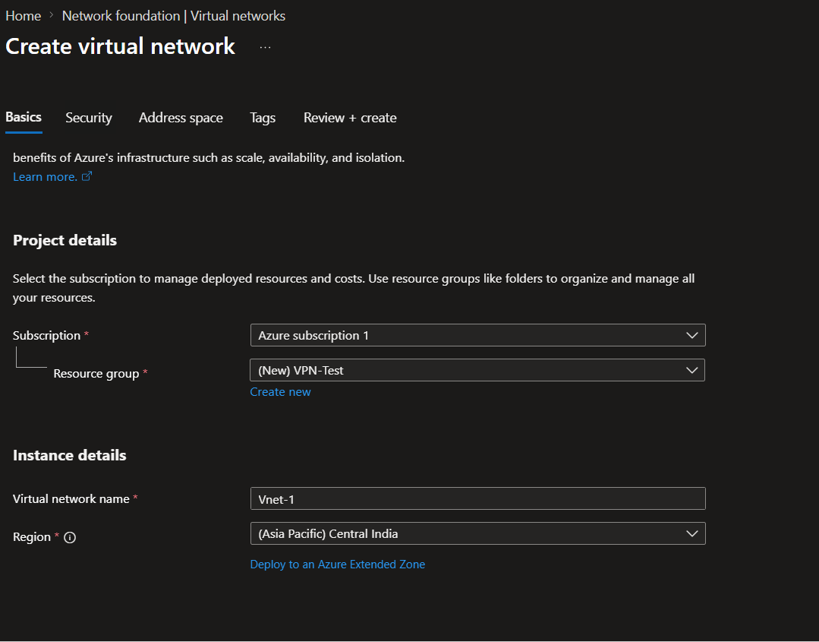
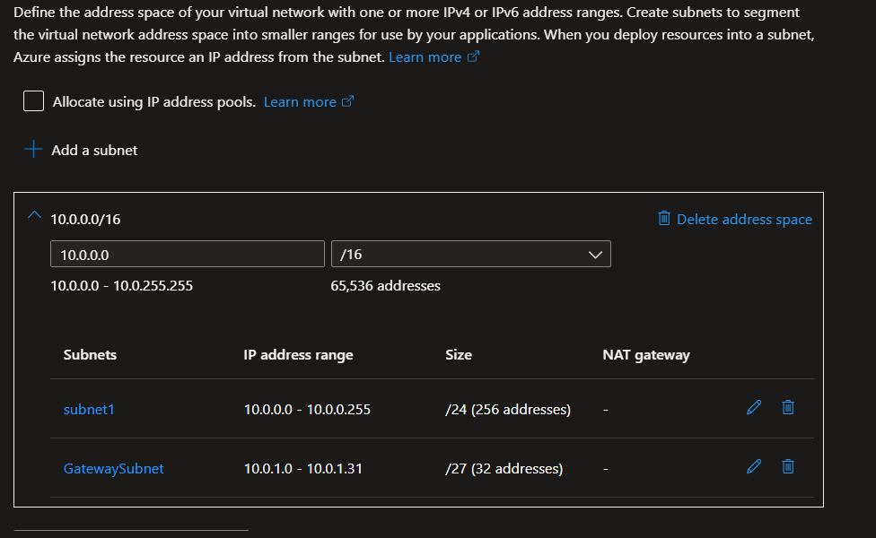

🔹 Step 2: Backend VM Deployment

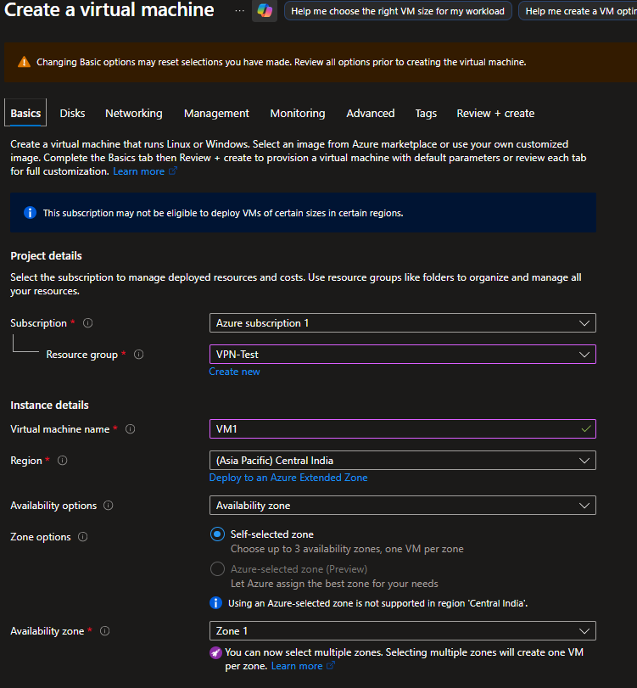
- Instances: Deployed two Virtual Machines (vm1 and vm2) into the backend-subnet
- Web Server Configuration: Configured web servers on both VMs with distinct landing pages for identification
- Networking: Ensured Port 80 (HTTP) is allowed in the Network Security Group (NSG)
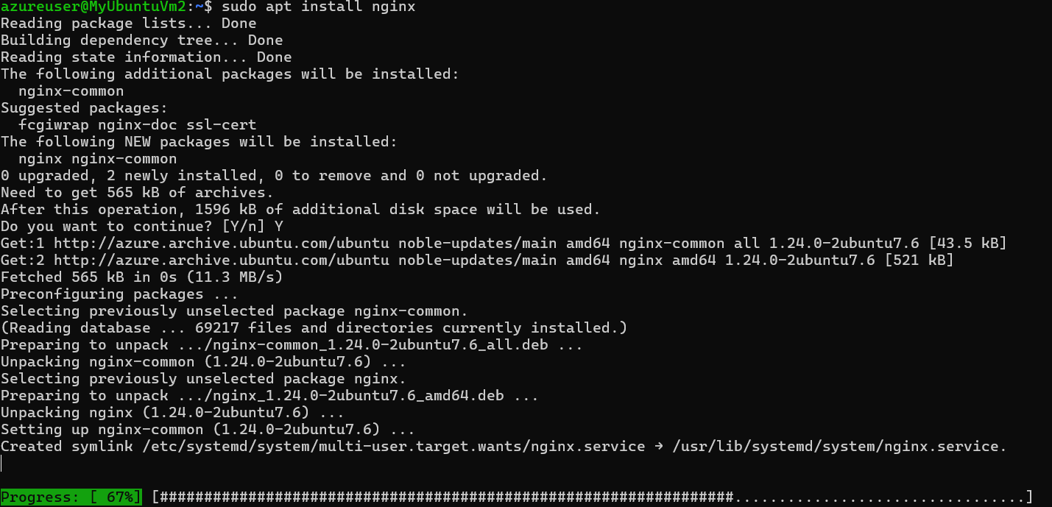

🔹 Step 3: Application Gateway Provisioning
- Basics: Named the resource appgw-demo using the Standard v2 tier
- Frontend: Created a Public IP named appgw-pip
- Backend Pool: Added vm1 and vm2 using their private IP addresses
- Configuration (The "Three Pillars"):
  - Listener: Configured on Port 80 (HTTP) to receive external requests
  - HTTP Setting: Defined communication with backend servers over Port 80
  - Routing Rule: Created rule1 to link the Listener, HTTP Setting, and Backend Pool
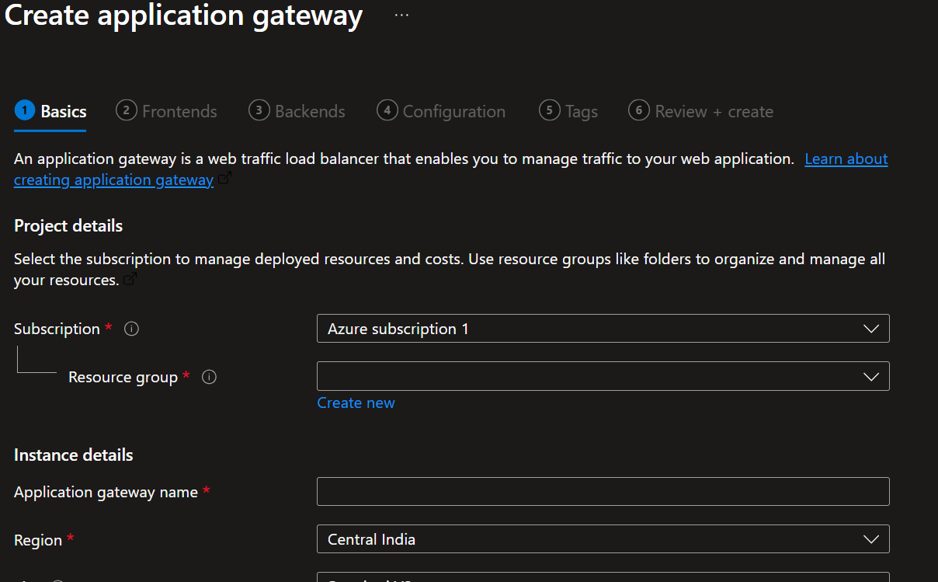

4. 🧪 Verification and Testing

4.1 Connectivity Test
- Copied the Frontend Public IP from the Application Gateway overview
- Accessed it via a web browser
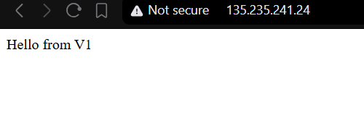

4.2 Expected Results
Upon refreshing the browser, responses alternate between the two backend servers:
- First Load: Response from VM1
- Refresh: Response from VM2
This confirms successful load balancing behavior.

5. 🧠 Key Concept Summary
Feature | Description
Layer 7 Load Balancing | Distributes traffic based on application-level data (HTTP/HTTPS)
Dedicated Subnet | Application Gateway requires its own subnet
Round Robin | Default mechanism for equal traffic distribution

6. 🏁 Conclusion
This lab successfully demonstrates the deployment of an Azure Application Gateway. By isolating the gateway in a dedicated subnet and configuring multiple backend Virtual Machines, a scalable and highly available architecture was achieved.
This setup also provides a strong foundation for implementing advanced features such as URL-based routing and Web Application Firewall (WAF) for enhanced security.
à

