Detailed Project Report
Intelligent Research Assistant using RAG and LLMs
Objective 1: User Authentication and Personal Workspace Management System

1. Introduction
The Intelligent Research Assistant platform is designed to provide secure and personalized access to users who interact with AI-powered research tools.
The system enables multiple users to register, authenticate, manage projects, upload documents, and securely store AI-generated conversations.
The project focuses on developing a secure authentication and workspace management architecture using modern web technologies and industry-standard security practices.

2. Background
Modern AI applications require strong authentication systems because users interact with sensitive research information and personal data.
Without proper authentication and authorization mechanisms, systems become vulnerable to unauthorized access, session hijacking, and data leakage.
This project introduces a scalable authentication framework capable of supporting multi-user AI environments securely.

3. Problem Statement
Most beginner-level AI applications lack secure authentication and user management systems. Common problems include:
• Insecure password storage
• Lack of session management
• No protected APIs
• Poor scalability
• Unauthorized data access
• Weak authentication architecture
The challenge is to create a secure and scalable system that supports authenticated sessions, personalized workspaces, and protected AI services.

4. Objectives of the Project
The major objectives of the project are:
• Secure user registration
• Login using JWT authentication
• Session management
• OAuth integration
• Protected API access
• Personalized dashboards
• Secure storage of research documents
• Chat history management
• Workspace management

5. Functional Requirements
Module 1 — User Registration
The system should allow users to create accounts securely using validated email addresses and strong passwords.
Module 2 — User Login
Users must be able to authenticate using credentials and receive JWT tokens.
Module 3 — JWT Authentication
The backend should generate, validate, and expire authentication tokens securely.
Module 4 — OAuth Login
The system should support Google and GitHub authentication.
Module 5 — Session Management
Persistent sessions, secure logout, and session timeout handling should be implemented.
Module 6 — Personal Workspace
Each user should have a personalized dashboard with uploaded documents, chat history, and saved summaries.
Module 7 — Authorization
Unauthorized access to APIs and user resources must be restricted.

6. Non-Functional Requirements
Security:
• Password hashing
• HTTPS-ready APIs
• Secure token storage
Scalability:
• Support multiple concurrent users
Performance:
• Fast authentication response
Reliability:
• Stable session handling
Usability:
• Simple and intuitive user interface

7. Recommended Technology Stack
Backend:
• FastAPI (Recommended)
• Flask
• Spring Boot
Database:
• PostgreSQL
Authentication:
• JWT
• OAuth
Frontend:
• React
• Tailwind CSS
• HTML/CSS/JavaScript

8. High-Level System Architecture
Authentication Workflow:
User
↓
Register/Login API
↓
Authentication Backend
↓
PostgreSQL Database
↓
JWT Token Generation
↓
Frontend Stores Token
↓
Protected API Access
The architecture ensures secure communication between frontend and backend systems.

9. Database Design
Users Table:
Stores user information such as id, name, email, password hash, and timestamps.
Sessions Table:
Stores active session information including login time and expiry time.
Workspace Table:
Stores project and workspace metadata for each user.
Chat History Table:
Stores user conversations and AI responses.
Uploaded Documents Table:
Stores research document metadata and file paths.

10. API Design
Register API
POST /register
Login API
POST /login
Protected Profile API
GET /profile
Logout API
POST /logout
The APIs are protected using JWT-based authentication middleware.

11. Development Phases
Phase 1 — Environment Setup
Install Python, FastAPI, PostgreSQL, VS Code, and Postman.
Phase 2 — Database Setup
Create schemas and configure database connections.
Phase 3 — User Registration
Implement validation and password hashing.
Phase 4 — Login System
Implement JWT authentication.
Phase 5 — Protected APIs
Create authentication middleware.
Phase 6 — Session Management
Implement persistent sessions and logout handling.
Phase 7 — Personal Workspace
Develop dashboards and workspace pages.
Phase 8 — OAuth Integration
Add Google and GitHub login support.
Phase 9 — Deployment
Deploy backend, frontend, and database services.

12. Security Concepts
Password Hashing:
Passwords should never be stored in plain text. bcrypt hashing should be used.
JWT Security:
Students should understand token expiration, refresh tokens, and secure token validation.
API Security:
Authentication middleware and authorization mechanisms must be implemented.
Environment Variables:
Secret keys and database credentials should be stored securely using .env files.

13. Advantages of the System
• Secure authentication
• Personalized workspaces
• Multi-user support
• Scalable architecture
• Modern API design
• Secure document management
• AI integration support

14. Future Enhancements
Future improvements may include:
• Multi-factor authentication
• AI-based recommendations
• Real-time collaboration
• Cloud storage integration
• Advanced analytics dashboards
• Role-based admin systems

15. Conclusion
The User Authentication and Personal Workspace Management System provides a strong foundation for secure AI-powered research platforms.
The project combines secure authentication, API protection, database management, session handling, and personalized user experiences. It also helps students understand modern backend development practices and real-world security concepts.

1. Homepage / Landing Page Introduction
This image represents the main landing page of the Secure User Authentication & Workspace Management system.
The interface is designed with a modern dark gradient theme that provides a professional and attractive appearance.
It contains navigation buttons such as Explore Features, Documentation, Login, and Register for easy user access.
The page highlights secure authentication, protected workspaces, and dashboard management functionalities.
A system status panel is also included to display authentication, JWT security, and database connection status.
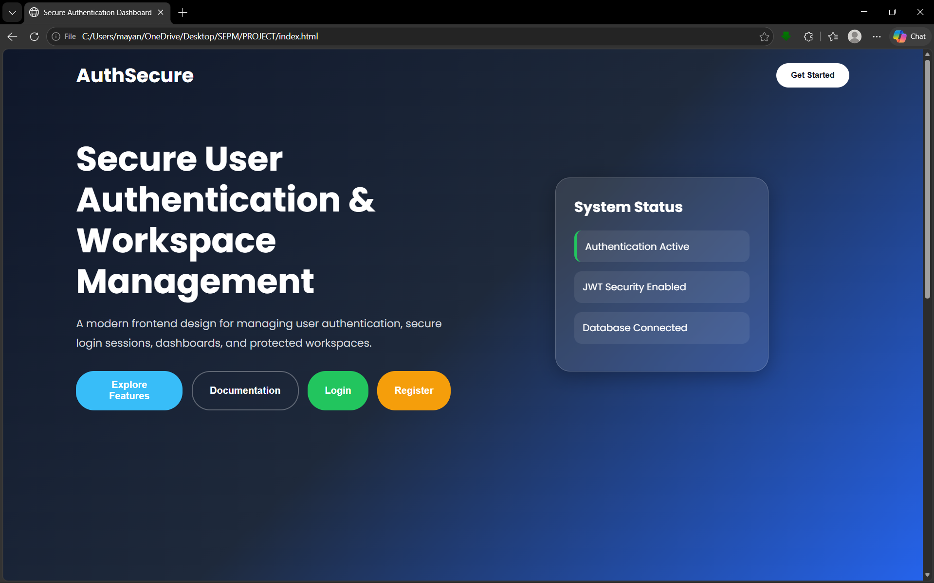
2. Authentication Dashboard Introduction
This image displays the overall Secure Authentication Dashboard interface.
The dashboard combines frontend design elements with workspace and authentication management features.
It demonstrates a responsive layout with secure login and registration functionality integrated into the system.
The application uses modern UI components, gradient backgrounds, and interactive buttons for better user engagement.
This dashboard serves as the central interface for managing authentication, security status, and user access controls.
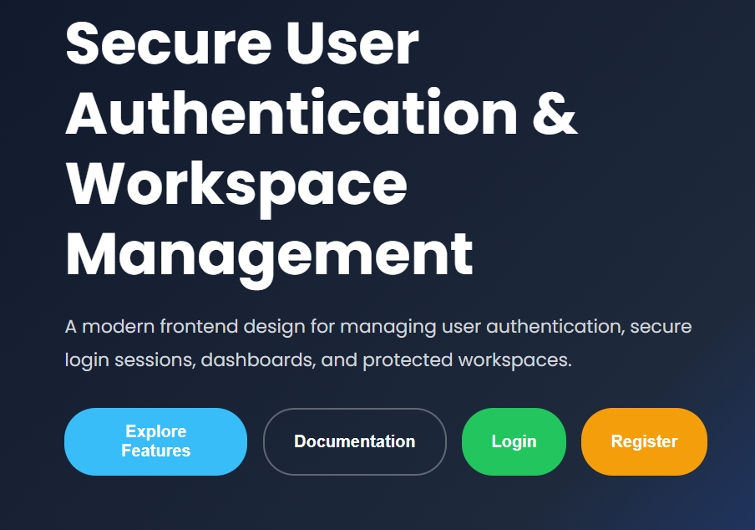

3. Login Page Introduction
This image shows the Login interface of the authentication system.
The page allows users to securely enter their email address and password to access their account.
Its minimal dark-themed UI improves readability and creates a professional user experience.
The login form is designed to support secure session handling and authenticated user access.
The clean structure makes the login process simple, fast, and user-friendly.
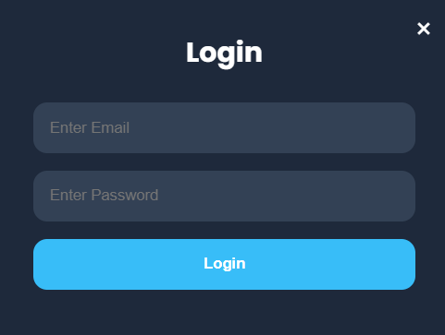
3. Registration Page Introduction
This image represents the user registration or account creation page.
New users can create an account by entering their full name, email address, and password.
The interface also provides third-party authentication options such as Google and GitHub sign-in integration.
The design focuses on accessibility, simplicity, and secure account creation.
This module helps users quickly register and access protected workspace features.
