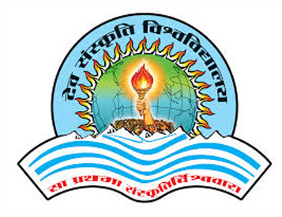
Department of Computer Science
Dev Sanskriti Vishwavidhyalaya, Gayatrikunj, Shantikunj, Haridwar.

Certificate
This is to certify that the project entitled, “Student Information System" submitted by “Mayank Kashyap" in partial fulfillment of the requirements for the award of "Master of Computer Application" in " Computer Science" at the "Dev Sanskriti Vishwavidyalaya" is an authentic work carried out by him under my supervision and guidance.

Date:

Dr. Gopal Krishna Sharma Dr. Abhay Saxena
(Internal Guide) (HOD) (Sign of External)

www.dsvv.in
Department of computer science
Dev Sanskriti Vishwavidyalaya, Haridwar, Uttrakhand-249411

