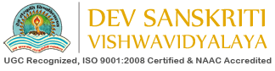

Department of Computer Science
Master of Computer Application
Academic Session
2018-2020
Mini Project On:-

“STUDENT INFORMATION SYSTEM”

Submitted To Submitted By
Dr. Gopal Krishna Sharma Mayank kashyap
Assistant Professor MCA(L) 5th Semester
Department of Computer science Department of Computer science

www.dsvv.in
Department of computer science
Dev Sanskriti Vishwavidyalaya, Haridwar, Uttrakhand-249411

