1. **INTRODUCTION**

This section gives a scope description and overview of everything included this Project Report. Also, the purpose for this document is described and system overview along with goal and vision are listed.

**Purpose**

The purpose of this document is to give a detailed description of Student Information System Project. It will illustrate the purpose and complete declaration for the development of system. It will also explain system constraints, interface and interactions with Window based application. Which is made PHP this document is primarily intended to anyone who wants to get an overview of how Student Information System works its outcomes and possible usages in future.

**System Overview**

In the existing system, most of the records are maintained on paper. It becomes very inconvenient to modify the data. In the existing system, here is a possibility that the same data in different registers may have different values which means the entries of the same data do not match. This inconsistent state does not supply the concrete information which poses a problem in the case information related to particular search record.

Our project is very useful. User is no longer required to check his register in search of records, as now it can be searched over the web site by choosing some options. The user need not to type in most of the information. He/she is just required to enter the desired options. On the whole it liberates the user from keeping lengthy manual records. In a nutshell, it abates the work load of an organization.

In today’s world, no one likes to perform operation manually when computer is there. Everyone wants his/her work to be done by computer automatically and displaying the result for further manipulations. So this project is about providing convenience regarding Student Information system.

**Name of the Project: Student Information System**

**Objectives:**

* Online registration of students
* Maintenance of student records
* Searching student records

**Users Views:**

There are two types of users that interact with the system:-

* Administrator
* Teacher

**Snapshot of Administrator interface.**

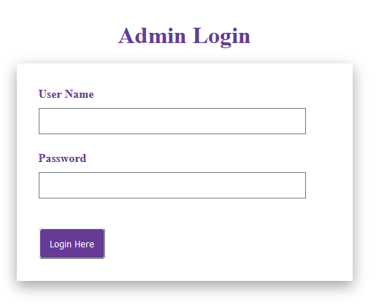

**Snapshot of Teacher interface.**

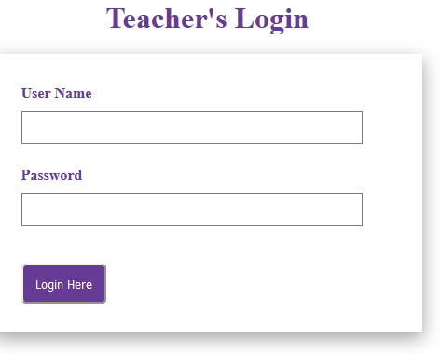

1. **REQUIREMENTS SPECIFICATIONS**

* **Functional Requirement**

**User 1:- Administrator.**

Actor: Administrator.

Input:- Feed Text as Input.

Description: Admin has access to the system through GUI based which is design in PHP.

**User 2:- Teacher.**

Actor: Teacher.

Input:- Feed Text as Input.

Description: Teacher has access to the system through GUI based which is designed in PHP using text editor. Which is adding student information, updating, deleting student information? One of the main modules of Student Information System.

**Module Description**

* **Administrator Login.**
* Administrator Section.
* Class
* Subject
* Staff
* View Staff
* Set Exam
* View Exam
* View Student
* Logout
* **Teacher Login.**
* Teacher Section.
* Handled Class
* Students
* View Student
* View Exam
* Add Marks
* View Marks
* Logout
* **Technology used.**
* **Front-end:** PHP, HTML, CSS, jquery
* **Back-end:** MySQL
* **Software Requirements:**
* Sublime Text 3(Text Editor)
* XAMPP Server
* FrontPage for Front End Programming
* Microsoft Windows, or Linux
* Web Browser(chrome, Mozilla Firefox)
* **Hardware Requirements:**
* Intel Core i3 processor or equivalent or higher
* 4GB
* 500GB or Higher
* Network Connectivity

1. **DESIGN**

**DFD:** Student Information System

Level 0

Admin

Software Setting

Report

Student Data

Read Information

Teacher

Level 1

Check

Login DB Std_Info DB

Detail

verify

Detail

Std_data

Admin

Detail

Report

Std_detail DB

Report

Teacher

Level 2 staff db

Exam

Login db

Marks db

Std_db



View db

Class db

Teacher

* **ERD:** Student Information System

Teacher

Add

Admin

Add

Student_Detail

**4.TECHNOLOGY OVERVIEW**

The technology selected for implementing Student Information System is PHP/MYSQL.Apache is used as the PHP server.The development was done in a ‘windows’ environment using Sublime Text Editor.

**PHP**

PHP is a general-purpose scripting language that is especially suited to server side web development where PHP generally runs on a web server.PHP code is embedded into the HTML source document. Any PHP code in a requested file is executed by the PHP runtime, usually to create dynamic web page content. It can also be used for command-line scripting and client-side GUI applications. PHP can be deployed on many web servers and operating systems, and can be used with many relational database management systems (RDBMS). It is available free of charge, and the PHP Group provides the complete source code for users to build, customize and extend for their own use.

**MySQL**

MySQL is a relational database management system (RDBMS)[1] that runs as a server providing multi-user access to a number of databases. MySQL is a popular choice of database for use in web applications and is an open source product. The process of setting up a MySQL database varies from host to host, however we will end up with a database name, a user name and a password. Before using our database, we must create a table. A table is a section of the database for storing related information. In a table we will set up the different fields which will be used in that table. Creating a table in phpMyAdmin is simple, we just type the name, select the number of fields and click the ‘go’ button. we will then be taken to a setup screen where you must create the fields for the database.Another way of creating databases and tables in phpMyAdmin is by executing simple SQL statements.We have used this method in order to create our database and tables.

**Apache**

The Apache HTTP Server is a web server software notable for playing a key role in the initial growth of the World Wide Web. In 2009 it became the first web server software to surpass the 100 million web site milestone. Apache is developed and maintained by an open community of developers under the auspices of the Apache Software Foundation. Since April 1996 Apache has been the most popular HTTP server software in use. As of November 2010 Apache served over 59.36% of all websites and over 66.56% of the first one million busiest websites.

**XAMPP**

XAMPP is a small and light Apache distribution containing the most common web development technologies in a single package. Its contents, small size, and portability make it the ideal tool for students developing and testing applications in PHP and MySQL. XAMPP is available as a free download in two specific packages: full and lite. While the full package download provides a wide array of development tools, XAMPP Lite contains the necessary technologies that meet the Ontario Skills Competition standards.The light version is a small package containing Apache HTTP Server, PHP, MySQL, phpMyAdmin, Openssl, and SQLite.

**Obtaining and Installing XAMPP**

As previously mentioned, XAMPP is a free package available for download and use for various web development tasks. All XAMPP packages and add-ons are distributed through the Apache Friends website at the address: http://www.apachefriends.org/. Once on the website, navigate and find the Windows version of XAMPP and download the self-extracting ZIP archive. After downloading the archive, run and extract its contents into the root path of a hard disk or USB drive. For example, the extract path for a local Windows installation would simply be C:\. If extracted properly we will notice a new xampp directory in the root of your installation disk. In order to test that everything has been installed correctly, first start the Apache HTTP Server by navigating to the xampp directory and clicking on the apache_start.bat batch file. Next we will test if the server is running correctly by opening an internet browser and typing http://localhost/ into the address bar. If configured correctly, we will be presented with a screen similar to that of the one below.

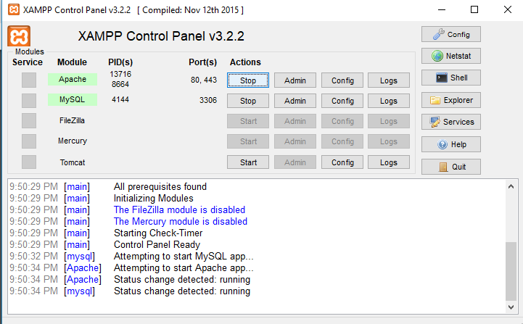

XAMPP splash screen.

In order to stop all Apache processes we do not close the running terminal application, but instead run another batch file in the xampplite directory called apache_stop.bat.

**Creating a Database and Inserting Data**

Now that we have run and tested Apache and PHP, the next step is running MySQL and creating a database and table which will hold information to be used by our website. In order to start MySQL, navigate to the xampp directory and run the mysql_start.bat batch file.The XAMPP package contains an application called phpMyAdmin which allows developers to administer and maintain MySQL databases.We will be using phpMyAdmin to create a database and table, and enter test data. Before testing phpMyAdmin, make sure that both Apache and MySQL are running by opening their respective batch files: apache_start.bat and mysql_start.bat. Along with Apache and MySQL running in the background, we type http://localhost/phpMyAdmin/ into our web browser. If successful we will be presented with a phpMyAdmin start page similar to the one shown below.

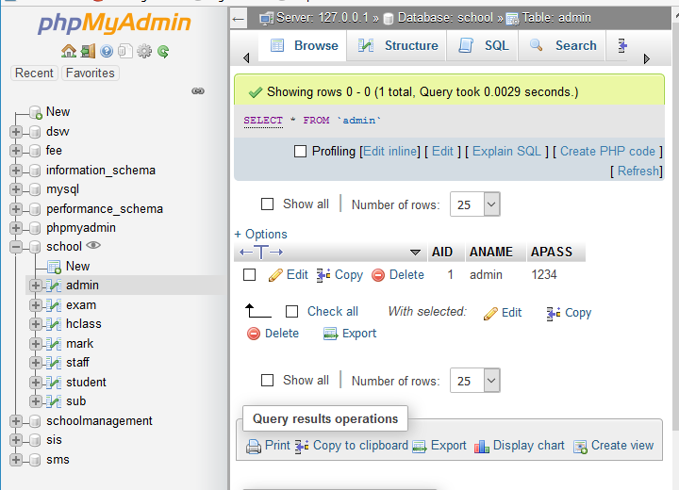

The first step with phpMyAdmin running is creating a new database.We create a new database by directly executing SQL statements as shown below.The successful execution of the sql querry creates a database ‘school’ with eight tables in it.The tabels are admin_login exam,hclass, mark, staff, student, sub.We also inserted values in the admin table.The screenshot below shows the successful execution of the query thus creation of a database named school.

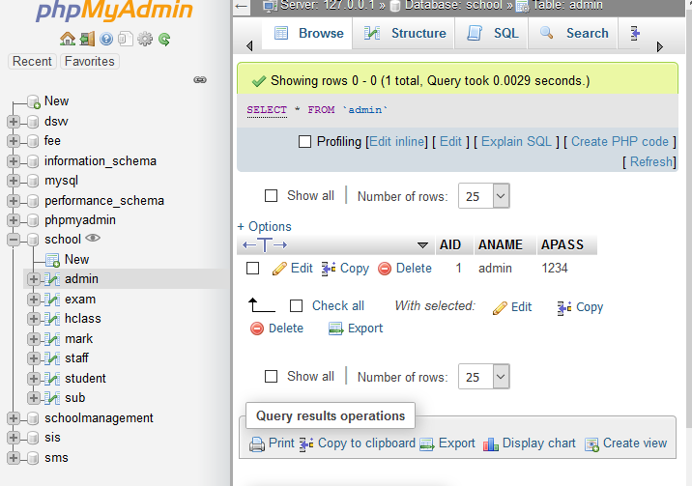

Thus we have learned to create a database in MYSQL by executing sql statements. After creating the database and tables we are now ready to use them in our website “Student Information System” .

**TABLE STRUCTURE:-**

Features of admin module:-

* Admin itself have the admin user name and password in admin table.
* Admin can add new class.
* Add subject
* Add staff details
* Admin can view staff
* Set Exam
* View Exam
* View Student
* Logout

Features of Teacher module:-

* Teacher add profile
* Handle class
* Set exam time table
* View student
* View exam
* Add marks
* View marks
* Logout

**Table:- Admin**

**Fields:-**

• Admin user-name.

• Admin Password.

**Snapshot of Table:-**

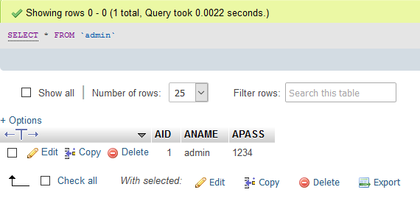

* Admin can add new class.

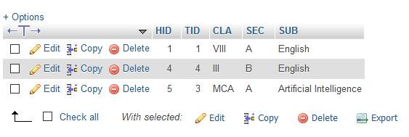

* Add subject

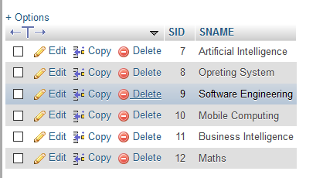

* Add staff details

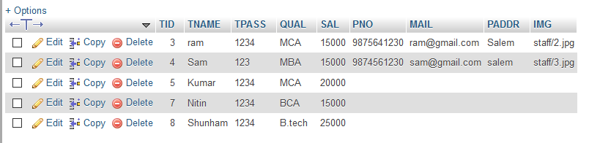

* Set Exam

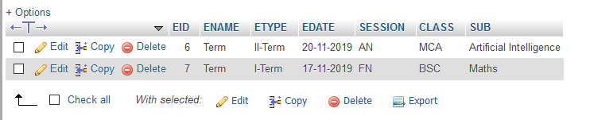

* View Exam



* View Student

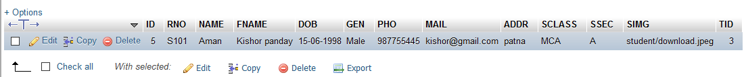

* Teacher add profile

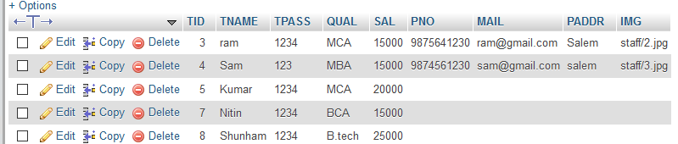

* Handle class

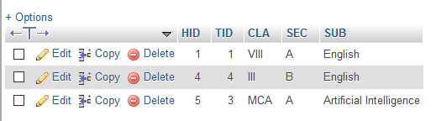

* Set exam time table

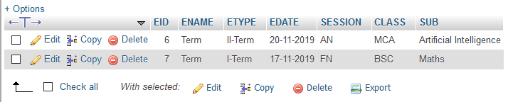

* View student

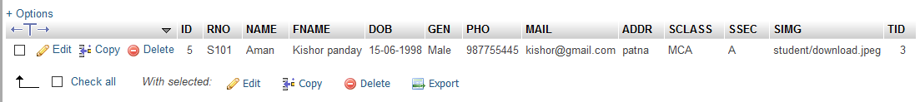

* View exam



* Add marks

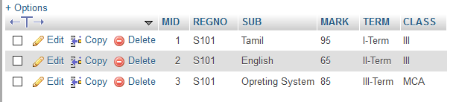

* View marks



**5.DESIGN FOR FRONT-END**

* Student Information System home page

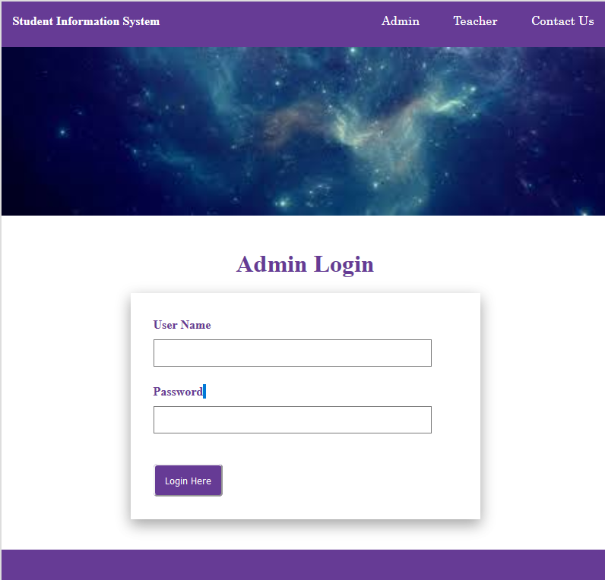

**Snapshot detail:-**

In the student Information System home page contain admin, teacher, and contact us option. Where admin option contain admin dashboard teacher contain teacher dashboard and contact us contain address of developer.

* **Administrator Login Interface.**

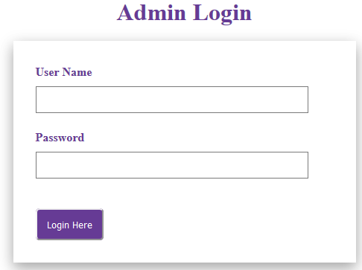

**Snapshot detail:-**

Administrator Login:- Admin can enter the correct user-name and password to enter into the admin section. The admin can need only user-name and password detail.

**Teacher Section Interface:**

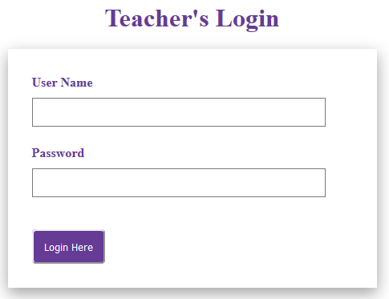

**Snapshot detail:-**

Teacher Login: Teacher can enter the correct user-name and password to enter into the teacher section. The teacher can need only user-name and password detail.

* **Administrator Dashboard.**

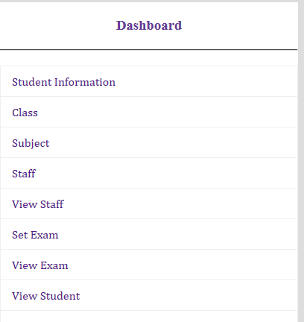

**Add Class**

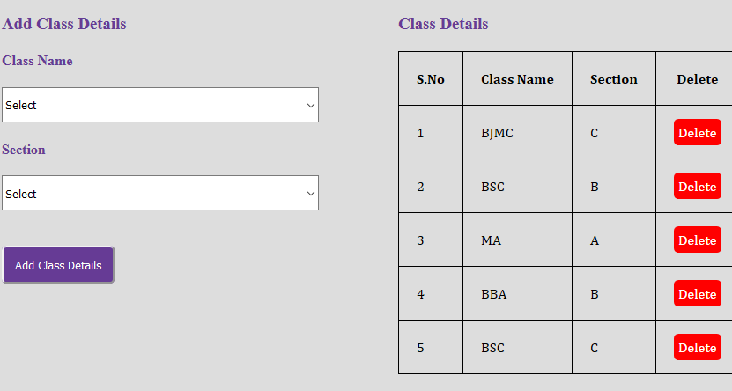

**Snapshot Detail:**

In this section admin can add new class. Where it contain class name, and section.

**Add Subject:**

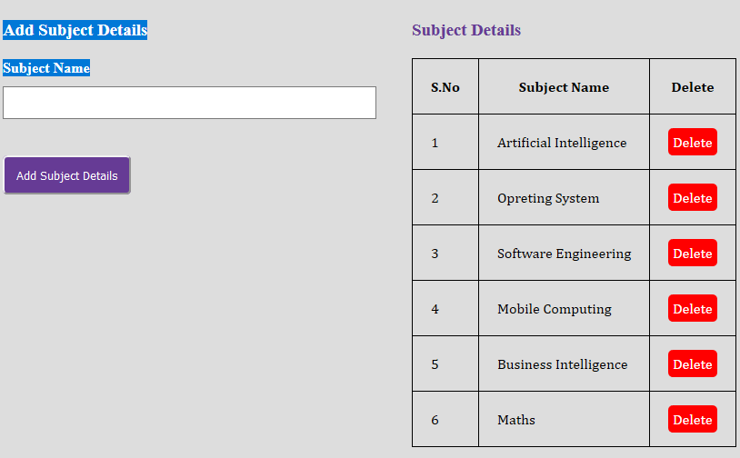

**Snapshot Detail:**

In this section admin can add student subject. Where this contain subject name.

**Add staff Details:**

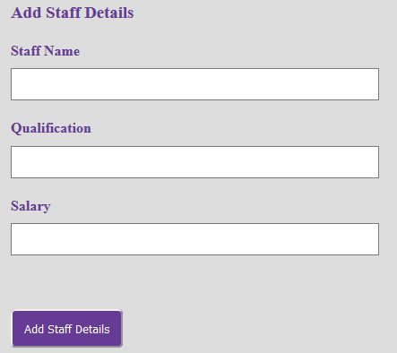

**Snapshot Detail:**

In this section admin can add staff detail like staff name, qualification and salary.

**View staff Detail**

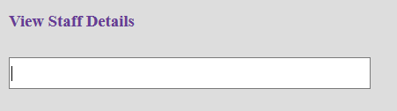

**Snapshot Detail:**

In this section admin can also view staff detail by simple enter staff name.

**Set Exam:**

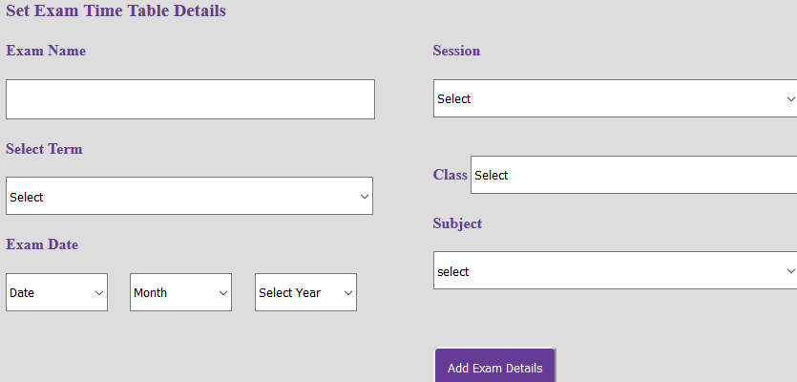

**Snapshot Detail:**

In set exam section admin can make time table of exam. Where admin can enter exam name select term exam date, section, class, and subject.

**View Exam:**

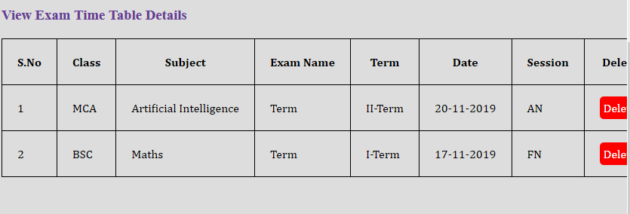

**Snapshot Detail:**

In this section admin can view exam detail.

**View Student:**

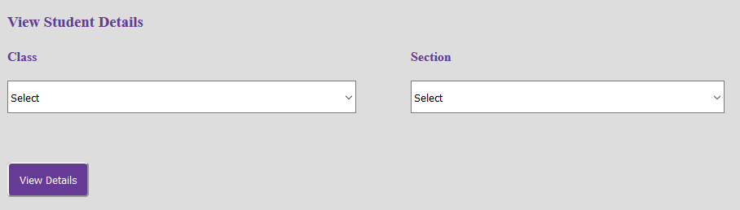

**Snapshot Detail:**

In this section admin can view detail of students.

**Teacher Dashboard:**

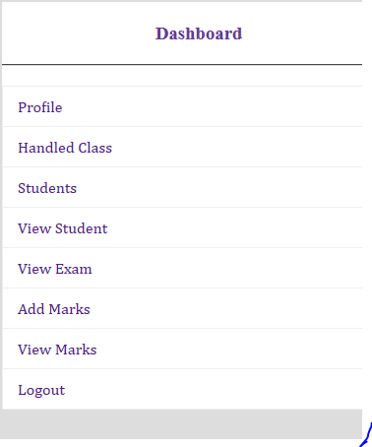

**Add Profile:**

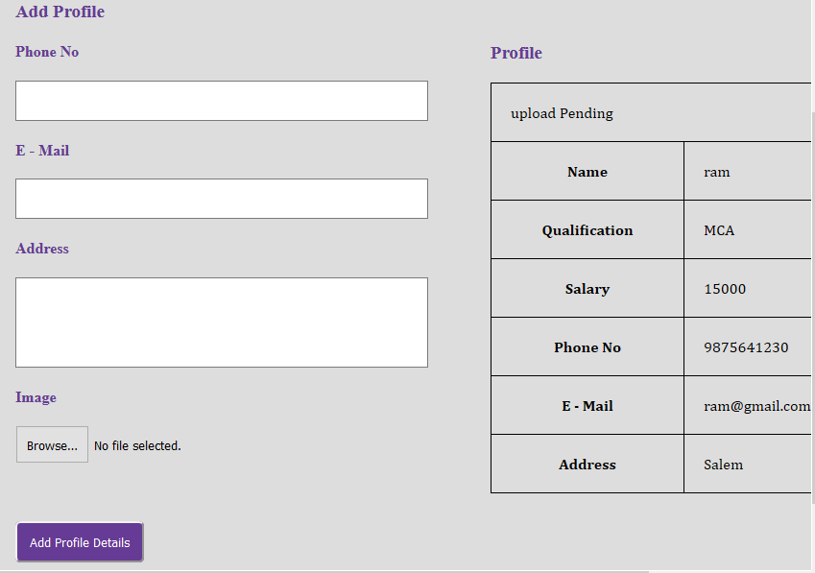

**Snapshot Detail:**

In this section teacher can add their profile detail.

**Add Class:**

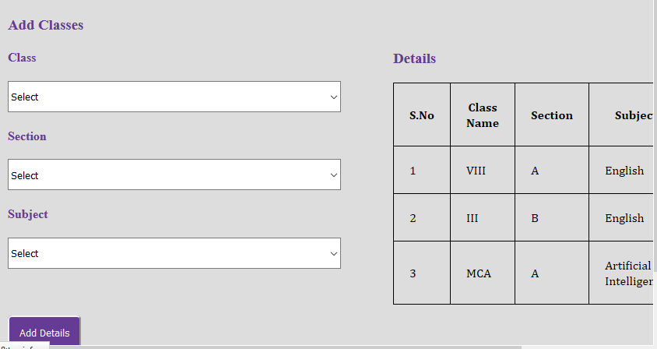

**Snapshot Detail:**

In this section teacher can add student class.

**Student:**

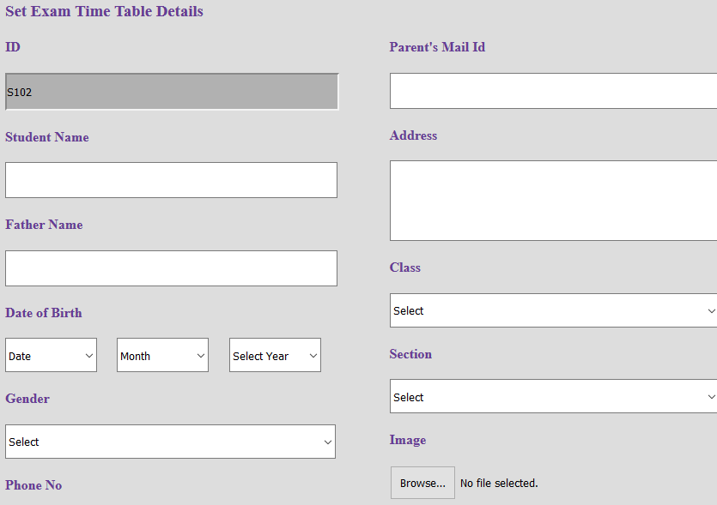

**Snapshot Detail:**

In this section teacher set exam time table.

**View Student detail:**

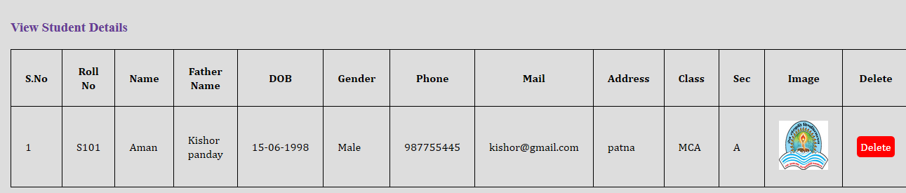

**Snapshot Detail:**

In this section teacher view student details.

**View Exam:**

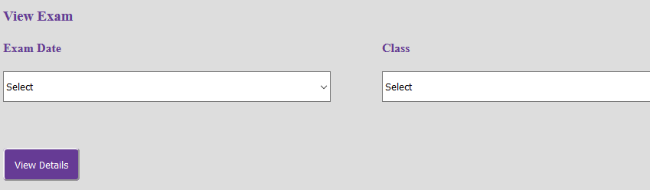

**Snapshot Detail:**

In this section teacher can view the exam time table.

**Add Mark:**

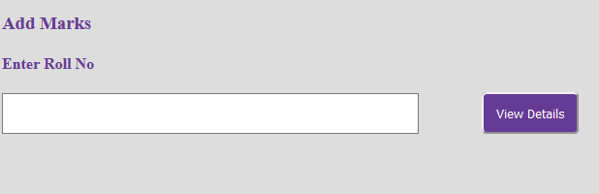

**Snapshot Detail:**

In this section teacher can add marks of student.

**View Mark:**



**Snapshot Detail:**

In this section teacher can view marks of student.

**Contact Us:**

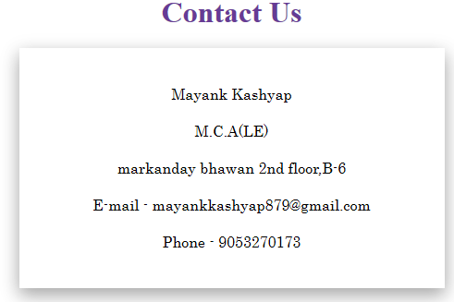

**Snapshot Detail:**

In this section it shows the address of developer.

**Setting:**

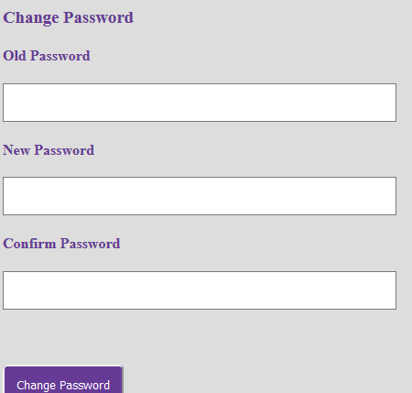

**Snapshot Detail:**

In this section admin and teacher can change their login password.

**6.CODING OF PROJECT**

* **Index.php**

<?php

include "database.php";

session_start();

?>

<!DOCTYPE html>

<html>

<head>

<title>Student Information System </title>

<link rel="stylesheet" type="text/css" href="css/style.css">

</head>

<body class="back">

<?php include"navbar.php";?>

<img src="img/download.jpg" width="800">

<div class="login">

<h1 class="heading">Admin Login</h1>

<div class="log">

<?php

if(isset($_POST["login"]))

{

$sql="select * from admin where ANAME='{$_POST["aname"]}' and APASS='{$_POST["apass"]}'";

$res=$db->query($sql);

if($res->num_rows>0)

{

$ro=$res->fetch_assoc();

$_SESSION["AID"]=$ro["AID"];

$_SESSION["ANAME"]=$ro["ANAME"];

echo "<script>window.open('admin_home.php','_self');</script>";

}

else

{

echo "<div class='error'>Invalid Username or Password</div>";

}

}

if(isset($_GET["mes"]))

{

echo "<div class='error'>{$_GET["mes"]}</div>";

}

?>

<form method="post" action="<?php echo $_SERVER["PHP_SELF"];?>">

<label>User Name</label><br>

<input type="text" name="aname" required class="input"><br><br>

<label>Password </label><br>

<input type="password" name="apass" required class="input"><br>

<button type="submit" class="btn" name="login">Login Here</button>

</form>

</div>

</div>

<div class="footer">

<footer><p> </p></footer>

</div>

<script src="js/jquery.js"></script>

<script>

$(document).ready(function(){

$(".error").fadeTo(1000, 100).slideUp(1000, function(){

$(".error").slideUp(1000);

});

$(".success").fadeTo(1000, 100).slideUp(1000, function(){

$(".success").slideUp(1000);

});

});

</script>

</body>

</html>

* **Database.php**

<?php

$db=new mysqli("localhost","root","","school");

if(!$db)

{

echo "failed";

}

?>

* **Admin_home.php**

<?php

include"database.php";

session_start();

if(!isset($_SESSION["AID"]))

{

echo"<script>window.open('index.php?mes=Access Denied..','_self');</script>";

}

?>

<!DOCTYPE html>

<html>

<head>

<title>Student Information</title>

<link rel="stylesheet" type="text/css" href="css/style.css">

</head>

<body>

<?php include"navbar.php";?><br>

<img src="img/1.jpg" style="margin-left:90px;" class="sha">

<div id="section">

<?php include"sidebar.php";?><br>

<div class="content">

<h3 class="text">Welcome <?php echo $_SESSION["ANAME"]; ?></h3><br><hr><br>

<h3 > Student Information</h3><br>

<img src="img/home.jpg" class="imgs">

<p class="para">

Student Information System is a complete student Information software designed to automate a school's diverse operations from classes, exams.

</p>

<p class="para">

This software has a powerful online community to bring parents, teachers and students on a common interactive platform. It is a paperless office automation solution for today's modern schools. The Student Information System provides the facility to carry out all day to day activities of student.

</p>

</div>

</div>

<?php include"footer.php";?>

</body>

</html>

* Navbar.php

<div class="navbar">

<ul class="list">

<b style="color:white;float:left;line-height:50px;margin-left:15px;font-family:Cooper Black;">

Student Information System</b>

<?php

if(isset($_SESSION["AID"]))

{

echo'

<li><a href="admin_home.php">Admin Home</a></li>

<li><a href="change_pass.php">Settings</a></li>

<li><a href="logout.php">Logout</a></li>

';

}

elseif(isset($_SESSION["TID"]))

{

echo'

<li><a href="teacher_home.php">Teacher Home</a></li>

<li><a href="teacher_change_pass.php">Settings</a></li>

<li><a href="logout.php">Logout</a></li>

';

}

else{

echo'

<li><a href="index.php">Admin</a></li>

<li><a href="teacher_login.php">Teacher</a></li>

<li><a href="contact.php">Contact Us</a></li>';

}

?>

</ul>

</div>

* Contact.php

<?php

include "database.php";

session_start();

?>

<!DOCTYPE html>

<html>

<head>

<title>Student Information System</title>

<link rel="stylesheet" type="text/css" href="css/style.css">

</head>

<body class="back">

<?php include"navbar.php";?>

<img src="img/download.jpg" width="800">

<div class="login">

<h1 class="heading">Contact Us</h1>

<div class="cont">

<form method="post" action="<?php echo $_SERVER["PHP_SELF"];?>">

Mayank Kashyap<BR>

M.C.A(LE)<BR>

markanday bhawan 2nd floor,B-6<BR>

E-mail - mayankkashyap879@gmail.com<br>Phone - 9053270173

</form>

</div>

</div>

<div class="footer">

<footer><p> </p></footer>

</div>

<script src="js/jquery.js"></script>

<script>

$(document).ready(function(){

$(".error").fadeTo(1000, 100).slideUp(1000, function(){

$(".error").slideUp(1000);

});

$(".success").fadeTo(1000, 100).slideUp(1000, function(){

$(".success").slideUp(1000);

});

});

</script>

</body>

</html>

* **Change_pass.php**

<?php

include"database.php";

session_start();

if(!isset($_SESSION["AID"]))

{

echo"<script>window.open('index.php?mes=Access Denied...','_self');</script>";

}

?>

<!DOCTYPE html>

<html>

<head>

<title>Student Information</title>

<link rel="stylesheet" type="text/css" href="css/style.css">

</head>

<body>

<?php include"navbar.php";?><br>

<img src="img/1.jpg" style="margin-left:90px;" class="sha">

<div id="section">

<?php include"sidebar.php";?><br><br><br>

<h3 class="text">Welcome <?php echo $_SESSION["ANAME"]; ?></h3><br><hr><br>

<div class="content1">

<h3 > Change Password</h3><br>

<?php

if(isset($_POST["submit"]))

{

$sql="select * from admin where APASS='{$_POST["opass"]}' and AID='{$_SESSION["AID"]}'";

$result=$db->query($sql);

if($result->num_rows>0)

{

if($_POST["npass"]==$_POST["cpass"])

{

$s="update admin SET APASS='{$_POST["npass"]}' where AID='{$_SESSION["AID"]}'";

$db->query($s);

echo "<div class='success'>Password Changed</div>";

}

else

{

echo "<div class='error'>Password Mismatch</div>";

}

}

else

{

echo "<div class='error'>Invalid Password</div>";

}

}

?>

<form method="post" action="<?php echo $_SERVER["PHP_SELF"];?>">

<label>Old Password</label><br>

<input type="text" class="input3" name="opass"><br><br>

<label>New Password</label><br>

<input type="text" class="input3" name="npass"><br><br>

<label>Confirm Password</label><br>

<input type="text" class="input3" name="cpass"><br><br>

<button type="submit" class="btn" style="float:left" name="submit"> Change Password</button>

</form>

</div>

</div>

<?php include"footer.php";?>

</body>

</html>

* **Search.php**

<?php

include"database.php";

$sql="SELECT * FROM staff WHERE TNAME LIKE '{$_POST["s"]}%' ";

$res=$db->query($sql);

echo "<table border='1px' class='table'>

<tr>

<th>S.No</th>

<th>Name</th>

<th>Qualification</th>

<th>Salary</th>

<th>View</th>

<th>Delete</th>

</tr>

";

if($res->num_rows>0)

{

$i=0;

while($row=$res->fetch_assoc())

{

$i++;

echo "<tr>

<td>{$i}</td>

<td>{$row["TNAME"]}</td>

<td>{$row["QUAL"]}</td>

<td>{$row["SAL"]}</td>

<td><a href='staff_view.php?id={$row["TID"]}' class='btnb'>View</a></td>

<td><a href='staff_delete.php?id={$row["TID"]}' class='btnr'>Delete</a></td>

</tr>

";

}

echo "</table>";

}

else

{

echo "<p>No Record Found</p>";

}

?>

* **Teacher_login.php**

<?php

include"database.php";

session_start();

?>

<!DOCTYPE html>

<html>

<head>

<title>Student Information System </title>

<link rel="stylesheet" type="text/css" href="css/style.css">

</head>

<body class="back">

<?php include"navbar.php";?>

<img src="img/download.jpg" width="800">

<div class="login">

<h1 class="heading">Teacher's Login</h1>

<div class="log">

<?php

if(isset($_POST["login"]))

{

$sql="select * from staff where TNAME='{$_POST["name"]}'and TPASS='{$_POST["pass"]}'";

$res=$db->query($sql);

if($res->num_rows>0)

{

$ro=$res->fetch_assoc();

$_SESSION["TID"]=$ro["TID"];

$_SESSION["TNAME"]=$ro["TNAME"];

echo "<script>window.open('teacher_home.php','_self');</script>";

}

else

{

echo "<div class='error'>Invalid Username Or Password</div>";

}

}

?>

<form method="post" action="<?php echo $_SERVER["PHP_SELF"];?>">

<label>User Name</label><br>

<input type="text" name="name" required class="input"><br><br>

<label>Password </label><br>

<input type="password" name="pass" required class="input"><br>

<button type="submit" class="btn" name="login">Login Here</button>

</form>

</div>

</div>

<div class="footer">

<footer><p> </p></footer>

</div>

<script src="js/jquery.js"></script>

<script>

$(document).ready(function(){

$(".error").fadeTo(1000, 100).slideUp(1000, function(){

$(".error").slideUp(1000);

});

$(".success").fadeTo(1000, 100).slideUp(1000, function(){

$(".success").slideUp(1000);

});

});

</script>

</body>

</html>

* **Teacher_Home.php**

<?php

include"database.php";

session_start();

if(!isset($_SESSION["TID"]))

{

echo"<script>window.open('teacher_login.php?mes=Access Denied...','_self');</script>";

}

$sql="SELECT * FROM staff WHERE TID={$_SESSION["TID"]}";

$res=$db->query($sql);

if($res->num_rows>0)

{

$row=$res->fetch_assoc();

}

?>

<!DOCTYPE html>

<html>

<head>

<title>Student Information</title>

<link rel="stylesheet" type="text/css" href="css/style.css">

</head>

<body>

<?php include"navbar.php";?><br>

<div id="section">

<?php include"sidebar.php";?><br>

<h3 class="text">Welcome <?php echo $_SESSION["TNAME"]; ?></h3><br><hr><br>

<div class="content">

<h3>Add Profile</h3><br>

<div class="lbox1">

<?php

if(isset($_POST["submit"]))

{

$target="staff/";

$target_file=$target.basename($_FILES["img"]["name"]);

if(move_uploaded_file($_FILES['img']['tmp_name'],$target_file))

{

$sql="update staff set PNO='{$_POST["pno"]}',MAIL='{$_POST["mail"]}',PADDR='{$_POST["addr"]}',IMG='{$target_file}'where TID={$_SESSION["TID"]}";

$db->query($sql);

echo "<div class='success'>Insert Success</div>";

}

}

?>

<form enctype="multipart/form-data" role="form" method="post" action="<?php echo $_SERVER["PHP_SELF"];?>">

<label> Phone No</label><br>

<input type="text" maxlength="10" required class="input3" name="pno"><br><br>

<label> E - Mail</label><br>

<input type="email" class="input3" required name="mail"><br><br>

<label> Address</label><br>

<textarea rows="5" name="addr"></textarea><br><br>

<label> Image</label><br>

<input type="file" class="input3" required name="img"><br><br>

<button type="submit" class="btn" name="submit">Add Profile Details</button>

</form>

</div>

<div class="rbox1">

<h3> Profile</h3><br>

<table border="1px">

<tr><td colspan="2"><img src="<?php echo $row["IMG"] ?>" height="100" width="100" alt="upload Pending"></td></tr>

<tr><th>Name </th> <td><?php echo $row["TNAME"] ?> </td></tr>

<tr><th>Qualification </th> <td><?php echo $row["QUAL"] ?> </td></tr>

<tr><th>Salary </th> <td> <?php echo $row["SAL"] ?> </td></tr>

<tr><th>Phone No </th> <td> <?php echo $row["PNO"] ?> </td></tr>

<tr><th>E - Mail </th> <td> <?php echo $row["MAIL"] ?> </td></tr>

<tr><th>Address </th> <td> <?php echo $row["PADDR"] ?> </td></tr>

</table>

</div>

</div>

</div>

<?php include"footer.php";?>

</body>

</html>

* **Logout.php**

<?php

include "database.php";

session_start();

unset ($_SESSION["AID"]);

unset ($_SESSION["ANAME"]);

unset ($_SESSION["TID"]);

unset ($_SESSION["TNAME"]);

session_destroy();

echo "<script>window.open('index.php','_self');</script>";

?>

* **CSS**

**Style.css**

*{

padding:0px;

margin:0px;

}

html{

background:#dddddd;

}

.back{

background:white;

height:800px;

width:800px;

margin:0 auto;

margin-top:5px;

margin-bottom:5px;

font-family:Century;

}

a{

text-decoration:none;

}

.navbar{

background:#663b95;

height:60px;

width:100%;

}

.list{

list-style:none;

text-align:right;

}

.list li{

display:inline;

}

.list li a{

text-decoration:none;

color:white;

line-height:50px;

padding:20px;

}

h1,h2,h3,h4,h5,h6,label{

font-family:roboto;

color:#663b95;

}

.heading{

text-align:center;

margin-top:40px;

}

.btn{

border-radius:5px;

padding:10px;

background:#663b95;

color:white;

margin-top:40px;

}

.btn:hover{

border-radius:5px;

padding:10px;

background:#8959bd;

color:white;

margin-top:40px;

}

.btnr{

border-radius:5px;

padding:5px;

background:#ff0000;

color:white;

}

.btnr:hover{

border-radius:5px;

padding:5px;

background:#ff5e5e;

color:white;

}

.btnb{

border-radius:5px;

padding:5px;

background:#43a7bc;

color:white;

}

.btnb:hover{

border-radius:5px;

padding:5px;

background:#68b9ca;

color:white;

}

.log{

height:auto;

width:50%;

margin:0 auto;

margin-top:20px;

padding:30px;

margin-bottom:40px;

-webkit-box-shadow: 0 8px 17px 0 rgba(0, 0, 0, 0.2), 0 6px 20px 0 rgba(0, 0, 0, 0.19);

-moz-box-shadow: 0 8px 17px 0 rgba(0, 0, 0, 0.2), 0 6px 20px 0 rgba(0, 0, 0, 0.19);

box-shadow: 0 8px 17px 0 rgba(0, 0, 0, 0.2), 0 6px 20px 0 rgba(0, 0, 0, 0.19);

}

.cont{

height:auto;

width:50%;

margin:0 auto;

margin-top:20px;

padding:30px;

margin-bottom:40px;

text-align:center;

line-height:40px;

-webkit-box-shadow: 0 8px 17px 0 rgba(0, 0, 0, 0.2), 0 6px 20px 0 rgba(0, 0, 0, 0.19);

-moz-box-shadow: 0 8px 17px 0 rgba(0, 0, 0, 0.2), 0 6px 20px 0 rgba(0, 0, 0, 0.19);

box-shadow: 0 8px 17px 0 rgba(0, 0, 0, 0.2), 0 6px 20px 0 rgba(0, 0, 0, 0.19);

}

.sha{

-webkit-box-shadow: 0 8px 17px 0 rgba(0, 0, 0, 0.2), 0 6px 20px 0 rgba(0, 0, 0, 0.19);

-moz-box-shadow: 0 8px 17px 0 rgba(0, 0, 0, 0.2), 0 6px 20px 0 rgba(0, 0, 0, 0.19);

box-shadow: 0 8px 17px 0 rgba(0, 0, 0, 0.2), 0 6px 20px 0 rgba(0, 0, 0, 0.19);

}

.input{

height:30px;

width:90%;

padding:2px;

margin-top:10px;

}

.input2{

width:80%;

height:40px;

margin-top:20px;

}

label{

font-weight:bold;

}

footer{

text-align:center;

color:white;

line-height:50px;

}

.success{

background:green;

color:white;

line-height:30px;

border-radius:5px;

height:30px;

text-align:center;

margin-bottom:10px;

}

.error{

background:#ff1515;

color:white;

line-height:30px;

border-radius:5px;

height:30px;

text-align:center;

margin-bottom:10px;

}

.content1{

margin-top:30px;

}

.s{

list-style:none;

}

.li{

position: relative;

display: block;

padding: 10px 15px;

margin-bottom: -1px;

background-color: #ffffff;

border: 1px solid #ecf0f1;

}

.imgs{

height:200px;

width:200px;

float:left;

margin:20px;

}

.text{

text-align:center;

}

.footer{

background:#663b95;

height:60px;

width:100%;

float:left;

}

#section{

height:auto;

width:1400px;

margin-left:90px;

font-family:cambria;

}

.sidebar{

width:400px;

height:auto;

margin-top:30px;

margin-right:30px;

float:left;

background:white;

}

.content{

margin-top:30px;

height:auto;

width:950px;

float:left;

}

.content1{

margin-top:30px;

height:auto;

width:450px;

float:left;

}

.para{

text-align:justify;

padding:15px;

line-height:34px;

}

.tbox{

float:left;

}

.tbox table{

border-collapse:collapse;

}

tr,td,th{

padding:20px;

}

.table{

border-collapse:collapse;

}

.input3{

width:90%;

height:40px;

margin-top:20px;

}

.input4{

width:90%;

height:40px;

margin-top:20px;

}

.input5{

width:25%;

height:40px;

margin-top:20px;

margin-right:20px;

}

.lbox{

width:45%;

margin-right:20px;

float:left;

}

.rbox{

width:45%;

float:left;

}

table{

border-collapse:collapse;

}

.lbox1{

width:50%;

margin-right:20px;

float:left;

}

.rbox1{

width:45%;

float:left;

}

.rbox1 table{

width:100%;

}

textarea{

resize:none;width:90%;margin-top:20px;

}

.Output table

{

width:100%;

}

.ibox{

width:65%;

float:left;

}

.tsbox{

width:35%;

float:left;

}

**7.SCOPE OF THE PROJECT**

* The Student Information System can be enhanced to include some other functionality like marks, set exam time table etc.
* Student class detail added.
* Student exam time table detail can be added.
* Functionality of view the exam time table view marks and many more.
* And second end user which is teacher can see their profile.
* Teacher has functionality to handle class.
* Teacher can add marks of students.
* Also teacher has permission to view the marks and student details.

**8.CONCLUSION**

From this project we can conclude that if this program is very useful in student information system as it provides more convenience than manual work. It provides easy methods to manage the load of work easily for the users. It is much fast and more efficient as the data once entered can be modified and accessed easily. The Program can be used per the requirement of the user as it is very easy to understand.

**9. REFERENCES**

1://www.freeprojectz.com/project-report/6766

2:https://www.tutorialspoint.com/mysql/mysql-introduction.htm

3: https://1000projects.org/student -information-system projectdocumentation.html

4:https://www.google.com/search?client=firefoxd&q=summary+of+Student+Information+ system