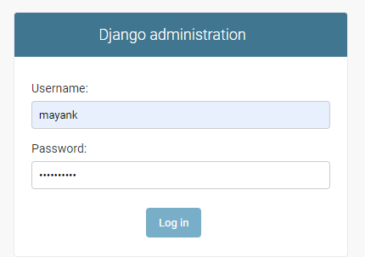Make login form in django

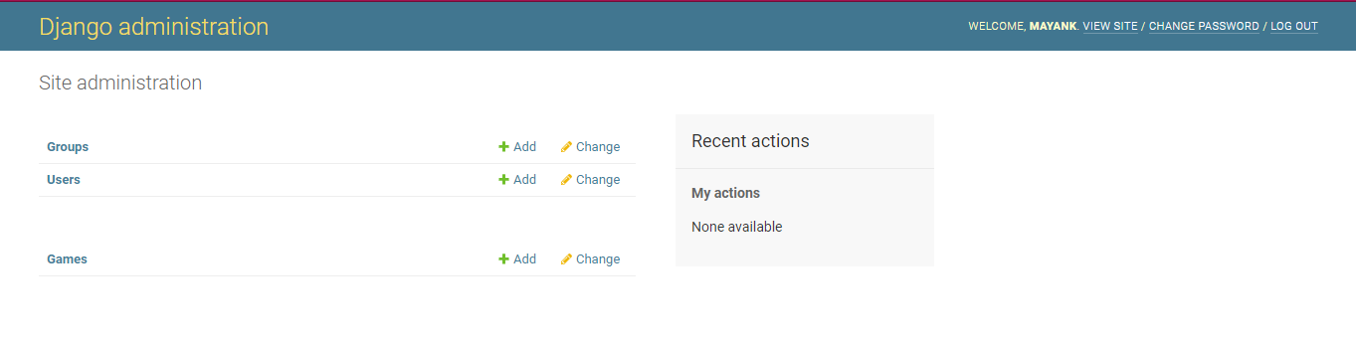

Create model in django

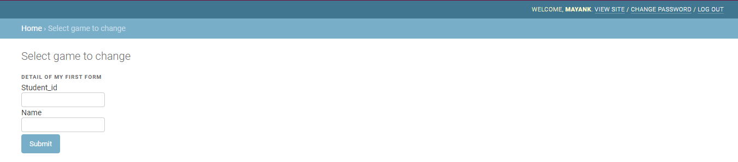create template in model

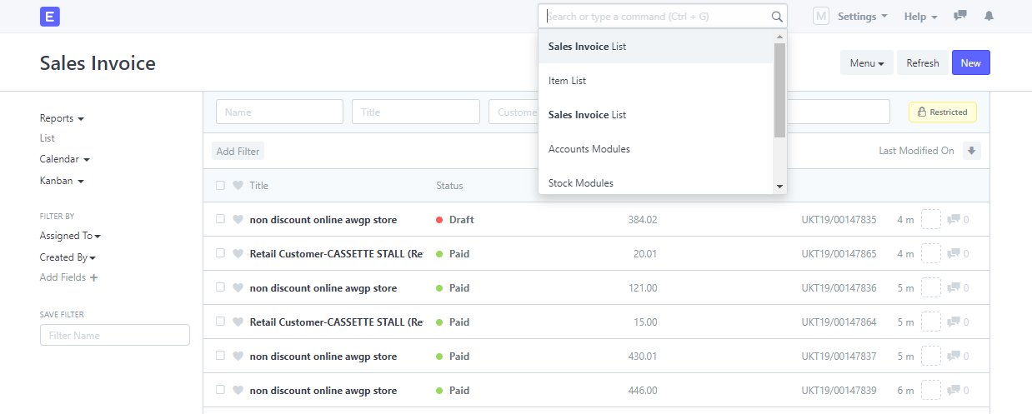

Work on erpnext.awgp.in

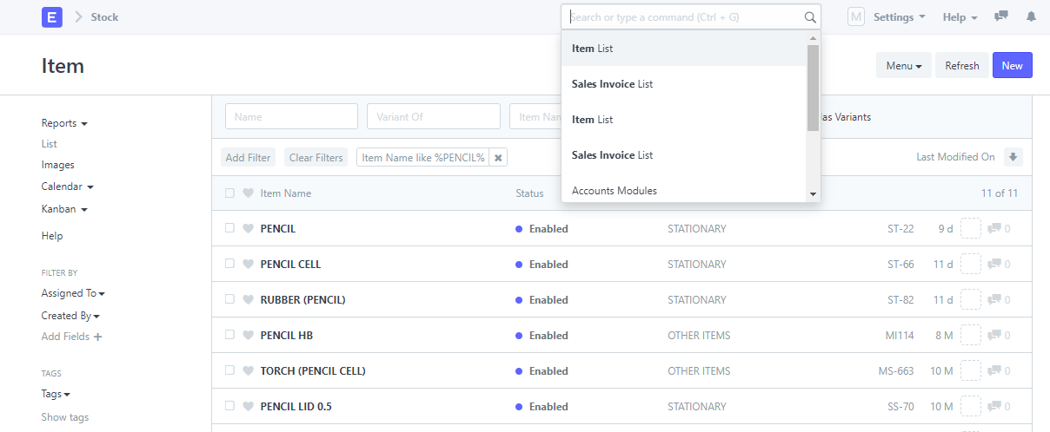

I also work on yugrishi.awgp.in portal.

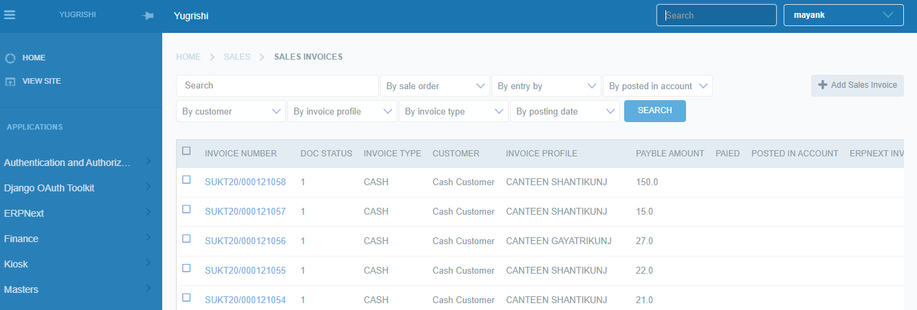

1. Learn making activity diagram

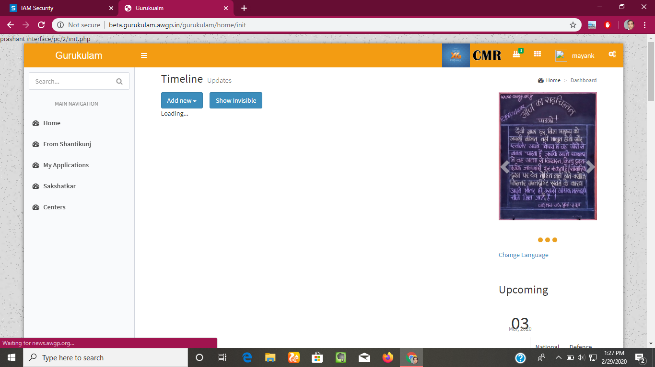

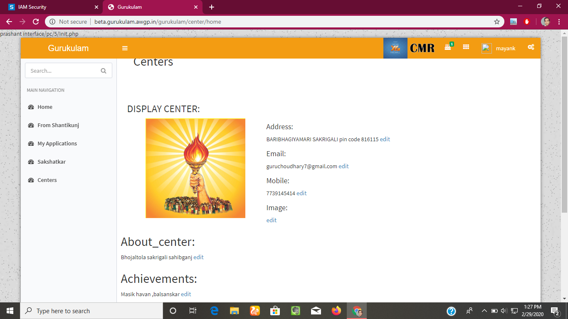

1-02-20: Sunday

2-03-20:

Work on beta.gurukulam.awgp.in .

Where I design the form and fetch the data from database.

Arrange the page in better way.

Learn python (basics)

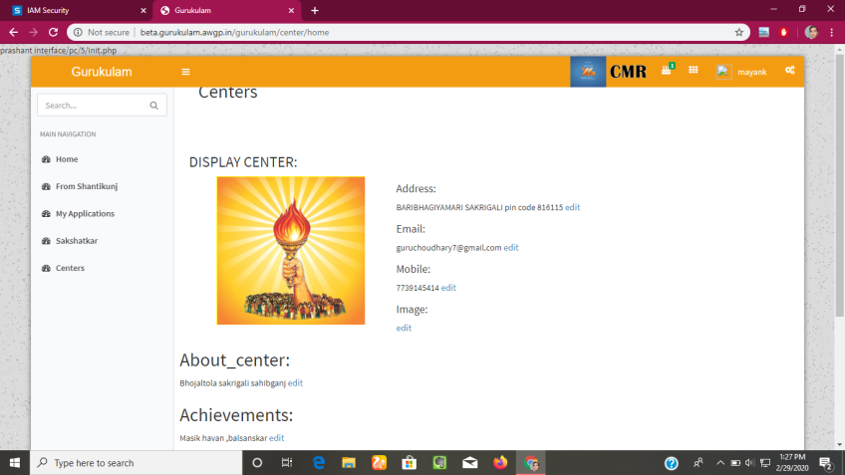

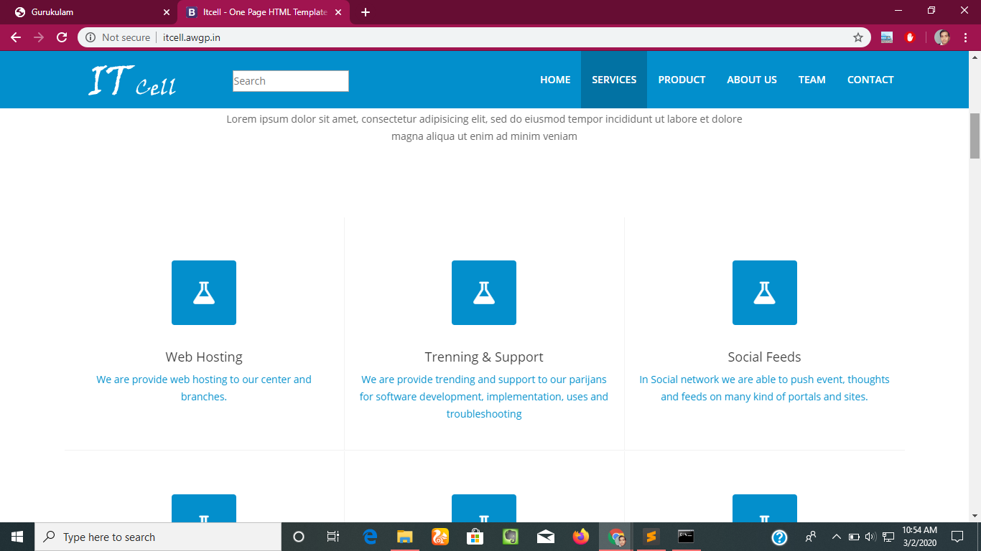

3-03-20:

4-03-20: work on gurukulam portal.

5-03-20: we fetch the data from database in gurukulam project.

6-03-20:

7-03-20:

12-03-20:

13-03-20: learn how to load external css file in django.

14-03-20: Learn how to add link on fetched data from the data base.