Employee Essence
A Major Project-II (CS805)

Submitted in partial fulfillment of the requirements for the Award of Degree of
Bachelor of Technology in Computer Science & Engineering
Submitted to


RAJIV GANDHI PROUDYOGIKI VISHWAVIDHYALAYA, BHOPAL (M.P)
Submitted by

Kaihkasha Naz (0111CS201070) Md Khaliqur Rahman (0111CS201087) Mayank Shrivastava (0111CS201083)
Mohit Tiwari (0111CS201099)

Under the Guidance of
Dr. Ravindra Yadav
(Associate Professor, CSE Department)


DEPARTMENT OF COMPUTER SCIENCE & ENGINEERING TECHNOCRATS INSTITUTE OF TECHNOLOGY, BHOPAL
SESSION: Jan-June 2024

TECHNOCRATS INSTITUTE OF TECHNOLOGY, BHOPAL
DEPARTMENT OF COMPUTER SCIENCE & ENGINEERING


CERTIFICATE

This is to certify that the work embodies in this Major Project-II (CS805) work entitled “Employee Essence” being submitted by Kaihkasha Naz (0111CS201070), Md Khaliqur Rahman (0111CS201087), Mayank Shrivastava(0111CS201083) & Mohit Tiwari (0111CS201099) in partial fulfillment of the requirement for the award of Bachelor of Technology in Computer Science & Engineering to Rajiv Gandhi Proudyogiki Vishwavidyalaya, Bhopal ( M.P.) during the academic Session Jan-June 2024 is a record of bonafide piece of work, carried out them under my supervision and guidance in the Computer Science & Engineering, Technocrats Institute of Technology, Bhopal.

Guided by:
Dr. Ravindra Yadav ( Associate Professor )
Computer Science & Engineering
Approved by:
Dr. Manoj Tyagi
(Head of the Department) Computer Science & Engineering

TECHNOCRATS INSTITUTE OF TECHNOLOGY, BHOPAL
DEPARTMENT OF COMPUTER SCIENCE & ENGINEERING



DECLARATION

We, Md Khaliqur Rahman(0111CS201087) , Kaihkasha Naz(0111CS201070), Mayank Shrivastava (0111CS201083) & Mohit Tiwari (0111CS201099) Students Of Bachelor Of Technology in Computer Science & Engineering ,Academic session Jan-June 2024 Technocrats Institute of Technology ,Bhopal M.P., hereby declare that the work presented in this project Report entitled “Employee Essence” is the outcome of our own work, is bonafide and correct to the best of our knowledge and this work has been carried out taking care of Engineering Ethics.

Kaihkasha Naz (0111CS201070)
Md Khaliqur Rahman(0111CS201087)
Mayank Shrivastava (0111CS201083) Mohit Tiwari (0111CS201099)

ACKNOWLEDGEMENT

We deem it’s our privilege to extent our profound gratitude and appreciation towards all those who have directly or indirectly involved themselves in making this project a great success. It gives us immense pleasure to express our deepest sense of gratitude and sincere thanks to our respected guide Dr. Ravindra Yadav for his valuable guidance, encouragement and help for this work.

We would also like to express our sincere thanks to Dr. Shashi Kumar Jain, Director Technocrats Institute of Technology, Bhopal for his encouragement and support.

We would also like to thank Dr. Manoj Tyagi, Head of Department Computer Science & Engineering for providing me with all the moral support and necessary help. We are also thankful to all the staff members of the Institute for their cooperation in our work.

Our sincere appreciation and thanks to our family members and friends for keen interest, continued encouragement and support.

Kaihkasha Naz (0111CS201070)
Md Khaliqur Rahman (0111CS201087)
Mayank Shrivastava (0111CS201083)
Mohit Tiwari (0111CS201099)

List of Figures

Name of Figure Page No.

Figure 1 29

Figure 2 30

Figure 3 31

Figure 4 32

Figure 5 33

Figure 6 34

Figure 7 35

Figure 8 36

Figure 9 37

Figure 10 38

Figure 11 39

Figure 12 40

TABLE OF CONTENTS

- Introduction 2
  - Literature Review 2
  - Problem Statement 2
  - Project Background 3
- Requirements and Constraints 3
  - Functional Requirements 4
  - Non-Functional Requirements 4
- Flow Diagram 4
- Data flow diagram 5
  - Data flow diagram level 1 7
  - Data flow diagram level 1 8
- System Specification 9
  - Hardware specification 9
  - Software Specification 9
- Software Features 10
  - NetBeans IDE (Smarter way to code) 10
- System Design and Development 10
  - File design 10
  - Relational file database 11
  - Input design 12
  - Output design 12
  - Database design 13
    - Objective of database design 13
- System Maintenance 14
  - Threats of System Security 15
  - System security 15
  - System security Measures 16
  - Identification 16
  - Access Control 16
  - Audio Control 17
  - System Integrity 18
- System Testing and Implementation 19
  - System Testing 20
  - Test Plan 20
  - Black Box Testing 21
  - Unit Testing 22
  - Integration Testing 22
- Project Work 24

10.1 Feasibility Study | 224
10.2 Objective | 25
10.3 Scope of project | 26
10.4 Project description in details | 26
10.5 Result | 27

- Conclusion & Discussion 29
  - Conclusion 30
  - Benefit of the project 30
  - Future of the project 31
  - Limitation 31

Snapshots of Reports 32
  - Login view 33
  - Home view 34
  - Add Employee view 35
  - View Employee 36
  - Update employee data 37
  - Employee Attendance view 38
  - View all employee attendance 39
  - Apply Leave view 40
  - View employee leave data 41
  - Employee Salary view 42
  - Generate pay slip view 43
  - Delete employee view 44

References 45

ABSTRACT
Employees are the backbone of any company therefore their management plays a major role in deciding the success of an organization. Employees Management Software makes it easy for the employer to keep track of all records. This software allows the administrator to edit employees, add new employees, transfer/promote/terminate employees. Each employee in the database is associated with a position can be added and edited when need arises. Employees can be transferred between positions easily without having to retype back their information in the database. You can check to see if there are duplicate positions/employees in the database. Most of all, the employer can assign tasks to employees and assess their progress in order to keep track of employee performance. A flexible and easy to use Employee Management software solution for small and medium sized companies provides modules for personnel information management thereby organization and companies are able to manage the crucial organization asset – people. The combination of these modules into one application assures the perfect platform for re-engineering and aligning Human Resource processes along with the organizational goals. This system brings about an easy way of maintaining the details of employees working in any organization. It is simple to understand and can be used by anyone who is not even familiar with simple employees system. It is user friendly and just asks the user to follow step by step operations by giving easy to follow options. It is fast and can perform many operations for a company. The goal of this project is to design and develop an employee management system to fill existing gaps in the electronic management of employees. This software allows the administrator to edit employees, add new employees, transfer/promote/terminate employees. Each employee in the database is associated with a position can be added and edited when need arises. Employees can be transferred between positions easily without having to retype back their information in the database

1. INTRODUCTION

Literature Review

Employees are the backbone of any company therefore their management plays a major role in deciding the success of an organization. Human Resource Management Software makes it easy for the employer to keep track of all records. This software allows the administrator to edit employees, add new employees as well as evaluate an employee’s performance. Employees can be managed efficiently without having to retype back their information in the database. You can check to see if there are duplicate positions/employees in the database. A flexible and easy to use Employee Management software solution for small and medium sized companies provides modules for personnel information management thereby organization and companies are able to manage the crucial organization asset – people. The combination of these modules into one application assures the perfect platform for re-engineering and aligning Human Resource processes along with the organizational goals. This system brings about an easy way of maintaining the details of employees working in any organization. It is simple to understand and can be used by anyone who is not even familiar with simple employees system. It is user friendly and just asks the user to follow step by step operations by giving easy to follow options. It is fast and can perform many operations for a company.

Problem Statement

Manual handling of employee information poses a number of challenges. This is evident in procedures such as leave management where an employee is required to fill in a form which may take several weeks or months to be approved. The use of paper work in handling some of these processes could lead to human error, papers may end up in the wrong hands and not forgetting the fact that this is time consuming. A number of current systems lack employee self-service meaning employees are not able to access and manage their personal information directly without having to go through their HR departments or their managers. Another

challenge is that multi-national companies will have all the employee information stored at the headquarters of the company making it difficult to access the employee information from remote places when needed at short notice. The aforementioned problems can be tackled by designing and implementing a web based HR management system. This system will maintain employee information in a database by fully privacy and authority access. The project is aimed at setting up employee information system about the status of the employee, the educational background and the work experience in order to help monitor the performance and achievements of the employee through a password protected system.

Project Background

Employees are the backbone of any company therefore their management plays a major role in deciding the success of an organization. Human Resource Management Software makes it easy for the employer to keep track of all records. This software allows the administrator to edit employees, add new employees as well as evaluate an employee’s performance. Employees can be managed efficiently without having to retype back their information in the database.
You can check to see if there are duplicate positions/employees in the database. A flexible and easy to use Employee Management software solution for small and medium sized companies provides modules for personnel information management thereby organization and companies are able to manage the crucial organization asset – people.
The combination of these 8 modules into one application assures the perfect platform for re- engineering and aligning Human Resource processes along with the organizational goals. This system brings about an easy way of maintaining the details of employees working in any organization. It is simple to understand and can be used by anyone who is not even familiar with simple employees system. It is user friendly and just asks the user to follow step by step operations by giving easy to follow options. It is fast and can perform many operations for a company

REQUIREMENTS AND CONSTRAINTS

Functional Requirements
Authentication Login- The user can login to the HRMS system with his/her username and password.
- Logout- The user can log out from the HRMS system.

- Login failure- If the user does not exist in the database or the user has not yet being authorized by the HRMS admin. Authorization User role check- After logging in, the user role will be checked from the database and the user interface will be displayed according to their role.
- Process Data Display- User with defined roles can display the content of the database. Being more specific, employee can only view his/her personal information.

Non-Functional Requirements

There is no restriction on the number of the users to be added to the database. Hardware requirements EMS should be able to work on a computer with the following minimum hardware specifications: OS: Windows XP/Vista/7/8 and Linux CPU: Pentium III (700MHz) and above Memory: 128 MB and above Capacity: 4GB of hard drive Others: Network interface card, mouse, keyboard, and monitor. Software requirements Since EMS application is a web- based application, internet connection must be established. The EMS software personal database model will support ORACLE environment as DBMS.

FLOW DIAGRAM

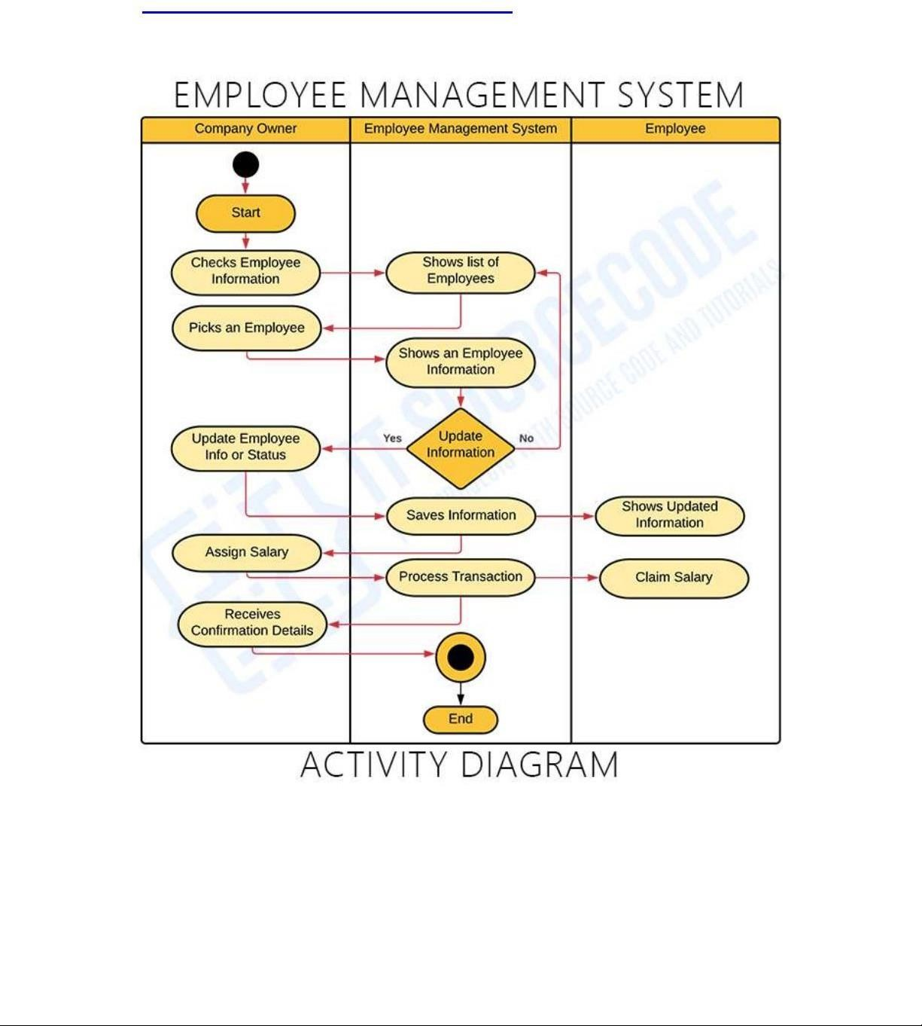

DATA FLOW DIAGRAM

A Data Flow Diagram (DFD) is a diagram that describes the flow of data and the processes that change data throughout a system. It’s a structured analysis and design tool that can be used for flowcharting in place of or in association with information. Oriented and process oriented system flowcharts. Four basic symbols are used to construct data flow diagrams. They are symbols that represent data source, data flows, and data transformations and data storage. The points at which data are transformed are represented by enclosed figures, usually circles, which are called nodes. For achieving the abovementioned criteria’s we have to make use of various features that are available with the RDBMS by enforcing integrity constrains, it is possible to ensure data integrity and reduce data inconsistency to a great extent.
When analysts prepare the Data Flow Diagram, they specify the user needs at a level of detail that virtually determines the information flow into and out of the system and the required data resources.
The network is constructed by using a set of symbols that do not imply physical implementations. The Data Flow Diagram reviews the current physical system, prepares input and output specification, and specifies the implementation plan.

Steps to Construct Data Flow Diagrams

Four steps are commonly used to construct a DFD

- Process should be named and numbered for easy reference. Each name should be representative of the process.
- The destination of flow is from top to bottom and from left to right.

- When a process is exploded in to lower level details they are numbered.

- The names of data stores, sources and destinations are written in capital letters.

Rules for constructing a Data Flow Diagram

- Arrows should not cross each others• Squares, circles and files must bear names.

- Decomposed data flow squares and circles can have same names.
- Draw all data flow around the outside of the diagram.

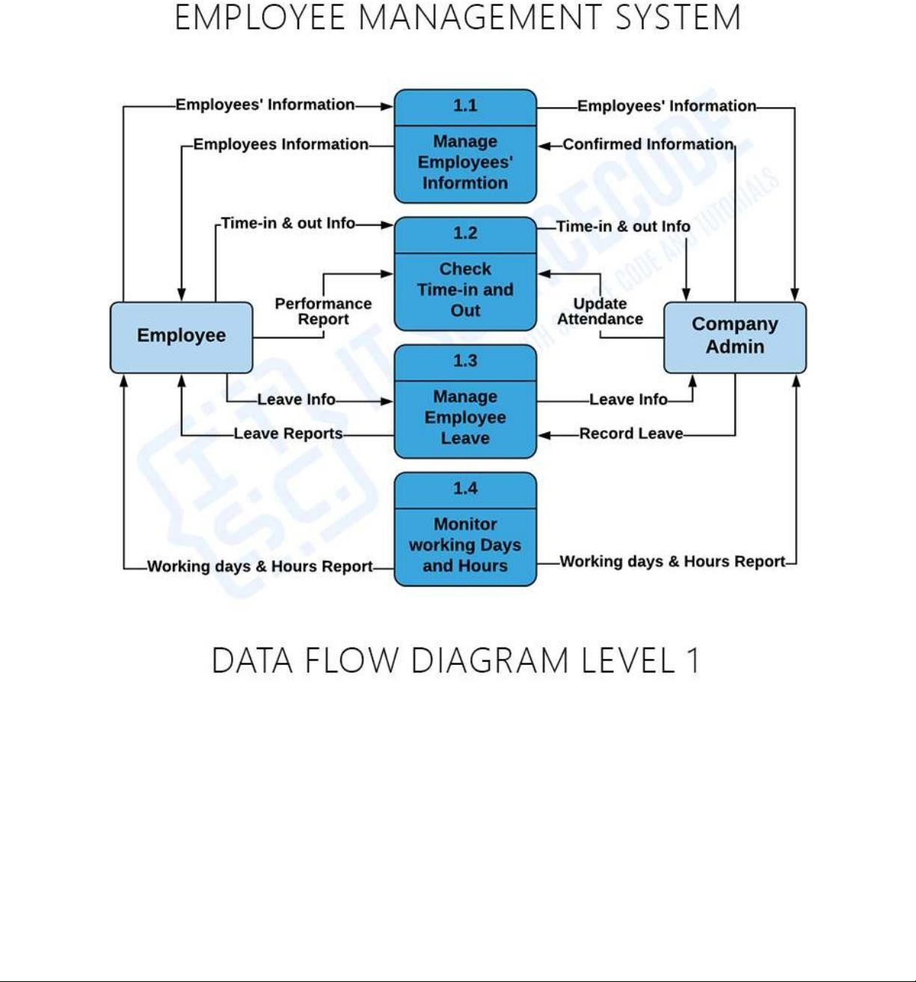

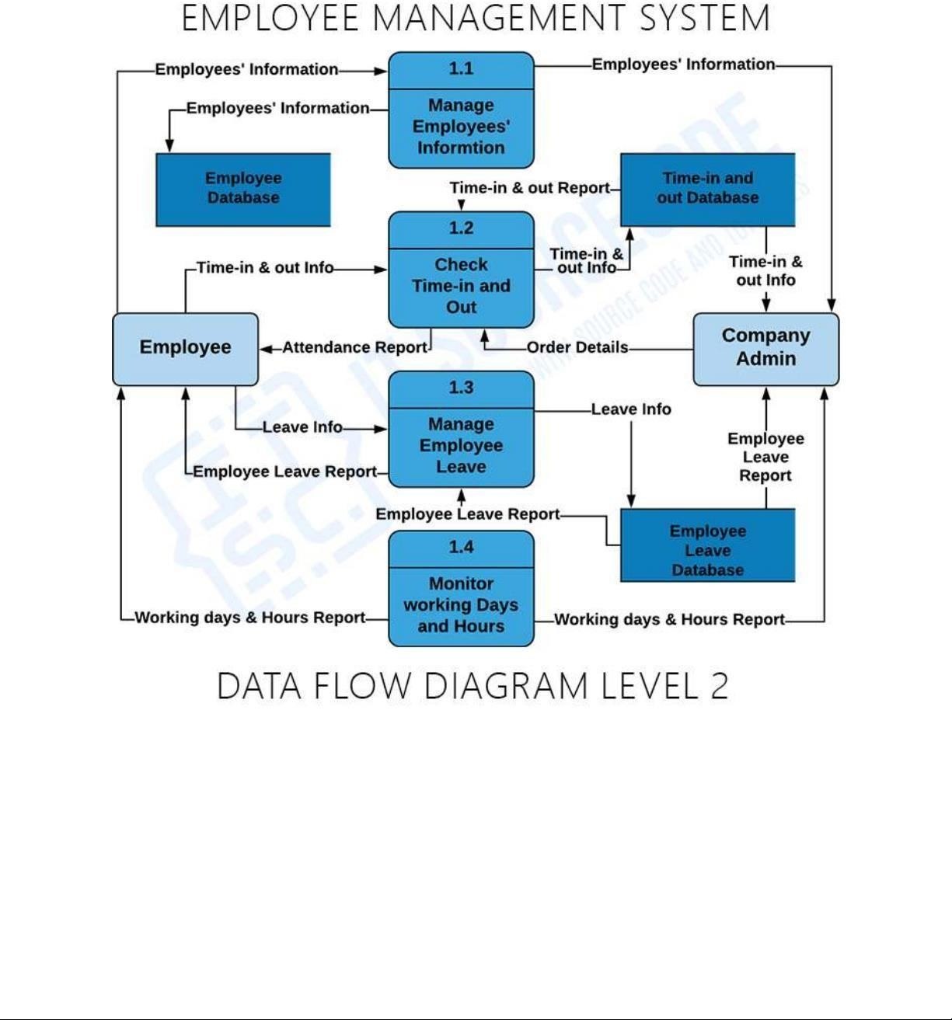

SYSTEM SPECIFICATION

Hardware Specification

    - CPU : Intel Core i3
    - RAM : 1GB
    - Hard Disk : 80 GB
    - Monitor : 16 LG
    - Mouse : Logitech mouse
    - Keyboard : 104 Keys
    - Mother Board : Intel
    - Speed : 3.3 GHZ

Software Specification

    - Operating System : Windows 10
    - Front End : C
    - Back End : JAVA, Oracle Database.
    - Reports : Data Report
    - Tools : NetBeans (Smarter way to code)

SOFTWARE FEATURES :

NetBeans IDE (Smarter way to code)

NetBeans IDE gives you skeleton applications in the form of project templates for all the technologies it supports. In addition, it provides a set of sample applications, some of which can be recreated step by step by following a related tutorial available on NetBeans.org.
The IDE provides project templates and sample projects that help you create Java SE applications, Java EE applications, Java ME applications, HTML5 applications, NetBeans Platform applications, PHP application, and C/C++ applications.

- Best Support for Latest Java Technologies

- Fast & Smart Code Editing

- Easy & Efficient Project Management

- Rapid User Interface Development

- Bug Free Code

- Support for Multiple Languages

- Language cross platform support

SYSTEM DESIGN AND DEVELOPMENT

File design :

A flat file database is a database designed around a single table. The flat file design puts all database information in one table, or list, with fields to represent all parameters. A flat file may contain many fields, often, with duplicate data that are prone to data corruption. If data between two flat files have to be merged, it is needed to copy and PSMte relevant information from one file to the other. There is no automation between flat files.

If two or more flat files that contain client addresses, it is required to manually modify the address parameters in each file that contains that client’s information. Changing information in one file has no bearing on other files. Flat files offer the functionality to store information, manipulate fields, print or display formatted information and exchange information with others, through email and over the Internet. Some flat files may be attached to external files, such as text editors, to extend functionality and manage related information.

Relational File Database :

A relational database, on the other hand, incorporates multiple tables with methods for the tables to work together. The relationships between table data can be collated, merged and displayed in database forms. Most relational databases offer functionality to share data:
- Across networks

- Over the Internet

- With laptops and other electronic devices, such as palm pilots

- With other software systems

Each row in a table has its own unique key. Rows in a table can be linked to rows in other tables by adding a column for the unique key of the linked row (such columns are known as foreign keys). Code showed that data relationships of arbitrary complexity can be represented by a simple set of concepts. Part of this processing involves consistently being able to select or modify one and only one row in a table. Therefore, most physical implementations have a unique primary key (PK) for each row in a table. When a new row is written to the table, a new unique value for the primary key is generated; this is the key that the system uses primarily for accessing the table. System performance is optimized for PKs. Other, more natural keys may also be identified and defined as alternate keys (AK). Often several columns are needed to form an AK (this is one reason why a single integer column is usually made the PK). Both PKs and AKs have the ability to uniquely identify a row within a table. Additional technology may

be applied to ensure a unique ID across the world, a globally unique identifier, when there are broader system requirements. The primary keys within a database are used to define the relationships among the tables. When a PK migrates to another table, it becomes a foreign key in the other table. When each cell can contain only one value and the PK migrates into a regular entity table, this design pattern can represent either a one-to-one or one-to-many relationship. Most relational database designs resolve many-to-many relationships by creating an additional table that contains the PKs from both of the other entity tables—the relationship becomes an entity; the resolution table is then named appropriately and the two FKs are combined to form a PK. The migration of PKs to other tables is the second major reason why system- assigned integers are used normally as PKs; there is usually neither efficiency nor clarity in migrating a bunch of other types of columns. When a PK migrates to another table, it becomes a foreign key in the other table. When each cell can contain only one value and the PK migrates into a regular entity table, this design pattern can represent either a one-to-one or one-to-many relationship.

Input Design

Input is any data or instructions entered into the memory of a computer. Two types of input are data and instructions. Data is a collection of unorganized items that can include words, numbers, pictures, sounds, and video. A computer processes data into information, which is organized, meaningful, and useful. Instructions can be in the form of programs, commands, or user responses. A program is a series of instructions that tells a computer how to perform the tasks necessary to process data into information. A command is an instruction given to a computer program. A user response is an instruction you issue to the computer by responding to a question posed by a computer program. Any hardware component that allows entering data, programs, commands, and user responses into a computer is an input device. Inputs of Automobile Management System are eid, ename, qualification, automobileid, brand, cusid, cusname and salary.

Output Design

Output design involves specifying how production of on-screen reports and paper based reports will occur. Output may occur to database or file for storing information entered or also for use by other systems. Output is data that has been processed into a useful form called information. Four types of output are text, graphics, audio, and video. Text consists of characters (letters, numbers, punctuation marks, or any other symbol requiring one byte of computer storage space) that are used to create words, sentences, and paragraphs.
Graphics are digital representations of non-text information such as drawings, charts, photographs, and animation (a series of still images in rapid sequence that gives the illusion of motion). Audio is music, speech, or any other sound. Video consists of images played back at speeds to provide the appearance of full motion. An output device is any computer component capable of conveying information to a user. Audio is music, speech, or any other sound. Video consists of images played back at speeds to provide the appearance of full motion.

Database Design

Database is designed to manage large bodies of information. The management of data involves both the definitions of structures for the storage of information. In addition the data base system must provide for the safety of the information solved, despite system crashes or due to attempts at unauthorized access. For developing an efficient database proposed project have to fulfill certain conditions such as controlled redundancy.
- Defining the data

- Inputting the data

- Locating the data

- Accessing the data

- Communicating the data

- Revising the data

Objectives of Database design

In database design several objectives are designed such as:

- Ease of use

- Control of data integrity

- Control of redundancy

- Control of security

- Data independence (logical & physical)

- Data storage protection
- System performance

- System functions

- System compatibility

In a majority of cases, a person who is doing the design of a database is a person with expertise in the area of database design, rather than expertise in the domain from which the data to be stored is drawn e.g. financial information, biological information etc. Therefore, the data to be stored in the database must be determined in cooperation with a person who does have expertise in that domain, and who is aware of what data must be stored within the system.
This process is one which is generally considered part of requirements analysis, and requires skill on the part of the database designer to elicit the needed information from those with the domain knowledge. This is because those with the necessary domain knowledge frequently cannot express clearly what their system requirements for the database are as they are unaccustomed to thinking in terms of the discrete data elements which must be stored. Data to be stored can be determined by Requirement Specification

SYSTEM MAINTENANCE

All system is dynamic and subjects to constantly changing requirements. Effort must be devoted to adapting them and design must be flexible specified so that such changes can be easily implemented. It activity is called system maintains. It includes improvement of system functions and correction of errors. Back up of the entire database files are taken and stored in secondary storage devices like magnetic tapes and disks so that it is possible to restore the system at the earliest. If there is a break down or collapse, then the system giver provision to restore database files, storing data in a separate secondary device leads to an effective and efficient maintains of the system. The master file has flags for maintains after for maintains. After the mentioned period, the rejection suppliers, unused data in the files will be deleted in the master file. It method is the increasing the memory to store the data. Software maintenance is a set of software engineering activities that occur after software has been delivered for the customer and put into operation. The success of the software and the project relies on the maintenance procedure adopted. As with the venture of human, not a single one is perfect. The further modifications are left to the followers. It is because the opinion or vision or a thing differs from individual to individual. The maintenance is performed at regular intervals to keep the project safe and reliable. Development is single activity maintenance is a continuous activity. Maintenance involves activities like inspections, corrections and enhancements. Once the system is delivered and deployed, it enters the maintenance phase. The system need to be maintained not because of some of its components wear out and need to be replaced, but because there are some residual errors remaining in the system that must be removed as they are discovered. It includes activities related to debugging the software after it goes live, changes are required to address evolving software and enhancement to meet changing customer requirements. So maintenance phase involve
- Understanding the effects of change.

- Testing the new parts

- Retesting the old parts that were not changed

Threat to System Security

The lists of potential threats are as follows

- Errors and Omissions

- Disgruntled and Dishonest Employees

- Fire

- Natural Disaster

- External Attack

The object-oriented paradigm emphasizes modularity and re-usability. The goal of an object-oriented approach is to satisfy the "open closed principle". A module is open if it supports extension, or if the module provides standardized ways to add new behaviors or describe new states. In the object-oriented paradigm this is often accomplished by creating a new subclass of an existing class.
A module is closed if it has a well defined stable interface that all other modules must use and that limits the interaction and potential errors that can be introduced into one module by changes in another. In the object-oriented paradigm this is accomplished by defining methods that invoke services on objects. Methods can be either public or private, i.e., certain behaviors that are unique to the object are not exposed to other objects. This reduces a source of many common errors in computer programming.

System Security

Security is a critical stage in system development. Even candidate system must provide built-in features for security and integrity of data. Without safe guards against unauthorized access, fraud, embezzlement, fire and natural disaster, a system could be so vulnerable as to threaten the survival of the organizations.
To do an adequate job on security, the risk, exposure, cost and specific measures such as password should be analyzed to provide protection. In addition, back up of copies of software and recovery restart procedures must be available when needed. The amount of protection depends on the sensitivity of data, the reliability of the user and the complexity

of the system. The motive behind security is to keep the organization running, protect data as an asset and seek management support for more installations.

System Security Measures

After system security risk has been evaluated, the next step is to select security measures. The measures are
- Identification

- Access Control

- Audit Control

- System Integrity

Identification

It is the scheme of identifying person to the system based on “Something you know” such as a password or a picture badge, “Something you are” such as finger print or voice print or “Something you have” such as credit card, key or special terminal.

Access Control

Controlling the access to the computer facility is secured through encoded cards or similar devices. Encryption prevents intruders from accessing data by scrambling messages across telephones to the destination. The goal of the analysis phase is to create a functional model of the system regardless of constraints such as appropriate technology. In object-oriented analysis this is typically done via use cases and abstract definitions of the most important objects .

Audio Control
Auditing must be supported at all levels of management. Audit control protects a system from external security breaches and internal fraud or embezzlement. Various software programs are available to help in audit function.

9.6 System Integrity

The line of different safeguards the functioning of hardware, software and physical security and operating procedure. Proper back of hardware and software are extremely important.

SYSTEM TESTING AND IMPLEMENTATION

System Testing

The common view of testing held by users is that it is performed to prove that there are no errors in a program. It is extremely difficult since designer cannot prove to be one hundred percent accurate. Therefore, the most useful and practical approach is with the understanding that testing is the process of executing a program with explicit intention of finding errors that make the program fail. Testing has its own cycle. The testing process begins with the product requirements phase and from there parallels the entire de velopment process. In other words, for each phase of the development process there is an important testing activity. It is extremely difficult since designer cannot prove to be one hundred percent accurate. Therefore, the most useful and practical approach is with the understanding that testing.

Successful testing requires a methodical approach. It requires focusing on basic critical factors:
    - Planning
    - Project and process control
    - Risk management
    - Inspections
    - Measurement tools
    - Organization and professionalis

velopment process. In other words, for each phase of the development process there is an important testing activity. It is extremely difficult since designer cannot prove to be one hundred percent accurate. Therefore, the most useful and practical approach is with the understanding that testing.
Successful testing requires a methodical approach. It requires focusing on basic critical factors:
    - Planning
    - Project and process control
    - Risk management
    - Inspections
    - Measurement tools
    - Organization and professionalis

Test Plan

Before going for testing, first we have to decide upon the type of testing to be carried out. The following factors are taken into consideration:

    - To ensure that information properly flows into and out of program 29
    - To find out whether the local data structures maintains its integrity during all steps in an algorithm execution
    - To ensure that the module operate properly at boundaries established to limit or restrict processing
    - To find out whether error - handling paths are working correctly or not
    - To find out whether the values are correctly updated or not
    - Check for validations

Black Box Testing

It is a software testing approach in which the tester doesn’t know the internal working of the item being tested. For example in a Black box test, on software design the tester only knows the input and the expected outputs. Tester doesn’t know how the program derives the output. Tester doesn’t even imagine as to how, the coding is done. Tester need to know only the specifications.

The advantages of black box testing approach are :
- The test is unbiased because the designer and the tester is independent of each other
- The tester needs no specific knowledge on any programming language
- The test is done from the point of view of the user, not the designer.
- The test can be designed as soon as the specifications are complete The disadvantages of black box testing approach are
- The test can be redundant if the software designer has already run a test case.
- The test can be difficult to design
- Testing every possible input stream is unrealistic.

Unit Testing
Unit or module testing is the process of testing the individual components (subprograms or procedures) of a program. The purpose is to discover discrepancies between the modules interface specification and its actual behavior. In our system each module must be tested independently for validation.

Integration Testing

Integration testing is the process of combining and testing multiple components together. The primary objective of integration testing is to discover errors in the interfaces between the components. In our system each of the modules mentioned above, are tested for checking the integration between them, after each of them are tested individually. Software testing is an investigation conducted to provide stakeholders with information about the quality of the software product or service under test. Software testing can also provide an objective, independent view of the software to allow the business to appreciate and understand the risks of

software implementation. Test techniques include the process of executing a program or application with the intent of finding software bugs (errors or other defects), and verifying that the software product is fit for use. Software testing involves the execution of a software component or system component to evaluate one or more properties of interest. In general, these properties indicate the extent to which the component or system under test:
- meets the requirements that guided its design and development,
- responds correctly to all kinds of inputs,
- performs its functions within an acceptable time,
- it is sufficiently usable,
- can be installed and run in its intended environments, and
- achieves the general result its stakeholders desire. 31 As the number of possible tests for even simple software components is practically infinite, all software testing uses some strategy to select tests that are feasible for the available time and resources. As a result, software testing typically (but not

exclusively) attempts to execute a program or application with the intent of finding software bugs (errors or other defects). The job of testing is an iterative process as when one bug is fixed, it can illuminate other, deeper bugs, or can even create new ones. Software testing can provide objective, independent information about the quality of software and risk of its failure to users or sponsors. Software testing can be conducted as soon as executable software (even if partially complete) exists.

The overall approach to software development often determines when and how testing is conducted. For example, in a phased process, most testing occurs after system requirements have been defined and then implemented in testable programs. In contrast, under an agile approach, requirements, programming, and testing are often done concurrently.

As a result, software testing typically (but not exclusively) attempts to execute a program or application with the intent of finding software bugs (errors or other defects). The job of testing is an iterative process as when one bug is fixed, it can illuminate other, deeper bugs, or can even create new ones

PROJECT WORK

Feasibility Study:

To make this software more handy and feasible to the user we have divided it into few different different modules and they are as follows :

- Login module
- Home module
- Employee module
- Add new employee module
- Update employee module
- Show employee module
- Employee attendance module
- Show employee attendance module
- Salary module
- Generate salary slip module
- Delete employee module

Login module :

It is used for logging in the employee details manager. It is used for verifying the user. Once the user is authenticated, they can access the system.

Registration module :

New user can register in order to use the full features of this system. Normal users can also access the proposed system but with limited features. Only the registered users can get more priorities than the unregistered guest user. Once the guest users register to this system, they can also get full access to this system.

User module :

It is used for adding new user and for updating existing customers. It is used for storing new user as well as for updating the customer’s details. The module is very useful to find the number of user who registered.

Add Employee module :

It is used for adding new employee and for viewing, editing and deleting existing employees. It is used for searching items in this system. Here the admin have the privileges to search items in this system. Employee details are stored with their name. When a particular module is being liked by people, that particular module will be shown to user.

Attendance module :

In this module of project we are keeping records of employee attendance and if any new employee comes into the company than we have a option to add that new employee into the database.

Salary module :

In this module of project we are keeping records of employee salary and if any new employee comes into the company than we have a option to add that new employee salary into the database.

Delete module :

In this module of our project we delete the employee details from every where such as attendance, salary e.t.c.

Objective

In this world of growing technologies everything has been computerized. With large number of work opportunities the Human workforce has increased. Thus there is a need of a system which can handle the data of such a large number of Employees. This project simplifies the task of maintaining records because of its user friendly nature. The objective of this project is to provide a comprehensive approach towards the management of employee information.
This will be done by designing and implementing an HR management system that will bring up a major paradigm shift in the way that employee information is handled. The objectives of this system include: Design of a web based HR management system to fulfill requirements such as project

- management, leave management, report generation to assist in performance appraisal, ESS and employee trainings.

- Well-designed database to store employee information.

- A user friendly front-end for the user to interact with the system.

Scope

The scope of this project will be limited to the following: Employee profiles:

- Employees will have access to their personal profiles and will be able to edit their details.

- Complete elimination of paperwork in leave management by enabling an employee apply for leave as well as check their leave status through the system. This will also enable the HR manager to accept/reject leave application through the system Project Management.

- Assign tasks and projects to employees, assign a project team and keep track of the progress. Report generation.

- The HR manager will be able to generate timely reports in order to monitor employees and this can be used for performance appraisals. The reports will be have all the information of an employee from educational background, trainings attended, projects done as well as technical skills. Recruitment Process.

- The admin will add an employee and a default password and employee id will be generated and sent to the new employees email. The HR manager will then have the ability to add an employee’s information to the database.

Project description

An employee management system is technology designed to streamline core HR services and improve workforce productivity. It accomplishes these goals largely by automating labor-intensive, administrative tasks and using analytics to drive business decisions.

Result

A “Employee Management System” I have created performs as I thought of .

It can perform task like:

- It can store data and details of the employee.
- It can store employee complete profile, attendance record, salary record , phone number.
- It can generate pay slip with details like employee id, month, year.

CONCLUSION & DISCUSSION

Conclusion

The system is completely menu driven and extremely user friendly since it is developed in an efficient front end tools and back end tools. Appropriate error messages are also provided too guide the user in a proper and user friendly manner.

The software “Employee Management System” has been developed in windows 2010 environment using C as front end and ORACLE as back end. Time consumptions reduced to a great extent and user as less complexity in handling it database.

The project is fully fledged and user friendly, End users will be lightened in using it software because it is easy to have many employee related utilities and mostly all contents to be entered are to selected from combo box and textfields. It reduces the calculating efforts to be carried out by the user.

Benefit of the project

- Minimize handwritten work from admission to leave company.
- It helps you to minimize your repeated works and take care of the complete functionality of your company.
- It is a huge time saver and facilities proper communication among the management, staff, and the employee parties.
- Provide computerized system for maintaining records.
- Avoide Human storage with less computer memory.

Future Scope of the Project

- This project will enhance the employee and the company to serve more quickly and efficiently. This software is developed in order to computerize the activities which take more time, if done manually.

- Employee billing system will enable the employee and company staff to make things faster and can get information quickly. If we want any information about employee, we can access it quickly.

Limitation

- This software will run on a single pc.

- Admin and Employee have to sit on the same pc.

- No network connection.

SNAPSHOTS OF REPORTS

  - Login view

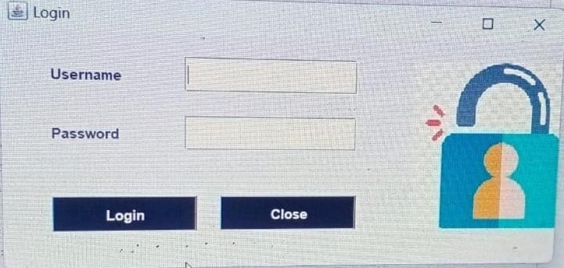

Figure 1

This screenshot captures the login interface for our Employee Essence , where users can securely log in to access the system.
• The form includes fields for entering a username and password, both of which are required for authentication.
• A 'Login' button is prominently displayed to submit the login credentials.

Home view

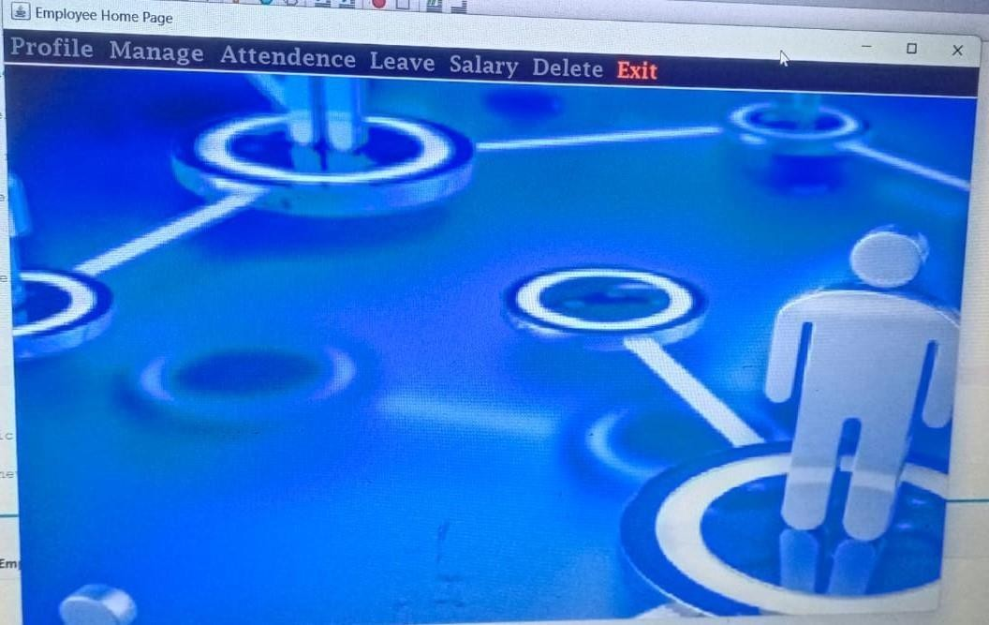
Figure 2

This layout provides employees with quick access to essential functionalities, such as adding
viewing employees, managing leave, and generating reports. It also includes important announcements,
upcoming events, and reminders, enhancing communication and productivity within the organization.

Add Employee view

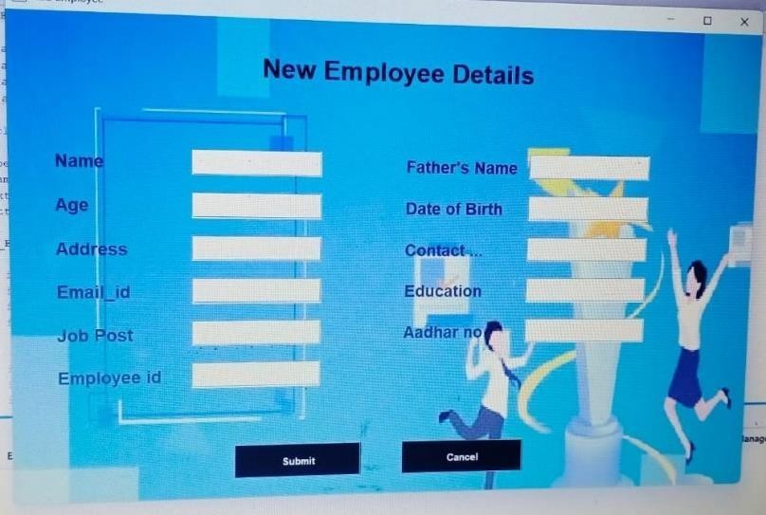
Figure 3

These fields cover the essential information needed to add a new employee to the system, ensuring that all critical personal, contact, and employment-related data are collected. You can further customize these fields based on the specific requirements of your organization or the functionalities of your employee management system.

View Employee

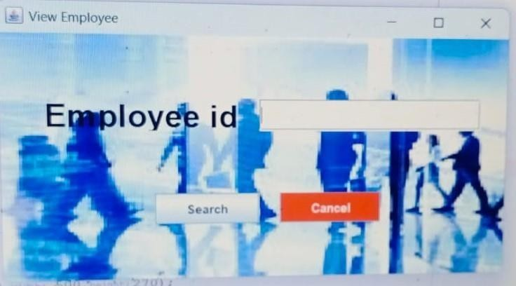
Figure 4

These sections cover comprehensive details about an employee, including personal and
employment information, activity records, and actionable items. This layout ensures
that users can quickly access and manage all relevant information related to an employee.

Update employee data

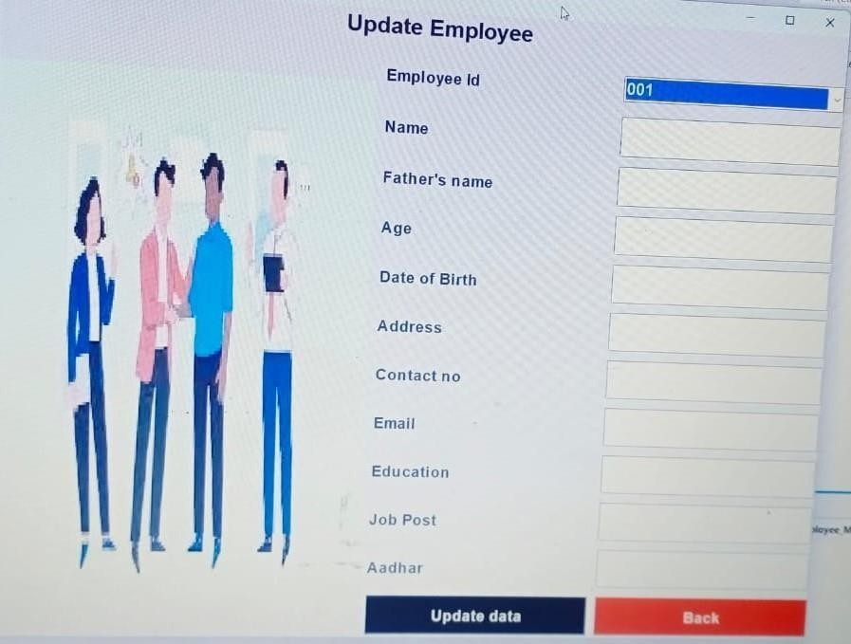
Figure 5

These sections provide a clear and structured layout for updating employee information.
Users can easily navigate through different sections to update specific details and save the
changes efficiently.

Employee Attendance view

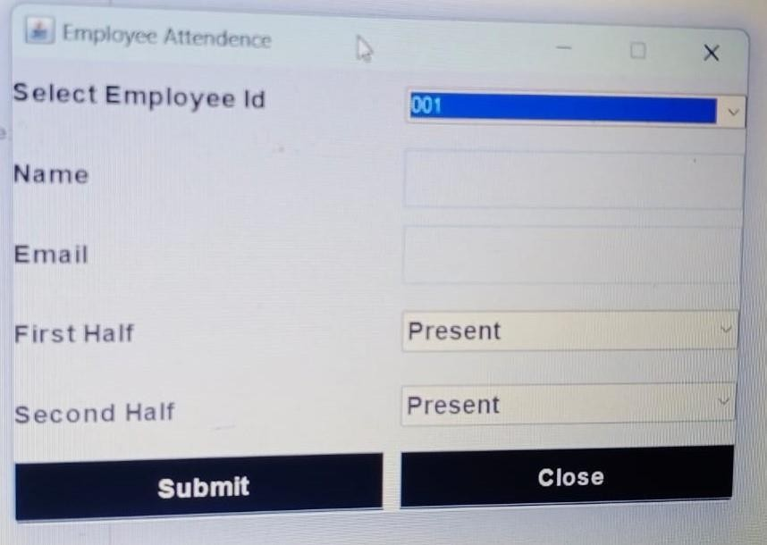

Figure 6

These sections provide a comprehensive overview of an employee's attendance records,
Allowing for detailed tracking and management. Users can view summaries, detailed
records by different time periods, and take actions such as marking or editing attendance.

View all employee attendance

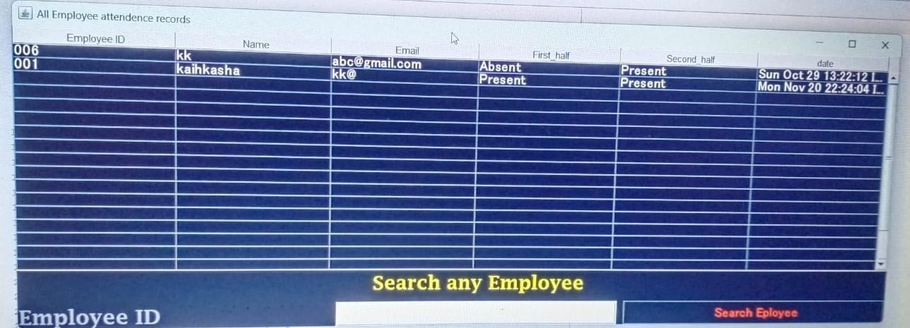
Figure 7

These sections provide a comprehensive view of all employees' attendance, allowing for
detailed analysis and reporting. Users can filter records, view summaries, export data, and
generate reports, making it easier to manage and monitor attendance across the organization.

Apply Leave view

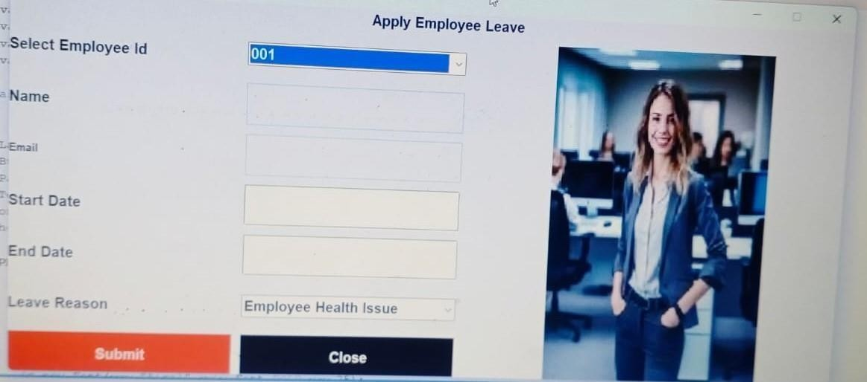

Figure 8

This layout allows employees to easily apply for leave, view their leave requests, check their
leave balances, and understand the company's leave policies. Managers can efficiently
review and manage leave requests, ensuring smooth workflow management.

View employee leave data

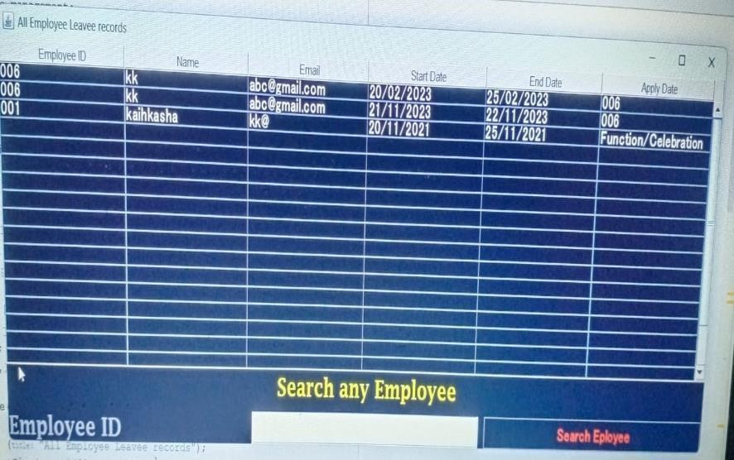
Figure 9

Employee salary view

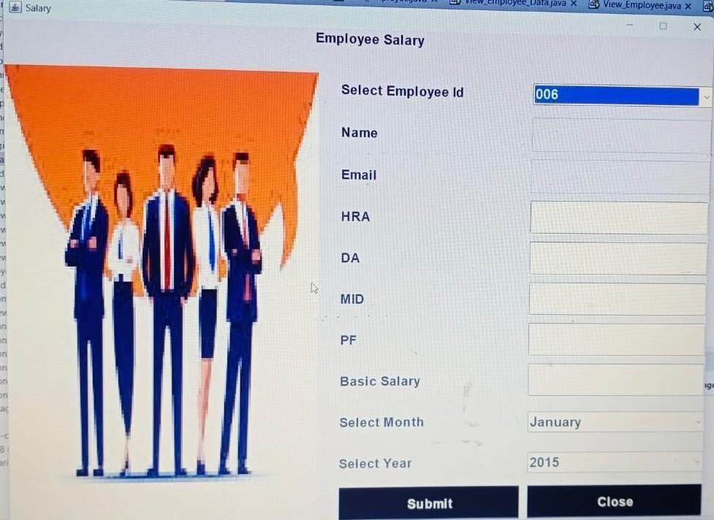
Figure 10

Generate pay slip view

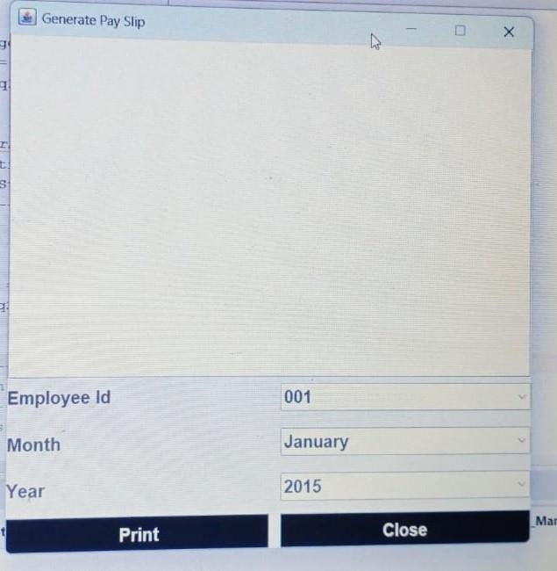

Figure 11

Delete employee view

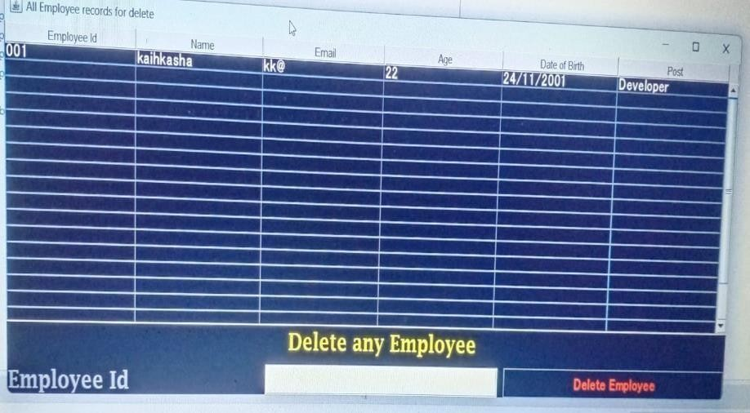

Figure 12

References

References books:
    - www.stackoverflow.com
    - www.flaticon.com
    - www.materialui.co
    - www.youtube.com/durgasoft
    - www.github.com

References Books

- – Begg Carolyn, Connolly Thomas, Database systems (a Practical approach to
Design, Implementation, and Management), Addison-Wesley, an imprint of Pearson Education, University of Paisley (U.K.), Fourth edition 2005
- – Bodnar George /Duquesne University/, Hopwood William /Florida Atlantic
University/, Accounting Information systems, Eighth Edition, Prentice Hall, Upper Saddle River, New Jersey .
- – Andersen Virginia, Access 2000: The Complete Reference, Blacklick, OH, USA:
McGraw-Hill Professional Book Group, 2001, http://site.ebrary.com/lib/vaxjo/Doc?id=5002842 (2006-05-25).
- – Andersson Tobias, [DAB744] C# Course Lectures, School of Mathematics and
System Engineering, Växjö University.

