Data Mining and Analysis

Lab Assignment

***Submitted by***

**MAYANK RATHORE**

***24MCA10158***



**Submited to**

**Dr. Sandeep Monga**

**VIT Bhopal University**

**Bhopal, Madhya Pradesh**

**May, 2025**

|  |  |  |
| --- | --- | --- |
| **Table of Contents** | | |
| **SL.NO** | **Name of the experiment** | **DATE:** |
| **1.** | **Write a function in python that takes a DataFrame and generates a complete statistical**  **summary for numerical variables: count, mean, std, min, max, quartiles with out using**  **any inbuilt library/functions** | **29/05/25** |
| **2** | **Write a Python program that implements the Apriori algorithm to find frequent itemsets from transaction data. Input: List of transactions (each as a list of items) andminimum support threshold. Output: All frequent itemsets with their support counts** | **29/05/25** |
| **3** | **Write a python program to implement various evaluation metrics without using scikit-learn, such as Confusion matrix Precision, Recall, F1-score** | **29/05/25** |
| **4** | **Write a python program to implement Euclidean, Manhattan distance metrics without using inbuilt function** | **29/05/25** |
| **5** | **Write a python program to calculate R2, MAE, RMSE, MSE without using Sklearn**  **library** | **29/05/25** |
| **6** | **Write a program in python to convert non-stationarity data into stationarity** | **29/05/25** |
| **7** | **You are given a dataset consisting of 2D points. Your task is to implement the K-Means Clustering algorithm (i.e., without using libraries like scikit-learn) and group the data**  **into k clusters.** | **29/05/25** |
| **8** | **Write a Python program to decompose a time series into Trend, Seasonality, and Residual components using: Additive model, Multiplicative model Input: Monthly sales data (e.g., 3–5 years) Frequency = 12 (for monthly seasonality)**  **Output: Plot of the original series, trend, seasonal,and residual components** | **29/05/25** |

|  |  |
| --- | --- |
| **Date: 29/05/25** | **Data Mining and Analysis** |
| **Exp. No:1** | Write a function in python that takes a DataFrame and generates a complete statistical summary for numerical variables: count, mean, std, min, max, quartiles with out using any inbuilt library/functions |

Code

def read_air_passengers(file_path):

    months = []

    passengers = []

    with open(file_path, 'r') as f:

        next(f)  *# Skip header*

        for line in f:

            month, count = line.strip().split(',')

            months.append(month)

            passengers.append(int(count))

    return {'Month': months, 'Passengers': passengers}

def statistical_summary(data_dict, column_name):

    data = data_dict[column_name]

    n = len(data)

*# Count*

    count = n

*# Mean*

    total = 0

    for val in data:

        total += val

    mean = total / count

*# Standard Deviation*

    variance = sum((val - mean) ** 2 for val in data) / count

    std_dev = variance ** 0.5

*# Min and Max*

    min_val = data[0]

    max_val = data[0]

    for val in data:

        if val < min_val:

            min_val = val

        if val > max_val:

            max_val = val

*# Sort data for quartiles*

    sorted_data = sorted(data)

    def get_percentile(data, p):

        k = (len(data) - 1) * p

        f = int(k)

        c = f + 1

        if c >= len(data):

            return data[f]

        return data[f] + (data[c] - data[f]) * (k - f)

    q1 = get_percentile(sorted_data, 0.25)

    q2 = get_percentile(sorted_data, 0.50)

    q3 = get_percentile(sorted_data, 0.75)

*# Display summary*

    print(f"Statistical Summary for '{column_name}':")

    print(f"Count     : {count}")

    print(f"Mean      : {round(mean, 2)}")

    print(f"Std Dev   : {round(std_dev, 2)}")

    print(f"Min       : {min_val}")

    print(f"25% (Q1)  : {q1}")

    print(f"50% (Q2)  : {q2}")

    print(f"75% (Q3)  : {q3}")

    print(f"Max       : {max_val}")

data = read_air_passengers("AirPassengers.csv")

statistical_summary(data, "Passengers")

Ouput:

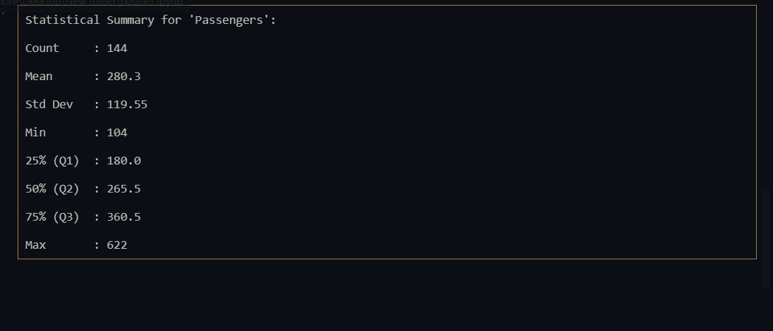

|  |  |
| --- | --- |
| **Date: 29/05/25** | **Data Mining and Analysis** |
| **Exp. No:2** | Write a Python program that implements the Apriori algorithm to find frequent itemsets from transaction data. Input: List of transactions (each as a list of items) and minimum support threshold. Output: All frequent itemsets with their support counts |

Code: def get_frequent_itemsets(transactions, min_support):

    from itertools import combinations

    def get_support(itemset, transactions):

        count = 0

        for transaction in transactions:

            if set(itemset).issubset(set(transaction)):

                count += 1

        return count

    def generate_candidates(prev_frequent, length):

        candidates = []

        prev_frequent = list(prev_frequent)

        for i in range(len(prev_frequent)):

            for j in range(i + 1, len(prev_frequent)):

                candidate = tuple(sorted(set(prev_frequent[i]) | set(prev_frequent[j])))

                if len(candidate) == length and candidate not in candidates:

                    candidates.append(candidate)

        return candidates

    itemsets = []

    support_data = {}

*# Get unique items*

    items = set()

    for transaction in transactions:

        for item in transaction:

            items.add(item)

*# Level 1: single items*

    L1 = []

    for item in sorted(items):

        support = get_support([item], transactions)

        if support >= min_support:

            L1.append((item,))

            support_data[(item,)] = support

    current_L = L1

    k = 2

    while current_L:

        itemsets.extend(current_L)

        candidates = generate_candidates(current_L, k)

        current_L = []

        for candidate in candidates:

            support = get_support(candidate, transactions)

            if support >= min_support:

                current_L.append(candidate)

                support_data[candidate] = support

        k += 1

    return support_data

transactions = [

    ['milk', 'bread', 'eggs'],

    ['milk', 'bread'],

    ['milk', 'eggs'],

    ['bread', 'eggs'],

    ['milk', 'bread', 'eggs'],

    ['bread']

]

min_support = 3

frequent_itemsets = get_frequent_itemsets(transactions, min_support)

print("Frequent Itemsets with Support Counts:")

for itemset, support in frequent_itemsets.items():

    print(f"{itemset} : {support}")

Output:

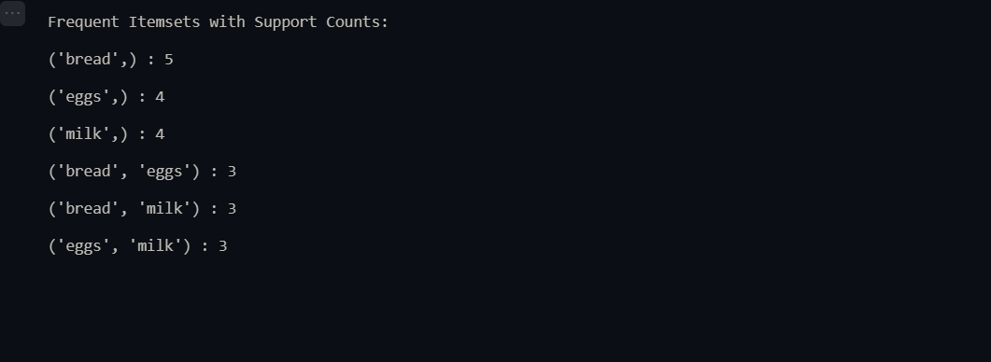

|  |  |
| --- | --- |
| **Date: 29/05/25** | **Data Mining and Analysis** |
| **Exp. No:3** | **Write a python program to implement various evaluation metrics without using scikit-**  **learn, such as Confusion matrix Precision, Recall, F1-score** |

Code:

import pandas as pd

import random

import matplotlib.pyplot as plt

import seaborn as sns

*# Load the data*

df = pd.read_csv('Iris.csv')

*# Extract true labels*

true_labels = df['Species'].tolist()

*# Step 1: Get unique classes*

classes = sorted(list(set(true_labels)))  *# ['Iris-setosa', 'Iris-versicolor', 'Iris-virginica']*

*# Step 2: Generate mock predictions*

def generate_mock_predictions(true_labels):

    predicted = []

    for label in true_labels:

        if random.random() < 0.85:

            predicted.append(label)

        else:

            predicted.append(random.choice(classes))

    return predicted

*# Step 3: Confusion Matrix*

def compute_confusion_matrix(true_labels, pred_labels, classes):

    matrix = {actual: {pred: 0 for pred in classes} for actual in classes}

    for t, p in zip(true_labels, pred_labels):

        matrix[t][p] += 1

    return matrix

*# Step 4: Precision, Recall, F1*

def compute_metrics(conf_matrix, classes):

    metrics = {}

    for *cls* in classes:

        tp = conf_matrix[*cls*][*cls*]

        fp = sum(conf_matrix[other][*cls*] for other in classes if other != *cls*)

        fn = sum(conf_matrix[*cls*][other] for other in classes if other != *cls*)

        precision = tp / (tp + fp) if (tp + fp) else 0

        recall = tp / (tp + fn) if (tp + fn) else 0

        f1 = 2 * precision * recall / (precision + recall) if (precision + recall) else 0

        metrics[*cls*] = {

            'Precision': round(precision, 2),

            'Recall': round(recall, 2),

            'F1-Score': round(f1, 2)

        }

    return metrics

*# Run evaluation*

pred_labels = generate_mock_predictions(true_labels)

conf_matrix = compute_confusion_matrix(true_labels, pred_labels, classes)

metrics = compute_metrics(conf_matrix, classes)

*# Print confusion matrix*

print("🔹 Confusion Matrix:")

for actual in classes:

    print(f"{actual}: {conf_matrix[actual]}")

*# Print metrics*

print("\n🔹 Evaluation Metrics:")

for *cls* in metrics:

    m = metrics[*cls*]

    print(f"{*cls*}: Precision = {m['Precision']}, Recall = {m['Recall']}, F1-Score = {m['F1-Score']}")

Output:

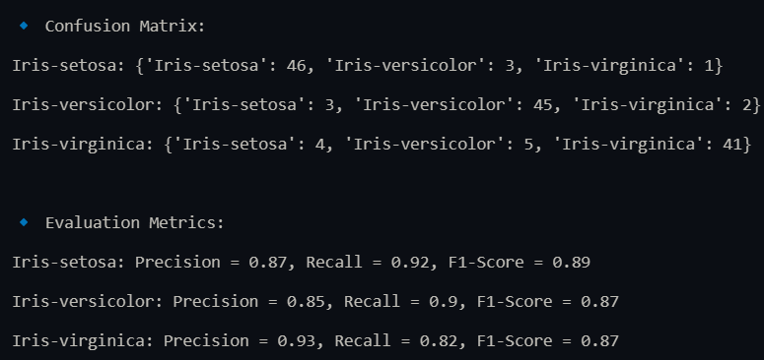

|  |  |
| --- | --- |
| **Date: 29/05/25** | **Data Mining and Analysis** |
| **Exp. No:4** | **Write a python program to implement Euclidean, Manhattan distance metrics without**  **using inbuilt function** |

Code:

def euclidean_distance(point1, point2):

    sum_sq = 0

    for i in range(len(point1)):

        diff = point1[i] - point2[i]

        sum_sq += diff * diff

    x = sum_sq

    guess = x / 2.0

    for _ in range(20):

        guess = (guess + x / guess) / 2

    return guess

def manhattan_distance(point1, point2):

    total = 0

    for i in range(len(point1)):

        total += abs(point1[i] - point2[i])

    return total

p1 = [2, 4, 5]

p2 = [5, 1, 7]

print("Euclidean Distance:", round(euclidean_distance(p1, p2), 3))

print("Manhattan Distance:", manhattan_distance(p1, p2))

Output:

Euclidean Distance: 4.69

Manhattan Distance: 8

|  |  |
| --- | --- |
| **Date: 29/05/25** | **Data Mining and Analysis** |
| **Exp. No:5** | **Write a python program to calculate R2, MAE, RMSE, MSE without using Sklearn library** |

Code:

def mean(values):

    return sum(values) / len(values)

def mse(y_true, y_pred):

    n = len(y_true)

    error_sum = 0

    for yt, yp in zip(y_true, y_pred):

        error_sum += (yt - yp) ** 2

    return error_sum / n

def rmse(y_true, y_pred):

    return sqrt(mse(y_true, y_pred))

def mae(y_true, y_pred):

    n = len(y_true)

    error_sum = 0

    for yt, yp in zip(y_true, y_pred):

        error_sum += abs(yt - yp)

    return error_sum / n

def r2_score(y_true, y_pred):

    mean_y = mean(y_true)

    ss_tot = 0

    ss_res = 0

    for yt, yp in zip(y_true, y_pred):

        ss_tot += (yt - mean_y) ** 2

        ss_res += (yt - yp) ** 2

    return 1 - (ss_res / ss_tot)

def sqrt(x):

    guess = x / 2.0 if x > 1 else 1

    for _ in range(20):

        guess = (guess + x / guess) / 2

    return guess

y_true = [3, -0.5, 2, 7]

y_pred = [2.5, 0.0, 2, 8]

print("MSE:", mse(y_true, y_pred))

print("RMSE:", rmse(y_true, y_pred))

print("MAE:", mae(y_true, y_pred))

print("R2 Score:", r2_score(y_true, y_pred))

Output:

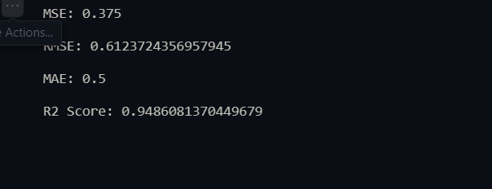

|  |  |
| --- | --- |
| **Date: 29/05/25** | **Data Mining and Analysis** |
| **Exp. No:6** | **Write a program in python to convert non-stationarity data into stationarity** |

Code:

import pandas as pd

import matplotlib.pyplot as plt

df = pd.read_csv('AirPassengers.csv')

data = df['#Passengers']

plt.figure(figsize=(12,4))

plt.plot(data)

plt.title('Original Air Passenger Data')

plt.show()

diff_data = data.diff().dropna()

plt.figure(figsize=(12,4))

plt.plot(diff_data)

plt.title('Stationary Series after Differencing')

plt.show()

Output: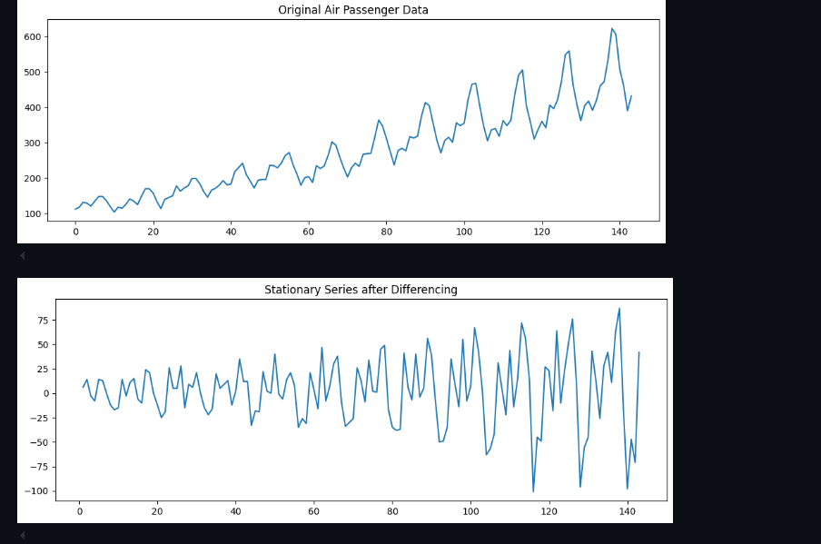

|  |  |
| --- | --- |
| **Date: 29/05/25** | **Data Mining and Analysis** |
| **Exp. No:7** | **You are given a dataset consisting of 2D points. Your task is to implement the K-Means Clustering algorithm (i.e., without using libraries like scikit-learn) and group the data into k clusters.** |

Code:

import pandas as pd

import random

import matplotlib.pyplot as plt

df = pd.read_csv('Iris.csv')

*# print(df.head())*

data = df[['SepalLengthCm', 'SepalWidthCm']].values.tolist()

*# Step 2: Euclidean Distance*

def euclidean(p1, p2):

    return sum((x - y) ** 2 for x, y in zip(p1, p2)) ** 0.5

*# Step 3: Initialize centroids randomly*

def initialize_centroids(data, k):

    return random.sample(data, k)

*# Step 4: Assign clusters*

def assign_clusters(data, centroids):

    clusters = [[] for _ in centroids]

    for point in data:

        distances = [euclidean(point, centroid) for centroid in centroids]

        cluster_idx = distances.index(min(distances))

        clusters[cluster_idx].append(point)

    return clusters

*# Step 5: Update centroids*

def update_centroids(clusters):

    new_centroids = []

    for cluster in clusters:

        mean = [sum(dim) / len(cluster) for dim in zip(*cluster)]

        new_centroids.append(mean)

    return new_centroids

def has_converged(old, new):

    return all(euclidean(o, n) < 1e-4 for o, n in zip(old, new))

def kmeans(data, k, max_iter=100):

    centroids = initialize_centroids(data, k)

    for _ in range(max_iter):

        clusters = assign_clusters(data, centroids)

        new_centroids = update_centroids(clusters)

        if has_converged(centroids, new_centroids):

            break

        centroids = new_centroids

    return centroids, clusters

k = 3

centroids, clusters = kmeans(data, k)

colors = ['r', 'g', 'b']

plt.figure(figsize=(8, 6))

for idx, cluster in enumerate(clusters):

    x, y = zip(*cluster)

    plt.scatter(x, y, color=colors[idx], label=f'Cluster {idx+1}')

cx, cy = zip(*centroids)

plt.scatter(cx, cy, color='black', marker='x', s=100, label='Centroids')

plt.xlabel('Sepal Length')

plt.ylabel('Sepal Width')

plt.title('K-Means Clustering (Iris Dataset - Sepal Features)')

plt.legend()

plt.grid(True)

plt.show()

Output:

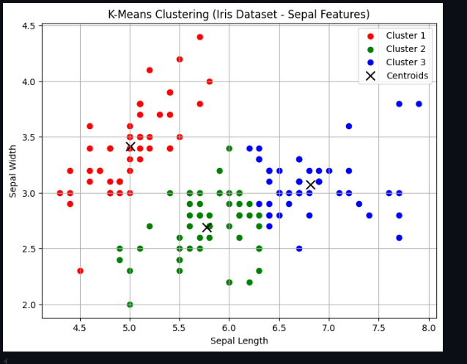

|  |  |
| --- | --- |
| **Date: 29/05/25** | **Data Mining and Analysis** |
| **Exp. No:8** | **Write a Python program to decompose a time series into Trend, Seasonality, and Residual components using: Additive model, Multiplicative model Input: Monthly sales data (e.g., 3–5 years) Frequency = 12 (for monthly seasonality).**  **Output: Plot of the original series, trend, seasonal, and residual components** |

Code:

import pandas as pd

import matplotlib.pyplot as plt

from statsmodels.tsa.seasonal import seasonal_decompose

*# Step 1: Load the dataset*

df = pd.read_csv('AirPassengers.csv', parse_dates=['Month'], index_col='Month')

data = df['#Passengers']

*# Step 2: Additive Decomposition*

add_decomp = seasonal_decompose(data, model='additive', period=12)

*# Step 3: Multiplicative Decomposition*

mult_decomp = seasonal_decompose(data, model='multiplicative', period=12)

*# Step 4: Plot Additive Decomposition*

plt.figure(figsize=(12, 8))

plt.suptitle('Additive Decomposition of Air Passenger Data', fontsize=16)

add_decomp.plot()

plt.tight_layout()

plt.show()

*# Step 5: Plot Multiplicative Decomposition*

plt.figure(figsize=(12, 8))

plt.suptitle('Multiplicative Decomposition of Air Passenger Data', fontsize=16)

mult_decomp.plot()

plt.tight_layout()

plt.show()

Output:

