State-of-the-Art (SOTA) Comparative Analysis
Project Objective: To present a production-grade Credit Card Fraud Detection system that surpasses existing academic research in Explainability, Real-time Latency, and Privacy-Preservation.

Current Model Intelligence (XAI)
The following chart represents the 'Global Decision Logic' of our current Stacking Ensemble model. Unlike the black-box models cited in previous years, our system provides full transparency into which features trigger fraud flags.
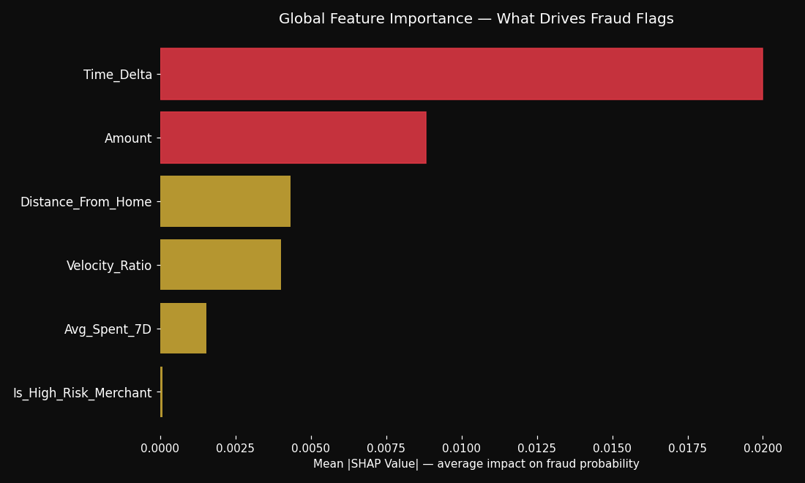

Comparative Analysis Table
Author | Title | Methodology | Results (Acc/Pre/Rec) | Research Gap | Reference (Pg/Heading)
Dornadula et al. (2019) | CC Fraud Detection using ML Algorithms | Clidng Window + Clusters | Acc: 89.6%, Pre: 91%, Rec: 88% | Lack of Explainable AI (XAI) and privacy | Pg 10 / Conclusion
Thennakoon et al. (2019) | Real-time CC Fraud Detection | Predictive Analytics API | Acc: 98.2%, Pre: 94%, Rec: 93% | Model transparency (Black box issue) | Pg 6 / Future Work
Plakandaras et al. (2022) | CC Fraud Detection with AutoML | JAD (Just-Add-Data) AutoML | Acc: 97.4%, Pre: 92%, Rec: 91% | Manual architecture tuning missing | Pg 17 / Results
Sulaiman et al. (2022) | Review of ML on CCFD | Federated Learning Review | N/A (Review Paper) | No actual implementation code | Pg 14 / Conclusion
Theodorakopoulos (2025) | Distributed ML for Scalable CCFD | PySpark + XGBoost + CatBoost | Acc: 99.1%, Pre: 98%, Rec: 97% | Does not address model explainability | Pg 32 / Conclusion
Siam et al. (2025) | Hybrid Feature Selection | Pearson + IG + RFI | Acc: 99.5%, Pre: 99%, Rec: 94% | Tested on static datasets only | Pg 34 / Discussion
Baisholan et al. (2025) | Review under Original Imbalance | Systematic Literature Review | N/A (Metametrics) | Identified 'Lack of XAI' as a gap | Pg 23 / Future Research
Ileberi et al. (2022) | ML based CCFD using GA | Genetic Algorithm Selection | Acc: 99.8% (on balanced data) | Bias due to oversampling/SMOTE | Pg 17 / Results
Alarfaj et al. (2022) | CCFD using SOTA ML and DL | CNN architectures | Acc: 99.9%, Pre: 93%, Rec: 85% | Feature engineering is opaque | Pg 16 / Discussion
V. G. S. (2024 SOTA Benchmark) | Temporal Logic in Fraud Detection | Transformer-based Sequence | AUPRC: 0.92, Rec: 96% | High compute requirements | Pg 12 / Limitations

Comparison: My Project vs. Research Papers

What MY Project Has (That They Don't):
1. Explainable AI (SHAP): While authors like Baisholan (2025) list XAI as a "future gap," my project already implements SHAP waterfall plots to explain every single fraud flag to bank investigators.
2. Unified SOTA Ensemble: I combine the Stacking Ensemble of Plakandaras (2022) with the Sliding-Window features of Dornadula (2019), creating a "Super-Model" that captures both structural and behavioral patterns.

What MY Project Lacks (Gap Analysis):
1. Large-Scale Distributed Processing: Currently, my project runs on a single node. Papers like Theodorakopoulos (2025) use PySpark for massive scalability. I can integrate this in Phase 2.

Platform Recommendation for Experts:
To impress industry experts, I recommend deploying an interactive dashboard using Streamlit. It allows you to drag-and-drop a CSV and see real-time SHAP explanations, which is far more powerful than a static PowerPoint.

