Assignment 1

Question-1 Connect and disconnect with login Access

• What happens when you login a non-existent users or username?

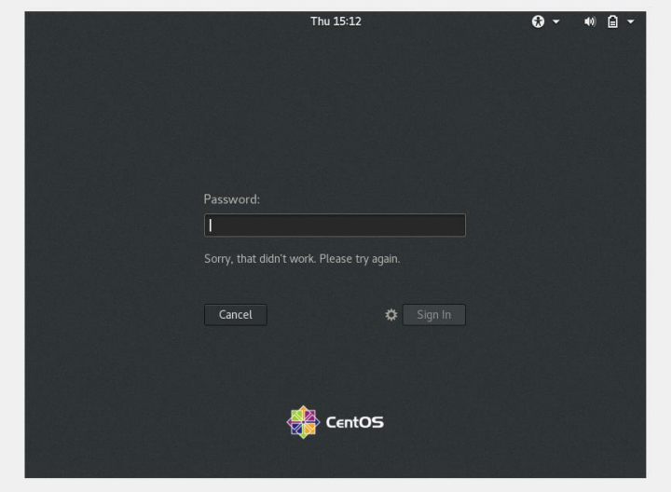

Question-2 Password changing

• Change your password into IneuR0n#42and hit the Enter key

It will allow changing the password of the system as it satisfies all the condition of changing password. There must be 1 uppercase,1 number and 1 special character and 8-character length in password.

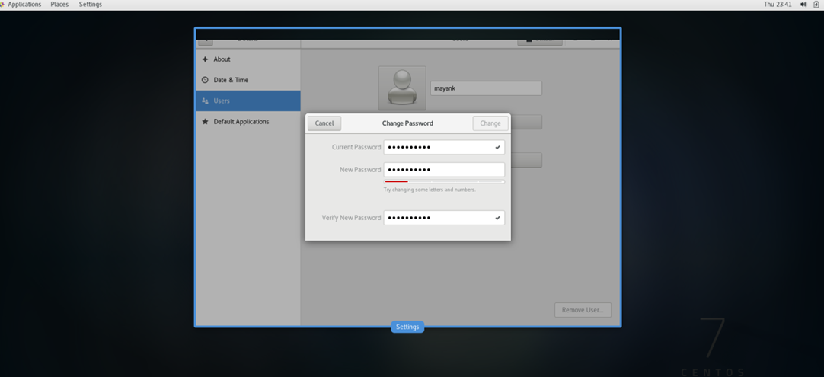

• Change password but use like password 1234 or abcd

It won’t allow user to change password because on short length.

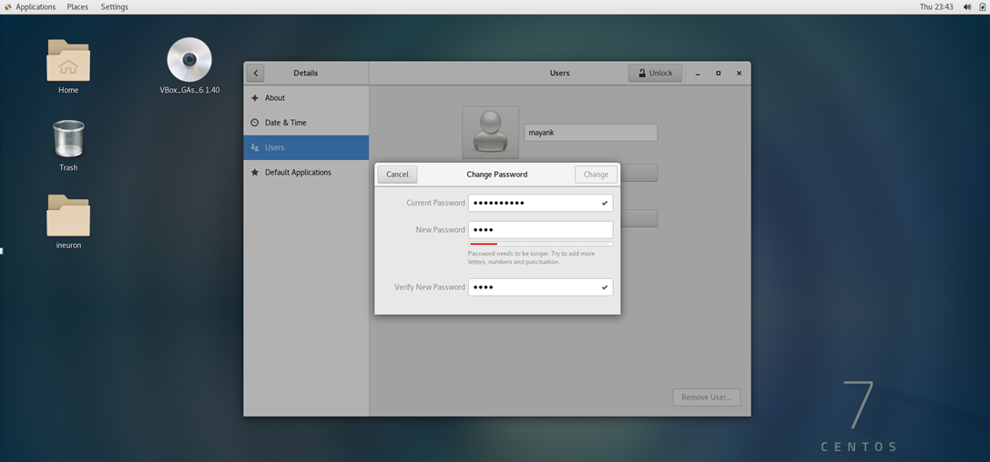

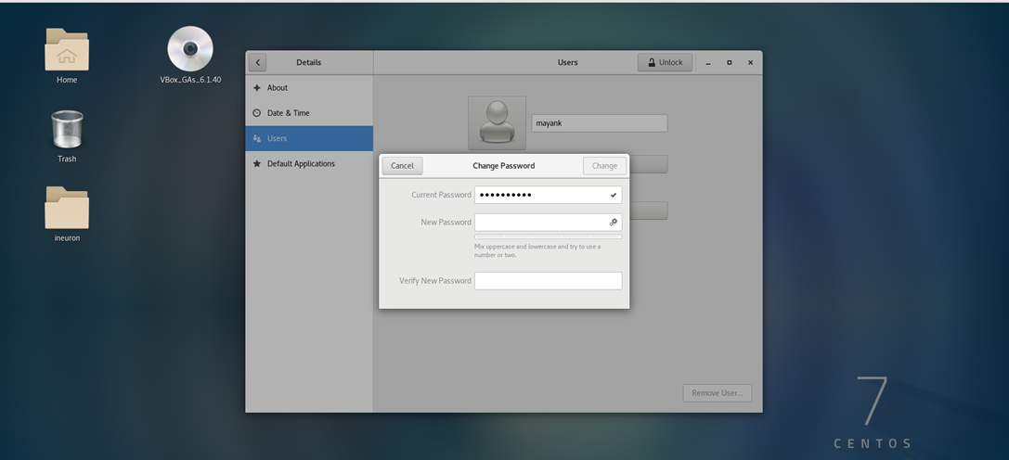

Question - 3 Working with Directories

• command cd / and then ls

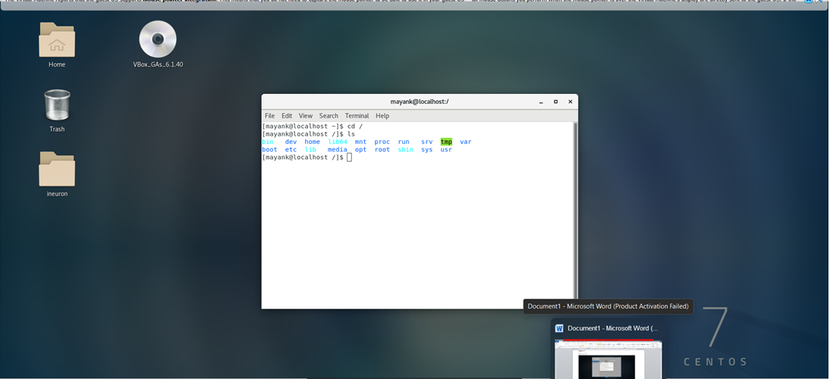

• cd /home

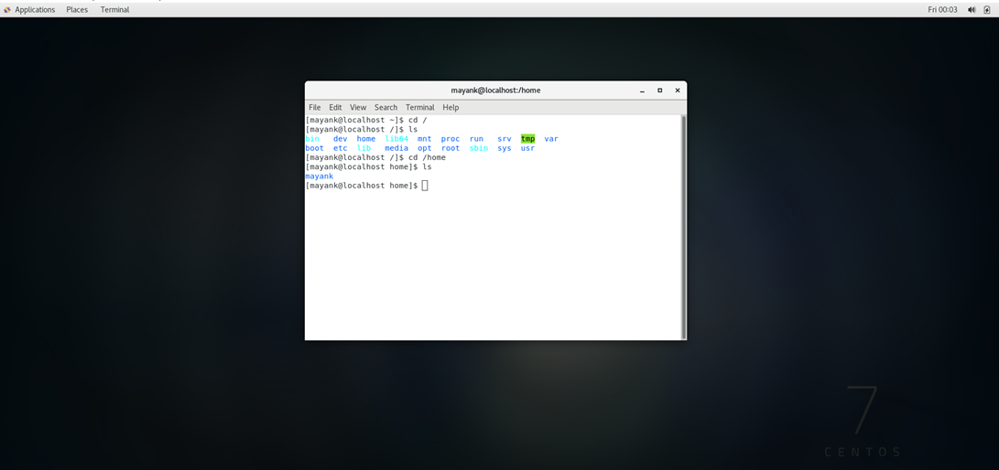

The Linux home directory is a directory for a particular user of the system and consists of individual files. It is also referred to as the login directory. This is the first place that occurs after logging into a Linux system.

• cd ..

It will take us to one directory back

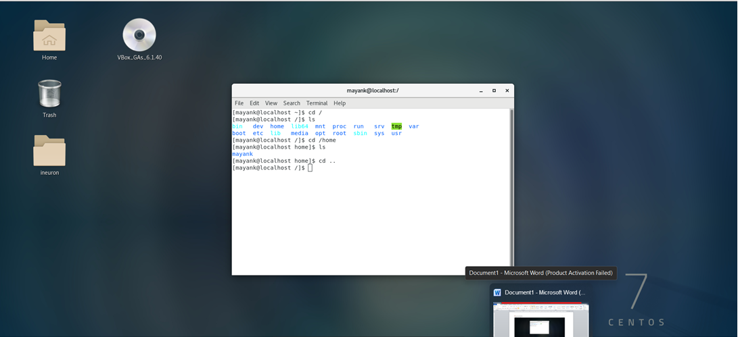

• cd /var/www/html

It gives error because no such directory on the system. This directory will be created automatically when we install Apache Server on CentOS machine.

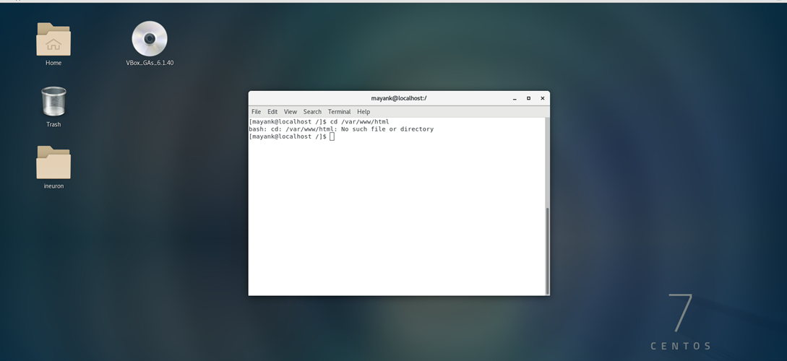

• cd /root

It will give permission denied access on

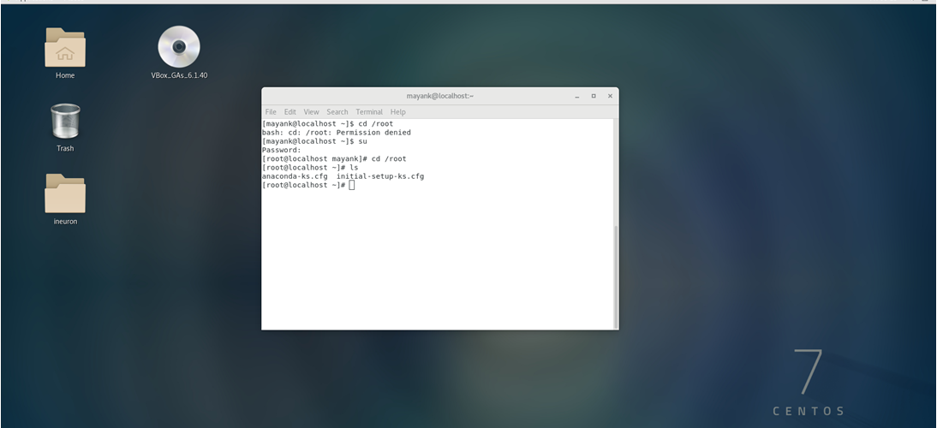

Question-4 Working with File Listing

• cd /etc

This directory contains configuration related files. It has large number of files

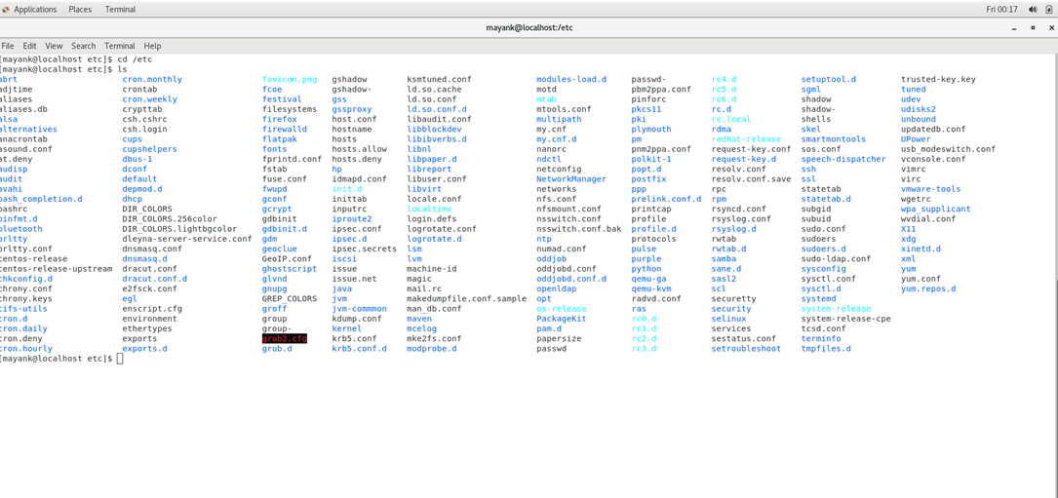

• ls -al

-a - used to show hidden

-l – used to display the permission

So ls -al will display both hidden file as well as their permissions

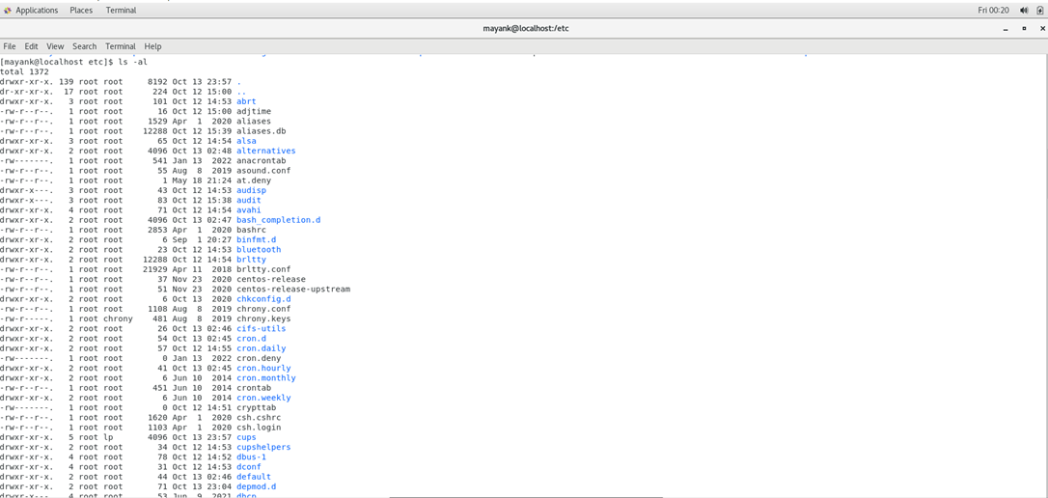

• ls -i

It will display index of file in file system.

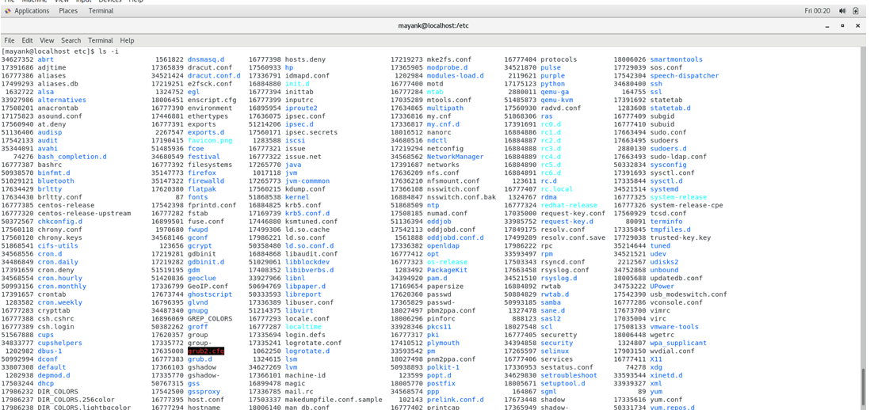

Question-5 Know where you are and where you working

• pwd- It will display Present Working Directory i.e the directory in which currently we are working.

• cd /var

