**Business case study (Target Company)**

**1 - Import the dataset and do usual exploratory analysis steps like checking the structure & characteristics of the date set:**

* 1. - Data type of all columns in the “customers” table:

**Result: -**

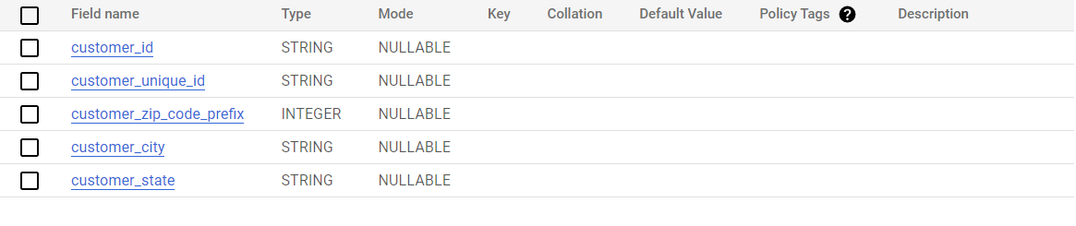

* 1. - Get the time range between which the order were placed.

**Query: -**

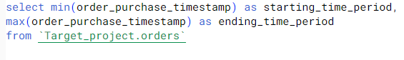

**Result: -**

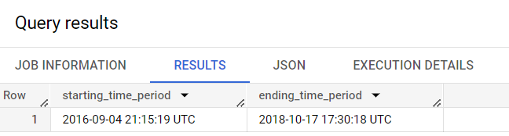

**1.3** - Count the Cities & States of customers who ordered during the given period.

**Query: -**

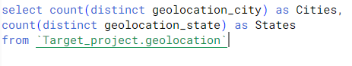

**Result: -**

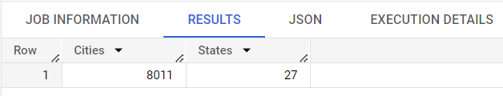

**2. In-depth Exploration:**

**2.1: -** Is there a growing trend in the no. of orders placed over the past years?

**Query: -**

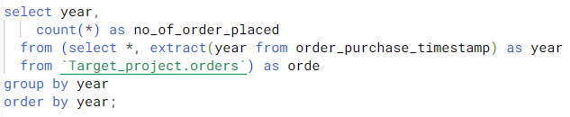

**Result: -**

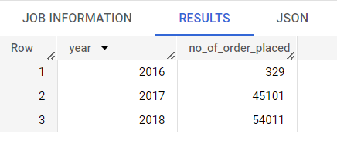

**2.2:** - Can we see some kind of monthly seasonality in terms of the no. of being placed?

**Query: -**

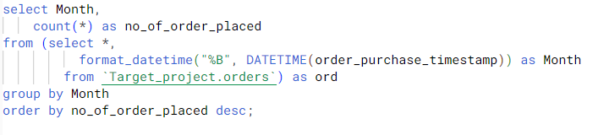

**Result: -**

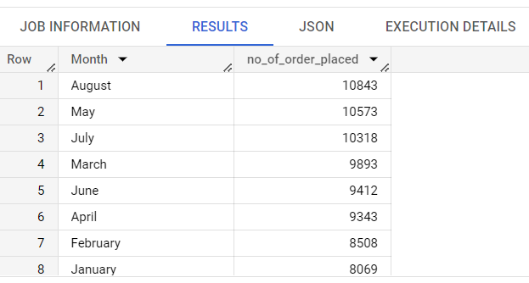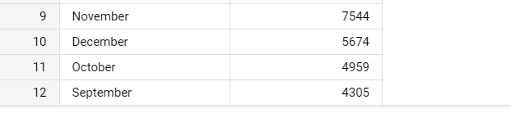

**2.3:** - During what time of the day, do the Brazilian customers mostly place their orders? (Dawn, Morning, Afternoon or Night)

* 0-6 hrs.: Dawn
* 7-12 hrs.: Mornings
* 13-18 hrs.: Afternoon
* 19-23 hrs.: Night

**Query: -**

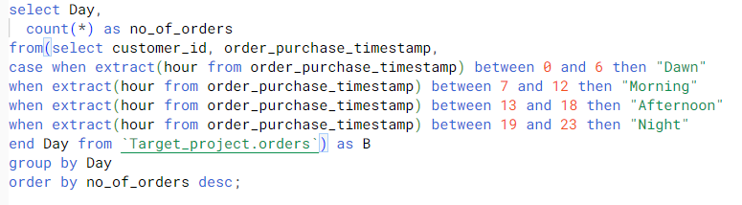

**Result: -**

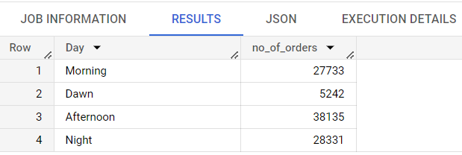

**Graph Table (Result): -**

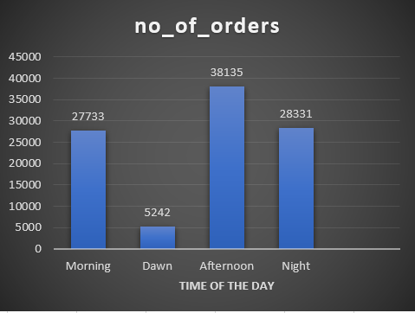

**3. Evolution of E-commerce orders in the Brazil region: -**

**3.1**- Get the month-on-month no. of orders placed in each state.

**Query: -**

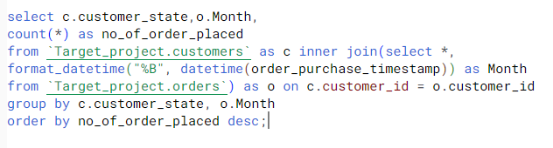

**Result: -**

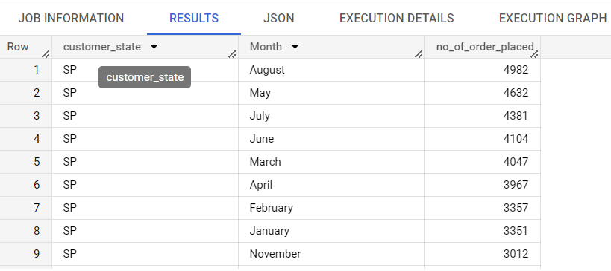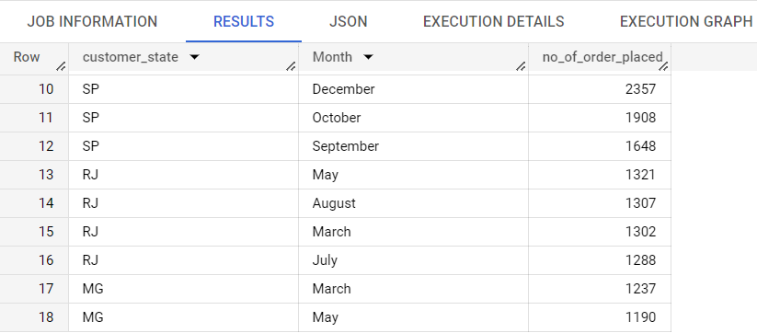

**Pivot Table (Month wise total information of output): -**

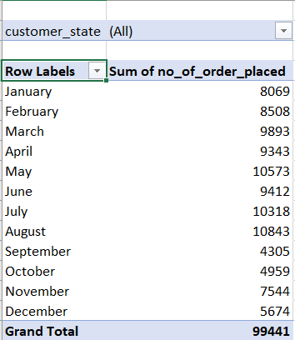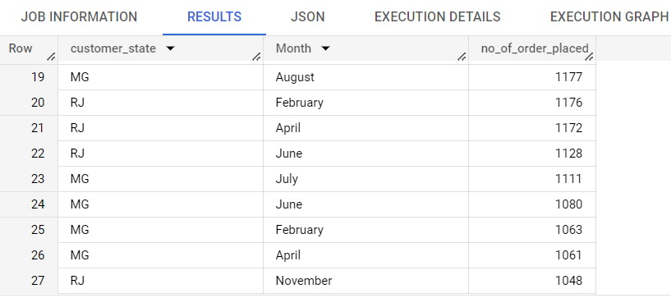

**3.2** - How are the customers distributed across all the states?

**Query: -**

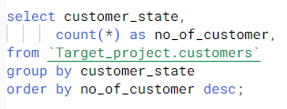

**Result: -**

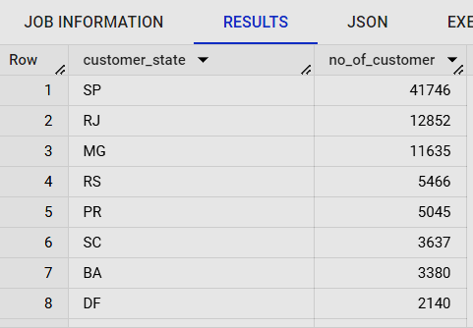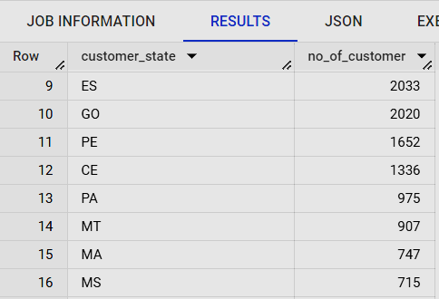

**Graph Table (Result): -**

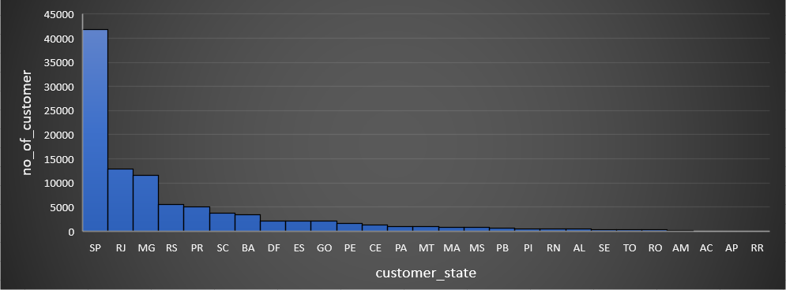

4. **Impact on Economy: Analyze the money movement by e-commerce by looking at order prices, freight and others.**

4.1- Get the % increase in the cost of orders from year 2017 to 2018 (include months between Jan to Aug only).

You can use the "payment value" column in the payments table to get the cost of orders.

**Query: -**

**Result: -**

4.2 - Calculate the Total & Average value of order price for each state.

**Query: -**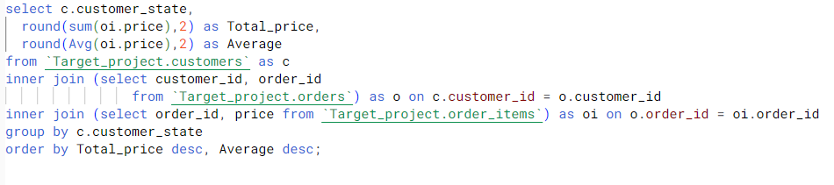

**Result: -**

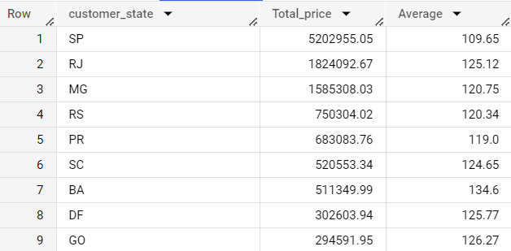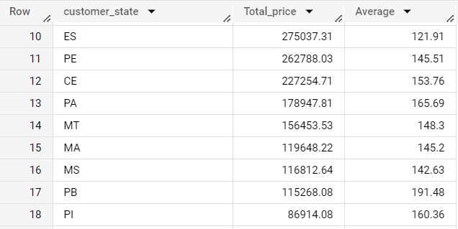

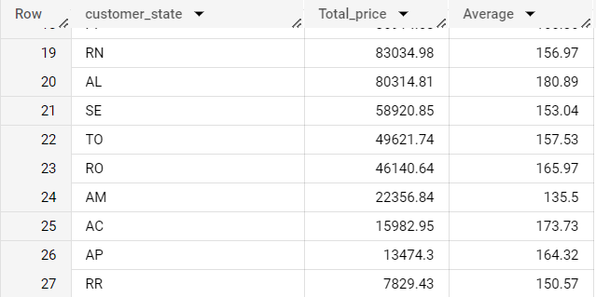

4.3- Calculate the Total & Average value of order freight for each state.

**Query: -**

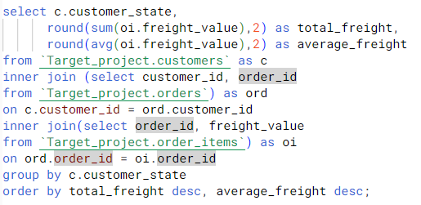

**Result: -**

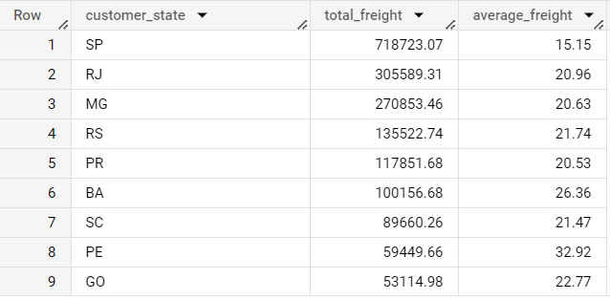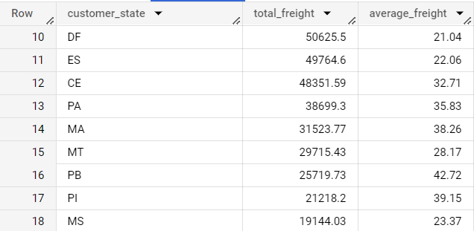

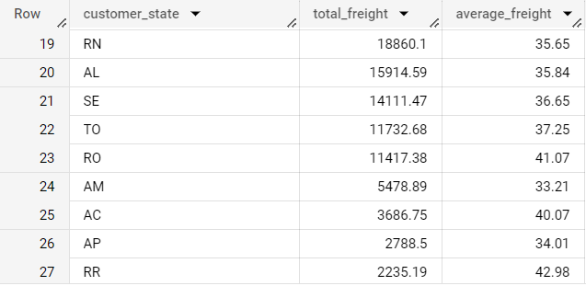

**5 - Analysis based on sales, freight and delivery time.**

**5.1 -** Find the no. of days taken to deliver each order from the order’s purchase date as delivery time. Also, calculate the difference (in days) between the estimated & actual delivery date of an order.  
Do this in a single query.

You can calculate the delivery time and the difference between the estimated & actual delivery date using the given formula:

* **time_to_deliver =** order_delivered_customer_date - order_purchase_timestamp
* **diff_estimated_delivery =** order_estimated_delivery_date order_delivered_customer_date.

**Query: -**

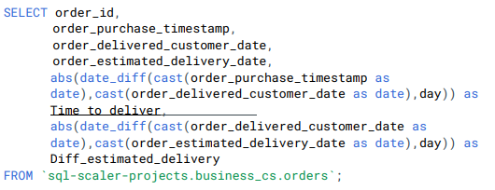

**Result: -**

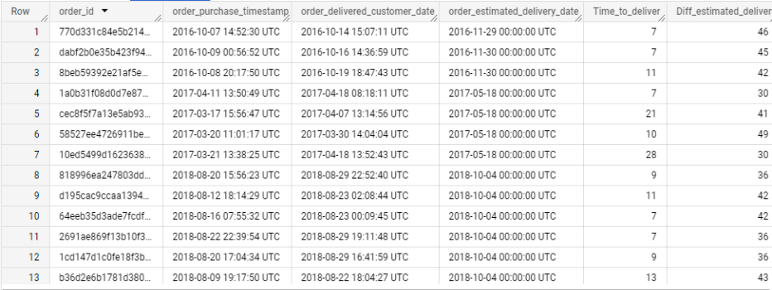

5.2 - Find out the top 5 states with the highest & lowest average freight value.

**Query: -** Top 5 states with the lowest average freight value.

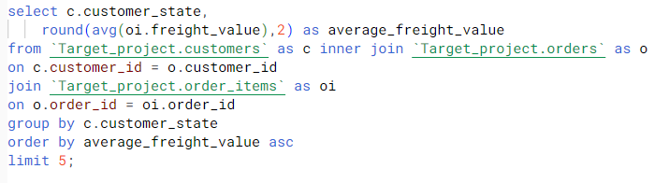

**Result: -**

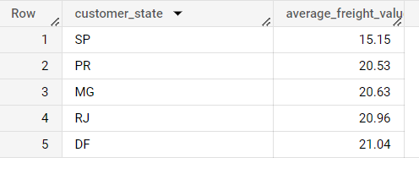

**Query: -** Top 5 states with highest average freight value.

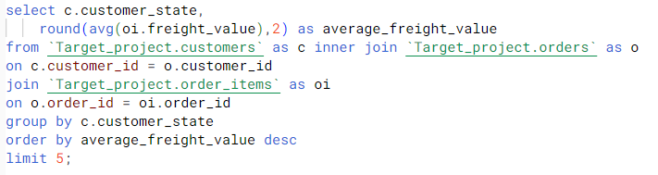

**Result: -**

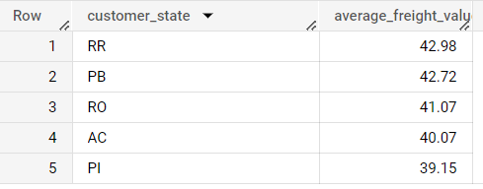

5.3 - Find out the top 5 states with the highest & lowest average delivery time.

**Query: -** Top 5 states by highest Average delivery time

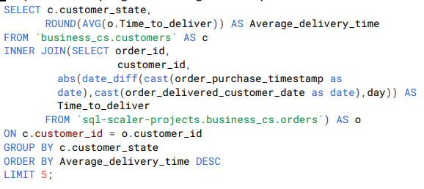

**Result: -**

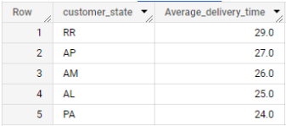

**Query: -** Top 5 states lowest Average delivery time –

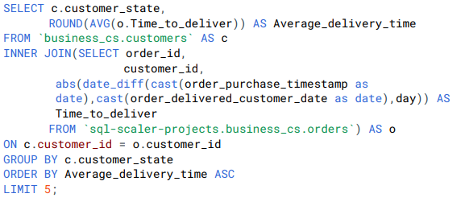

**Result: -**

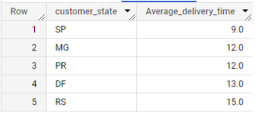

5.4 – Find out the top 5 states where the order delivery is really fast as compared to the estimated date of delivery.

You can use the difference between the averages of actual & estimated delivery date to figure out how fast the delivery was for each state.

**Query: -**

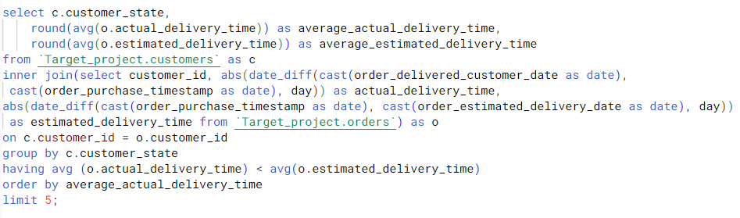

**Result: -**

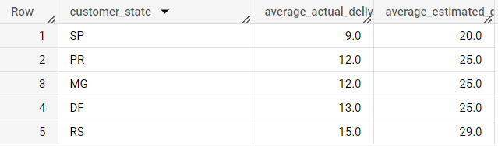

**6 - Analysis based on the payments:**

**6.1 -** Find the month-on-month no. of orders placed using different payment types.

**Query: -**

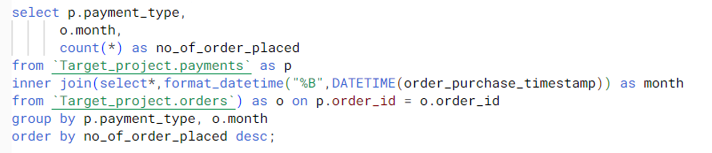

**Result: -**

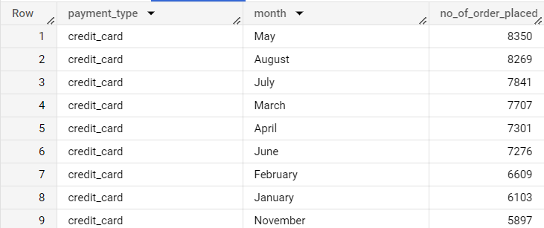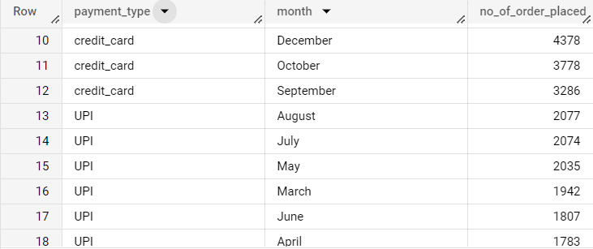

**Pivot Table (Month wise total transaction with different mode of payment): -**

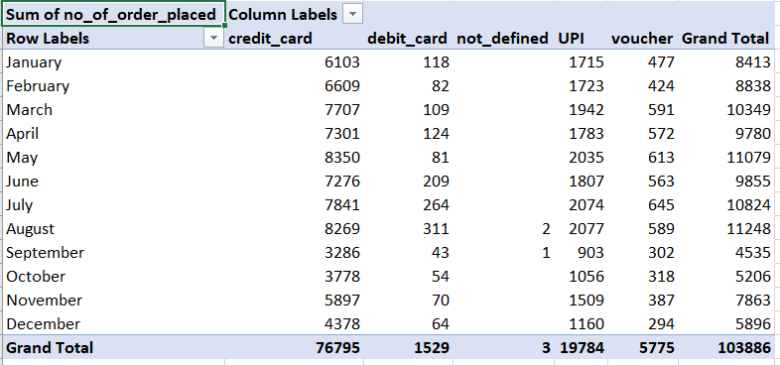

6.2 - Find the no. of orders placed on the basis of the payment installments that have been paid.

**Query: -**

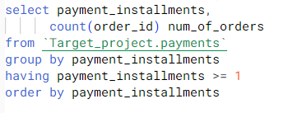

**Result: -**

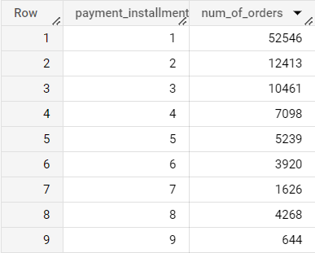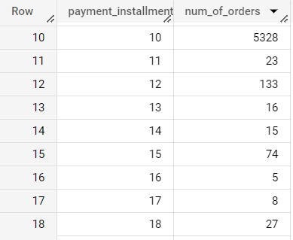

**Pivot Table (shows total no payment_installments and num_of_orders): -**

